Valvular Heart Disease – Facilitator Guide
Agenda:
1:00 – 1:15pm Theory Burst
1:15 – 2:15pm Case 1 & 2
2:15 – 2:30pm Break/Expert Questions
2:30 – 3:15pm Case 3 & 4
3:15pm Expert Questions

Case 1:
A 67y/o M with PMHx of HTN and HLD who presents to clinic for a routine check-up, though he hasn’t seen a doctor in years. He states he has been feeling well, has no complaints, and came to clinic at the urging of his wife. He is hoping to leave the office with a clean bill of health. Vitals: BP 160/88, HR 74, T 98.4 deg, RR 14, SpO2 99 on RA. On physical exam, you think you hear a systolic murmur, best heard at the cardiac apex. Listening closely, you hear it consistently throughout systole, and you can even hear the murmur tracing toward his axilla.

- What is your thought process when evaluating a murmur? Let’s create a systematic approach to murmurs.
- Murmurs result from turbulent blood flow through cardiac structures such as valves. Functional murmurs occur when there is increased blood flow through normal valves (think pregnancy, anemia. Note: all functional murmurs are systolic). Pathologic murmurs indicate dysfunctional valves.
  - Dysfunctional in 2 ways:
    - Stenotic: problem with opening
    - Regurgitant: problem with closing
- The first thing to identify when a murmur occurs in the cardiac cycle: systole or diastole.
  - Can be difficult to discern, especially if a patient is tachycardic
  - Can feel for patient’s pulse to help determine if systolic (shortly after pulse felt) or diastolic (later between pulses)
- When timing of murmur is identified, review which structures are open or closed during cycle:
  - Systole:
    - Atrioventricular valves (mitral, tricuspid) are closed
      - Mitral or tricuspid regurg (problem with closing) would cause systolic murmur
    - Semilunar valves (aortic, pulmonic) are open
      - Aortic or pulmonic stenosis (problem with opening) would also cause systolic murmur
  - Diastole:
    - Atrioventricular valves are open
      - Mitral or tricuspid stenosis (problem with opening) would cause diastolic murmur
    - Semilunar valves are closed
      - Aortic or pulmonic regurgitation (problem with closing) would also cause diastolic murmur
- To differentiate between semilunar vs atrioventricular valves involved, listen to the various regions on the chest to better interpret where the murmur originates.
- Left-sided valvular disease (mitral and aortic) is much more common than right-sided, increased wear and tear from higher pressure system

- What murmur are you most concerned about? How do you categorize this murmur and what follow up questions do you need to ask the patient?
- Mitral regurgitation (MR) - holosystolic, flat murmur that radiates to the axilla.
  - pressure in LV will always be greater than in LA, pushing blood back into LA at the very beginning of systole through to the end; also, why there is no change in intensity of the sound of the murmur. Radiates to axilla à path of regurgitant blood flow back toward LA.
- Important to distinguish mitral regurgitation as acute vs chronic primary (due to issues with valve leaflets or chordae tendineae) or chronic secondary (stretching of mitral annulus from LV dysfunction/remodeling), as this impacts management:
  - Acute MR: occurs abruptly, usually as a result of papillary muscle or chordae tendineae rupture in the setting of ischemia OR endocarditis.
  - Primary chronic MR: mitral valve prolapse (most common, connective tissue disease vs. idiopathic; mid-systolic click), rheumatic heart disease (MR is usually the earlier lesion in setting of rheumatic disease, later followed by MS), and degenerative processes
  - Secondary chronic MR: mitral annulus calcification, LV dilatation (ischemic vs nonischemic CM). Usually a functional defect.
- Important follow up questions for the patient:
  - Assess for signs of ischemic disease to rule out acute MR: ask about chest pain, DOE, etc.
    - With acute MR, would also anticipate symptoms of heart failure with pulmonary edema
  - Hx drug use or endocarditis?
  - hx of rheumatic heart disease?
  - Hx connective tissue disorders (Marfan’s, Ehler’s Danlos) to assess for dilated mitral annulus?
  - Ask about palpitations, LA dilation from chronic MR frequently leads to arrhythmias such as afib

- The patient denies any hx of ilicit drug use, rheumatic heart disease, or connective tissue disease. He says he has been told long ago that he has high blood pressure but has never taken medications for it because he hates taking pills. He denies chest pain, shortness of breath, or palpitations. He remains fairly active for his age. He asks you if you think he’ll need surgery for this. What are your recommendations for next steps?

- Management of MR depends on etiology (primary vs secondary) and severity.
  - In this patient, likely etiology is chronic secondary MR due to long-standing, untreated HTN resulting in hypertrophic cardiomyopathy and changes in the LV.
    - How are we going to approach treatment? What are our BP goals?
  - For secondary chronic MR – the valve itself is usually normal, but LV dysfunction often causes regurgitation. Thus, valve replacement would not be effective treatment.
- For management, TTE necessary to grade severity of regurgitation
  - Grade of severity determines surveillance and follow up:
    - At risk – little risk of progression of disease (MVP, annular dilation). Do not require regular surveillance.
    - Mild progressive – requires monitoring with TTE every 3-5yrs.
    - Moderate progressive – TTE every 1-2yrs.
    - Severe
- Indications for surgical intervention: Class 1, Level B
  - Symptomatic, severe chronic primary MR with LVEF > 30%
  - Asymptomatic, severe chronic primary MR and LV dysfunction (LVEF 30-60% and/or LVESD >40mm)
  - MV repair/replacement for chronic severe primary MR and undergoing other cardiac surgery
  - Severe MR and new onset Afib, pulm HTN, contraindication for anticoag, severely depressed LVEF
  - No class 1 recommendations for intervention in secondary MR! Only class 2a for severe secondary MR undergoing other cardiac surgery and persistent for LV dysfunction despite optimal GDMT
- Mitral valve can frequently be surgically repaired rather than replaced. This is preferable because the mitral valve is more than just the valves themselves, but an apparatus that includes the chordae and papillary muscles.

Case 2:
You’re seeing a new patient, a 20 yo male with no pmhx other than a childhood sore throat that he says caused a heart murmur, though he doesn’t know much more. He was born in Mexico City and immigrated to the US when he was 6. He was in his usual state of health until about 4 weeks ago when he developed mild shortness of breath and lightheadedness with exertion. He now has persistent shortness of breath and is worried he might have COVID.

On exam, he is afebrile, BP is 122/82, HR 108, RR 18, SpO2 98% on RA. His exam is notable for a low-pitched diastolic murmur with an opening snap. See QR code for EKG.

What is his rhythm? You suspect he has underlying valvular heart disease from his childhood illness. What is most likely?
- The patient is in atrial fibrillation.
- He likely has rheumatic heart disease, caused by a group A beta-hemolytic Strep infection that was not properly treated. Incidence is much less common in the US than developing countries.
  - Majority patients with chronic rheumatic heart disease do not have a history of acute rheumatic fever, many cases are subclinical or not detected. Take into consideration when assessing murmurs in young patients who have RHD risk factors.

What would you do next, and what would you discuss with your patient about upcoming treatment possibilities?
- He needs an echocardiogram to assess his murmur.
- He has “valvular afib” and should be anticoagulated. The term “valvular afib” is falling out of favor because it is confusing. It specifically refers to patients with mitral stenosis due to rheumatic disease or a mechanical valve replacement. Discuss how to go about the decision to anticoagulated these patients.
  - If learners use the CHADS2VASc scoring system, he will score a 0 and not qualify for AC. However, CHADS2VASc is only used for non-valvular afib. Long term AC with warfarin is recommended because of a much higher yearly risk of stroke compared to the non-valvular afib population.
- Natural course of rheumatic heart disease is variable. Progressive heart disease may develop, but not in every pt. One 20 year follow up study of 1000 children and adolescents showed that 65% had evidence of valvular heart disease after an initial episode of rheumatic fever, however at the 20 year follow-up, clinical symptoms had resolved in 17%. The other 35% of patients in this study did not develop valvular heart disease after their initial rheumatic fever episode, however 20 years later 44% had overt signs of valvular heart disease.
- Would counsel pt that he might need repair or replacement

MKSAP Question:
A 65 year old woman is evaluated during a routine examination. She was diagnosed with a cardiac murmur in early adulthood. She is active, healthy, and without symptoms. She takes no medications. On physical examination, vitals are normal. A grade 3/6 holosystolic murmur preceded by multiple clicks is present at the apex. Physical findings are otherwise unremarkable.

An echocardiogram demonstrates a left ventricular ejection fraction of 50%. The left ventricle is moderately dilated with an end-systolic dimension of 42 mm. Myxomatous degeneration of the mitral valve is present with severe regurgitation due to posterior leaflet prolapse.

Which of the following is the most appropriate next step in management?
A. Serial clinical echocardiographic evaluations
B. Surgical mitral valve repair
C. Surgical mitral valve replacement
D. Transcatheter mitral valve repair

Answer: B. Surgical mitral valve repair. This patient meets criteria for surgical valve repair vs replacement. Mitral valve repair is preferred over replacement because it is associated with improved survival. Valve repair is recommended in patients with chronic severe primary MR with symptoms if LVEF is >30%, asymptomatic patients with EF 30-60% and/or LVESD > 40mm, patients undergoing another cardiac procedure; it is also considered a reasonable procedure in asymptomatic patients with pulmonary HTN with PASP > 50 mmHg or new onset afib.
Memory tool: Indications for MV repair are “symptoms, 60, 50, 40”

EF<60 in patients with MR is basically considered reduced EF due to low afterload conditions in MR (left atria is very low pressure). The goal of fixing the MR is to prevent further cardiac remodeling and development of clinical heart failure.

Bonus Question: Describe the murmur you would expect to hear with the most common cause of primary mitral regurgitation? Why is this different?
- Mitral valve prolapse is the most common cause of primary MR, with up to 3% of the population having some degree of mitral prolapse (occurs more commonly in females).
- MVP characteristically has an early- to mid-systolic ejection click as the prolapsed, floppy valve snaps into place, followed thereafter by the flat, systolic murmur of mitral regurgitation.

BREAK

Case 3:
Your next patient is an 88y/o M with PMHx HTN, HLD, OA, and prostate cancer presents to your office for symptoms of shortness of breath. He notes this has been occurring for some time now, but over the past few weeks he has felt really winded when walking around his neighborhood. He’s wondering what you can do to help him breathe more easily.

On physical exam, his vitals are within normal limits. He does not appear breathless while sitting on the exam table, but you do notice some swelling of his legs. You go to listen to his heart and you hear another systolic murmur (you’re on a roll) and you hear it best at the R upper sternal border.

1. What valvular disease are you worried about and why? Describe the murmur and pathophysiology in more detail.
- The location is most consistent with AS. Usually described as an ejection click followed by a crescendo-decrescendo murmur. The ejection click occurs shortly after S1 as a result of stenotic valves snapping into place. The crescendo occurs as there is an increase in pressure in the LV during systole forcing blood through stenotic valve. However, as LV volume decreases over the course of systole, the murmur decrescendos. The murmur also radiates to the carotids (turbulent blood flow to early branches from aorta)
- Aortic stenosis is the most common among valvular diseases, and is associated with increasing age
  - Severe AS prevalence ~3.5% in patients >75y/o
  - Also occurs as a result of bicuspid aortic valves (up to 2% of individuals have this congenital abnormality), but AS usually presents earlier
- Pathophysiology of AS is similar to that of atherosclerosis Thought to involve inflammation and endothelial dysfunction, leading to sclerosis of the valve, and eventual calcium deposition and ossification of valves.
- How does the myocardium respond to AS? Initially, the LV hypertrophies and maintains wall stress and cardiac output. With time, it decompensates due to cell death and myocardial fibrosis.

2. What are the characteristic symptoms and other physical exam findings associated with this
murmur? Describe the pathophysiology underlying these symptoms.
- Angina, syncope, dyspnea on exertion are 3 characteristic symptoms of AS. Typically, patients are not particularly symptomatic until their disease progresses to the severe stage.
  - Angina – decreased blood flow into coronary circulation immediately after passing through stenotic aortic valve; increased myocardial oxygen demand with myocardial hypertrophy of LV pushing against stenotic valve; decreased capillary density in a hypertrophic myocardium.
  - Exertional Syncope – global cerebral hypoperfusion due to decreased cardiac output with a stenotic valve; further thought to be due to an imbalance in vasodilation of exercising muscle vasculature to inadequately vasoconstricted non-exercising muscle with decreased arterial pressure.
  - Dyspnea on exertion – indicative of heart failure; inability of the LV to accommodate cardiac output with exercise, elevated PCWP from elevated LV diastolic pressure from reduced LV compliance.
*** Note that onset of symptoms does not effectively correlate with severity of AS
- Other notable physical exam findings in AS:
  - Diminished S2
  - Pulsus parvus et tardus à weak (low volume) carotid pulse that is palpable later than anticipated (late upstroke) due to declining stroke volume.
  - Laterally displaced LV impulse
  - Crescendo decrescendo murmur
  - Murmur may become fainter as disease progresses to very severe (due to very low flow state)

You tell the patient that you are concerned he has aortic stenosis and that his symptoms could be the result of heart failure related to valve disease. You order a TTE and a few days later you get the echo report back:
LVEF: 40%
AV area: 1.0cm²
Peak velocity: 4.5m/s
Pressure gradient: 45mmHg

3. What are the stages of aortic stenosis? What stage does your patient fall into? Why is this
important?

- Review the basics of Stage A, B, C, D (no need to go into details of flows and gradients)
- Severe AS remember 1, 4 and 40.
  - Valve Area <1 cm²
  - Vmax >/= 4 m/s
  - Mean transvalvular gradient >/= 40 mm Hg
  - Need to meet Vmax >/= 4 m/s or Mean transvalvular gradient >/= 40 mm Hg to qualify as severe. Usually Valve Area <1 cm² but not necessary to define severe
- The patient falls into Stage D – symptomatic, severe disease (high Vmax and high gradient)
- (table below in learner appendix)
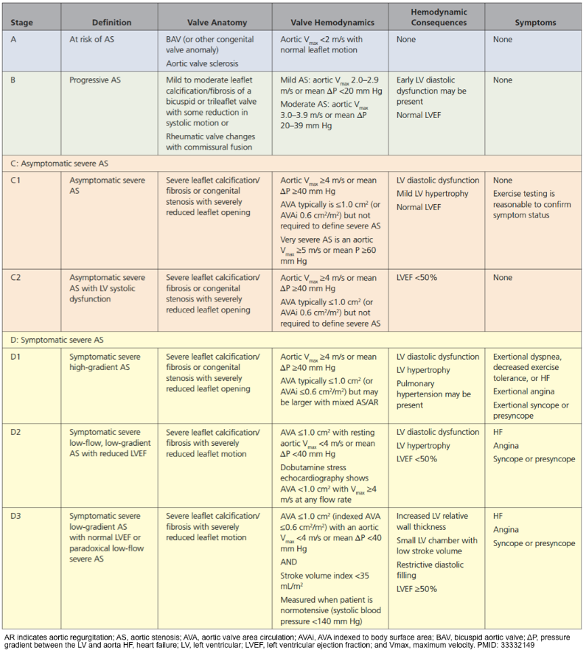

- You call the patient to follow up on his results. What are your recommendations?
- High risk of mortality without surgical intervention, with an event-free survival rate of 30-50% at 2 years à recommend he undergo evaluation for aortic valve replacement. For asymptomatic patients with severe AS, risk of sudden death is ~1% per year; once symptoms develop, clinical deterioration can be rapid and risk of sudden death increases to 4% at 1 month and 12% at 6 months if not intervened upon.
  - The top two causes of death are HF and sudden cardiac death in a multi-center observational study of causes of death in patients with severe AS.
Minamino-Muta E, Kato, T, et al. Causes of death in patients with severe aortic stenosis: an observational study. Scientific Reports. 2017;7(14723).
- Important point here to is also to discuss surgical options based on surgical risk
- Asymptomatic patients with calcific AS and severe obstruction should be followed carefully for development of symptoms with serial TTE. Surgery is indicated if severe, symptomatic, LVEF less than 50%, bicuspid disease, root or ascending aorta dilation > 5.5 cm. Furthermore, all patients who need some sort of intervention should be screened for CAD. If they need a CABG, they should undergo SAVR over TAVR.
  - Currently, we do not have a lot of long-term data on TAVR. Thus, younger patients are typically preferred to undergo SAVR, especially mechanical valve (which is proven to be the most durable). The downside of the mechanical valve is permanent anticoagulation.
  - Greater than 65 yo it is reasonable to choose bioprosthetic valve (TAVR is also bioprosthetic) over mechanical valve
  - SAVR is favored in patients with bicuspid or rheumatic disease
  - Transaortic Valve Replacement (TAVR) - accepted as Class 1 recommendation for those with high or prohibitive surgical risk. Also Class 1 for patients age >80 and for patients aged 65-80 (with risk/benefit discussion of TAVR vs SAVR in this age cohort)
  - See appendix for further differentiating factors favoring SAVR vs TAVR

- What if your patient had no symptoms and normal EF? How would your recommendations change? What if the patient has a depressed EF but is asymptomatic?
- In asymptomatic patients with severe AS and intact LV function, it is reasonable to consider stress testing to determine whether symptoms change with exercise.
  - Frequently, pts will self-limit activity without realizing to prevent symptoms. If exercise testing provokes symptoms, the patient is considered symptomatic.
  - Stress testing should NOT be done in symptomatic patients or in those with reduced EF
- Cardiac catheterization may also be reasonable before surgical intervention if sx of angina, known CAD or risk factors for CAD
  - AVR appropriate for asymptomatic patients with severe stenosis AND undergoing some other cardiac procedure such as CABG!
- There is a recently identified type of AS called Low Flow Low Gradient Aortic Stenosis. This is seen in patients with reduced EF < 50% who have a discordant aortic valve area or mean gradient. Their low flow and gradients are due to the low EF wherein the LV is unable to generate enough contractility to create a truly severe velocity and gradient. These patients need to undergo dobutamine stress echo in order to assess for truly severe AS. This is an advanced topic and will be discussed further in the next case.

Bonus Case: Case 4:
Your last patient of the day is 80-year-old woman who is coming in for a 6-month history of worsening DOE. Two nights ago, she awoke with sudden-onset dyspnea that was relieved with ambulation. She has not had chest pain. Medical history is significant for an MI 8 years ago. She has a history of LV dysfunction but has been previously well compensated. Her medications are lisinopril, aspirin, metoprolol, and rosuvastatin.

Exam: AF, BP 95/60, HR 56, RR 18. The lungs are clear. The carotid upstroke is low in volume. The apical impulse is laterally displaced and enlarged. S1 is soft; the aortic component of S2 is diminished. There is no S3 or S4. A grade 2/6 mid-peaking systolic murmur is heard throughout the precordium. The remainder of examination is normal.

She just so happened to have gotten a TTE that morning. It shows an LVEF of 32%. AV is slightly calcified. The stroke volume is markedly decreased (23 mL/m2). The mean aortic gradient is 20 mmHg (c/w mild to moderate stenosis), and the aortic valve area is calculated to be 0.7 cm2.

What should you do next?

This patient has low flow-low gradient aortic stenosis. And should get a dobutamine stress echo.
She either has severe LV dysfunction with pseudostenosis or a critical aortic stenosis. With diminished cardiac output due to LV dysfunction, opening forces to the aortic valve are decreased and the valve area may be calculated as falsely low even if it is not anatomically severe (pseudostenosis). Using an inotropic agent like dobutamine will help to increase cardiac output and differentiate between pseudostenosis and truly severe stenosis. If she has truly severe AS, AVR should be considered given her symptoms.

Bonus: If there is time…review dynamic auscultation methods!
- Valsalva maneuver – creates an increase in intrathoracic and abdominal pressure, decreasing blood return to the right side of the heart, reducing cardiac preload and LV end-diastolic volume (LVEDV).
  - Useful in distinguishing HOCM from AS
    - HOCM: murmur gets louder with Valsalva (worse with low LVEDV)
    - AS: murmur gets softer or stays the same
    - MR: gets softer
    - Generally, decreased LV end-diastolic volume leads to a decreased pressure gradient between the ventricle and aorta, so flow will decrease as well. Less flow = reduced ejection velocity = less turbulence across a valve = softer murmur.
- Squatting – lower extremity veins are compressed, augmenting venous return to the right atrium, thus increasing preload and LV filling.
  - Also useful in distinguishing HOCM from AS
    - HOCM: murmur improves/softens with squatting
    - AS: murmur gets louder with squatting
    - MR: murmur gets louder with squatting
  - Increase in preload also causes delay in ejection click with MVP
- Standing – decreases preload (the reverse of squatting), similar to Valsalva
- Leg raise – increases preload, like squatting.
  - Remember this useful tool to assess for volume responsiveness as it functions like a small fluid bolus!
- Hand grip – an isometric exercise that increases blood pressure and increases afterload
  - Intensifies L sided regurgitant murmurs (AR, MR)
  - No impact to less intensity AS murmur

Appendix:

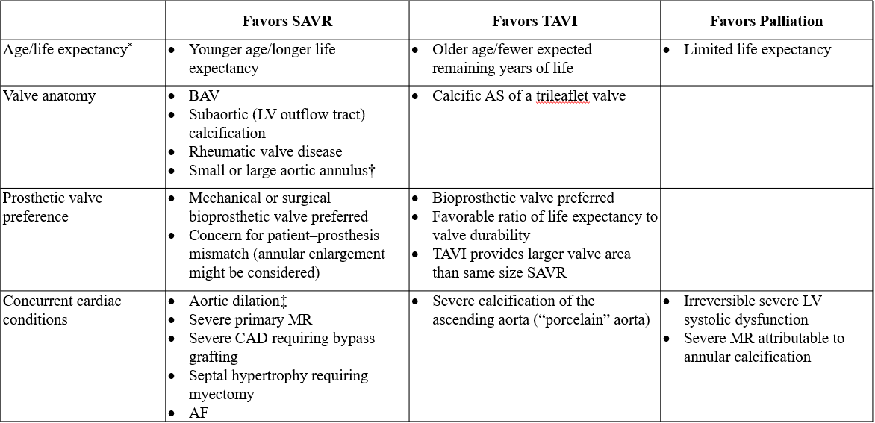

Summary of Valvular Conditions
Lesion | Causes | Symptoms | Physical Findings | Important Additional Info
Mitral Stenosis | Rheumatic fever sequelae, senile calcific disease | Dyspnea on exertion, decreased exercise tolerance | Opening snap, loud S1, diastolic rumble | Severe: MV area < 1.5 cm2  Anticoagulation recommended for patients with MS and AF, MS and prior embolic event, MS and LA thrombus
Mitral Regurgitation | Acute: endocarditis, papillary muscle dysfunction | Acute: pulmonary edema, cardiogenic shock | Holosystolic murmur at apex, radiates to axilla | Distinguishing primary from secondary important as intervention is curative for primary.
 | Chronic Primary: Mitral Valve Prolapse, Rheumatic  Chronic Secondary: LV dysfunction | Chronic: fatigue, DOE
Aortic Stenosis | Degenerative calcification, congenital, rheumatic | Angina, syncope, DOE | SEM loudest at RUSB, crescendo/decrescendo, soft S2, radiates to carotids | Severe AS: Aortic Vmax ≥ 4.0 m/sec or mean ΔP ≥ 40 mmHg, typically AV area ≤ 1.0 cm2
Aortic Regurgitation | Bicuspid AV, calcific disease, aortic root dilation, endocarditis | DOE, angina | Early diastolic decrescendo murmur, wide pulse pressure, bounding pulses | AVR indicated for asymptomatic severe AR if LVEF < 50% or if LVEF ≥ 50% but LVESD > 50 mm
Class I Surgery Indications:
Aortic Stenosis- symptomatic severe AS (stage D), asymptomatic severe AS with LVEF < 50% (stage C), pts undergoing other cardiac surgeries (stage C or D)
Aortic Regurgitation- symptomatic severe AR (stage D), asymptomatic severe AR with LVEF < 55% (stage C), patients undergoing other cardiac surgeries (stage C or D)
Mitral Stenosis- percutaneous balloon commissurotomy for symptomatic severe MS (stage D), MV surgery for symptomatic severe MS (stage D) who failed commissurotomy or who can’t undergo commissurotomy, patients undergoing other cardiac surgeries (stage C or D)
Mitral Regurgitation- symptomatic severe chronic primary MR with EF > 30%, asymptomatic severe chronic primary MR with EF 30-60% or LVESD > 40 mm

