Academic Half Day – LGBTQIA+ & Sexual Health
Facilitator Guide
Agenda:
1:10 – 1:20 pm Theory Burst
1:20 – 2:10 pm Small Groups
2:10 – 2:20pm Questions with the Expert
2:20 – 2:30pm Break
2:30 – 3:20pm Small Groups
3:20 – 3:30pm Questions with the Expert

Case One:

A 52-year-old assigned female at birth (AFAB) non-binary patient presents to establish care in your clinic for primary care.

PMH: They have no known past medical history
Family History: Dad – MI at age 67
PSH: Appendectomy, Keyhole top procedure
Social History: Currently working as a librarian. Lives at home with their wife. Sexually active with their wife. Denies any tobacco or illicit drug use. Drinks 1-2 glasses of wine socially a few times per month.

Medications: Daily multi-vitamin

Vitals: BP 134/80, HR 84, spO2 98% on room air

- What preventative care should be discussed with your patient at this visit?

- Important to know what organs the patient has. *Important to ask this question safely. For example: “There are specific screenings that we do for specific organs, for example breasts, prostate, uterus. Could you tell me which of those is pertinent to you?”
  - Cervical Pap smear every 5 years.
    - A painful pap smear experience is correlated with non-adherence to future screening and colposcopy. Several anecdotal techniques may reduce pain associated with speculum exams. A pediatric speculum may allow visualization of the cervix and can reduce discomfort with the exam; however, it is important to avoid using a speculum so short that it requires excessive external pressure to visualize the cervix – “UCSF guidelines for primary care for transgender and gender non-binary individuals”
  - Breast cancer screening
    - Clinicians should engage in dialogue with transgender men or non-binary patient who have undergone bilateral mastectomy about the unknown risks associated with residual breast tissue, as well as the possible technical limitations of mammography (Grading: X C S).
    - Use terminology that patients are most comfortable with. (Example: instead of breast cancer can say chest cancer, instead of breast exam can say chest exam.)
    - Transgender men who have not undergone bilateral mastectomy, or who have only undergone breast reduction, should undergo screening according to current guidelines for non-transgender women. No reliable evidence exists to guide the screening of transgender men who have undergone mastectomy. Since most or nearly all breast tissue may have been removed, mammography for the evaluation of a palpable lesion may not be technically feasible, and alternatives such as ultrasound or MRI may be necessary. The risk of breast cancer in residual breast tissues after mastectomy is unknown. “UCSF guidelines for primary care for transgender and gender non-binary individuals”
  - Cardiovascular Health: ASCVD
    - Current American Heart Association - American College of Cardiology guidelines for prevention and lipid management involve the use of sex-specific calculators to determine risk and guide interventions.[14] Determination for the use of aspirin also uses these calculators when conducting a risk-benefit assessment for gastrointestinal bleeding. Currently there is no guidance on whether to use risk calculators based on natal sex or affirmed gender. It may be reasonable to use natal sex-based calculators in transgender people who have medically transitioned later in life, given their long-term exposure to the natal hormonal milieu
    - Depending on the age at which hormones are begun and total length of exposure, providers may choose to use the risk calculator for the natal sex, affirmed gender, or an average of the two (Grading: X C M)
    - For transgender women with cardiovascular risk factors or established CVD, using the transdermal route of estrogen may be preferred due to lower rates of venous thromboembolism, and lack of associated changes in lipid profile or markers of coagulation (Grading: NT O M).[15,16] Additional modifiable interventions to reduce risk include smoking cessation, weight loss, management of diabetes, and encouraging physical activity. It is theoretically possible that the psychosocial benefits of hormone therapy may have an independent and protective effect through reduction of stress, improved body image resulting in healthier lifestyle choices, reduced tobacco use, and increased physical activity “UCSF guidelines for primary care for transgender and gender non-binary individuals”
  - Diabetes Screening
  - Osteoporosis
    - Transgender people (regardless of birth-assigned sex) should begin bone density screening at age 65. Screening between ages 50 and 64 should be considered for those with established risk factors for osteoporosis. Transgender people (regardless of birth assigned sex) who have undergone gonadectomy and have a history of at least 5 years without hormone replacement should also be considered for bone density testing, regardless of age (Grading: X C W)
    - Transgender people without gonads, and who are not using hormone replacement, should follow screening and prevention guidelines for agonadal or postmenopausal women, regardless of birth-assigned sex or gender identity (Grading: X C W).

Case Two:

36-year-old trans femme presents to your clinic for an acute visit for evaluation of right lower extremity pain and swelling.

- What additional information would you like to know?
- Differential for unilateral edema:
  - DVT
  - Cellulitis
  - Abscess

- What are the patient’s risk factors for DVT?
  - Recent Fracture/Immobilization
  - Smoking
  - Family history (Factor V Leiden, Protein C,S deficiency)
  - Nephrotic
  - Heart Failure
  - Malignancy
- How long has the patient been on Estrogen?
- Type of Estrogen (Oral, Transdermal, Injections)
  - Some data is showing that Estrone is more thrombogenic that Estradiol. Physiologic ratios of Estrone to Estradiol is about 3. Oral formularies of estrogen can contribute to higher levels of E1:E2 ratios where transdermal or injectable formularies have ratios that are closer to physiologic.

    - “Therefore, we recommend that individuals with the aforementioned high‐risk features should be given formulations containing E₂V or 17𝛽‐estradiol at the lowest possible dose. As noted above, transdermal preparations appear to have low to no risk of VTE, leading some experts to suggest it as first‐line therapy – particularly for patients aged >40 years.” ⁵⁷
      - LaVasseur C, Neukam S, Kartika T, Samuelson Bannow B, Shatzel J, DeLoughery TG. Hormonal therapies and venous thrombosis: Considerations for prevention and management. Res Pract Thromb Haemost. 2022 Aug 23;6(6):e12763. doi: 10.1002/rth2.12763. PMID: 36032216; PMCID: PMC9399360.

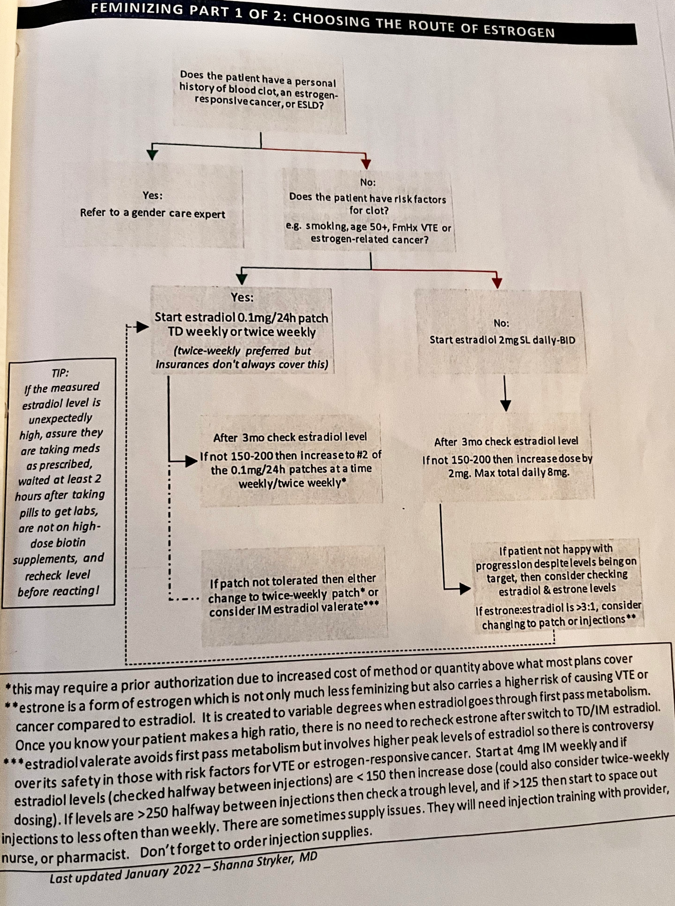

- You refer your patient for doppler which reveals an extensive proximal DVT. What are your next steps in management? How will you discuss this with your patient?

There is not a consensus over the different guidelines, but the most conservative guidelines would be the UCSF guidelines which suggest stopping hormone therapy during the acute treatment of a clot. After acute treatment can resume with a transdermal formulary.

UCSF guidelines

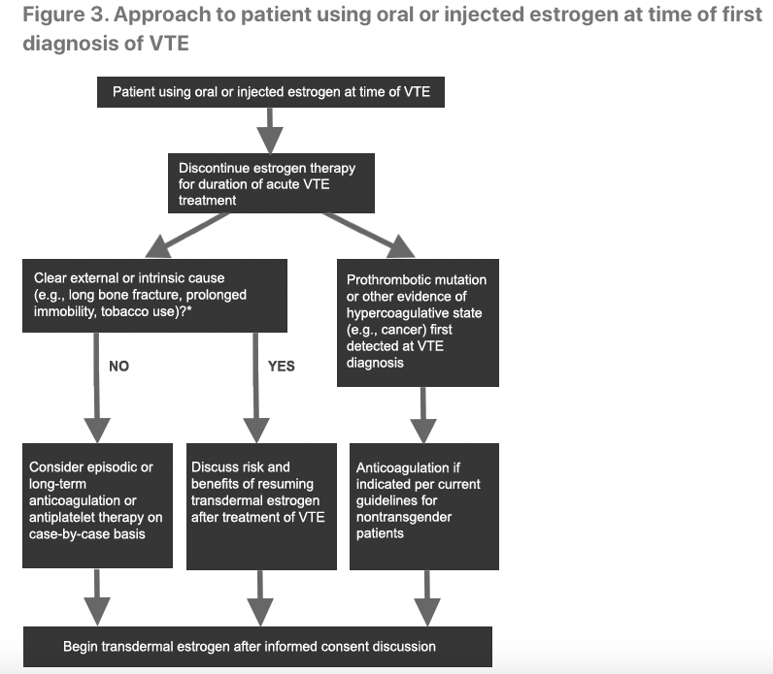

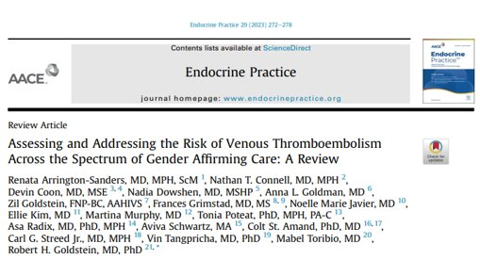
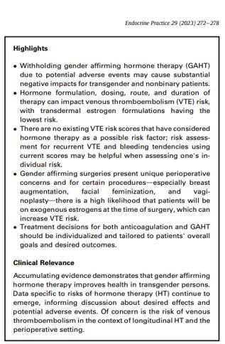

Case Three:

A 26-year-old cis woman comes to your clinic for an acute visit for vaginal discharge and discomfort. She has a past medical history of recurrent UTI’s and bacterial vaginosis.

- What additional questions are important to discuss with this patient?

How to take an inclusive sexual history: The 5 P’s Method:
- Partners: Who are your partners? What are their genders?
- Practices: What types of sex you having? Who puts what where? Do you use any toys during sex and, if so, what are tices around both use and cleaning?
- Pregnancy prevention: Are you have sex that puts you at risk of pregnancy? If so, what are you goals around pregnancy and pregnancy prevention, and what strategies are you using to achieve those goals?
- STI Prevention: What methods are you using to prevent STI’s?
- Previous STIs: Have you had prior STI’s? Which ones and when?

- Your patient discloses to you that she is bisexual. She is currently sexually active with 1 cis-female partner. She is frustrated by her frequent vaginal infections/UTIs and wonders if they are related to having sex. You ask her if she is using safe sex practices and she isn’t sure (she never received any sexual education about safe sexual practices with a woman). How would you advise her?

Addressing safe sex practices
- STI’s
  - Woman who have sex with women (WSW) are less likely to receive asymptomatic screening for STI’s
  - However, WSW are not much less likely to be found to have STI’s when tested
  - Similarly, WSW tend to receive less frequent pap smear testing
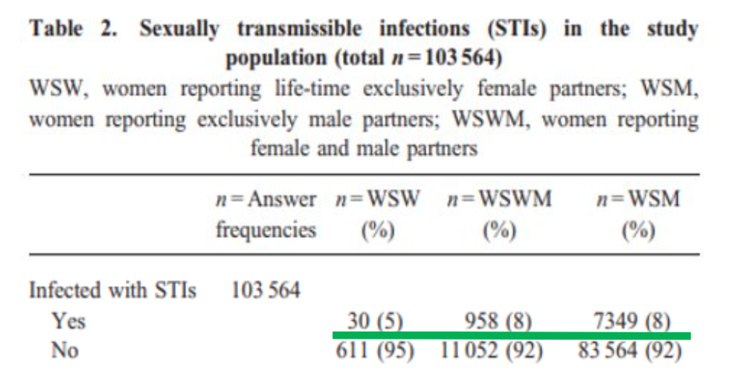
- BV and vaginal infections
  - WSW are more likely to test positive for BV. While it is not recognized by the CDC as an STI, there is evidence that it may be in this setting, and partner testing may be valuable.
- Use of toys
  - Safe use of toys includes both methods of use and methods of cleaning

Healthcare Disparities Among Bisexual Individuals
39% Bisexual men, 33% Bisexual women do not disclose their sexual orientation to any medical provider. Bisexual individuals frequently face negative attitudes from heterosexual, gay and lesbian communities – indicating that bisexual individuals face double discrimination.

Case Four:

A 26-year-old trans man with a PMH of tobacco use, anxiety and OSA presents to your clinic to establish care. Current medications include weekly testosterone (IM) and Zoloft.
- During your physical exam, you notice that he is wearing a binder. What recommendations might you discuss with your patient regarding safe binder use?
- A binder is a type of undergarment that is worn to gently compress breast tissue to allow the chest to appear and feel flatter.
- You should easily be able to fit your fingers underneath a binder and take a deep breath.
- When to take your binder off: During strenuous activity (including sex), during sleep, after 8 hours
- Improper binder use can cause pneumonia, permanent MSK damage, scarring

- Six months later, your patient returns to clinic for pre-op clearance prior to planned double incision top surgery. You obtain routine screening labs which reveal a hematocrit of 51. How would you advise your patient? What are your next steps in management?
- Switch to transdermal or consider decreasing dose of testosterone or reduce frequency if >50
- >55, need to pause therapy for 2 weeks, recheck then change to transdermal, lower dose or reduce frequency
- Tobacco cessation education
- Referral to sleep medicine if not using CPAP

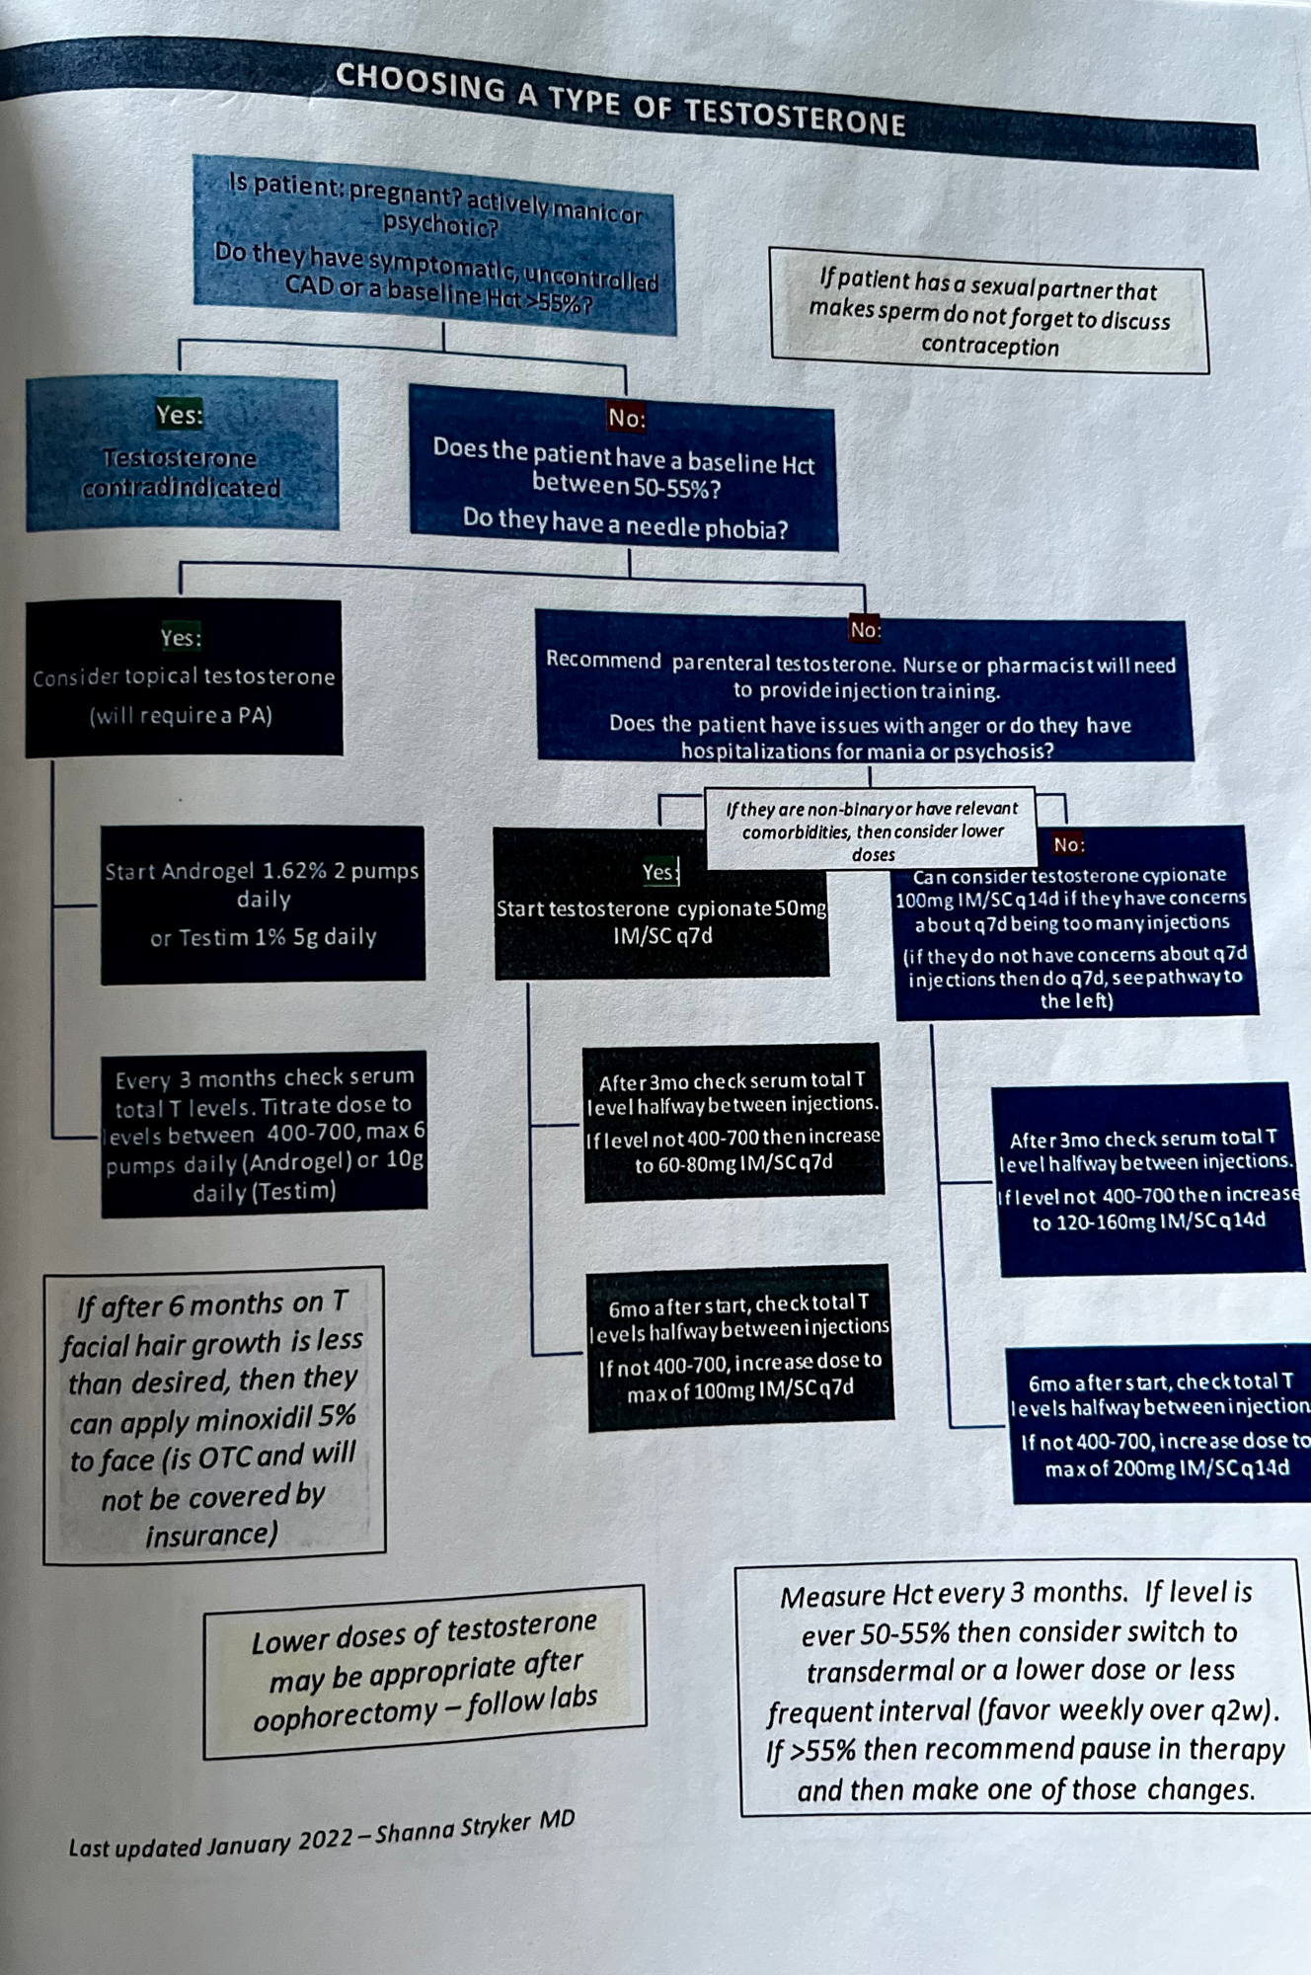
Case Five:

A 22-year-old cis male is brought to the Emergency Department by his friends after he passed out at a party. He is lethargic and unable to provide any history. His friends don’t think he has been having any fevers, chills, or other symptoms but they aren’t sure. They do know he has not traveled recently.

Per chart review:
PMH: Migraines
Meds: Descovy

Physical Exam:
Temp 99.2, BP 86/48, spO2 83% on room air, RR 28
CV: Tachycardic, no murmurs
Lungs: Tachypneic, CTAB
Abdomen: Soft, nontender
Skin: Slight erythema around the right nares and gray hue of hands and face
Neuro: Somnolent, awakens briefly to sternal rub, withdrawals all 4 extremities to pain, PERRL

Labs:
Renal: Na 135, K 4.2, Cl 110, Bicarb 15, BUN 24, Creatinine 0.84
CBC: WBC 8.2, Hgb 13.2, PLT 210

- You are the senior on long call admitting this patient. How would you triage? Level of care?
- MICU
- What is your differential and what orders would you place?
Differential: Meningitis, Intoxication (alcohol, drugs), Post-ictal state, trauma, brain aneurysm, stroke, metabolic encephalopathy, sepsis, obstructive shock
Some orders for consideration:
CT Head, CTPA, EKG, Infectious workup, ABG
Empiric antibiotics, IVF
Your ABG returns: ABG: 7.37/37/98 -- Methemoglobin: 13 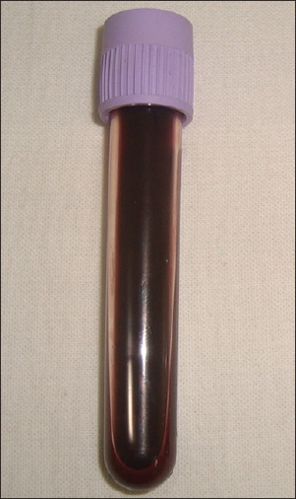

- What medications can cause methemoglobinemia?
Dapsone, Nitrates or nitrites, Chloroquine, Metoclopramide, sulfonamides, rasburicase, local anesthetics, POPPERS and many more!

- What are Poppers and what are common health concerns associated with their use?
- Poppers are inhaled Alkyl nitrite that causes relaxation of involuntary smooth muscles in blood vessels, throat, vagina and anus.
- These drugs have been often used in those who engage in receptive anal intercourse.
- Popularity of use
  - 35% of gay males have used inhaled alkyl nitrites at least once
  - 11% of bisexual males
  - 6.3% of lesbian women
  - 3% of the general population
- Common side effects: headaches/migraines, skin irritation, dizziness, flushing
- Serious adverse effects:
  - Methemoglobinemia
  - Life-threatening hypotension: at especially high risk if used with other nitrates or alcohol
  - Macular degeneration: thought to be related to vascular effects of popper use

APPENDIX:

