HIV and AIDS Academic Half Day
Learner Guide

1:10 - 1:25: Theory Burst
1:25 – 2:15: Cases
2:15 – 2:25: Questions for the Expert
2:25 – 2:35: Break
2:35 – 3:20: Cases
3:20 – 3:30: Questions for the Expert

Case #1
A 32 yo F with no past medical history sends you a MyChart message:
Hi doc- Two days ago I had unprotected sex with a man who has HIV. Yesterday I took an at home HIV test which was negative. Is there anything else I should do?

1) EBM Review: Which of the following qualities is most important in a screening test for HIV? Why?
High sensitivity, High Specificity, High Positive Predictive Value, High Negative Predictive value.

2) There is one FDA approved at-home oral swab to test for HIV, Oraquick. How does it work and what does it test for? What is the 4th generation blood test for HIV that we use here, and what does it detect?

3) Should this patient receive post-exposure prophylaxis (PEP)? Should you get any labs before starting PEP? What is a standard PEP regimen and duration?

Case #1, Continued: Despite several attempts, you are unable to contact your patient for follow-up. 10 days later, she presents to the ED with fever, malaise, and sore throat.
4) How does Acute HIV present and what else should be in your differential?

5) You suspect Acute HIV. What is the best test to order at this time and why?

6) You check the lab discussed above. What do you think this patient’s CD4 count, RNA PCR, HIV Antibody testing to show?

7) You discuss the patient’s HIV infection as well as Anti-Retroviral Therapy (ART). Who should be treated with ART? After initial diagnosis, what other baseline labs should she receive?

8) How are you going to monitor her HIV and potential complications?

9) What preventative care items need to be addressed in patients with HIV?

Case #1 Continued
Your patient moves to Florida and loses touch with the medical system. 12 years later she presents with a generalized tonic-clonic seizure. Prior to this, she had a 2-3 week history of fevers and headaches. CD4 count is 14, HIV RNA is >500,000. She is confused, and has a temperature of 101. No nuchal rigidity. On a cursory neurologic exam she has no focal abnormalities.

10) What is on your differential? If you were admitting this patient, what would you do next? Meningitis review: Does this patient require a head imaging before lumbar puncture?

11) How would you further evaluate her? How would you proceed to treat and/or differentiate between etiologies of your differential?

12) How could this complication have been prevented in this patient? What are the indications for primary prophylaxis against opportunistic infections in patients with HIV/AIDs?

Questions for the Expert

Break

Case #2
32 y/o M presents with 2 weeks of shortness of breath, dyspnea on exertion, and cough. He has a 25 lb weight loss over the past 2-3 months. He was diagnosed with HIV in 2006 and had a “pneumonia” five months ago. He takes only OTC medications. When he had “pneumonia”, his CD4 was 135, HIV Quant 329,000 copies
Vital Signs: T 103F, HR 132, BP 80/40, RR 24, SaO2 80% on RA.
Physical Exam: He is thin, tacky mucous membranes, tachycardic, in moderate respiratory distress, has a mildly productive cough, no lymphadenopathy, and has some minor diffuse crackles in his lungs bilaterally.

1) You are admitting this patient to step down level of care during long call. What are your initial steps in management?

2) What is your differential and what are the next steps in your workup?

3) You obtain the appropriate test and your suspicion was confirmed. How do you grade severity? How can you treat this infection?

Case #3:
45 year old F with history of AIDS (recent PJP infection, last CD4 of 28) who presents with headache and fever over the last 2 weeks. Her boyfriend brought her in because she was confused. She didn’t know where she was, and wasn’t answering questions appropriately. Her temperature is 101 and she has some neck rigidity and grimaces and resists when you try to flex her neck. He does not believe she has been taking any medications recently.

A CT head is obtained which shows mild atrophy but no mass lesions. A lumbar puncture is performed and analysis of the CSF shows 7 WBC/mm³, glucose of 41 mg/dL and a negative gram stain. The opening pressure is 310 mm H₂O (normal 10-20 mm H₂O). Her current CD4 count is 12. Toxoplasma serology shows IgG positive and IgM negative.

1) What is on your differential diagnosis?

- What test helps to make the diagnosis?

- How do you treat the infection?

- Your patient is started on the above therapy, your patient initially improves, but then over the next 24-48 hours her mental status waxes and wanes. Her nurse calls you to the bedside to evaluate the patient – he is worried your patient may be seizing. What could be going on?

- The patient improves with your treatment and is discharged on all of her medications including starting ART with plans to complete therapy for her infection. Several days later she returns with severe headache, nausea, vomiting, and malaise, and myalgia. She has had low grade fevers at home. She’s been taking all of her medications, what could be going wrong?

Case #4
A 25 yo M presents to your clinic to establish care. He recently saw a TV ad for PrEP and is wondering if he should be on PrEP. He was treated for gonorrhea 6 months ago at the health department.

1) What else would you like to know? What are the indications for PrEP? What is the recommended PrEP regimen? What are common side effects of this regimen?

2) Before initiating PrEP, what testing would you like to order?

3) How often should patients on PrEP be evaluated? What lab testing should you order at each visit?

Appendix

Fig 1. Indications for nPEP (non-occupational post-exposure prophylaxis)
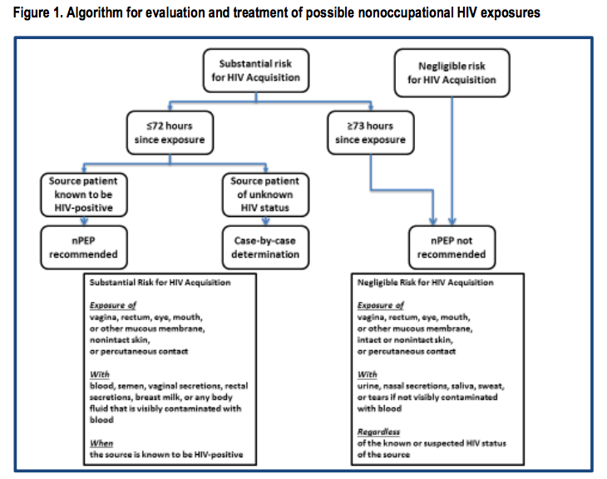

Fig 2. Vaccine schedule for patients infected with HIV
 | HIV Infection with CD4 < 200 | HIV Infection with CD4 >=200 for 6 months
Influenza (inactivated) | 1 dose annually
Influenza (live) | Not recommended
Tdap | 1 dose Tdap then Td or Tdap booster every 10 years
MMR | Not recommended | 2 doses
Varicella | Not recommended | 2 doses
Shingrix | No recommendation
Zostavax | Not recommended | No recommendation
HPV | 3 doses through age 26 years
PCV13 | 1 dose
PPSV23 | 1st – 8 weeks after PCV13, 2nd – 5 years later, 3rd – after age 65 and 5 years from previous PPSV23
Hep A | 2 or 3 doses depending on vaccine
Hep B | 2 or 3 doses depending on vaccine
MenACWY | 2 doses 8 weeks apart and then Q5Years
MenB | Recommended if another risk factor or indication
Hib | Recommended if another risk factor or indication
Fig 3. Summary of Guidance for PrEP use

