HIV and AIDS Academic Half Day
9/13/2018 – Facilitator Copy
Case #1
A 27 y/o previously healthy male presents with 2 days of mild fever, sore throat, generalized malaise. You note cervical and axillary lymphadenopathy, mild meningismus, and a diffuse rash on his trunk. On further history he notes an episode of unprotected intercourse roughly 2 weeks prior. He had otherwise not been sexually active for many months.
1) How does Acute HIV present and what should be in your differential?
Symptoms can include acute malaise, myalgias, anorexia, weight loss, GI upset, apthous ulcers, lymphadenopathy, pharyngitis, and rash. Sometimes non-specific symptoms.
Differential Diagnosis:
Most Common: EBV, Influenza, Strep pharyngitis, Viral/Noninfectious gastroenteritis, Viral URI
Less Common: Acute Viral Hepatitis, Drug Reaction, Primary Herpes Simplex, Secondary Syphillis
Uncommon: Acute CMV, Disseminated Gonococcemia, Primary Immunodeficiencies, Measles, Travel Related Diseases – Malaria, Typhoid
2) You suspect Acute HIV. What is the best test to order at this time and why?
Answer: HIV RNA Viral Load PCR.
Signs and symptoms of Acute HIV Infection can occur between 6-56 days after exposure. If the patient is having signs and symptoms, they likely have a detectible RNA PCR, but may not have a detectable antigen or antibody test. Discuss the window period: This is the time when the antibody detected on ELISA is often not detectible during the acute phase.
RNA PCR: Detectible as early as 5 days post-exposure (ultrasensitive) (4-12 days)
4th Generation Ag/Ab assay: Detectible 15-20 days post-exposure
Ask learners what this includes? It includes the p24 antigen.
Antibody formation: 3-5 weeks post-exposure

3) You check the lab discussed above. What do you think this patient’s CD4 count, RNA PCR, HIV Antibody testing to show?
Acute HIV often presents with really high Viral Load by RNA PCR. This high viremia means that the patient is very contagious at this point. CD4 count in acute HIV can be variable, HIV Antibody may not be present yet due to the window period as noted above.
4) You discuss the patient’s HIV infection as well as Highly Active AntiRetroviral Therapy. You set him up with an initial appointment with Dr. Fichtenbaum. After initial diagnosis, what other baseline labs should he receive? What are you looking for with these baseline labs?
Baseline labs should assess comorbidities, disease baseline, infectious screening, resistance testing, pregnancy testing, and consideration for side effects from HIV medications.
Comorbidities: CBC, Renal Function (HIV Nephropathy), Hepatic Function, Lipid Panel (Increased risk of cardiac events in HIV and effects of HAART), Glucose
Disease Baseline: HIV RNA level and CD4 count
Infectious Screening: Toxoplasma IGG (If future low CD4 will be at risk for encephalitis), syphilis testing (discuss RPR vs trepia testing – trepia testing if no history of syphilis), Gonorrhea/Chlamydia, HPV, HBV (HIV quickens liver damage of HBV – coinfection is indication for HAART), HCV, HAV, PPD (what would be positive? - >5mm would need Tx for latent infection)
Resistance Testing: HIV Genotyping
Side Effects: G6PD Deficiency – Certain ethnic groups for dapsone ppx, HLA-B*5701 (before initiation of abacavir)– Associated with abacavir hypersensitivity reaction – approx. 4% of population: Potentially lethal syndrome including fever, malaise, nausea, diarrhea, rash which can progress to multiorgan failure.
Pregnancy: alters treatment regimen but supports absolute indication for treatment for prevention of mother to child transmission
5) How are you going to monitor their HIV and potential complications? How will you change your screening and vaccinations?
Asymptomatic patients with normal CD4 counts can be monitored with CD4 count and Viral Load Q3-6 months. Newest guidelines (2018) say viral load q 3 months until <50, for one year, then q 6 months. A bit more controversial is CD4 count q 6 months until >250 for a year, then stop checking CD4 unless viral load increases
Co-infection screening: GC/Chlamydia, RPR, HCV yearly
Vaccinations: Stress influenza. Should get Pneumococcal, Prevnar, (prevnar before pneumovax) HAV, HBV
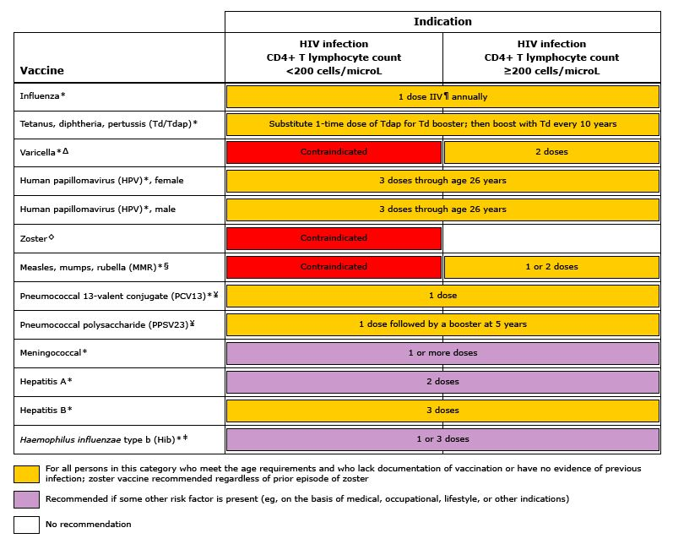
Have learners note what vaccines (live) are contraindicated in patients with low CD4 counts. Can discuss why prevnar should be given prior to pneumovax. Prevnar, PCV13 is a conjugated vaccine whereas pneumovax, PPSV, is a polysaccharide vaccine. PCV is recognized as T cell dependent, stimulating antibody response, mucosal immunity, and immunologic memory. PCV stimulates memory B cells and can “prime” the immune system for an enhanced secondary immune response to PPSV.

Case #1 Continued…
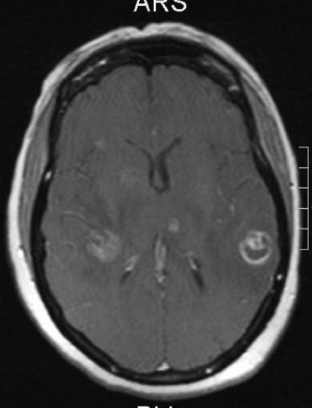
Your patient moves to Florida and loses touch with the medical system. 12 years later he presents as a 39 year old male with a generalized tonic-clonic seizure. Prior to this, he had a 2-3 week history of fevers and headaches. His CD4 count is 14, His HIV RNA is >500,000. He is confused, and has a temperature of 101. He has no nuchal rigidity, on a cursory neurologic exam he has no focal abnormalities.
6) What study would you like? What is your on differential? What do you think is most likely?
CT Scan without Contrast showed a space occupying lesion in the bilateral temporoparietal regions. MRI With Gadolinium showed the following:
We see a ring enhancing lesion on imaging. Most concerning given his CD4 count is Toxoplasmosis or CNS Lymphoma. Toxoplasmosis often has multiple ring-enhancing lesions. This is less likely but also still concerning for brain abscess or tuberculosis.
7) How would you further evaluate him? How would you proceed to treat and/or differentiate between etiologies of your differential?
Toxoplasmosis serology studies that are negative or a high CD4 would lead you away from toxoplasmosis – patients are at risk for this reactivation disease when CD4 drops below 100. The only way to tell between toxoplasmosis and CNS lymphoma for sure is via brain biopsy. If clinically the pt is at risk for toxo and serologically positive, you should start treatment for toxoplasmosis. Toxoplasmosis is treated with pyrimethamine and sulfadizine, Leucovorin is a folic acid anolog to help prevent marrow hematologic toxicity from pyrimethamine. If clinical improvement within several days, you can continue to follow for radiologic improvement within 2-3 weeks. Otherwise, you may need a brain biopsy.
8) How could this complication have been prevented in this patient? What are the indications for prophylaxis against Toxoplasmosis in patients with HIV?
Patients with a CD4 count <100 AND positive Toxoplasma IgG should be given prophylaxis. First line is TMP-SMX 1 DS tab daily. Alternative regimens include dapsone + pyrimethamine + leucovorin or atovaquone +/- pyrimethamine + leucovorin.
Prophylaxis can be discontinued once CD4 >200 sustained over 3 months on ART.

Questions for the Expert
Break
Case #2
32 y/o M presents with 2 weeks of shortness of breath, dyspnea on exertion, and cough. He has a 25 lb weight loss over the past 2-3 months. He was diagnosed HIV+ in 2006, had a “pneumonia” five mos ago, now takes only OTC medications. When he had “pneumonia”, his CD4 was 135, HIV Quant 329,000
T 103F, HR 132, BP 80/40, RR 24, SaO2 80% on RA.
He is thin, in moderate respiratory distress, has a mildly productive cough, no lymphadenopathy, and has some minor diffuse crackles in his lungs bilaterally.
1)What do you think is going on? How will you confirm your diagnosis?
Discuss differential: Concerning for PCP Pneumonia – why? Subacute +/- acute decompensation, SOB, dry cough, fever, diffuse bilateral infiltrate. CXRay can be wnl in 1/3 of cases, High Res CT often has ground glass opacities. Bacterial Pneumonia? Tuberculosis? Histoplasmosis?
Definitive diagnosis can only be made by demonstration of organism in tissue, sputum, or BAL fluid.
Induced Sputum: Sensitivity 50-90%. Consider obtaining if bronch is delayed.
Bronchoscopy: Sensitivity 96-98% by obtaining samples for PCR.
Discuss empiric treatment vs definitive diagnosis.
What about other possible tests? Beta d glucan will be elevated in patients with PJP. Ask learners what this detects. Some may mention LDH, used to be present in 90% of HIV infected patients with PJP (in the age before ART).
Can discuss management of respiratory failure here as well – the patient needs an ABG, both for grading severity of his respiratory failure (regardless of etiology) and for management decisions related to his likely PJP.

2) You obtain the appropriate test and your suspicion was confirmed. How do you grade severity? How can you treat this infection?
See chart for Abx below. Need ABG to eval A-a Gradient. LDH useful correlates to severity/prognosis.
Moderate-to-severe disease is defined by room air pO2 <70 mm Hg or A-a O2 gradient ≥35 mm Hg
Adverse effects:
TMP-SMX: rash, fever, neutropenia, hyperkalemia, transaminase elevation
Pentamidine: nephrotoxicity, hyperkalemia, hypoglycemia, hypotension, pancreatitis, dysrhythmias, transaminitis
Atovaquone: rash, fever, transaminitis
Dapsone: rash, fever, GI upset, methemoglobinemia, hemolytic anemia (G6PD Deficiency)
Primaquine: rash, fever, methemoglobinemia, hemolytic anemia )G6PD Deficiency)
Clindamycin: rash, diarrhea, C diff colitis, abdominal pain

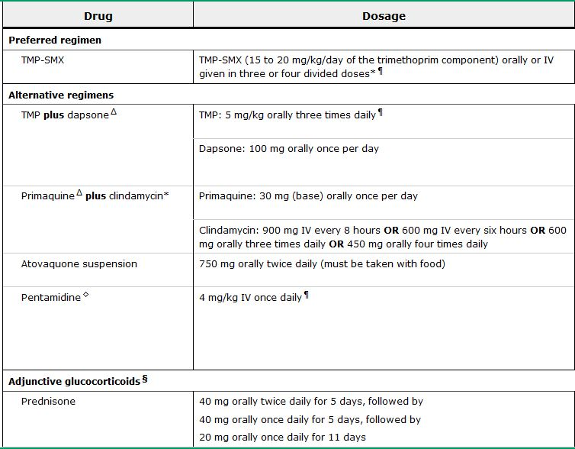

Discuss who gets steroids and why. Patients can clinically worsen on the 2nd and 3rd days of treatment, thought to be due to inflammation due to dying organisms. Steroids can decrease the mortality and respiratory failure associated with PJP. Compared with placebo, the risk ratios for overall mortality in patients receiving adjunctive corticosteroids were 0.56 at one month and 0.59 at three to four months of follow-up. Corticosteroids for patients with moderate to severe disease
3) He is now nearing discharge. What prophylactic medications should this patient be discharged home with? What pathogens will be covered?
Cover Prophylaxis for Opportunistic Infections:
PCP: Initiate CD4<200. TMP/SMX 1SS or 1DS Daily vs 3x/week. Or Dapsone 100mg QD (G6PD!) Mycobacterium avium complex: Initiate at CD4<50. Azithromycin 1200mg QWeek
Toxoplasmosis: discussed above -initiate at CD4<100. TMP/SMX 1DS Daily.
Histoplasmosis: Can discuss. Not routinely done – this is a good question for the expert. itraconazole at a dose of 200 mg daily can be considered for patients with CD4 counts <150 cells/mm3 who are at high risk because of occupational exposure or who live in a community with a hyperendemic rate of histoplasmosis (>10 cases/100 patient-years). Ask the expert about indications in our patients.

Case #3
45 y/o F with PMHx AIDS (recent PCP Pneumonia) presents with headache and fever over the last 2 weeks. Her boyfriend brought her in because she was confused, didn’t know where she was, and wasn’t answering questions appropriately. Her temperature is 101 and she has some neck rigidity and grimaces when trying to flex her neck.
A CT is obtained which shows mild atrophy, but no mass lesions. A lumbar puncture is performed and analysis of the CSF shows 7 wbc/mm³ , glucose of 41 mg/dL, and a negative gram stain. The opening pressure is 310 mmH20. CD4 count is 12. Toxoplasma shows IgG is positive, and IgM is negative.

- What is your differential diagnosis?
The patient’s clinical history is compatible with cryptococcal meningitis. The diagnosis of cryptococcal meningitis should not be ruled out with only 7 wbc/mm3 found in the CSF. More than 50% of AIDS patients with acute cryptococcal meningitis will have a CSF wbc count of less than 20.
- Toxoplasma? Less likely as more than 90% of patients with AIDS with Toxoplasma encephalitis will have one or more mass lesion observed on contrast brain CT Scan.
- PML? The clinical presentation for PML does not include fever. CT is typically normal, but brain MRI would show extensive white matter lesions.
- Most patients with CNS lymphoma present with a focal finding and evidence of a mass lesion on brain imaging
- What test helps to make the diagnosis?

- Cryptococcal antigen test – CSF or Serum. Serum antigen test is positive >95% of patients with active crypto meningitis. Lumbar puncture is important to eval for bacterial meningitis.
- Opening pressure should always be measured and often is the clue that suggests cryptococcal meningitis. In a study among 221 patients, 54% had an opening pressure greater than 250mm H20 and 27% had an opening pressure greater than 350mm Hg H20.

- How do you treat the infection?

Start induction therapy with amphotericin B (0.7mg/kg) IV PLUS Flucytosine (100mg/kg PO daily) x 2 weeks. Liposomal amphotericin B preparation 3-5 mg/kg IV (preferred due to lesser side effects)
Then consolidation therapy fluconazole 400mg po daily x 12 weeks. Prior to moving to consolidation, patient must have substantial clinical improvement and a negative CSF fungal culture on repeat lumbar puncture.
Then step down to Maintenance therapy , fluconazole 200mg po daily. Therapy remains lifelong at 200mg daily unless patient has completed initial course of therapy, has no symptoms of cryptococcosis, and the patient’s CD4 count >200 for at least 6 months.

- Your patient is started on the above therapy as well as HAART. At admission your patient initially improves, but then over the next 24-48 hours her mental status waxes and wanes. Her nurse calls you to the bedside to evaluate the patient – she is worried your patient may be seizing. What could be going on?
Among other things, the patient could have symptoms from increased intracranial pressure. They may require serial lumbar puncture taps, especially if the patient is symptomatic. Goal CSF pressure is <20cm H2O.
- The patient improves with your treatment and is discharged on all of her medications with plans to complete therapy for her crypto meningitis. Several days later she returns with severe headache, nausea, vomiting, and malaise, and myalgia. She has had low grade fevers at home. She’s been taking all of her medications, what could be going wrong?
She could have Immune Reconstitution Inflammatory Syndrome.
Consider IRIS when inflammatory signs or symptoms occur after recent initiation, re-initiation, or change to a more effective combination ARV therapy with associated increase in CD4 cell count and/or decrease in viral load and the following have been excluded:
- Worsening of known infections due to inadequate or inappropriate therapy
- New infections not known to be associated with IRIS (e.g., bacterial sepsis)
- Medication reaction

