Academic Half Day – Dermatology (04.29.21)
Facilitator Guide

Agenda
1:05-1:20pm Theory Burst
1:20-2:20pm Small group cases 1-2
2:20-2:35pm Break
2:35-3:15 Small group cases 3-4
3:15-3:30: Expert questions

As you wait, please fill out the table below to refresh your terminology for describing skin lesions.

Lesion | Flat, raised, or both? | Description
Macule |  | <10mm (ex: petecheia)
Patch |  | >10mm (ex: vitiligo)
Papule |  | <10mm (angioma)
Plaque |  | >10mm (psoriasis)
Maculopapular (aka morbilliform) |  | -
 | Raised | Liquid-filled <10mm (ex: herpes)
 | Raised | Liquid filled >10mm
 | Raised | Pus filled (ex: acne)
Nodules | Raised
 | Flat | Non-palpable, non-blanchable skin bleeding; <3mm
 | Flat or raised | May be palpable, non-blanchable skin bleeding; 3-10mm
 | Flat or raised | Non-palpable, non-blanchable skin bleeding; >10mm
Urticaria | Raised
 | Raised | Flaking of skin caused by epidermal thickening
 | Raised | Dried out exudate/sebum on skin (ex: impetigo)
Annular | Both
Nummular | Both (usually raised)
 | Both | Bull’s eye lesion with central duskiness/erythema
Reticular
 | Raised | Clusters of vesicles or papules
 | Raised | Irregular, dark (ex: seborrheic keratosis)
 | Usually both | Widespread rash outside the body that is usually accompanied by fever, malaise; most commonly due to a viral infection
Enanthem | Flat, raised, or both

Can refer to the video on TSF, www.dermnetnz.org, or Stanford Derm Guide to look at collection of rashes on different skin types

Case 1
A 27-year-old male with a corneal ulcer is admitted to the hospital for q1hour eye drops. He also reported dysuria on admission and was started on ceftriaxone at the time for suspected UTI. On HD 4, the nurse pages you stating the patient is reporting a rash and itchiness.

You go to the see the patient…
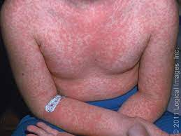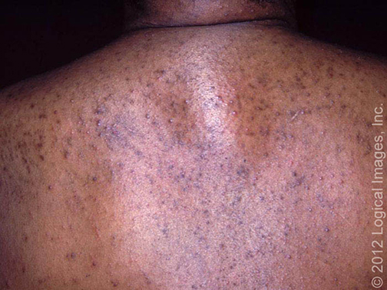

- How would you describe this rash? What is your approach to a rash?

- What is on your differential?

- What additional information would you want to know?

The patient tells you that he has not had any recent travel. He lives alone and has been working from home during the pandemic. Denies having been sick recently or any other medical problems. He was last sexually active 6 months ago with his last partner.
VS: Tmax 100F, HR 80, BP 120/80, RR 16, SpO2 99%

- What is the diagnosis and what are your next steps in management?

- What gives a rash high-risk features?

Case 2
A 67-year-old man with ESRD, HTN, and non-ischemic cardiomyopathy was admitted to the hospital for six days of nonbloody diarrhea, abdominal tenderness, and lightheadedness. On admission he was found to be hypotensive with a lactic acid of 4. The patient was admitted to stepdown and rehydrated with IV fluids. He was also started on ciprofloxacin.
On hospital day 2, patient’s symptoms began to improve, but he noted some dysuria and was started on ceftriaxone for a UTI.
On HD 4, the pt was switched to amoxicillin.
Home meds continued on admission: aspirin, captopril, carvedilol, furosemide, clonazepam.

On HD 7, you get a call as the team intern that the pt has an itchy rash on his chest, back, and legs.

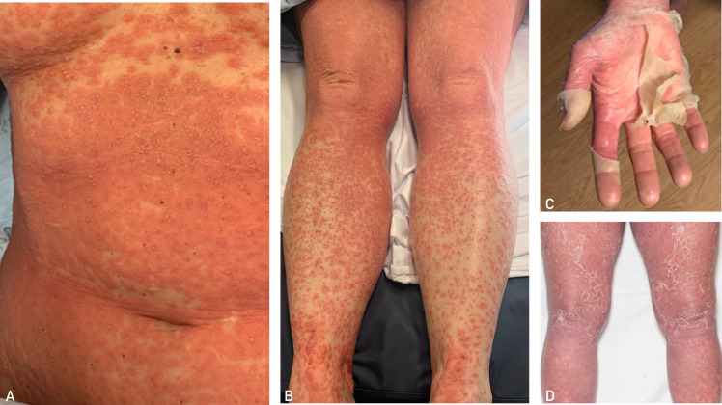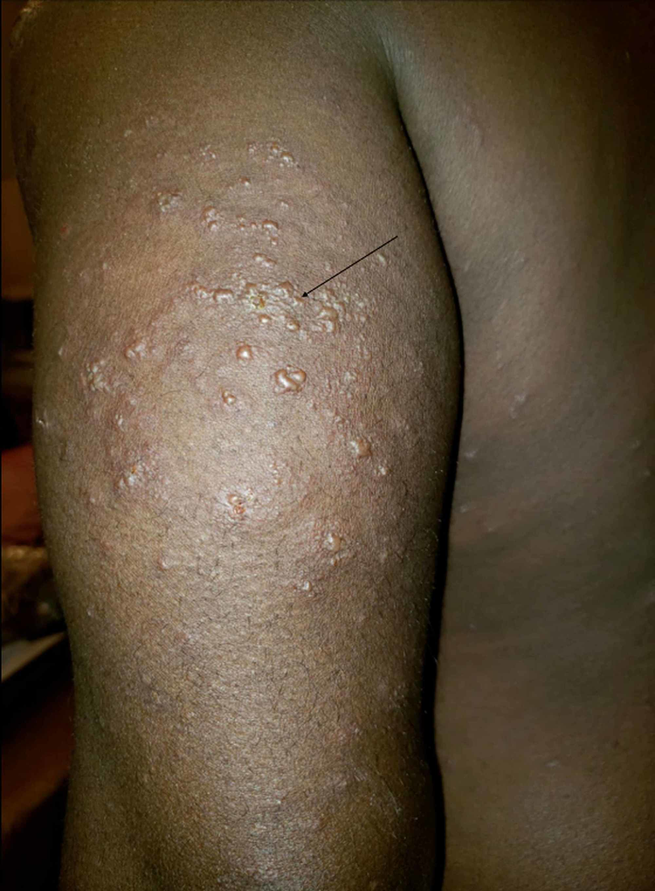

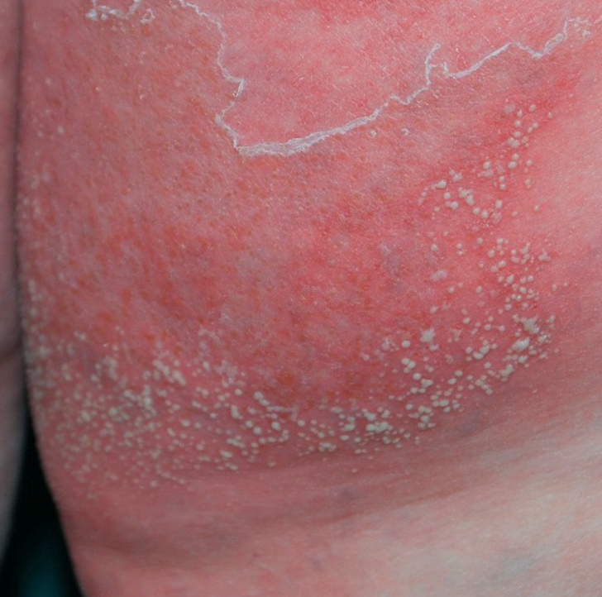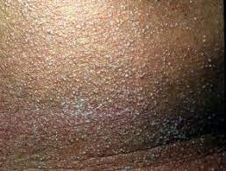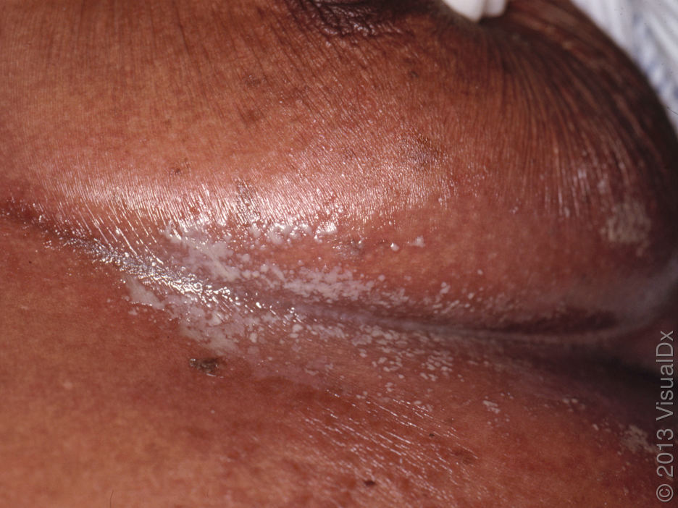

His vitals are: Tmax 101F, HR 90, BP 132/68, RR 18, Spo2 98%

- How do you describe this rash?

- What is on your differential?

You’re a great intern and you examine the patient’s eyes, oral cavity, and genitals and do not find any mucosal involvement. You look up the patient’s CBC, renal, and hepatic panel from that morning and note the following abnormalities:
WBC: 14.7k with 85% neutrophils (12,000 cell/ul – normal 1700-8000)
CRP: 136mg/l
Cr: 2.7 (baseline)
Albumin 2.8

- What is your most likely diagnosis at this time?

- What features of the history, physical, and morphology favor or do not favor the etiologies in your differential?

- What would your initial steps in management? How soon would you expect to see improvement?

----------- BREAK------------

Case 3:
A 45-year-old female patient presents to the ED for fever and a diffuse red rash that she noticed for the last 3 days. She has been taking Tylenol which only briefly suppresses the fever. The rash started on her chest but appears to have spread to her face, back, arms, and legs. Her husband was recently ill with flu-like symptoms 2 weeks ago.
Patient reports a past medical hx of epilepsy, HTN.
Home meds include: HCTZ, levetiracetam, and Depakote (started 4 weeks ago after stopping phenytoin).

She is admitted to the hospital for persistent tachycardia and dehydration and started on IV fluids. Overnight, the nurse notices increased facial and tongue swelling.

Vitals: Tmax 101.5F, HR 116, BP 118/72, RR 20, SpO2 94%

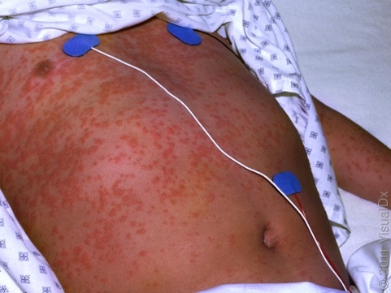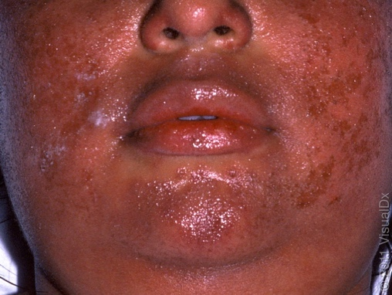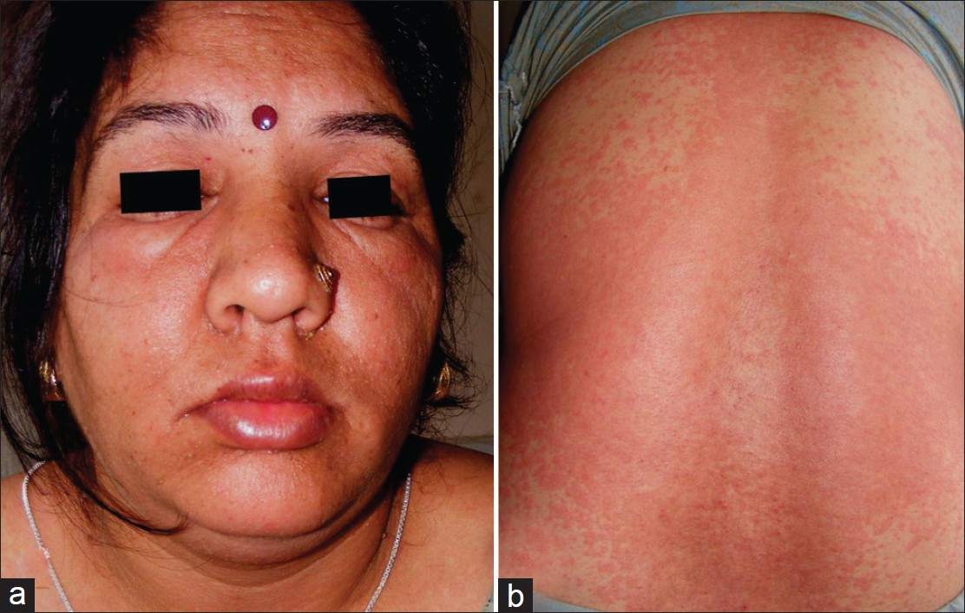

- How would you describe this rash? What are the most striking features of this eruption?

- What is on your differential at this time?

You order some labs which return as follows:
CBC: WBC 17,000, PLT 335,000, Hb 10.5 gr dL, Hct 33% with anisopoikilocytosis and eosinophilia 22.7%
Na 131, K 4.2, Cl 97, HCO3 29, BUN 82, Cr 1.47, Glucose 170
ALT 219, AST 226, Tbili 1.1, ALP 220; LDH 1023; CRP 114.67

- What is the most likely diagnosis?

- What organ systems can be involved in this reaction?

- After diagnosis, what would be your initial steps in management?

- Three months post-admission the patient presents to your outpatient clinic with complaints of fatigue, weight gain, thinning hair, and dry pruritic skin. What are you most concerned about and what initial work-up would you order?

Case 4:
A 55yo male with past medical history of diabetes, neuropathy, bipolar disorder, HTN, and a chronic L foot ulcer presents with 5 days of malaise and progressively “burning”, peeling, itchy rash over his check, back, arms, face, and scrotum. He does not recall any injury, soap, lotions, but does remember having some nasal congestion and drainage last week. He denies any known allergies.
Home meds: aspirin, atorvastatin, lisinopril, gabapentin, valproic acid, and “a lot of antibiotics” recently for his foot ulcer but he finished his course 2 weeks ago.

VS: Tmax 100.0F, HR 131, BP 123/58, RR 18, SpO2 96%
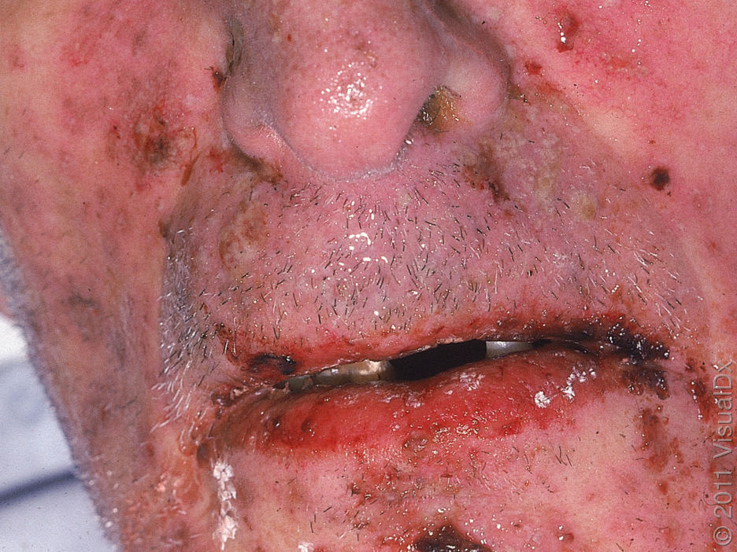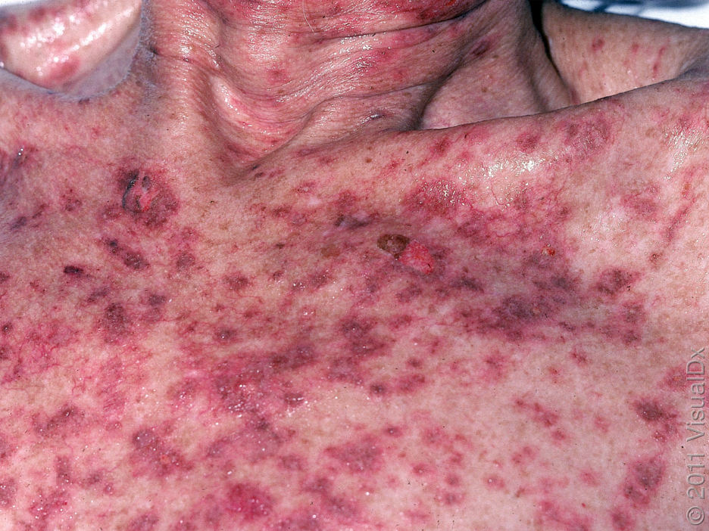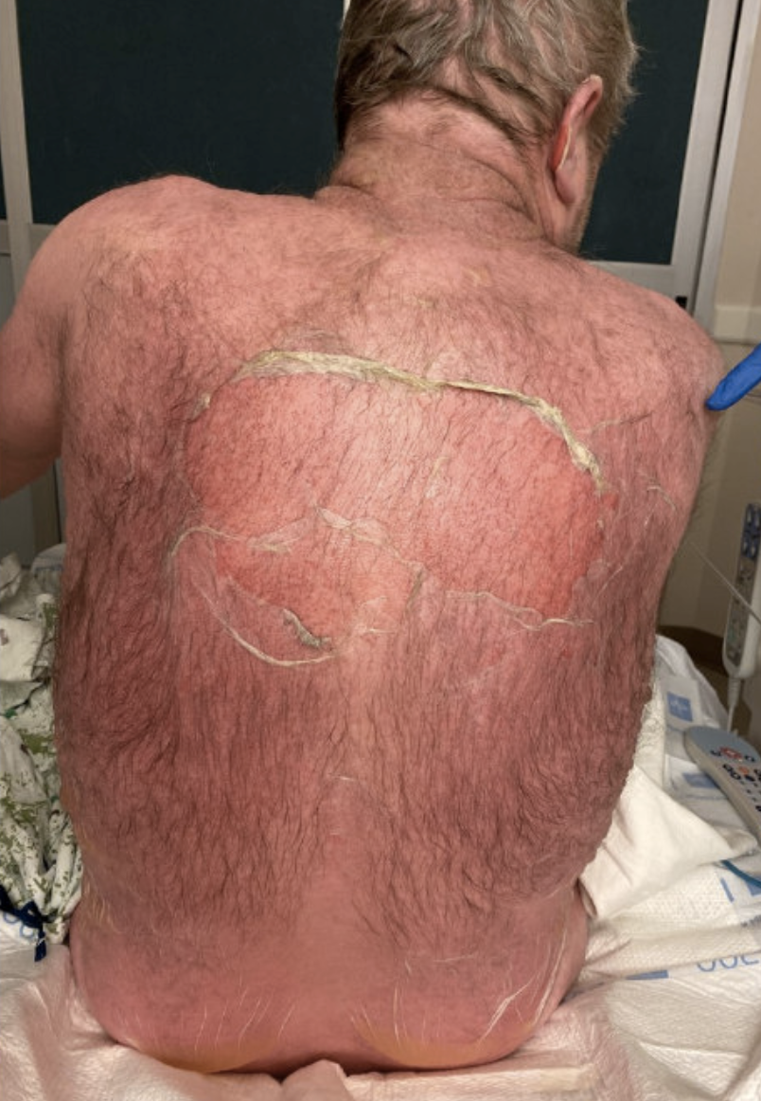
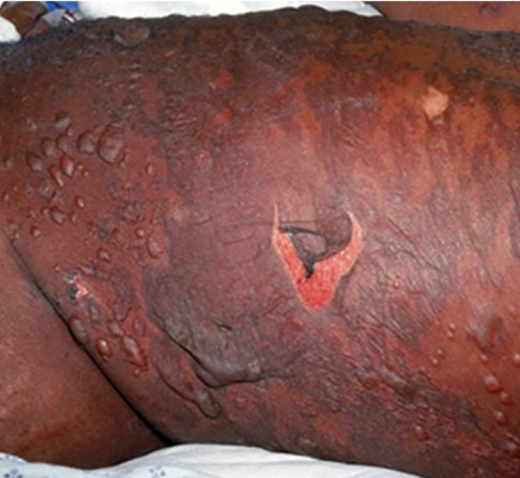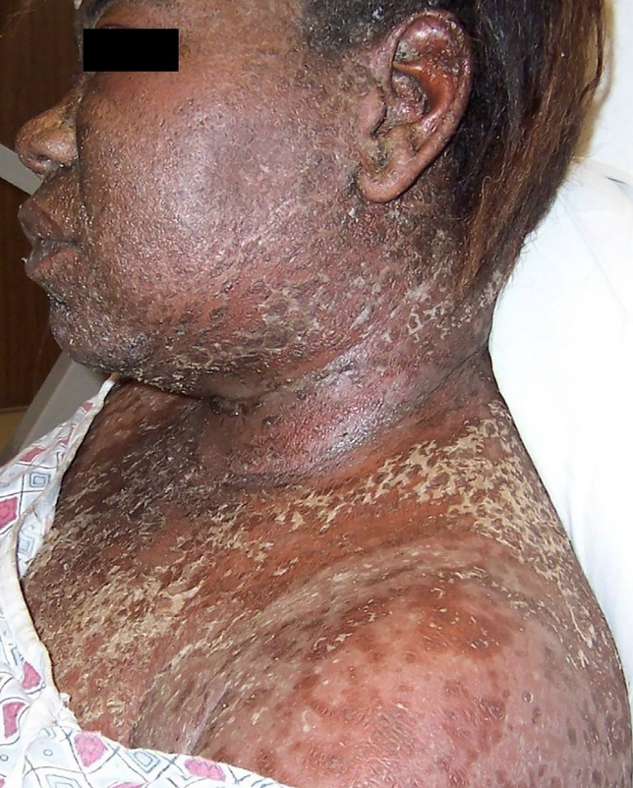

- How would you describe this rash? What are the most striking features of this eruption?

The admission labwork returns as follows:
CBC: WBC 9k, Hgb 12, Hct 34
Na 142, K 4.1, Cl 104, HCO3 27, BUN 25, Cr 0.8, Glucose 117
Calcium 8.7, Phos 3.0
AST 40, ALT 36, Tbili: 0.9, ALP 140, Albumin 3.3

- What is on your differential and what is the most likely diagnosis?

- How do you differentiate SJS from TEN?

- Where will you admit this patient and what initial orders will you place?

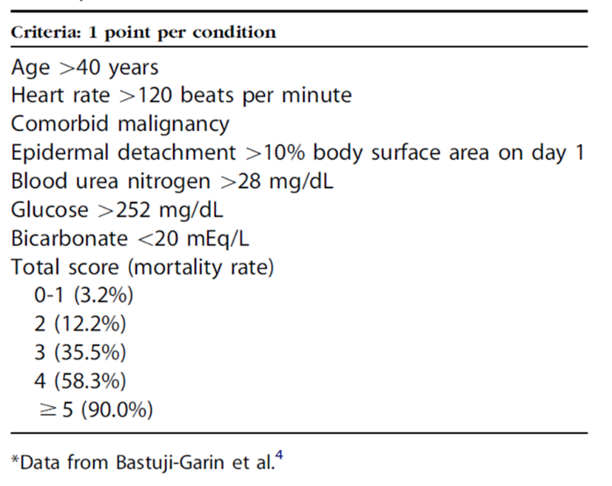
- Using SCORTEN criteria, what is the estimated mortality rate in this case (assume 8% involvement on day 1)?

Derm Pearls courtesy of Curbsiders (#161 A Rash approach to Rashes)

- Sick vs not sick. This is the first threshold for addressing a rash.
- “Inside job”: Does the rash have an internal cause (e.g. histamine degranulation, or systemic illness)? These rashes from an ‘inside job’ like hives are diffuse, symmetric, and bilateral.
- “Outside job”: Rashes with an external cause tend to be unilateral and asymmetric e.g. contact dermatitis, cellulitis, or other types of infection.
- Familiarize yourself with what different types of eruptions look like on ALL pigments of skin.
- Suspected severe drug reaction with rash perform a thorough physical exam with a focus on mucosal regions (oral, nasal, ocular, vulvar/vaginal in women, urethral, perianal).
- Describe what you see in regular, old words. Don’t try to “speak derm” if you don’t speak derm. You’ll cause more confusion.
- Urticarial (hives) or morbilliform?
  - Use a skin marker to draw around the rash. Then, examine the next day. Hives may change location, but morbilliform lesions do not move.
  - Use the wooden end of a cotton tipped applicator to check for dermatographism (suggestive of urticaria)
- Morbilliform exanthems: an itchy, symmetric, bilateral, diffuse, truncal rash is likely to be a benign morbilliform drug eruption. These are common and you can “treat through” if organs are spared and the reaction is limited to skin.
- Timing differentiates types of severe drug reaction: It can be tedious to figure out when people started and stopped medications. But the timeline is critical in determining between AGEP (<3 days), SJS/TEN (4-10 days), and DRESS/DIHS (often 6 weeks).
- Patients with SJS or TEN will feel very sick, have mucosal site involvement, skin pain, and a positive Nikolsky sign. When patients fit these criteria, admit them to the ICU, call dermatology immediately, stop every drug that is unnecessary, and carefully initiate a IV fluids.
- Complications of SJS/TEN: Over 50% of patients surviving TEN suffer from long-term sequelae of the disease, including ocular and gynecological issues. Consult with ophthalmology and gynecology early if managing patients who have experienced SJS/TEN.
