Academic Half Day – Dermatology (04.29.21)
Facilitator Guide

Agenda
1:05-1:20pm Theory Burst
1:20-2:20pm Small group cases 1-2
2:20-2:35pm Break
2:35-3:15 Small group cases 3-4
3:15-3:30: Expert questions

As you wait, please fill out the table below to refresh your terminology for describing skin lesions.

Lesion | Flat, raised, or both? | Description
Macule | Flat | <10mm (ex: petecheia)
Patch | Flat | >10mm (ex: vitiligo)
Papule | Raised | <10mm (angioma)
Plaque | Raised | >10mm (psoriasis)
Maculopapular (aka morbilliform) | Both flat and raised | -
Vesicles | Raised | Liquid-filled <10mm (ex: herpes)
Bulla | Raised | Liquid filled >10mm
Pustules | Raised | Pus filled (ex: acne)
Nodules | Raised | Solid (ex: epidermal inclusion cysts)
Petechiae | Flat | Non-palpable, non-blanchable skin bleeding; <3mm
Purpura | Flat or raised | May be palpable, non-blanchable skin bleeding; 3-10mm
Ecchymoses | Flat or raised | Non-palpable, non-blanchable skin bleeding; >10mm
Urticaria | Raised | Red/hyperpigmented, raised allergic rash (changes locations)
Scales | Raised | Flaking of skin caused by epidermal thickening
Crusts | Raised | Dried out exudate/sebum on skin (ex: impetigo)
Annular | Both | Rounded lesions with central clearing
Nummular | Both (usually raised) | Coin-shaped
Targetoid | Both | Bull’s eye lesion with central duskiness/erythema
Reticular | Flat | Lacy, web-like (ex: livedo reticularis)
Herpetiform | Raised | Clusters of vesicles or papules
Verrucous | Raised | Irregular, dark (ex: seborrheic keratosis)
Exanthem | Usually both | Widespread rash outside the body that is usually accompanied by fever, malaise; most commonly due to a viral infection
Enanthem | Flat, raised, or both | Rash inside the body on mucus membranes; most commonly within the oral cavity (ex: Koplik’s spots, strawberry tongue)

Facilitators: feel free to look some of these up with the group to visualize the descriptions if needed.
- Remind learners that seeing these lesions on all different skin colors and types in important for early recognition.
- Can refer to the video on TSF, www.dermnetnz.org, or Stanford Derm Guide to look at collection of rashes on different skin types

Case 1
A 27-year-old male with a corneal ulcer is admitted to the hospital for q1hour eye drops. He also reported dysuria on admission and was started on ceftriaxone at the time for suspected UTI. On HD 4, the nurse pages you stating the patient is reporting a rash and itchiness.

You go to the see the patient…
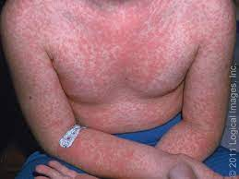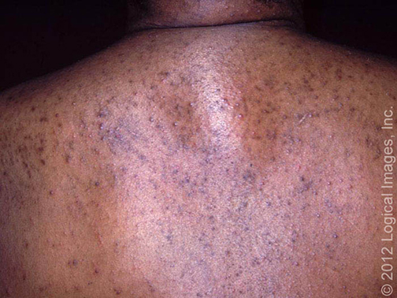

- How would you describe this rash? What is your approach to a rash? Facilitators: encourage learners to simply describe what they see without using “derm” words if the works are unfamiliar. This often leads to better descriptors rather than using incorrect terminology
  - Diffuse morbilliform/maculopapular rash extending on chest, back, arms, hands suggestive of an exanthem.
  - Recognize that that the erythematous base of a morbilliform rash often manifests simply as hyperpigmentation in darker skin colors and does not have its typical red/erythematous base as seen in lighter skin colors.
  - Primary morphology
    - Size, color, demarcation, flat/raised
  - Secondary morphology
    - Shape, texture, distribution/location

- What is on your differential?
  - Viral exanthems
  - Bacterial exanthems
  - Maculopapular rash associated with an autoimmune disease
  - Fixed drug reaction
  - Urticaria
  - Other cutaneous drug reactions less likely in this case: angioedema, AGEP, vesicobullous exanthem

- What additional information would you want to know? Facilitators: encourage learners to think about their approach to a generalized rash suspicious of a morbilliform drug eruption.
  - History and physical exam are adequate for dx-ing most rashes. Some require biopsy or other testing, but often either not necessary or non-discriminatory.
  - Important components of a dermatologic hx:
    - Personal or family history of atopy (suggesting atopic dermatitis)
    - Occupational exposures (contact dermatitis)
    - Longterm exposure to sunlight or other forms of radiation (skin tumors)
    - Systemic disease (DM, SLE, psoriasis, HCV, candida, immunosuppression)
    - Sexual history (syphilis, gonorrhea)
    - Use of drugs (Stevens-Johnson syndrome, toxic epidermal necrolysis, DRESS, AGEP, drug eruptions)
    - Travel history (Lyme disease, skin infections)
    - Prodromes (viral exanthems)
  - A negative history is as important as a positive history.
  - Hx of the particular skin lesion: time and site of initial appearance, spread, change in appearance, and triggering factors
  - A full skin exam, including exam of the scalp, nails, and mucous membranes

The patient tells you that he has not had any recent travel. He lives alone and has been working from home during the pandemic. Denies having been sick recently or any other medical problems. He was last sexually active 6 months ago with his last partner.

VS: Tmax 100F, HR 80, BP 120/80, RR 16, SpO2 99%

- What is the diagnosis and what are your next steps in management?
  - Exanthematous (morbilliform) drug eruption: most common type of drug hypersensitivity reaction
    - Rash ccurs ~7-14 days after drug exposure (may be earlier in a rechallenge) and frequently accompanied by low grade fever and eosinophilia
    - Lesions are typically symmetrically distributed erythematous macules and papules on the truck and extremities that may become confluent over time (may be petechieal, but mucus membranes always spared)
    - A viral exanthem is a close mimicker on ddx
      - Will see infectious sx, seasonality, eNanthem, children/elderly/immunosuppressed more likely
    - Most common causative drugs: PCNS, cephalosporins, sulfonamides, allopurinol
  - LOW risk rash stop nonessential drugs, but can treat through essential drugs; should resolve within 1-2 weeks

- What gives a rash high risk features?
  - Fever >101F
  - Edema of face, ears, eyes, hands
  - Vesicles or pustules
  - Dusky lesions or skin sloughing
  - Mucosal involvement
  - Marked eosinophilia
Case 2
A 67-year-old man with ESRD, HTN, and non-ischemic cardiomyopathy was admitted to the hospital for six days of nonbloody diarrhea, abdominal tenderness, and lightheadedness. On admission he was found to be hypotensive with a lactic acid of 4. The patient was admitted to stepdown and rehydrated with IV fluids. He was also started on ciprofloxacin.
On hospital day 2, patient’s symptoms began to improve, but he noted some dysuria and was started on ceftriaxone for a UTI.
On HD 4, the pt was switched to amoxicillin.
Home meds continued on admission: aspirin, captopril, carvedilol, furosemide, clonazepam.

On HD 7, you get a call as the team intern that the pt has an itchy rash on his chest, back, and legs.

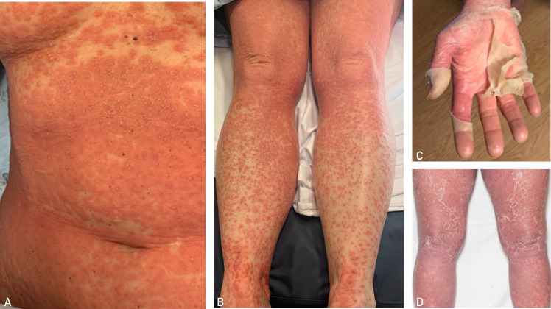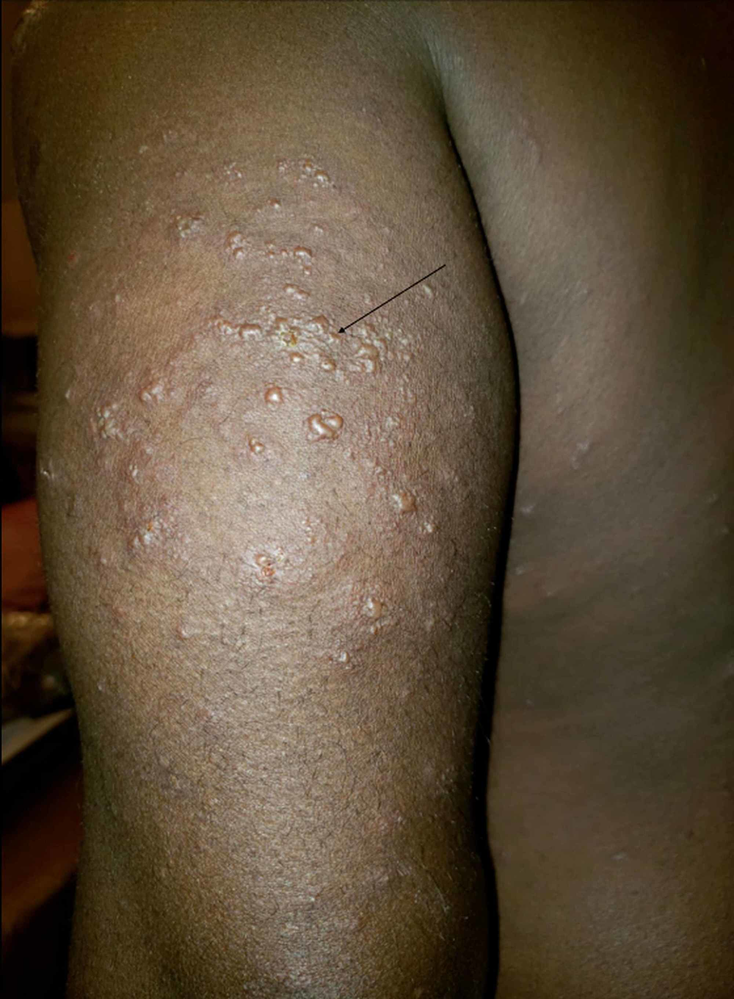

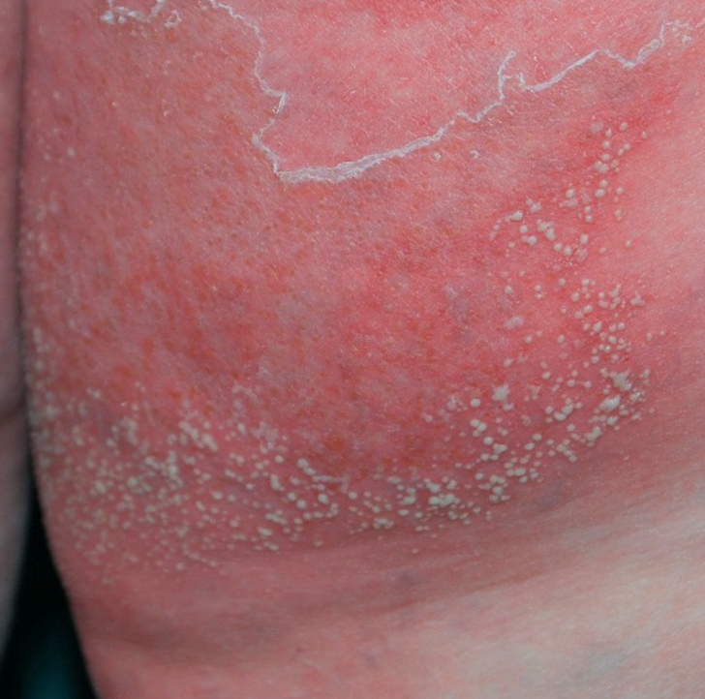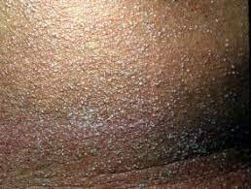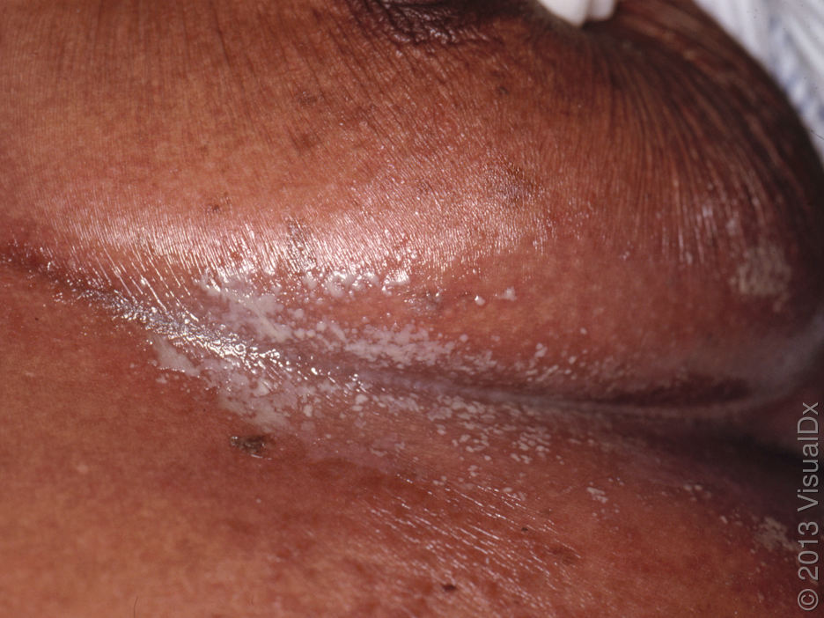

His vitals are: Tmax 101F, HR 90, BP 132/68, RR 18, Spo2 98%

- How do you describe this rash?
  - Numerous small pin-point superficial pustules arising over a patchy erythematous base
  - Note: erythematous bases are difficult to pick up on darker skin colors

- What is on your differential?
  - High risk rash severe cutaneous adverse reactions (SCARs)
    - Acute generalized exanthematous pustulosis (AGEP), Steven-Johnson syndrome (SJS), Toxic epidermal necrolysis (TEN), Generalized pustular psoriasis, DRESS
  - Facilitators: emphasize that some other dermatologic conditions can also have a similar presentation but main point is to recognize that this is a higher risk lesion due to higher fever, pustules, and desquamation

You’re a great intern and you examine the patient’s eyes, oral cavity, and genitals and do not find any mucosal involvement. You look up the patient’s CBC, renal, and hepatic panel from that morning and note the following abnormalities:
WBC: 14.7k with 85% neutrophils (12,000 cell/ul – normal 1700-8000)
CRP: 136mg/l
Cr: 2.7 (baseline)
Albumin 2.8

- What is your most likely diagnosis at this time?
  - Acute Generalized Exanthematous Pustulosis
    - rapid non-follicular pustular drug eruption characterized by superficial pustules within larger areas of edematous erythema. Intertriginous areas usually most prominent.
  - >90% of cases are drug provoked: most commonly PCNs, cephalosporins, and quinolones
  - Rapidity of onset (usually 2-4 days) is an important distinguishing feature from SJS, TEN, DRESS
  - Lesions last 1-2 weeks and are usually followed by superficial desquamation. Mucous membrane involvement can occur but rare (most commonly lips or buccal mucosa).
  - Labs show leukocytosis and neutrophilia, but typically have normal renal and hepatic function (different from DRESS, SJS, TEN)
  - Can be difficult to differentiate from acute generalized pustular psoriasis because pustules are clinically indistinguishable, but typically much slower onset with a hx of underlying psoriasis

- What features of the history, physical, and morphology favor or do not favor the etiologies in your differential?
  - Answered above, but main point is that the clinical picture of recent cephalosporin/amoxicillin use within 48-72hrs of an exanthematous pustular rash without systemic involvement is highly suggestive of AGEP
  - Of note however: the patient should continue to be followed on an outpatient basis to ensure resolution of eruption with drug cessation. If it does not resolve you either have the wrong drug or patient has another diagnosis such as DRESS, pustular psoriasis, etc.

- What would your initial steps in management? How soon would you expect to see improvement?
  - STOP the causative drug, symptoms should improve within a 2-3 days of cessation
  - Daily pictures of the rash
  - Labs: daily CBC w/diff, renal, hepatic function, calcium/phosphate
    - Monitor for signs of systemic involvement to rule out DRESS
    - Disturbance of fluid and electrolyte balance
  - Symptomatic therapies
  - Antipyretics
  - Gentle skin care and liberal use of emollients
  - Monitor for evidence of superinfection with cultures as clinically indicated
  - Topical corticosteroids for treatment of pruritus and inflammation

----------- BREAK------------

Case 3:
A 45-year-old female patient presents to the ED for fever and a diffuse red rash that she noticed for the last 3 days. She has been taking Tylenol which only briefly suppresses the fever. The rash started on her chest but appears to have spread to her face, back, arms, and legs. Her husband was recently ill with flu-like symptoms 2 weeks ago.
Patient reports a past medical hx of epilepsy, HTN.
Home meds include: HCTZ, levetiracetam, and Depakote (started 4 weeks ago after stopping phenytoin).

She is admitted to the hospital for persistent tachycardia and dehydration and started on IV fluids. Overnight, the nurse notices increased facial and tongue swelling.

Vitals: Tmax 101.5F, HR 116, BP 118/72, RR 20, SpO2 94%

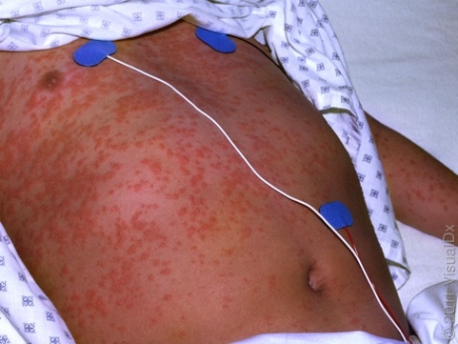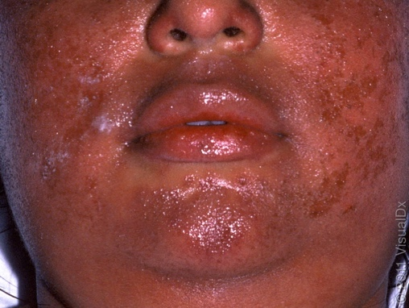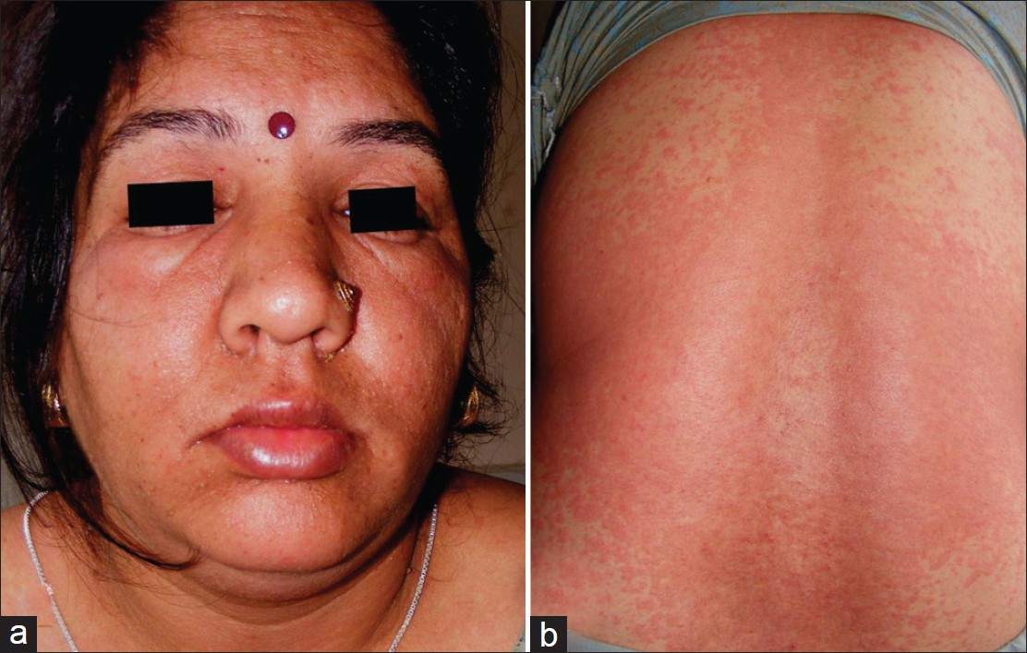

- How would you describe this rash? What are the most striking features of this eruption?
  - Morphology/distribution: note involvement of the trunk and extremities with many, discrete to coalescing, several mm to several cm, round to irregular, erythematous, macules, papules, patches, and thin plaques some with focal superficial desquamation.
  - Striking is the diffuse involvement of the face with significant facial edema particularly in the periorbital region.

- What is on your differential at this time?
  - High risk rash severe cutaneous adverse reactions (SCARs)
    - DRESS, AGEP, SJS/TEN, exanthematous morbilliform drug eruption
  - Key to differentiating between these etiologies is assessing systemic involvement, drug exposure history and timing, and clinical course
You order some labs which return as follows:
CBC: WBC 17,000, PLT 335,000, Hb 10.5 gr dL, Hct 33% with anisopoikilocytosis and eosinophilia 22.7%
Na 131, K 4.2, Cl 97, HCO3 29, BUN 82, Cr 1.47, Glucose 170
ALT 219, AST 226, Tbili 1.1, ALP 220; LDH 1023; CRP 114.67

- What is the most likely diagnosis?
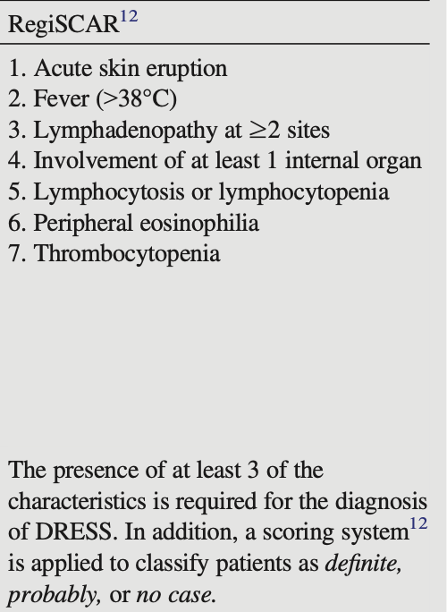
  - DReSS (Drug Rash with eosinophilla and Systemic Symptoms) aka DIHS (Drug Induced Hypersensitivity Syndrome)
    - Fever >101F (90%)
    - Lymphadenopathy (60-80%)
    - Facial edema (75%)
    - Rash (85%)
      - Most commonly morbilliform rash involving face, upper trunk, upper extremities
      - Can have any morphology, including pustules, targetoid, erythroderma, mucositis
    - Mucosal involvement in 30% (conjunctivitis, oral/anogenital erosions)
  - DReSS is often taught with a classic clinical presentation for testing, but the truth is that there is no classic presentation for DRESS clinically. It can have any number of various cutaneous manifestations, so labs and clinical course are required to make diagnosis.

- What organ systems can be involved in this reaction?
  - Multiple organ systems can be affected:
    - Hepatic: Hepatitis can be fulminant: elevated transaminases, alk phos, bilirubin, prothrombin time.
    - Renal: interstitial nephritis can progress to acute kidney failure
    - Pulmonary: interstitial pneumonitis, ARDS, pleuritis
    - Cardiac: myocarditis, acute necrotizing eosinophilic myocarditis (can occur weeks to months later; ANEM with 50% mortality rate)
    - CNS: encephalitis, aseptic meningitis
    - Endocrine: thyroiditis, hyperthyroid, hypothyroid, Type 1 diabetes (rarely acute; usually weeks to months after exposure
  - Eosinophilic involvement of cardiac muscle and hepatic necrosis are the most common causes of death

- After diagnosis, what would be your initial steps in management?
  - Mortality is 2-10% STOP THE DRUG! This is MOST important
  - Admit to Burns/Stepdown/ICU and call Dermatology
  - Keeping up with fluid loss and correcting electrolyte derangements is very important
  - High caloric intake
  - Prevent/treat superinfection
  - Skin care with emollient barrier dressing changes
  - Most patients will be started on systemic steroid therapy at a minimum of 1mg/kd/day of prednisone and will need a long steroid taper (3-6 months)
    - Significant improvement in both clinical symptoms and laboratory abnormalities is often seen within several days after initiating steroid therapy
    - Although steroid therapy is generally effective in the acute setting, its effect on the long-term disease course is unknown; there have been no controlled clinical trials (JAAD 2020)

- Three months post-admission the patient presents to your outpatient clinic with complaints of fatigue, weight gain, thinning hair, and dry pruritic skin. What are you most concerned about and what initial work-up would you order?
  - These symptoms in the setting of a hx of DRESS are concerning for thyroid disfunction hypothyroidism
    - Endocrine abnormalities are rarely seen in acute setting; more common as long-term sequela.
    - Thyroid is most commonly affected, complications include thyroid dysfunction, sick euthyroid syndrome, and or thyroiditis resulting in hyper or hypothyroidism.
  - It is important to monitor these patients for symptoms of thyroid disease: TSH, Free T4. There is no consensus on how long to screen labs, though some advocate for up to two years after diagnosis of DRESS.

Case 4:
A 55yo male with past medical history of diabetes, neuropathy, bipolar disorder, HTN, and a chronic L foot ulcer presents with 5 days of malaise and progressively “burning”, peeling, itchy rash over his check, back, arms, face, and scrotum. He does not recall any injury, soap, lotions, but does remember having some nasal congestion and drainage last week. He denies any known allergies.
Home meds: aspirin, atorvastatin, lisinopril, gabapentin, valproic acid, and “a lot of antibiotics” recently for his foot ulcer but he finished his course 2 weeks ago.

VS: Tmax 100.0F, HR 131, BP 123/58, RR 18, SpO2 96%
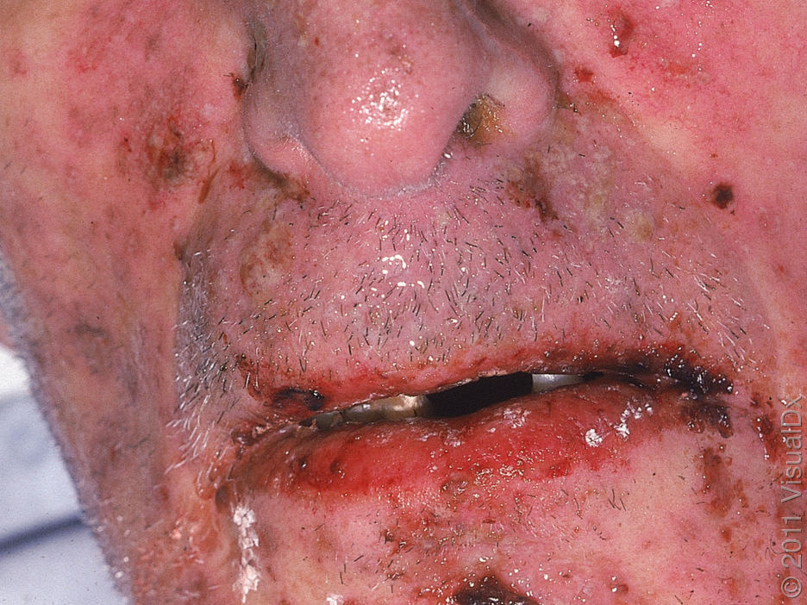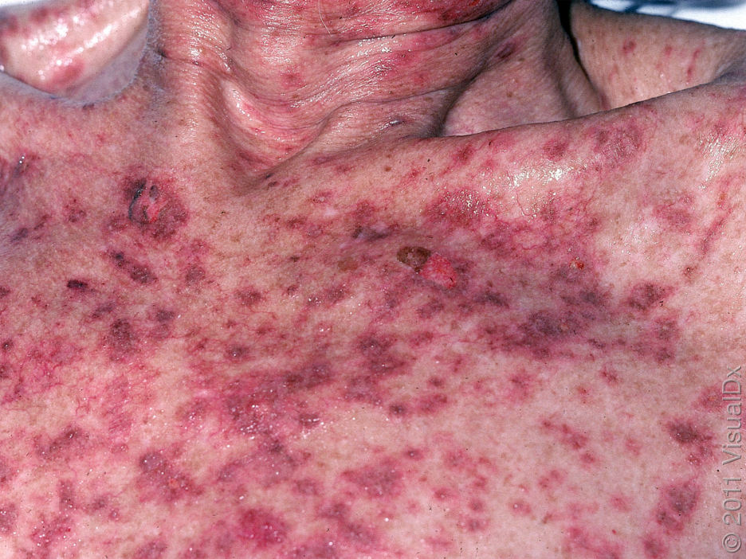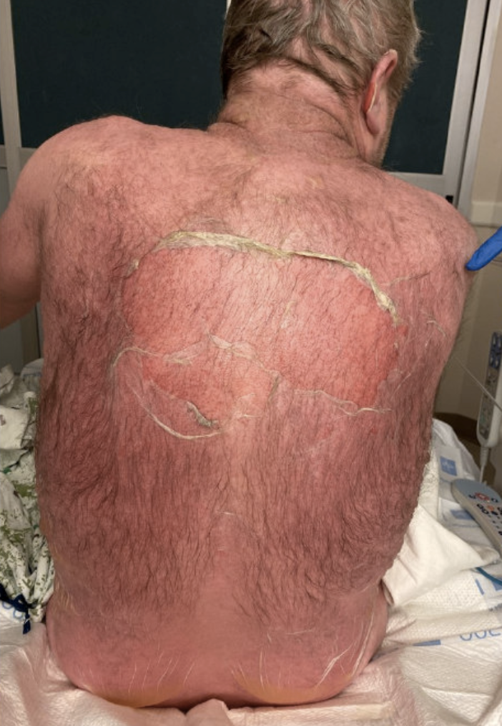
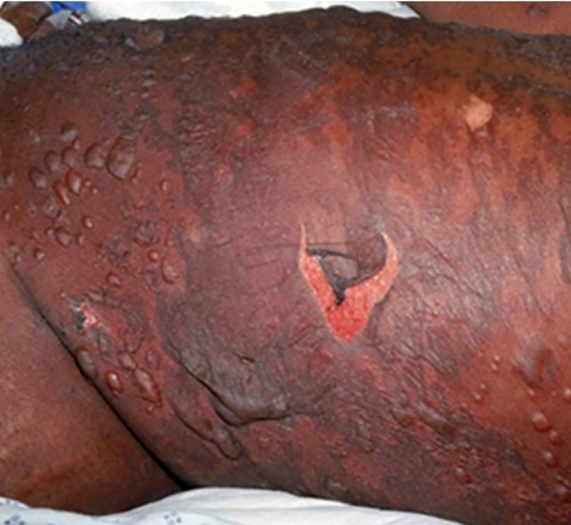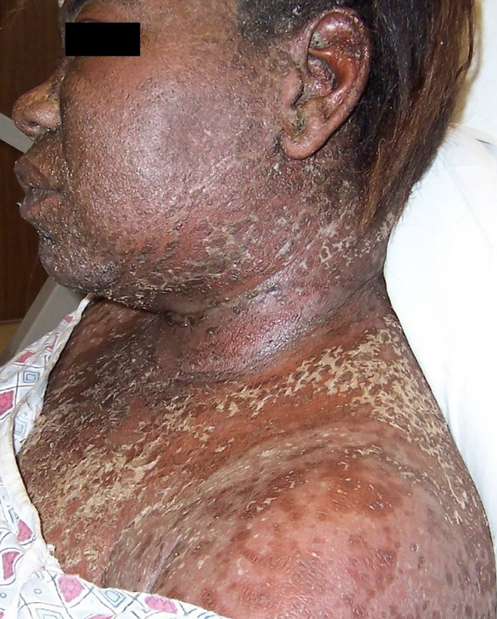

- How would you describe this rash? What are the most striking features of this eruption?
  - Morphology/distribution: numerous, discrete to coalescing, few mm to several cm, round and irregular, deeply erythematous to dusky, macules and patches with significant epidermal sloughing. Involving the face, trunk, and extremities including the palms. Notable erythema and erosions along lips and mucus membranes.
The admission labwork returns as follows:
CBC: WBC 9k, Hgb 12, Hct 34
Na 142, K 4.1, Cl 104, HCO3 27, BUN 25, Cr 0.8, Glucose 117
Calcium 8.7, Phos 3.0
AST 40, ALT 36, Tbili: 0.9, ALP 140, Albumin 3.3

- What is on your differential and what is the most likely diagnosis?
  - High risk rash --- likely drug eruption
  - Severe cutaneous adverse reaction (SCAR) such as SJS, TEN, DRESS
  - Infectious: staph scalded skin syndrome, erythema multiforme
    - EM was believed to be a common precedent to SJS/TEN, but now these conditions are clinically and immunopathologically considered separate entities. EM typically has target-like skin lesions with dark necrotic centers surrounded with erythema; bullous lesions may occur as well. EM is mostly secondary to infection, particularly to human herpesvirus (HHV), whereas SJS and TEN are vastly related to drugs
  - Steven Johnson Syndrome/Toxic Epidermal Necrolysis most likely
    - characterized by drug triggered mucosal erosions, atypical target lesions, erythematous to dusky macules/patches, and epidermal necrosis with skin detachment
    - clinical presentation typically has a prodrome that precedes rash by 1-3 days rash with atypical targets involvement of at least 2 mucosal membranes (ocular, nasal, oral, genital)
    - Skin is often tender to the touch and pressure/friction can induce shedding of epidermis
    - Most common inciting drugs in SJS/TEN are antibiotics, antiepileptic drugs, NSAIDs, and allopurinol

- How do you differentiate SJS from TEN?
  - SJS and TEN are on a continuum based on amount of body surface area involvement/detachment
    - SJS = <10% of BSA
    - SJS/TEN overlap = 10-30%
    - TEN = >30% BSA involvement
      - Painful erosion and ulceration of mucosal surfaces occurs in about 85-100% of TEN cases: oral (71-100%), ocular (50-78%), genital (40-63%), or all three mucosal sites (34-50%)

- Where will you admit this patient and what initial orders will you place?
  - Admit to Burns/Stepdown/ICU: these patients can rapidly deteriorate (fluid loss, electrolyte derangements, hypotension, respiratory distress due to airway involvement, sepsis) and will require 1:1 nursing monitoring
  - STOPPING the offending drug is PARAMOUNT
  - Supportive care and close monitoring have the most proven benefit of all current therapies (steroids and IVIG may be used as well)
    - Correction of severe transepidermal fluid loss, electrolyte imbalances, and a hypercatabolic state
    - Monitor and increase caloric intake
    - Prevent/treat superinfection
    - Skin care with dressing changes
  - Labs: CBC w/diff, renal, UA, hepatic function panel
  - Mortality is most frequently due to bacterial sepsis (staph, pseudomonas) if infection is clinically suspected, get complete infectious work-up for potential sources including superinfection of cutaneous lesions
  - Wound Care: debate used to exist between debridement vs. anti-shear, but now leans towards antishear
    - Keep vesicles and bullae intact and cover with petrolatum and petrolatum impregnated gauze
    - If vesicle or bullae becomes tender/painful can drain/open with sterile needle; keep overlying epidermis intact and cover with petrolatum gauze
    - Can use silver impregnated gauze in “dirty areas” to help prevent infection
    - MONITOR CLOSELY for evidence of infection
    - Use of prophylactic antibiotics is not recommended
    - Pain control with dressing changes
  - SJS-TEN requires a multidisciplinary approach. Focus on assessment and management:
    - Skin
    - Mucosal surfaces (oral, ocular, genital)
    - Pulmonary
    - Genitourinary
    - Gastrointestinal
  - Consultations:
    - Dermatology
    - Ophthalmology (evaluation for involvement, frequent lubrication, antibiotic drops, steroid drops, lysis of adhesions)
    - ENT (evaluation for esophageal involvement, prevention of strictures)
    - OB/GYN and/or Urology (maintain patency of urinary tract, lysis and prevention of adhesions/strictures)
    - Pulmonary if symptoms/evidence of decline in respiratory function (supplemental oxygen, intubation, and mechanical ventilation as necessary)
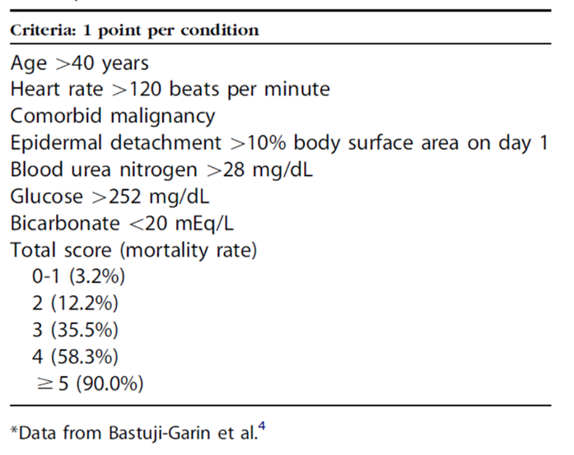
- Using SCORTEN criteria, what is the estimated mortality rate in this case (assume 8% involvement on day 1)?
  - SCORTEN score of 2 for age and pulse above 120bpm
  - Mortality rate is estimated at 12%

Derm Pearls courtesy of Curbsiders (#161 A Rash approach to Rashes)

- Sick vs not sick. This is the first threshold for addressing a rash.
- “Inside job”: Does the rash have an internal cause (e.g. histamine degranulation, or systemic illness)? These rashes from an ‘inside job’ like hives are diffuse, symmetric, and bilateral.
- “Outside job”: Rashes with an external cause tend to be unilateral and asymmetric e.g. contact dermatitis, cellulitis, or other types of infection.
- Familiarize yourself with what different types of eruptions look like on ALL pigments of skin.
- Suspected severe drug reaction with rash perform a thorough physical exam with a focus on mucosal regions (oral, nasal, ocular, vulvar/vaginal in women, urethral, perianal).
- Describe what you see in regular, old words. Don’t try to “speak derm” if you don’t speak derm. You’ll cause more confusion.
- Urticarial (hives) or morbilliform?
  - Use a skin marker to draw around the rash. Then, examine the next day. Hives may change location, but morbilliform lesions do not move.
  - Use the wooden end of a cotton tipped applicator to check for dermatographism (suggestive of urticaria)
- Morbilliform exanthems: an itchy, symmetric, bilateral, diffuse, truncal rash is likely to be a benign morbilliform drug eruption. These are common and you can “treat through” if organs are spared and the reaction is limited to skin.
- Timing differentiates types of severe drug reaction: It can be tedious to figure out when people started and stopped medications. But the timeline is critical in determining between AGEP (<3 days), SJS/TEN (4-10 days), and DRESS/DIHS (often 6 weeks).
- Patients with SJS or TEN will feel very sick, have mucosal site involvement, skin pain, and a positive Nikolsky sign. When patients fit these criteria, admit them to the ICU, call dermatology immediately, stop every drug that is unnecessary, and carefully initiate a IV fluids.
- Complications of SJS/TEN: Over 50% of patients surviving TEN suffer from long-term sequelae of the disease, including ocular and gynecological issues. Consult with ophthalmology and gynecology early if managing patients who have experienced SJS/TEN.
