COPD AHD 11/16/2023

Agenda
1:10-1:30 Theory Burst
1:30-2:15 Small groups – Part 1
2:15-2:30 Expert questions + break
2:30-3:20 Small groups – Part 2
3:20-3:30 Expert questions

GOLD 2023
Part 1
Ms. Puff is a 62 yo female with a PMH of HTN who presents to the clinic with a chief concern of shortness of breath. She feels winded with activity and had to give up her hobby of playing pickleball a few months ago. She has noticed this shortness of breath for about 1 year. She does not have any chest pain with exertion, but has noticed her ankles swell up at the end of the day. She sleeps on 2 pillows at night. She has had a chronic productive cough for “years” which is unchanged.

Social history: Currently smokes 1 ppd (40 pack year hx), rare EtOH. No other drug use.
Medications: multivitamin and amlodipine 5 mg daily

Physical Exam:
Vitals: T 98.6, BP 132/84, HR 86, POX 95% on RA, BMI 29

Gen: well-appearing, no acute distress
CV: RRR, nl S1/S2, no murmurs, normal PMI, no JVD
Pulm: reduced breath sounds throughout, clear to auscultation. No wheezing, crackles, or rhonchi. Prolonged expiratory phase noted.
MSK: 1+ pitting edema of ankles bilaterally. No joint swelling or tenderness.
Skin: no rashes

1. What is your differential diagnosis and what would support each diagnosis (list at least 5)? What additional history and examination findings would help you build or narrow your differential?

Remind your learners to suggest differentials even if they don’t “totally fit” the current clinical picture. The goal is to be broad, so they are on your radar if the clinical picture changes!

DDx:
- COPD: +smoking history with progressive SOB that is now worse with exertion. Query family hx of early lung disease or cirrhosis, volume of sputum. Exam clues: chest A/P diameter, decreased breath sounds, prolonged expiration, wheezing on expiration.
- Asthma: probably a little old for a new asthma diagnosis but still possible. Any hx of allergies, eczema? Do symptoms vary from day to day?
- CHF: ask about weight change, walking distance before dyspnea, orthopnea, PND. On exam look for JVD, crackles, 3rd or 4th heart sound. Only has ankle edema b/l and on amlodipine.
- ILD: exposure history (pets, jobs, did she move around the time of symptoms, renovate her house, mold, etc), drugs, radiation hx. Exam clues: joint swelling, rash, dry crackles.
- Pulmonary HTN: signs of right heart failure? Loud P2, JVD.
- Anemia: anemia can cause sxs of DOB/DOE. Is she up to date on her screening colonoscopy?
- CAD: has the risk factors of HTN and tobacco abuse. Needs risk stratification. Any family hx?
- Chronic PE: family hx? Prior VTE? Calf swelling, pain?
- Anxiety: any change in stressors in her life in the past year?

2. What work-up do you want to do?

Reasonable to start with CBC, EKG, CXR, TTE, PFTs. Depending on the results of the above, would consider further work up such as a 6MWT, VQ, high-res CT.

3. Which set of PFTs do you expect her to have and why? What disease script matches with each PFT?
A.
 | Baseline |  |  |  | Post Bronchodilator
 | Actual | Pred | %Pred | LLN | Actual | %Chg | %Pred
FVC (L) | 3.1 | 4.05 | 77 | 3.23 | 3.2 | 3 | 79
FEV1 (L) | 2.6 | 3.05 | 85 | 2.34 | 2.75 | 6 | 90
FEV1/FVC (%) | 84 | 75 | 113 | 65 | 86 | 2 | 115
TLC (Pleth) (L) | 4.73 | 6.31 | 75 | 4.91
DLCO | 23.20 | 24.04 | 97 | 16.05

No obstructive defect. Restrictive pattern (FVC < LLN, FEV1/FVC > 70%, TLC decreased). DLCO normal.
Example – a patient with kyphoscoliosis. Would expect a decreased DLCO if pulmonary fibrosis, especially in advanced cases.

B.
 | Baseline |  |  |  | Post Bronchodilator
 | Actual | Pred | %Pred | LLN | Actual | %Chg | %Pred
FVC (L) | 3.92 | 4.05 | 97 | 3.23 | 4.28 | 9 | 106
FEV1 (L) | 1.70 | 3.05 | 62 | 2.34 | 1.87 | 10 | 61
FEV1/FVC (%) | 43 | 75 | 65 | 65 | 44 | 0 | 58
TLC (Pleth) (L) | 9.32 | 6.31 | 148 | 4.91
DLCO | 26.20 | 24.04 | 109 | 16.05

Obstructive defect. FEV1/FVC < 70%. FEV1 between 50 and 80% so it is moderate. No reversibility with bronchodilator (no increase in FEV1 and/or FVC of ≥12% AND ≥200 ml). TLC increased. DLCO normal.
Example – COPD (our patient).

C.
 | Baseline |  |  |  | Post Bronchodilator
 | Actual | Pred | %Pred | LLN | Actual | %Chg | %Pred
FVC (L) | 3.92 | 4.05 | 97 | 3.23 | 4.18 | 7 | 103
FEV1 (L) | 2.9 | 3.05 | 95 | 2.34 | 2.82 | 4 | 92
FEV1/FVC (%) | 74 | 75 | 98 | 65 | 67 | 2 | 89
TLC (Pleth) (L) | 6.5 | 6.31 | 103 | 4.91
DLCO | 25.20 | 24.04 | 105 | 16.05

Normal pattern (FVC > LLN, FEV1/FVC > 70%)
Example – 29 year old resident with allergies

Case continued:
CXR: (scan QR code to review)
CXR: have learners interpret what they see. Note the hyperinflation, flattened hemidiaphragms, and small heart. On lateral view can really appreciate the “barrel chest”, noting the widened AP diameter.
PFTs: Have learners give you relevant numbers from above (FEV1/FVC of 0.43, FEV1 of 62% predicted without reversibility) - use PFT set B above
TTE: LVEF 60%, otherwise unremarkable.

Ms. Puff returns for her follow up visit to discuss her test results.

4. How is COPD currently defined based on the new GOLD 2023 guidelines? How do you explain the diagnosis to Ms. Puff?

Heterogenous lung condition characterized by chronic respiratory symptoms (dyspnea, cough, expectoration, +/- exacerbations) due to abnormalities of the airways and/or alveoli that cause a persistent obstructive deficit with FEV1/FVC < 0.7​.

Can also discuss that the new guidelines have introduced pre-COPD and PRISM diagnoses:
- Pre-COPD: Individuals with COPD-consistent respiriaotry symptoms or structural lung abnormalities but FEV1/FVC > 0.7
- PRISM (Preserved Ratio with Improved Spirometry): Patient with preserved FEV1/FVC but reduced FEV1
Discuss how you would approach explaining this in non-medical jargon.

5. You ask Ms. Puff to tell you more about her symptoms, what a typical day looks like for her, and she tells you the following: “I cough a moderate amount but I don’t have much phlegm. I do not have significant chest tightness, but I am winded going up the flight of stairs from my basement to do my laundry. Otherwise, I can take care of my daily activities around the house and do not have issues leaving my home. I sleep pretty well and I have not had issues with energy level.”
Based on the information available how would you classify and grade the severity of and classify COPD in this patient?

The FEV1 values serves to determine severity. (These cutoffs have not changed in the 2023 guidelines). A FEV1 62% predicted, our patient is in the moderate range.
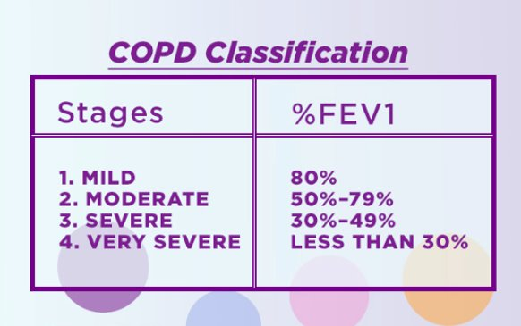

The classification system *has* changed in the 2023 guidelines from ABCD to ABE. On the X-axis, you have the modified medical research dyspnea questionnaire (mMRC) or the COPD Assessment Tool (CAT), and on the Y axis you have the number and severity of exacerbations. (These tools are both available on MDCalc, and you can have participants practice using them here based on the history above). Based on her mMC and CAT and no prior hospitalizations, she would be in Group A.

Note to facilitators – focus here on classifying and grading severity – we will discuss management in the next question.

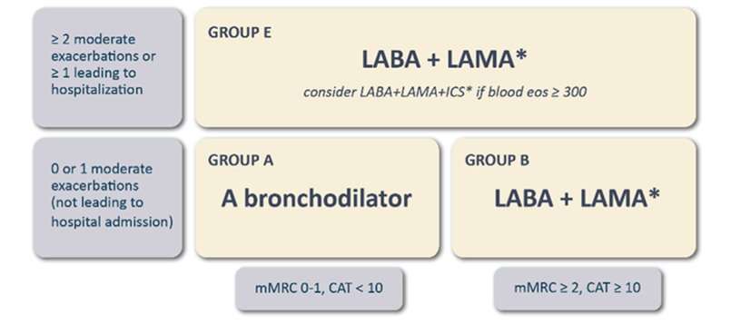

6. Broadly, what are your goals for treatment of stable COPD? What medication(s) would you start for this patient, and why?

Goals for treatment of stable COPD:
- Reduce symptoms (relieve symptoms, improve exercise tolerance, improve health status)
And
- Reduce risk (prevent disease progression, prevent and treat exacerbations, and reduce mortality)

Review the GOLD treatment table above.: Either LAMA or LABA scheduled and a SABA/SAMA prn

LAMA vs LABA – in 2 head-to-head comparisons, the tested LAMA was superior to LABA for exacerbation prevention. (POET-COPD Tiotropium vs salmeterol NEJM 2011 and INVIGORATE Lancet Respir Med 2011)

7. Ms. Puff asks if there is anything she can do in addition to medications because she wants to do everything she can to start playing Pickleball again. What do you tell her about adjunctive and non-pharmacological options?

Smoking cessation
- The greatest capacity to influence the natural history of COPD.
Vaccinations
- Pneumococcal – reduces exacerbations and incidence of CAP in select patients. Our patient is 62.
  - If has already received the PCV13, should get the PSV23
  - If has not received any PCV vaccines, then she should get the new and improved 20-valent pneumococcal polysaccharide vaccine (PSV20)
- Influenza annually – reduces exacerbations and death.
Pulmonary rehab
- For GOLD B, E

8. Ms. Puff wonders if her tobacco use could have anything to do with her COPD. How do you counsel her? What tools do we have to help with smoking cessation?
Pharmacotherapy
- Long acting:
  - Nicotine patch: 21mcg if >10 cigarettes per day, 14mcg if <10 cigarettes per day. Can do two patches if smoking more than a pack a day.
  - Varenicline: Contraindicated in unstable neuropsych disease (stable disease is just fine). Needs a dose-adjustment in CKD. Most common adverse effects are nightmares/vivid dreams.
  - Bupropion: Lowers seizure threshold, so contraindicated in patients with epilepsy, eating disorders, or severe/massive CVA that put that at increased risk of seizures. Works great for depression as well and helps with weight-loss.
  - Note: you can start with a patch AND an oral option right from the start!
- Short Acting:
  - Other forms of nicotine that help with cravings: gum, sprays, lozenges, inhalers
  - Use in conjunction with long-acting
- Behavioral therapy
  - Pharmacotherapy smoking cessation referral: help with long/short acting titration
  - 1-800-QUIT-NOW is the OH tobacco quit line. Will ship free NRT to the home. Get up to five free counseling sessions!
- Follow-up
  - Get a follow up appointment in the books! Intentionally schedule a visit for smoking cessation follow-up.

9. She returns for follow-up a few weeks later and continues to complain of shortness of breath. Her CAT score is 15. What do you do?
Review inhaler technique, discuss smoking cessation (every visit!), but ultimately escalate to LAMA+LABA (now would classify as Group B)

If time allows, can discuss indications for additional pharmacologic treatment options below:
- If blood eosinophils are ≥300 cells/µL, consider LABA + LAMA + inhaled corticosteroid (ICS). No recommendation is made (at any eosinophil level) for ICS without combined LABA + LAMA.​
- For patients with persistent exacerbations despite LABA + LAMA + ICS or for those who have >100 eosinophils/µL, roflumilast (for patients with chronic bronchitis and FEV1 <50% of predicted) or azithromycin (in nonsmokers) can be considered.

Part 2
A few months later, you are on an emergency medicine rotation and to your dismay, you see that Ms. Puff has checked in with shortness of breath! You learn that Ms. Puff had noted worsening SOB at home for the past four days along with increased sputum production and sputum that was more yellow/green than her normal. She says she was taking her Tiotropium + Formoterol as prescribed but she has also been needing her rescue inhalers every 2 hours for the last day.

- What is on your differential? What clarifying questions might you ask?
COPD exacerbation is the most likely diagnosis. Beware of anchoring. What else could be going on? PNA, ACS, PE, CHF, arrhythmia, pneumothorax

- How is a COPD exacerbation defined? How is severity defined?

- The Gold 2023 have presented a new, more specific definition of CODP exacerbations: Increased dyspnea or cough and sputum that worsen during ≤14 days, with associated inflammation due to airway infection, pollution, or other insult to the airways. ​

Severity is defined as outlined below:

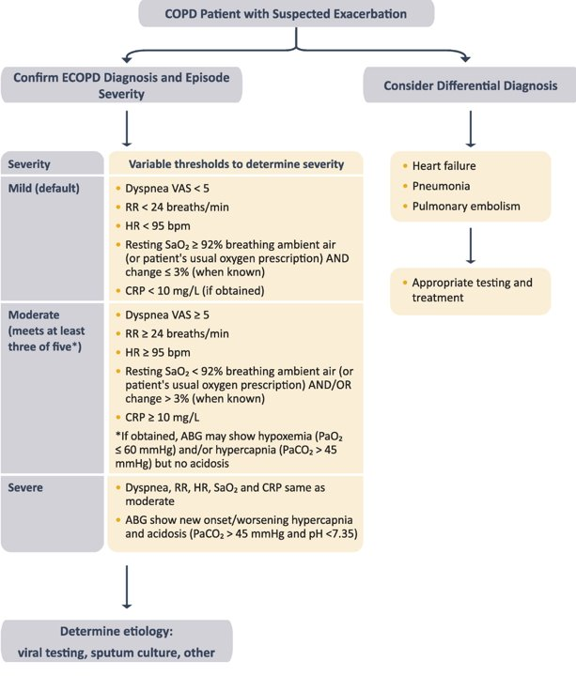

3. What set of vitals, exam findings, lab results, and imaging findings would:
a. Reassure you that Ms. Puff can go home?
b. Concern you enough that you would admit Ms. Puff to general medicine?
c. Make you call the MICU fellow?
Discussion points:
- Work up: blood gas (difference between ABG and VBG should be discussed if any confusion), CBC, CXR
- pH < 7.35, pCO2 > 45 are indications for admission and trial of NIPPV
- Other comorbidities that affect decision making?
- Failure to respond to initial therapy at home could be indicative of worsening exacerbation and therefore require hospitalization.

4. What are the common triggers of COPD exacerbations? What is the time course for recovery?
COPD exacerbations are often triggered by respiratory infections (viral >> bacterial).
Generally last 7-10 days, though about 20% of patients are not at their baseline after 8 weeks
Each COPD exacerbation can worsen baseline disease, and place patients at higher risk of another COPD exacerbation.

Case Continued
Physical Exam:
Vitals: 98.9, HR 92, RR 24, BP 121/98, SpO2 86% on RA
GEN: Sitting on edge of bed, appears a little uncomfortable/anxious, seems short of breath after speaking
CV: Nml rate, reg rhythm, normal S1, S2, no M/R/G
Pulm: Distant breath sounds, prolonged expiratory phase accompanied by expiratory wheezes throughout, scant crackles at the bases with some clearing when asked to cough
Extremities: 1+ pitting edema to ankles bilaterally
CBC: WBC 8.8, Hb 14.8, Hct 44.5, Plt 185
Renal: Na 140, K 3.9, Cl 98, HCO3 32, BUN 20, Cr 1.2, Glu 127
BNP: < 15
CXR: no acute cardiopulmonary disease, stable compared to prior
VBG: 7.34/60

5. What sort of acid-base disturbance does this patient have? If you need
help refer to the acid-base AHD guide with the QR code:

Internal validity: (80-34) = 46 = 45 (24 x 60/32)
AG: 140 - (98+32) = 10
=> non-anion gap respiratory acidosis; assuming chronic resp acidosis determine appropriate compensation...
HCO3- increases 3.5 for every increase of 10 in PCO2, so HCO3- should be around (24 + (3.5x2)) = 31
Chronic respiratory acidosis with appropriate metabolic compensation

6. You decide to admit Ms. Puff. What orders do you place? What do you do with her home inhalers? How will each of your therapies help Ms. Puff?

Bronchodilators:
- SABA +/- SAMA, or both (do they know what duonebs are made of?)
- MDI vs nebulizers. There is no data favoring one over the other, so you can do whichever the patient prefers, though would make sure technique is correct if using MDI.
Steroids:
- Prednisone 40mg x5 days
- Improve lung function, oxygenation, and shorten recovery time & duration of hospitalization.
- (Do you need to continue inhaled steroid if on it if you’re on systemic steroids? Might be a good question for the expert since the practice pattern seems to vary!)
Antibiotics: 5 day course of either
- Azithromycin: QTc prolonger, if on chronic azithro might have a bit more resistance.
- Doxycycline: can consider if macrolide allergy or on chronic azithromycin
Oxygen: goal 88-92%. Review why our O2 goals are lower in COPD patients.

Case Continued

2 hours later Ms. Puff’s nurse calls you. She reports that Ms. Puff is still feeling quite SOB and appears more tired than before. You go and evaluate Ms. Puff.

Physical Exam:
Vitals: 98.9, HR 102, RR 26, BP 121/98, POX 85% on 4L
GEN: Is drowsy and seems much more tired and sleepy, dozes off but easily arousable. Follows commands. AAOx4
CV: Tachycardic, regular rhythm, normal S1, S2, no M/R/G
Pulm: Distant breath sounds, prolonged expiratory phase accompanied by expiratory wheezes, no gurgling or drooling

7. What concerns do you have? What do you do from here?
Repeat the VBG: Tell them it is 7.24/80
Discuss indications for NIPPV vs endotracheal intubation:

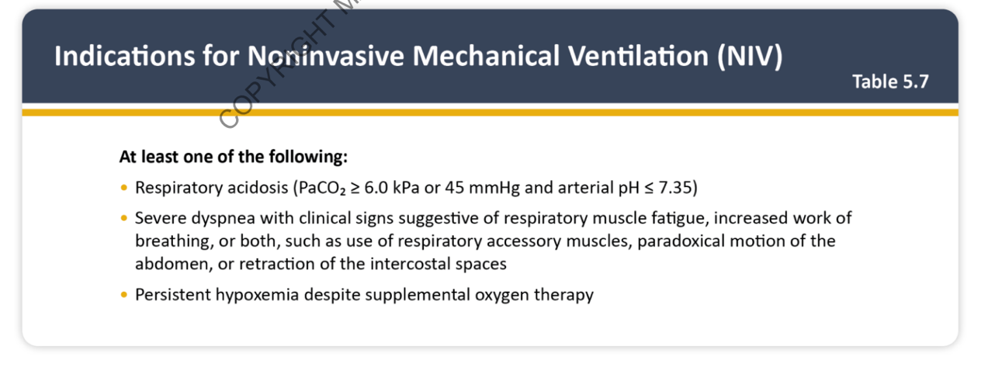
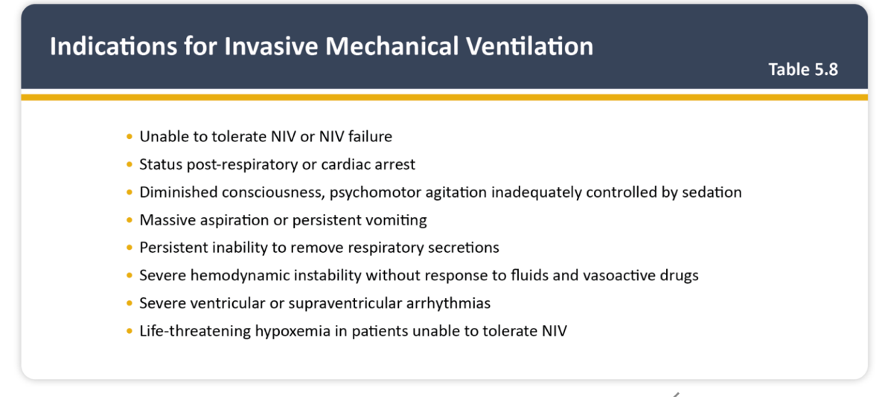

Follow up question: What do you do after starting NIPPV?
- Check a gas in 30 min
Follow up question: What are the contraindications to NIPPV?
- Severe AMS, inability to clear secretions or protect airway, aspiration risk, facial trauma

Case Continued
Ms. Puff ultimately improves under your team’s care and feels almost back to normal. You are preparing to discharge her, but she has remained on 2 liters O2.

8. Does she need supplemental oxygen? How will you evaluate for this?

Long term O2 is indicated in patients with COPD who have RESTING SpO2 ≤ 88% or PaO2 ≤ 55 mmHg.

Of note: chronic tobacco use is associated with elevated carboxyhemoglobin. Pulse oximeters cannot tell the difference between carboxyhemoglobin (carbon monoxide + Hgb) vs oxyhemoglobin (O2 + Hgb) and can artificially read a falsely elevated SpO2. More of a reason to obtain an ABG in this population.

Mortality benefit of supplemental oxygen requires CONTINUOUS oxygen

LOTT trial, NEJM 2016 – “In patients with stable COPD and resting or exercise-induced moderate desaturation, the prescription of long-term supplemental oxygen did not result in a longer time to death or first hospitalization.”
  - Moderate hypoxemia per LOTT trial = 89-93%
  - Moderate exercise-induced desaturation: SpO2 ≥ 80% for ≥ 5 minutes and < 90% for ≥ 10 seconds.

9. Do you need to make any changes to her medications before discharge? What resources will you provide her in the outpatient world?
With her CAT score and her 1 exacerbation which led to hospitalization, she is now GOLD group E, which could argue for initiating ICS if eos > 300. Would ADD ICS to LAMA+LABA (no indication for ICS without the other two therapies as well).

What are the risks of ICS?
- Pneumonia, oral candidiasis, hoarse voice
- What can you do to help prevent oral thrush?

- Refer to pulmonary rehab
- Continue to discuss smoking cessation
- Vaccinate!!
- Can consider pharmacotherapy referral (at Hoxworth) for inhaler teaching and med-rec

A note about triple therapy:
The IMPACT trial was a phase 3 randomized, double-blind parallel-group multicenter trial that compared the effects of once daily triple therapy with LABA+LAMA+ICS to LABA+ICS or LABA+LAMA on COPD exacerbation. Triple therapy resulted in significantly lower rates of moderate or severe COPD exacerbations and better lung function and quality of life. Note: No inhaler has demonstrated improvement in mortality.
Bonus question:
A 62 year old female with moderate-severe COPD, HTN, and OA is brought to the ED with acute onset of shortness of breath that started this morning. He was discharged 3 days ago for a COPD exacerbation treated with steroids, antibiotics, and BiPAP on admission, which was subsequently weaned off to supplemental O2 per nasal cannula. He finished antibiotics yesterday. He was discharged to a SNF due to being largely non-ambulatory during his admission. He complains of productive cough with white sputum and mild right-sided chest pain.

Vitals: 98.8 deg, BP 118/76, pulse 112, respirations 23, SpO2 89% on RA JVD
Exam is notable for end expiratory wheezing, mild tachypnea, b/l lower extremity edema (which he says is chronic), and JVD to 8 cm H2O.

Labs: WBC 14k, Hgb 15, Plt 100k
Na 135, K 4.2, HCO3 29, Cr 1.1
Trop 0.3
ABG pH 7.4, PaO2 57, PaCO2 41

EKG sinus tach with non-specific TW changes.
CXR hyperinflated lungs with linear densities at the RL base c/w atelectasis.

What is your next best step in management?
- IV antibiotics and steroids
- V/Q scan
- NIPPV
- CT angio chest
- Monitor troponin trend and EKG trend

CT angio chest is the next most important step. This patient is at risk for pulmonary embolus and most recently was immobilized during his hospitalization, further worsening his risk. Any patient recently treated for an exacerbation of COPD who presents with recurrent or worsening dyspnea should be evaluated for heart failure, pneumonia, and pulmonary embolus. This patient has signs of right heart volume overload with JVD and pulmonary edema and troponin elevation on initial labs. PE is a common contributing cause of early death in hospitalized patients with severe COPD exacerbation.

