COPD AHD- Facilitator Guide

Agenda
1:00-1:20 PM Theory Burst #1
1:20-2:00 PM Small groups
2:00-2:20 PM Expert questions
2:20-2:30 PM Break
2:30-2:40 PM Theory Burst #2
2:40-3:20 PM Small groups
3:20-3:30 PM Expert questions and wrap-up

How did the MKSAP 18 quiz go?
- Did everyone do it? Was 5 questions a reasonable length? Can this be expected work on a weekly basis? Can answer clarify right answers if need be.

Part 1
Ms. Puff is a 42 yo female with a PMH of pre-diabetes, HTN, and smoking who presents to clinic for routine follow-up. She is concerned about her worsening shortness of breath. She reports SOB over the last several months, worse with exertion. She denies chest pain. Reports lower extremity edema. She denies orthopnea and PND. She has had a chronic productive cough for “years” which is unchanged. She has never been hospitalized for her SOB. She denies hemoptysis. She has regular periods.

Social: Currently smokes 1 ppd (40 pack year hx), occasional EtOH. Denies drug use

Medications: multivitamin

Physical Exam:
Vitals: T 98.6, BP 132/84, HR 86, POX 95%, BMI 26
Gen: well appearing, no acute distress
CV: RRR, nl S1/S2, no murmurs, normal PMI, no JVD
Pulm: reduced breath sounds throughout, clear to auscultation. No wheezing or crackles
Extrem: 1+ pitting edema to ankles bilaterally

1. What is your differential diagnosis and what would support each diagnosis?
Discuss the differential and features that may point towards different diagnoses (you don’t have to discuss this all)
- COPD- because it’s COPD AHD- no, because patient has characteristic progressive SOB that worse with exertion + chronic cough + risk factors w/ smoking hx. Exam c/w decreased breath sounds; may also have wheezes or accessory muscle hypertrophy on exam, etc.
- Asthma- usually dx’ed before age 40, does her history of chronic symptoms support this diagnosis? Does she have a h/o allergies and eczema?
- CHF- RFs for CHF include HTN and smoking. +Ankle edema but no JVD, orthopnea, etc.
- Anemia- likely to be a significant anemia if causing dyspnea. She has regular periods, may need to assess heaviness of bleed etc.
- ILD- signs/sx of connective tissue disease? Environmental/occupational exposures? Drug induced? H/o radiation? Typically expect dry crackles on exam
- Chronic PE- family or personal h/o VTE? Other risk factors for VTE? Calf swelling, pain?
- Pulmonary HTN- Signs or sx of pulmonary HTN or right heart failure? Loud P2, JVD on exam

Potential Follow-up question: What about the patient’s edema?
May be related or unrelated, if related then concern for CHF or right heart failure from many things on our differential. Smoking hx puts her at risk for vascular insufficiency as well

2. How would you evaluate this patient in clinic and/or what work-up do you want to do?
- PFTs, TTE
- Labs?
  - Alpha-1 antitrypsin level recommended if diagnosing COPD at age < 45 yo (Am J Respir Crit Care Med. 2003;168(7):818)
  - Other labs only if history or physical point towards potential other causes (CBC, BNP)
- CXR: What information would it give us? What would it rule out that other tests can’t?
- 6MWT? We will want a 6MWT at some point but often don’t get until confirm the diagnosis

3. Which set of PFTs do you expect her to have and why? What disease script matches with each PFT?
A.
 | Baseline |  |  |  | Post Bronchodilator
 | Actual | Pred | %Pred | LLN | Actual | %Chg | %Pred
FVC (L) | 3.1 | 4.05 | 77 | 3.23 | 3.2 | 3 | 79
FEV1 (L) | 2.6 | 3.05 | 85 | 2.34 | 2.75 | 6 | 90
FEV1/FVC (%) | 84 | 75 | 113 | 65 | 86 | 2 | 115
TLC (Pleth) (L) | 4.73 | 6.31 | 75 | 4.91
DLCO | 23.20 | 24.04 | 97 | 16.05
Restrictive pattern (FVC < LLN, FEV1/FVC > 70%)
Example disease script: elderly women with kyphoscoliosis (restrictive pattern is due to decreased chest wall compliance since DLCO is normal). Dx like pulmonary fibrosis you would expect decreased DLCO
B.
 | Baseline |  |  |  | Post Bronchodilator
 | Actual | Pred | %Pred | LLN | Actual | %Chg | %Pred
FVC (L) | 3.92 | 4.05 | 97 | 3.23 | 4.28 | 9 | 106
FEV1 (L) | 1.70 | 3.05 | 62 | 2.34 | 1.87 | 10 | 61
FEV1/FVC (%) | 43 | 75 | 65 | 65 | 44 | 0 | 58
TLC (Pleth) (L) | 9.32 | 6.31 | 148 | 4.91
DLCO | 26.20 | 24.04 | 109 | 16.05
Obstructive pattern (FVC > LLN, FEV1/FVC < 70%)
Example disease script: our patient (COPD since there is NO reversibility with bronchodilator).
Make point that obstructive PFT is NOT pathognomic for COPD. Obstructive PFT ddx includes A1ATD, bronchiectasis, bronchiolitis obliterans, and cystic fibrosis
Follow-up question: What defines reversibility?
- Increase in FEV1 by >12% AND >200mL
C.
 | Baseline |  |  |  | Post Bronchodilator
 | Actual | Pred | %Pred | LLN | Actual | %Chg | %Pred
FVC (L) | 3.92 | 4.05 | 97 | 3.23 | 4.18 | 7 | 103
FEV1 (L) | 2.9 | 3.05 | 95 | 2.34 | 2.82 | 4 | 92
FEV1/FVC (%) | 74 | 75 | 98 | 65 | 67 | 2 | 89
TLC (Pleth) (L) | 6.5 | 6.31 | 103 | 4.91
DLCO | 25.20 | 24.04 | 105 | 16.05
Answer = Normal pattern (FVC > LLN, FEV1/FVC > 70%)
Example disease script: 21 yo female with h/o allergies and eczema reports SOB

Follow-up question: What additional test would you need to order for this patient with normal PFTs if you suspect asthma? → Methacholine challenge

Case continued:
Ms. Puff completes her PFTs which show an FEV1/FVC of 50%, FEV1 of 61% predicted without reversibility with bronchodilation. TTE results included an EF of 60% and is otherwise unremarkable. She returns for follow-up and continues to complain of SOB but no changes since her last visit. You discuss with her that she has a diagnosis of COPD. She completes the COPD Assessment Test (CAT) and her CAT score is 15.

4. How did we diagnose her COPD? How severe is her COPD?
Practically = obstructive PFT w/o normalization w/ bronchodilation + RFs & absence of alternative
explanations for symptoms and airflow limitation
Definition = Diagnosis of COPD if FEV1/FVC < 70% and does NOT normalize with bronchodilation
  - Note: ATS guidelines use FEV1/FVC < lower limit of normal
Chronic bronchitis vs. Emphysema
- CB = chronic productive cough for 3+ months in 2 successive years & other causes ruled out
- Emphysema = disease of permanent, enlarged airspaces. Dx on imaging or pathology
Severity: See classification below. Ms. Puff has Moderate Severity (FEV1 is 61% predicted, ATS & GOLD)
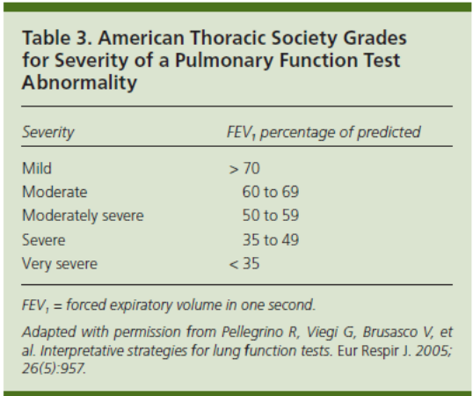
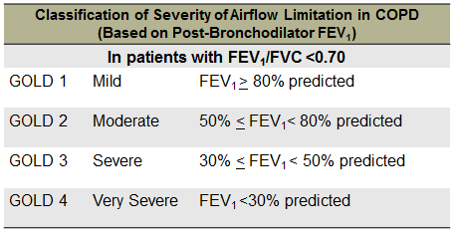

Severity- ATS and GOLD

5. What is Ms. Puff’s GOLD Grade & Group? Why is this helpful?
Grade is just another term for severity → she is GOLD 2
Group comes down to symptoms and exacerbation
- Symptoms assessed by mmRC (modified medical research council) dyspnea scale or the CAT
- Exacerbation history (risk) – annual, important to distinguish hospitalization or not, 1 hospitalization for COPD exacerbation puts in the higher risk groups (C, D)
- Ms. Puff is Group B (no exacerbations, CAT>10) = low risk, high symptoms

Why is group important? → It guides treatment

Point: Some studies show that when patient’s symptoms are worse than the obstruction they may actually be at higher risk of death, so when Sx are high still need more treatment (like our patient)
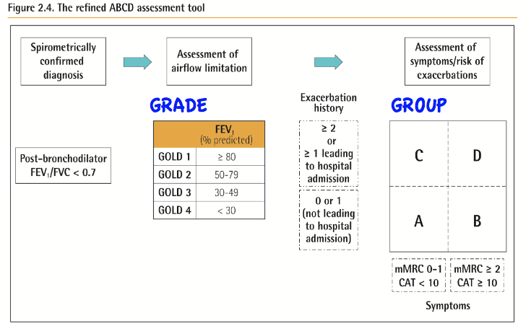

6. What medications would you prescribe for Ms. Puff? Think about this based on GOLD category.
Main quick points to get to:
GOLD A- SAMA PRN or SABA PRN
GOLD B- LABA or LAMA (Ms. Puff)
GOLD C- LAMA then can add LABA or LABA+ICS
GOLD D- LAMA + LABA +/- ICS
Try to simplify it:
- if minimal symptoms and no exacerbations, then PRN SABA
- if lots of exacerbation+minimal sx or minimal exacerbations+high sx, then start with LAMA
- if a lot of sx and exacerbations, start with LAMA+LABA
Have them name specific meds, not classes - common inhalers with brand names listed on last page
Depending on timing with your group can discuss below meds to choose and studies behind them:
- Tiotropium (Spiriva – LA anticholinergic) or Salmeterol (LA beta-2 agonist)
Aclidinium is another LA anticholinergic (Tudorza), ?advantage improving nocturnal symptoms
*NEJM, 2008 – UPLIFT trial – LAMA improved lung function vs placebo over 4-y period
*NEJM, 2011 – POET-COPD trial - Tiotropium vs Salmeterol - LAMA prevented exacerbation in patients with moderate to severe COPD better than Salmeterol
*Lancet, 2013 - INVIGORATE - LAMA superior to LABA in preventing exacerbations in moderate to very severe COPD

- Albuterol inhaler PRN (would not Rx ipratropium PRN while on LAMA, risk of cholinergic toxicity)

Case Continued
You prescribe Ms. Puff once daily Tiotropium and provide inhaler education. She returns to your clinic one month later. She reports continued symptoms of DOE and cough. Her CAT score is 16

7. Does your treatment change for Ms. Puff?
Please use this as an opportunity to discuss step-up and step-down approach with treatment escalation and de-escalation for COPD as a whole. Guided by patient’s symptoms and/or exacerbations
Since Ms. Puff is still having persistent symptoms despite initial LAMA:
- Ensure that she is adherent to inhaler regimen and using good inhaler technique
- Address smoking cessation
- Add on a LABA to her LAMA regimen
*NEJM, 2016 – FLAME trial - patient with group B & D COPD, a LAMA+LABA combo is associated with reduction in annual COPD exacerbation rate, improved FEV1, & lower PNA compared to LABA+ICS

Expert Questions!
Possible questions to ask expert depending on other questions people have:
- Difference/limitations in using fixed ratio of <70% vs LLN for COPD diagnosis
- What to do with incidental diagnosis of emphysema on chest imaging
- Are there certain patients to think about having an ICS included in inhaler regimen (reversibility on spirometry, eosinophil % on CBC differential)?
- Recent IMPACT trial in NEJM argues for LABA+LAMA+ICS in group D over LAMA+LABA

BREAK- 10 minutes

Part 2
A few months later, you are on night float and get called for an admission. You check Epic and see that Ms. Puff is being admitted to your team for SOB! In the ED, you learn that Ms. Puff had noted worsening SOB at home for a couple days along with increased sputum production and sputum that was more yellow/green than her normal. She says she was taking her Tiotropium + Formoterol as prescribed but she has also been needing her albuterol every 2 hours for the last day. The ED would like to admit Ms. Puff for a COPD exacerbation.

- How do you define a COPD exacerbation? What is the severity of the COPD exacerbation?
COPD exacerbation = acute worsening of respiratory symptoms that requires escalation of medications used to treat COPD; ≥1 cardinal sxs = increased dyspnea, increased cough, change in sputum volume/purulence
Exacerbation severity:
- Mild – able to be treated with short-acting bronchodilators (SABD) alone
- Moderate – treatment requires SABDs + corticosteroids +/- antibiotics
- Severe – treatment requires hospitalization or ED visit (Ms. Puff has severe exacerbation)

Discuss danger of anchoring – still need to think about other causes of SOB (PNA, ACS, PE, etc)
One study found 16% of unexplained COPD exacerbation found to have PE
Case Continued
Physical Exam:
Vitals: 98.9, HR 85, RR 22, BP 121/98, POX 91% on RA
GEN: Sitting on edge of bed, appears a little uncomfortable/anxious, speaking in full sentences
CV: RRR, normal S1, S2, no M/R/G
Pulm: Distant breath sounds, prolonged expiratory phase accompanied by expiratory wheezes throughout, scant crackles at the bases with some clearing when asked to cough
Extremities: 1+ pitting edema to ankles bilaterally

2. What labs/imaging will you include in your admission orders? What’s the most helpful lab?

CBC: WBC 8.8, Hb 14.8, Hct 44.5, Plt 185
Renal: Na 142, K 4.4, Cl 97, HCO3 34, BUN 16, Cr 1.05, Glu 127
BNP: < 15
CXR: no acute cardiopulmonary disease

VBG: 7.21/85 (most helpful, confirms CO2 retention)
Follow-up question: What else do you want to know along with current VBG?
- 1 year ago VBG was 7.32/68

Follow-up question: What is the acid-base disturbance?
- pH is low, pCO2 is high = respiratory acidosis
- Check compensation: you expect chronic resp acidosis given COPD so for chronic resp acidosis HCO3 increased by 3.5 for every 10 mmHg increase in PCO2
  - PCO2 is 45 mmHg higher than normal of 40 ➔ (85-40 = 45)
  - 45/10 = 4.5, 4.5 x 3.5 = ~16ish. 25 (normal HCO3) + 16 = 41. 40 ≠ 34
  - No anion gap: 142 – (97+34) = 11
  - Has chronic resp acidosis with metabolic compensation and NOW an acute respiratory acidosis or acute metabolic acidosis
- Based on clinical scenario has acute respiratory acidosis on chronic respiratory acidosis with metabolic compensation

3. In the ED Ms. Puff was started on Duonebs, received methylprednisolone 125mg IV, and 2L NC oxygen. What therapies would we start/continue/change/discontinue?

- BRONCHODILATORS
- Duonebs (albuterol/ipratropium bromide nebulizer) q4h or q6h
- Note: avoid too much anticholinergic effect – discuss practice of anticholinergic frequency and holding/restarting LAMA

- STEROIDS
- Switch IV steroid to oral
- Prednisone 40 mg daily, total 5 days of steroids. Note: 40 mg non-inferior to 60 mg
- Note: Cochrane review 2014 “Different durations of corticosteroid therapy for exacerbations of COPD” showed shorter durations (<7 days) were non-inferior to longer durations (10-14 days).
*REDUCE trial in JAMA 2013 showed PO steroid x 5 days non-inferior to 14 days.
Recommendation is 5 days
- ANTIBIOTICS
- GOLD indications: moderate and severe exacerbations with increased cough, sputum purulence
  - Indicated for Ms. Puff because she has a severe exacerbation
- Review from Antibiotics AHD → what bugs are we covering? Common respiratory bugs
  - H. influenza (13-50%), strep pneumo (7-26%), Moraxella catarralis (9-21%)
  - Recommended: Azithromycin, doxycycline, or respiratory fluroquinolone (levofloxacin or moxifloxacin)
- O2 THERAPY
- Oxygen by NC only to maintain SpO2 > 88-92%

- NIPPV
- Technically she meets criteria now with VBG, but could argue to wait and see if improves with medical treatment alone first

Case Continued
You are called 2 hours later by the ED nurse after admitting Ms. Puff. She reports that Ms. Puff is still feeling quite SOB and appears more tired than before. You go and evaluate Ms. Puff.

Physical Exam:
Vitals: 98.9, HR 102, RR 18, BP 121/98, POX 87% on 2L
GEN: Awakens but is more drowsy than before. Follows commands. AAOx4
CV: Tachycardic, regular rhythm, normal S1, S2, no M/R/G
Pulm: Distant breath sounds, prolonged expiratory phase accompanied by expiratory wheezes
4. What concerns do you have? What do you do from here?
Concern for persistent CO2 retention and drowsiness/AMS due to “CO2 narcosis”

Repeat the VBG → 7.21/86

Plan for positive pressure ventilation- BiPAP (NIPPV) vs. intubation. Review indications below
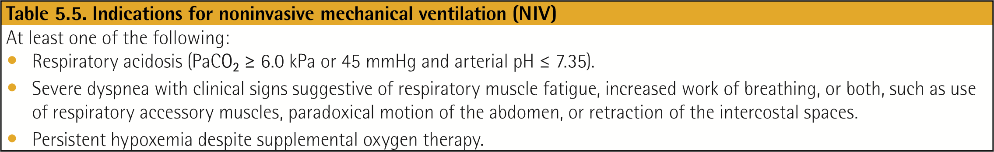
Follow-up question: If start BiPAP how would you do this?
- Initial settings: could be 8/3 or 10/5
- Recheck VBG in 1-2 hours to ensure CO2 decreasing

Follow-up question: What are contraindications to NIPPV?
- Severe AMS, inability to clear secretions or protect airway, high aspiration risk, facial trauma
- What about this patient’s AMS? Discuss

5. How would your impression and management change if instead Ms. Puff’s physical exam findings were the following? What do you do?
Physical Exam:
Vitals: 98.9, HR 102, RR 26, BP 90/55, POX 87% on 2L
GEN: Sitting on edge of bed, appears uncomfortable/anxious, taking a breath every few words
CV: Tachycardic, regular rhythm, normal S1, S2, no M/R/G
Pulm: Distant breath sounds, prolonged expiratory phase accompanied by inspiratory and expiratory wheezes throughout, significant accessory muscle use
Extrem: 1+ pitting edema to ankles bilaterally

More concerned due to her increased work of breathing and relative hypotension
Becoming unstable, will not be able to keep up with this for long if doesn’t improve

Could repeat VBG – though may not ultimately change management
- If CO2 is rising, more confirmation that the patient is tiring out
- Depending on the severity of increased WOB may not even get VBG as would just intubate

Needs mechanical ventilation. Review indications below
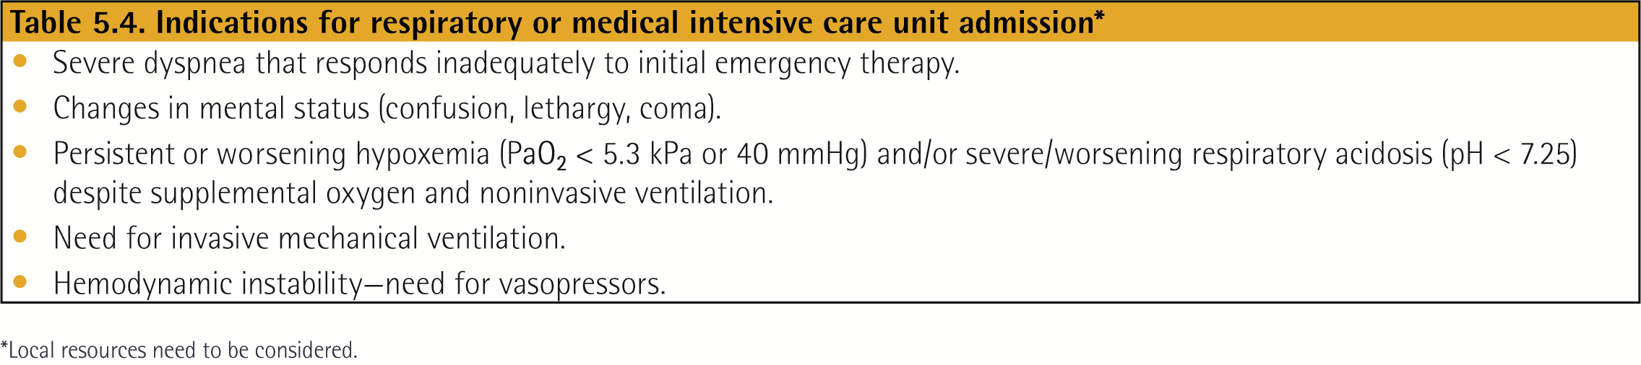

Follow-up question: What are the features of impending respiratory arrest that prompt intubation?
- Inability to maintain respiratory effort, cyanosis, hemodynamic instability, severely depressed mental status

Case Continued
Assuming exam from #4, you start Ms. Puff on Bipap and she quickly turns around. After another day of bronchodilators and steroids, she feels much better and no longer requires NIPPV. You are getting her ready for discharge and are discharging her home on appropriate inhalers, antibiotics, and prednisone.

6. What else does Ms. Puff need? What other management considerations are there for COPD?

- Smoking cessation
  - Single best thing to improve mortality, reduce exacerbations, and improve lung function
  - Addresses mortality associated with COPD as well as like co-morbidities with CAD, PVD, and CVA associated with smoking
- Yearly flu shot (decreases exacerbations)
- Pneumovax (not shown to reduce exacerbations but recommended for all adult smokers)

- O2 therapy? Only indicated on discharge if:
  - Resting SpO2 < 88% or PaO2 < 55 mmHg OR
  - SpO2 > 89% + signs of tissue hypoxia (pulmonary hypertension, cor pulmonale, erythrocytosis, edema from RHF, or AMS)
  - NEJM, 2016 – LOTT trial – no difference in mortality, COPD hospitalization, COPD exacerbations in O2 vs. no O2 for COPD pts that ONLY desat with exercise
- Statin? If patient has known co-existing CVD
  - Chest, 2017 – meta-analysis, statin txt associated with improved exercise tolerance, lung function, and dyspnea burden
- Physical activity
- Pulmonary rehab
- Discuss goals of care/advanced directives

Expert Questions and Wrap-Up
Possible questions to ask depending on other questions people have:
- Continuing LABA while patients are getting scheduled duonebs?
- What to do when patient admitted with exacerbation but no formal COPD dx? Get PFTs while inpatient or on inhaler regimen?
- Getting ABG to check PaO2 for resting saturation. Risk of carboxyhemoglobin in smokers.
- Should we stop prescribing O2 based off exercise desat alone?
- When to refer to pulmonology (inpatient and outpatient)?


