Arrhythmia AHD 3/7/2024
Developed by Jackson Walker
Expert: Wai Tam
Schedule:
1:00-1:20: Theory Burst
1:20-2:20: Cases
2:20-2:30: Expert Questions
2:30-2:40: Break
2:40-3:20: Cases
3:20-3:30: Expert Questions

Plug: AHA ACLS App. Very useful for codes, tachycardias, bradycardias. $3 per/yr
Case 1:
It's 7:30 AM and you are on Cardiology Wards. You get a STAT page from one of the 6S nurses. Your patient admitted to obs for ACS rule out is suddenly tachycardic. The nurse tells you that the patient is still feeling OK, but just feels lots of palpitations. BP 115/72, HR 160, SpO2 95% on 1L NC, RR 18. You walk over to the room.
What about the patient’s history and hospital course do you want to know as you are walking over?

What test do you already have that will be useful when assessing this new problem?
(look at this once you have answered)
You arrive at the room, what are the first things you are going to do?
You look at the tele box and see a fast rhythm reading about 162 BPM. You cannot clearly tell from the tele box whether the rhythm is wide or narrow.
What arrhythmias are on the ddx for this presentation?

While you are awaiting the formal ECG, you ask the nurse to wait with the patient and you go to the telemetry computer. What is your approach to interpreting the tele?

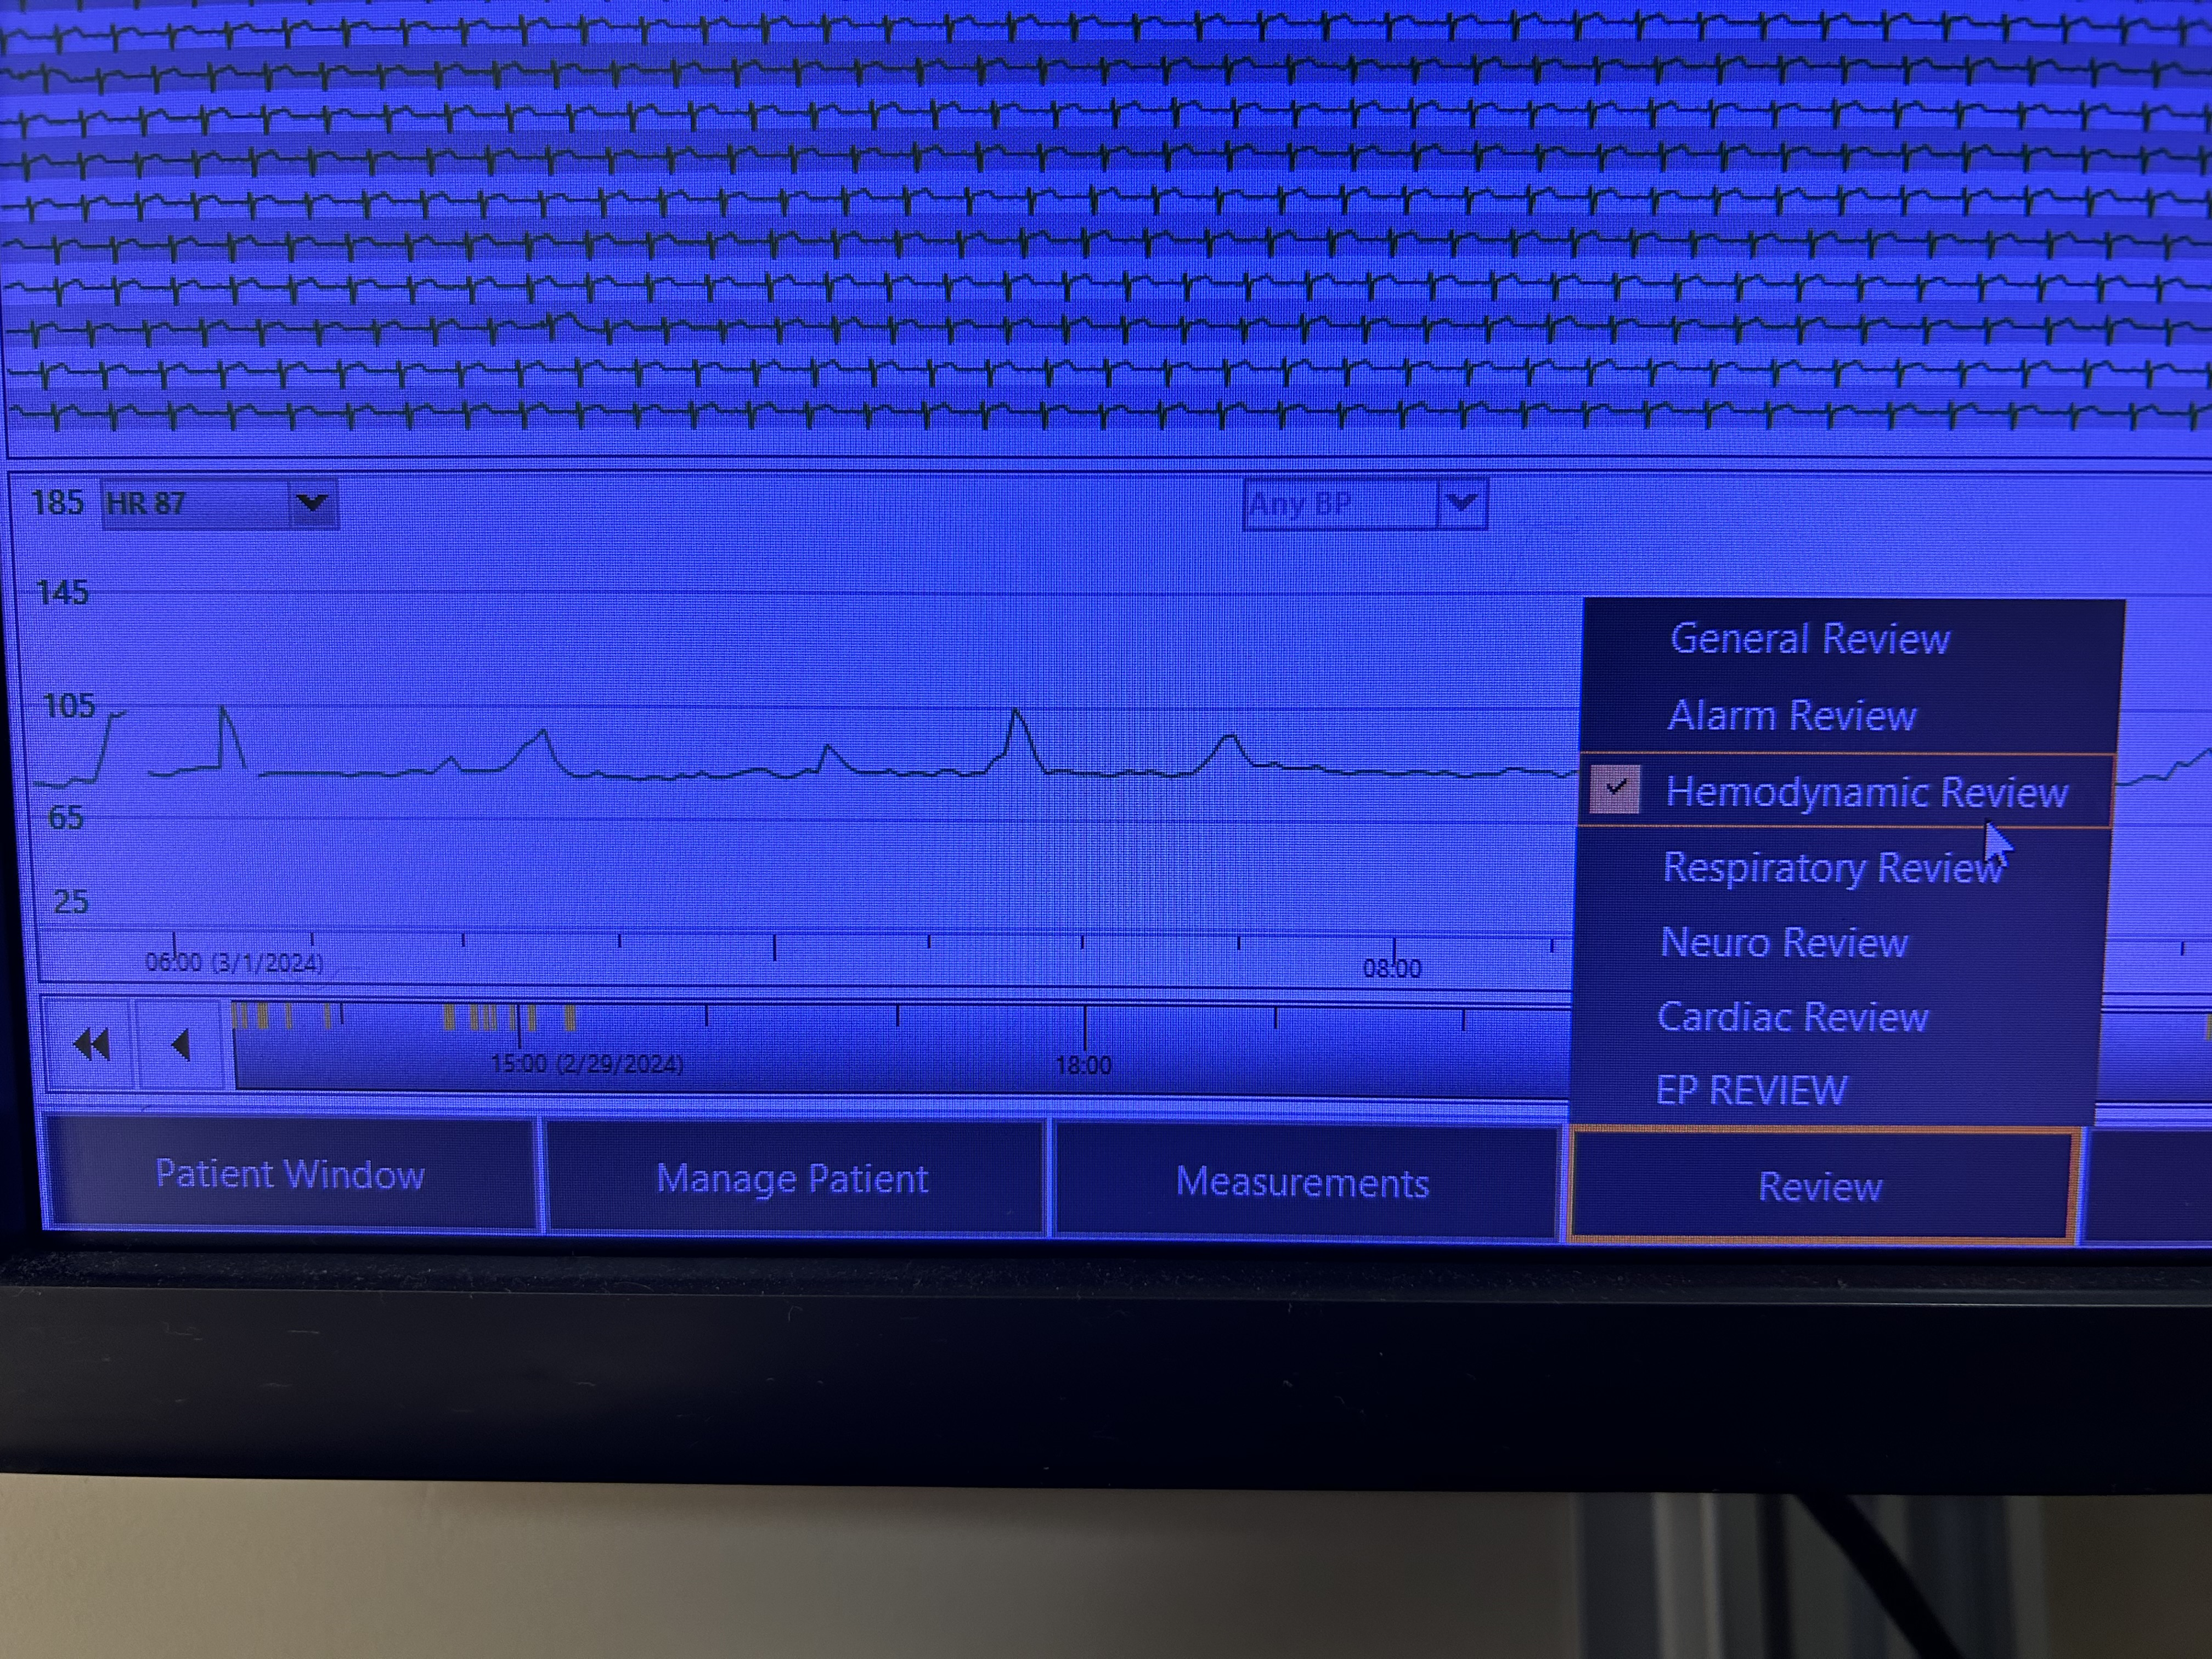
You obtain the ECG:
What do you think is going on here? (wait to flip to the next page until you answer)
How do we know this is AVNRT?

Now that we have a suspected diagnosis, what parts of this presentation argue against this tachycardia representing Atrioventricular Reentrant Tachycardia (AVRT)? How does the baseline ECG help you?
(look at this after you have answered the question)
How will you manage our patient?
(look at this after you have answered the question)
What are some vagal maneuvers?

The vagal maneuvers did not work, what will you do next?

How do you dose this medication? (wait to flip to next page until answered)
You give 6mg of adenosine and see this on the continuous ECG: Besides feeling terrible when the medication was given, your patient now reports the palpitations have stopped. Good work!
What if this patient did not have AVNRT? What will adenosine do for narrow complex tachycardias that are not AVRT or AVNRT?
(look at this after you have answered the question)
Back to the beginning of the case. What would you be concerned for if you were called to the room and the patient’s ECG looked like this?
What is the broad classification for this type of tachycardia? Narrow or Wide? What is your differential for wide complex tachycardia?
(look at this after you have answered the question)
Here are some methods for distinguishing VT from SVT (for your reference and as spaced learning from ACLS AHD): If your group would like to, try applying these criteria (below) to the above ECG. Is our patient’s ECG suggestive of VT or SVT? Know that this is an advanced skill and ok to skip to the next question.
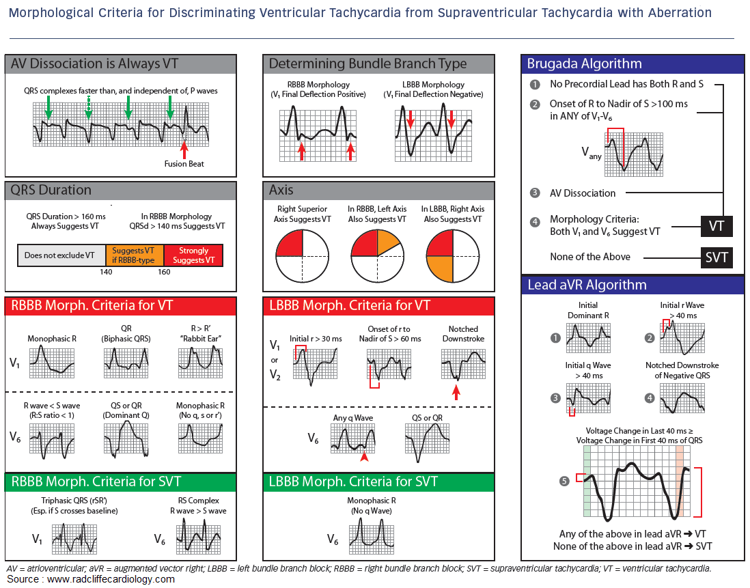
What are your management steps for a patient in VT that is stable? What about unstable?

Case 2:
You are called by the ED to admit a 75-year-old female patient with PMH notable for COPD on 2L supplemental O2, HFrEF (20-25%, NICM), group II PH, CKD, Afib on AC, DMII, hypothyroidism who presents with 4 pillow orthopnea, worsening dyspnea, leg swelling, weight gain and palpitations ongoing for the last week.
BP 105/75, HR 142, SpO2 92% on 4L, Afebrile, RR 18
Labs notable for Cr 1.8 (bl 1.2), HsT 32>>34, lactate 1.9, mild anemia, bilirubin mildly elevated, alk phos mildly elevated, BNP 2400 (1100 at last hosp discharge).
CXR with bilateral infiltrates at the bases, bilateral pleural effusions
ECG:
What does this ECG show?

You go to evaluate the patient and she reports similar chief complaints noted from the ED signout. In addition, she reports chest tightness and palpitations that have been ongoing since she began to feel more dyspneic.
What other information do you want to know from history and exam?

What is at the top of your differential in this case?

How do you triage this patient and why?

Can anyone summarize how the combination of HFrEF, volume overload and RVR all contribute to worsening cardiac output?

In addition to diuresis, should we attempt to control the patient’s heart rate?

What are ways in which we could attempt to control this patient’s heart rate?

What are some considerations when using amiodarone for rate/rhythm control of RVR? What are some of the adverse effects of amiodarone when used long-term?

How would digoxin be used in this situation? What are some of the adverse effects of digoxin?

Given the patient’s uninterrupted anticoagulation you initiate an amiodarone load and give some IV magnesium. You hold the patient’s home BB and initiate IV diuresis. The patient is tenuous over the first 6 hours and you keep a close eye on them. HR slowly starts to come down and patient begins making a lot of urine. By the next AM they seem to be out of the woods, and you downgrade to floor level of care. You transition to PO amiodarone with a total amiodarone load goal of 6-10 g. You refer to EP since this patient’s HF appears exacerbated by Afib for further consideration of rate vs rhythm control.

Case 3
Rapid Fire:
What are the types of bradycardias?

What ECG characteristics define Mobitz 1 AV block? What is the pathophysiology of Mobitz 1 AV block?
When there is 2:1 AV block, how do you tell if it is 2nd degree type 1 or 2?

What is sinus arrhythmia?

What types of AV block require evaluation for PPM? Why do these rhythms require PPM?

When is a PPM necessary for sinus node dysfunction?

The End

