Academic Half Day – Neurologic Emergencies
FACILITATOR GUIDE

CASE 1

You are the NMT B senior resident overnight and receive a call from a nurse who tells you she has a patient who is a 71 yo M admitted earlier today for an elective afib ablation scheduled for tomorrow morning. She remembers bringing him a dinner menu a couple hours ago. She just came in to give him his evening medications at 8 pm and he is not responding.
You ask the nurse to obtain a full set of vital signs and immediately go to evaluate the patient. You note the following when you see him:
VS: T 98.2, HR 111, BP 190/115, SpO2 96% on room air
He is lethargic but arousable. He is not speaking but seems to be able to understand you. He has a L gaze preference and R facial droop. Motor testing reveals 0/5 strength in R arm and 3/5 in R leg. Decreased sensation on R side. No neglect or extinction.
- After vitals, what is the first piece of objective data you should obtain in any patient with a change in neurologic status?
  - POC Glucose! – hypo and hyperglycemia can mimic or cause numerous neurologic sx and is an easily reversible etiology. Yes, glucose can even cause focal deficits such as in this case.

- What are you worried about based on the above scenario and what are your initial steps in management?
- Given the patient’s history of atrial fibrillation off of A/C and focal neurologic deficits above, this is highly concerning for a L MCA stroke.
- Things highly concerning for a stroke: hyperacute development of focal neurologic deficits (unilateral weakness/sensory changes, aphasia/dysarthria, facial droop, gaze preference with inability to cross midline, sudden vertigo/ataxia, visual field cuts

- What is the first history related information that you should obtain?
  - Last known normal (if patient woke up with deficits, LNK is when they went to sleep)
  - LKN is incredibly important in stroke reversal, helps guide if tx is safe
    - tPA – only effective/safe in first 4.5 hrs
    - Thrombectomy – Up to 24 hrs
    - Reversal of hemorrhagic stroke – Only first 2 hours

- Next, activate a code stroke! How do you call a code stroke at UCMC and the VA? Who is notified?
- VAMC protocol
  - Ask a nurse/NOD or use Vocera to call “Code Stroke”
  - An automatic page will go out to the VA neurology junior and senior (in house M-F 7a-6p, expected to be there in <15 minutes on nights/weekends)
  - Page will also go out to CT techs to make scanner immediately available
  - Neurology resident will communicate with UC stroke team if warranted

- UCMC protocol
  - Call the 3333 and tell the operator this is an inpatient CODE STROKE
  - This will simultaneously notify: neurology consult senior, stroke team (via telephone), medicine AOD, nursing supervisor, NSICU charge nurse, pharmacist, CT tech (with expectation to make the scanner immediately available)
  - NOTE: this does NOT automatically activate a rapid response. If the patient is unstable and you feel you need additional support (e.g., respiratory therapy) you should also call a rapid response separately.
- While waiting for the neurology team to arrive, what head imaging do you order and what are key pieces of information you should obtain from the patient’s chart?
- At UCMC you must place three separate orders for head imaging
  - CT head without contrast – ordered as “CODE STROKE” with indication as stroke
  - CT Angio Head – ordered as STAT with indication concern for stroke
  - CT Angio Neck – ordered as STAT with indication concern for stroke
- Other info to obtain/have immediately available:
  - Pertinent history: relevant medical comorbidities, last known normal (if patient woke up with deficits, LNK is when they went to sleep), anticoagulation status, recent surgery, hx CNS bleed
  - Objective data: vital signs (especially blood pressure), FINGERSTICK GLUCOSE, creatinine (may be relative contraindication to CTA), INR, platelets
  - NIHSS with pertinent signs/sx that elevated the score (available on MDCalc!)

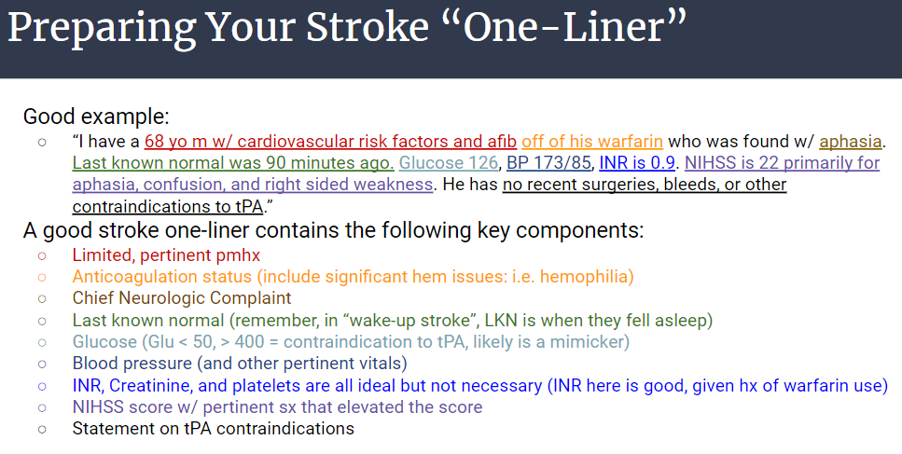

- What are your blood pressure goals in acute stroke and agents you should use?
- Blood pressure goal depends on type of stroke and if the patient is a tPA candidate or not
- Resist the initial temptation to treat BP at first (unless profoundly high – i.e. >220).
  - Remember, in stroke, this is the body’s way of compensating for ischemia!
  - Only treat BP once the decision is made to use tPA or if hemorrhage is found
- “Rule of 40’s”
  - SBP goal for hemorrhagic stroke is <140
  - SBP goal for ischemic stroke that is being treated w/ tPA is <180 (140 + 40)
  - SBP goal for ischemic stroke w/o treatment is <220 (180 + 40)
- In this case, tPA is warranted and so you must reduce to <180
  - Can use IV labetalol, nicardipine. Ideally avoid IV hydralazine as unpredictable patient response could lead to acute lowering of BP and result in watershed stroke

- What are some contraindications to tPA you should be aware of and ready to report to the neurology team when they arrive?
- Prior ICH, known intracranial neoplasm, ischemic stroke within 3 months, active bleeding/bleeding diathesis, significant closed head trauma within 3 months, presentation consistent with endocarditis, INR >1.7, platelets <100,000, Glu < 50 or > 400

CASE 2
You’re enjoying a delightful string cheese from the silver fridge when a rapid response page goes off. You enter the room and note a patient who is tachycardic, tachypneic, and non-responsive. Their head and eyes are forced to the right.

- What are you most concerned about? --> Seizure!
- Recognizing a seizure:
  - Sometimes it’s obvious: Generalized tonic clonic activity, Rhythmic jerking, grunting, foaming at mouth
  - Sometimes it’s more subtle: single extremity/face rhythmic twitching (not myoclonus), Eye/head version (eyes should be open), Behavioral arrest
  - Try to note “semiology”: the actions the patient does (which way head/eyes go, what limbs move, language behavior, etc.). This helps neurologists to determine the type and location of seizures.

- What are your first steps?
- Obtain vitals & glucose (again, very common cause of seizure)
- ABC’s, monitor airway (have a low threshold to place a NRB mask)
- Safely position
  - Get patient on ground or bed
  - Pad the area around them, especially underneath their head
  - Do NOT hold pt down, release restraints if present
  - Clear the mouth/airway, suction if needed
- Note time of seizure onset (seizures are traumatic, you will feel like the pt has been seizing far longer than they actually are. Keep an eye on the clock to ensure you know how long it has lasted)
  - Resist the urge to overtreat early. Large majority of seizures resolve within 90 seconds and early administration can often do more harm that good (i.e. hypoxia, hypotension)

- What is the definition of convulsive status epilepticus?
- Single seizure lasting > 5 minutes OR 2 or more seizures in close succession w/o return to baseline
  - Previous definition was seizure >30 minutes but irreversible brain damage can start as early as 5 min.
- Non-convulsive SE still is very dangerous but does not require the same degree of urgency and has different timing

- What is your treatment algorithm?
- 0-5 minutes – WAIT! Monitor/stabilize patient
- 5 minutes? Benzo time!
  - Ativan 1-2 mg
    - 2mg = standard dose
    - 1mg = for frail/elderly or medically unstable (i.e. hypoxic)
    - At times neurology will use 4mg if known etoh abuse or benzo dependent (will have tolerance to GABA modulation)
  - If no IV access?
    - IM Versed (5 mg), IN midazolam (Nayzilam), rectal diazepam (valium)
- 3-5 min later and still seizing??
  - Give additional benzo dose. Can give up to 8mg total during single seizure.
- If pt require more than a single benzo push, you should load an antiepileptic drug (AED). The following four agents are considered first line in status epilepticus.
  - Keppra 60 mg/kg (best tolerated)
  - Valproic Acid 40 mg/kg (more efficacious for generalized, hepatotoxic)
  - Phenytoin 20 mg/kg (very effective, risk of hypotension)
  - Vimpat 400mg (well tolerated but can cause heart block)
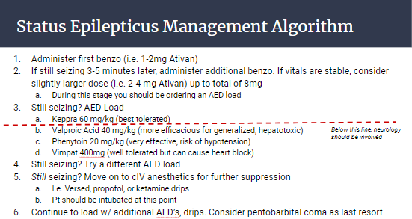
Neurology will often choose alternative agents but because of safety profile and overall effectiveness, please only use Keppra unless at instruction of neurology

BREAK

CASE 3
You receive a transfer from OSH for a pt who is in a “COPD” exacerbation. When you evaluate him at bedside you notice that he is tachypneic w/ shallow breathing. At first you assume that he is asleep but later note that he struggles to open his eyes or lift his head off of the bed. His voice is quiet and his speech is slurred

1. What are red flags for a neuromuscular cause of respiratory distress?
- Associated bulbar symptoms (ptosis, dysarthria, dysphagia)
- Associated weakness (primarily in neck flexors/extensors)
- Orthopnea – Remember, gravity supports the diaphragm when seated/standing. When a patient supine, they are fighting gravity and diaphragmatic weakness can be significantly exacerbated

2. The patient is satting at 93% on room air. Are you reassured?
- No! Oxygenation is the last thing to fail in neuromuscular crisis. If someone is already hypoxic in neuromuscular crisis then either you should look for alternative dx (i.e. PNA) or it’s too late (if a patient starts desatting, they’ll likely crash soon)
- What are better ways to test pending neuromuscular respiratory failure?
  - Breath count test – Take in a deep breath and count as high as you can in a single breath (consider having a learner try this – they should easily >50)
    - >50 = normal
    - 30-50 = concerning for early failure
    - 20-30 = monitor closely (i.e. stepdown status)
    - 10-20 =elective intubation
    - <10 = too late…
  - Neck flexion/extension (of all muscle strength testing, this correlates most closely w/ resp failure d/t similar upper cervical innervation)
  - VBG – patients w/ NM failure develop hypercarbia long before hypoxia
  - “Neuromuscular parameter” PFTs
    - Negative Inspiratory Force (NIF) & Force Vital Capacity (FVC) should be obtained and trended during admission to eval for pending collapse
    - NIF < -25 concerning for pending failure
    - FVC < 15 cc/kg concerning for pending failure

3. What is your differential for neuromuscular diseases that can cause subacute-acute respiratory collapse
- Myasthenia gravis, LEMS, Guillain Barre Syndrome (AIDP), Botulism, medication side effect (i.e. poor clearance of neuromuscular blockade agent)
- Remember, diseases such as ALS, muscular dystrophies, myopathies, myositis all progress more slowly. If a patient has a known history of one of these diseases and has rapid progression, look for an alternative cause (i.e. PNA, COPD, etc)
- Don’t forget brainstem pathology can affect respiratory centers and cause similar presentation

4. You perform a motor exam on the patient. You note that his neck flexors are 2/5, his proximal arms are 3/5 and symmetric w/ 4-/5 strength in his hands. His LE are 4/5 throughout. Can you describe what this patient looks like without using numbers?
- Use MRC scale to report strength findings:
  - 0 = no muscle contraction
  - 1 = trace of muscle contraction but not over a joint
  - 2 = movement over joint but not against gravity
  - 3 = movement against gravity but zero resistance
  - 4 = movement against some resistance
    - “4” is the only number where there is subjectivity to the exam. Are they almost a 5/5? Then call it 4+. Are they barely stronger than antigravity? They call it a 4-. No other number should have a + or – with it.
  - 5 = full strength
- Remember, these are not fractions/percentages. A person with 2/5 strength is remarkably weak, not just “40% full strength”.
- Use the motor exam to assess for pattern of weakness (helps w/ differential)
  - Focal versus diffuse
  - Symmetric versus asymmetric
  - Proximal (neck flexion/extension, deltoids, hip flexors) versus distal (grip strength, wrist flexion/extension, plantar flexion
  - If time allows, have one learner practice motor exam on another, check the following muscles:
    - Arms: deltoids, biceps, triceps, wrist extensors, interossei, grip
    - Legs: iliopsoas, quadriceps, hamstrings, dorsiflexors, plantar flexors

- You also perform a sensory exam and notice no sensory loss or neuropathic pain. How does this change your differential?
- Ddx for the peripheral nervous system can be cut in half with this simple question!
- There are 6 “localizations” for the peripheral nervous system. 3 of them have sensory symptoms and 3 do not
  - Motor horn (i.e. ALS) – NO sensory sx
  - Nerve root (i.e. disc compression) – HAS sensory sx
  - Brachial plexus (i.e. Erb’s palsy) – HAS sensory sx
  - Peripheral nerve (i.e. carpal tunnel) – HAS sensory sx
  - Neuromuscular junction (i.e. MG) – NO sensory sx
  - Muscule (i.e. myositis) – NO sensory sx
- These pt has no sensory sx so you automatically can rule out a disease such as Guillain Barre (which affects nerve roots, plexus, and peripheral nerves)
- Conversely, if they had significant sensory loss you could exclude diseases like MG or botulism

- You suspect myasthenia gravis, how to you formally make this diagnosis?
  - Send Acetylcholine receptor antibodies (order set w/ 3 Abs) as well as MuSK antibody (new AB implicated in MG)
  - EMG can help confirm seronegative cases (should see decremental response on EMG)
  - Consider CT chest to look for thymoma

- You this patient with myasthenic crisis, what is the treatment of choice?
- IVIG or PLEX, data is relatively equally efficacious
  - Pros to starting w/ IVIG – easily administered through PIV (PLEX needs trialysis line), shorter treatment length (3-5 days as compared to 10 days for PLEX), better tolerated than PLEX if hemodynamically unstable
  - Pros to starting w/ PLEX – No concerns of IVIG side effects (i.e. hypercoagulability, aseptic meningitis), if you start w/ IVIG and follow w/ PLEX then you will remove the immunoglobulins effectively “wasting” your IVIG
- Do NOT start with corticosteroids
  - Even though MG is an autoimmune disease, IV steroids are associated w/ worse outcomes and may accelerate neuromuscular collapse
  - Eventually, these patients may need long term steroids for chronic management. If they come into the hospital on steroids (i.e. prednisone 20) you should continue at home dose but do not “stress dose” them
- Long term management of MG
  - Pyridostigmine/Mestinon (acetylcholinesterase inhibitor – allows for acetylcholine to remain in synapse longer)
  - Immunosuppression
    - Chronic steroids (remember, do not start during a flare)
    - Azathioprine, mycophenolate,
- Low threshold to use NiPPV in MG and all neuromuscular disease, remember, these are diseases of ventilatory failure

- If this person had instead had ascending sensory symptoms, loss of reflexes and you diagnosed them with Guillain Barre, how would you treat them?
- IVIG and PLEX also are mainstays of therapy here. Again, steroids can cause decompensation

- What is the number one cause of death in patients with Guillain Barre?
- Cardiac arrhythmia! Severe GBS can cause demyelination of the autonomic system and result in arrhythmia and rapid BP swings. Avoid long-acting cardiovascular meds at all time (i.e. use short acting gtt’s like esmolol rather than meds like labetalol/metoprolol)
- Because of increased recognition of disease, respiratory failure is now a more rare cause of death

CASE 4
You’re on long block when a patient comes in complaining of their neuropathy “acting up”. They said that normally their neuropathy goes to their mid shin but over the recent days it has quickly risen to their left side where they are numb up to their belly button. Sensory loss has progressed up the right side as well to their knee. Additionally, they’re noting weakness in their legs L>R

1. What red flags suggest that this is not their neuropathy acting up
- Rapid onset – Classic neuropathy progressives over years
- Prominent motor symptoms – In classic neuropathy, sensory >>> motor. If prominent motor consider other diseases
- A peripheral nervous system should almost never involve the trunk.
  - If they are having truncal sensory loss (i.e. a “sensory level”) that is very concerning for spinal cord pathology
  - Hemisensory loss (i.e. left arm, leg +/- face) very concerning for brain or upper spinal cord (i.e. be very wary of asymmetric sx)

2. What additional question should be asked?
- Any bowel/bladder incontinence? If so, there should be significant concern for spinal cord involvement

3. You perform a strength exam and note distal > proximal weakness. You move on to the reflex exam. How do you grade a reflex exam again?
- 0 = no reflexes
- 1 = hyporeflexia
- 2 = normal
- 3 = hyperreflexia (crosses 2 joints)
- 4 = >3 beats of clonus

4. How does your reflex exam help you determine CNS vs PNS pathology?
- CNS pathology will have upper motor neuron (UMN) signs
  - Increased reflexes, clonus, upgoing Babinski, positive Hoffman’s
  - Spasticity, increased tone
- PNS pathology will have lower motor neuron (LMN) signs
  - Decreased reflexes, negative Babinski or Hoffman’s
  - Flaccidity, decreased tone
  - Atrophy & fasciculations (w/ chronic)
- Note: changes in tone may be delayed for a few days. Often acute stroke or spinal cord pathology at first presents w/ flaccidity

5. What’s the best next step in management?
- STAT MRI of T/L spine (likely don’t need C spine here w/o arm involvement)

6. What’s the difference between myelopathy and myelitis?
- “Myelopathy” = pathology of spinal cord, encases multiple causes
  - Compressive (epidural hematoma, metastatic disease, herniated disc)
  - Vascular (anterior spinal artery infarct, spinal AVM)
  - Nutritional (B12, copper def)
  - Or Myelitis
- “Myelitis” = inflammation of spinal cord
  - Can be inflammatory (MS, NMO, Sarcoid)
  - Can be infectious (HIV, syphilis, HTLV, West Nile)
  - Or can be idiopathic. This is named “Transverse Myelitis”
    - Note: transverse myelitis is not its own disease. It is idiopathic myelitis that may be a harbinger of an underlying undiagnosed infectious/inflammatory disease

7. How to you treat the causes of emergent myelopathy?
- Structural cause? STAT consult to neurosurgery for decompression
- Inflammatory/infectious cause? STAT initiation of high dose methylprednisolone

BREAK AND END

