Valvular Heart Disease – Learner Guide
Agenda:
1:00 – 1:15pm Theory Burst
1:15 – 2:15pm Case 1 & 2
2:15 – 2:30pm Break/Expert Questions
2:30 – 3:15pm Case 3 & 4
3:15pm Expert Questions

Case 1:
A 67y/o M with PMHx of HTN and HLD who presents to clinic for a routine check-up, though he hasn’t seen a doctor in years. He states he has been feeling well, has no complaints, and came to clinic at the urging of his wife. He is hoping to leave the office with a clean bill of health. Vitals: BP 160/88, HR 74, T 98.4 deg, RR 14, SpO2 99 on RA. On physical exam, you think you hear a systolic murmur, best heard at the cardiac apex. Listening closely, you hear it consistently throughout systole, and you can even hear the murmur tracing toward his axilla.

- What is your thought process when evaluating a murmur? Let’s create a systematic approach to murmurs.

- What murmur are you most concerned about? How do you categorize this murmur and what follow up questions do you need to ask the patient?

- The patient denies any hx of ilicit drug use, rheumatic heart disease, or connective tissue disease. He says he has been told long ago that he has high blood pressure but has never taken medications for it because he hates taking pills. He denies chest pain, shortness of breath, or palpitations. He remains fairly active for his age. He asks you if you think he’ll need surgery for this. What are your recommendations for next steps?

CASE 2

You’re seeing a new patient, a 20 year-old male with no past medical history other than a childhood sore throat that he says caused a heart murmur, though he doesn’t know much more. He was born in Mexico City and immigrated to the US when he was 6. He was in his usual state of health until about 4 weeks ago when he developed mild shortness of breath and lightheadedness with exertion. He now has persistent shortness of breath and is worried he might have COVID.

On exam, he is afebrile, blood pressure is 122/82, HR 108, RR 18, SpO2 98% on RA. His exam is notable for a low-pitched diastolic murmur with an opening snap. See QR code for EKG.

Read the EKG. What is his rhythm? You suspect he has underlying valvular heart disease from his childhood illness. What is most likely? What would you do next, and what would you discuss with your patient about upcoming treatment possibilities?

MKSAP Question:
A 65 year old woman is evaluated during a routine examination. She was diagnosed with a cardiac murmur in early adulthood. She is active, healthy, and without symptoms. She takes no medications. On physical examination, vitals are normal. A grade 3/6 holosystolic murmur preceded by multiple clicks is present at the apex. Physical findings are otherwise unremarkable.

An echocardiogram demonstrates a left ventricular ejection fraction of 50%. The left ventricle is moderately dilated with an end-systolic dimension of 42 mm. Myxomatous degeneration of the mitral valve is present with severe regurgitation due to posterior leaflet prolapse.

Which of the following is the most appropriate next step in management?
A. Serial clinical echocardiographic evaluations
B. Surgical mitral valve repair
C. Surgical mitral valve replacement
D. Transcatheter mitral valve repair
Bonus Question: Describe the murmur you would expect to hear with the most common cause of primary mitral regurgitation? Why is this different?

Case 3:
Your next patient is an 88y/o M with PMHx HTN, HLD, OA, and prostate cancer presents to your office for symptoms of shortness of breath. He notes this has been occurring for some time now, but over the past few weeks he has felt really winded when walking around his neighborhood. He’s wondering what you can do to help him breathe more easily. On physical exam, his vitals are within normal limits. He does not appear breathless while sitting on the exam table, but you do notice some swelling of his legs. You go to listen to his heart and you hear another systolic murmur (you’re on a roll) and you hear it best at the R upper sternal border.

1. Now what murmur are you worried about and why? Describe the murmur and pathophysiology in more detail.

2. What are the characteristic symptoms and other physical exam findings associated with this
murmur? Describe the pathophysiology underlying these symptoms.

You tell the patient that you are concerned he has aortic stenosis and that his symptoms could be the result of heart failure related to valve disease. You recommend that he get an echocardiogram to assess how well his heart is pumping and the severity of his valvular disease. He obliges, and a few days later you get an echo report in your Epic inbox with the following information:
LVEF: 40%
AV area: 1.0cm²
Peak velocity: 4.5m/s
Pressure gradient: 45mmHg

3. What are the stages of aortic stenosis? What stage does your patient fall into? Why is this
important?

- You call the patient to follow up on his results. What are your recommendations?

- What if your patient had no symptoms and normal EF? How would your recommendations change? What if the patient has a depressed EF but is asymptomatic?

Bonus: Case 4:
Your last patient of the day is 80 year old woman who is coming in for a 6 month history of worsening DOE. Two nights ago, she awoke with sudden-onset dyspnea that was relieved with ambulation. She has not had chest pain. Medical history is significant for an MI 8 years ago. She has a history of LV dysfunction but has been previously well compensated. Her medications are lisinopril, aspirin, metoprolol, and rosuvastatin.

Exam: AF, BP 95/60, HR 56, RR 18. The lungs are clear. The carotid upstroke is low in volume. The apical impulse is laterally displaced and enlarged. S1 is soft; the aortic component of S2 is diminished. There is no S3 or S4. A grade 2/6 mid-peaking systolic murmur is heard throughout the precordium. The remainder of examination is normal.

She just so happened to have gotten a TTE that morning. It shows an LVEF of 32%. AV is slightly calcified. The stroke volume is markedly decreased (23 mL/m2). The mean aortic gradient is 20 mmHg (c/w mild to moderate stenosis), and the aortic valve area is calculated to be 0.7 cm2.

Is this consistent with severe aortic stenosis? What could you do next to find out?

Bonus:
If there is time…review dynamic auscultation methods!
- Valsalva maneuver

- Squatting

- Standing

- Leg raise

- Hand grip

Appendix:

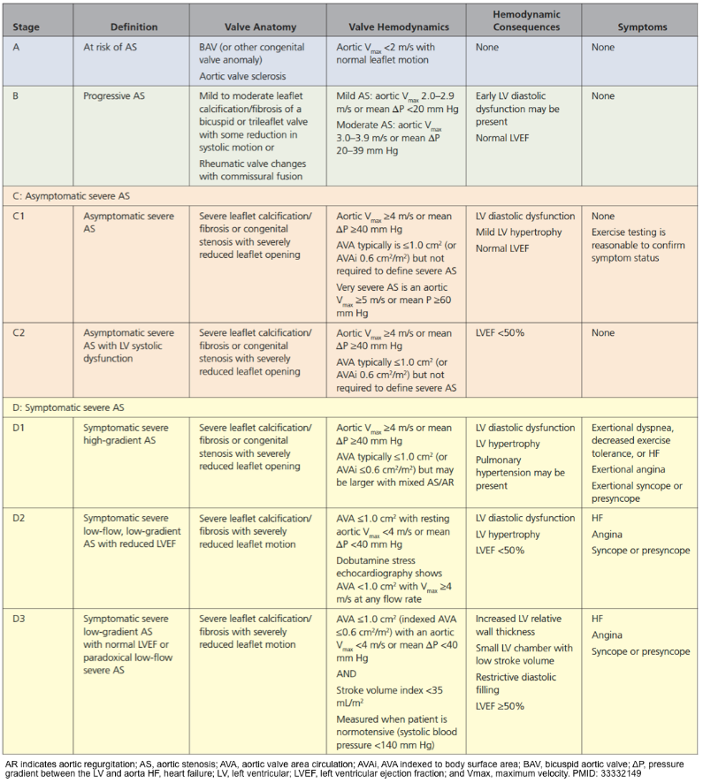

Summary of Valvular Conditions
Lesion | Causes | Symptoms | Physical Findings | Important Additional Info
Mitral Stenosis | Rheumatic fever sequelae, senile calcific disease | Dyspnea on exertion, decreased exercise tolerance | Opening snap, loud S1, diastolic rumble | Severe: MV area < 1.5 cm2  Anticoagulation recommended for patients with MS and AF, MS and prior embolic event, MS and LA thrombus
Mitral Regurgitation | Acute: endocarditis, papillary muscle dysfunction | Acute: pulmonary edema, cardiogenic shock | Holosystolic murmur at apex, radiates to axilla | Distinguishing primary from secondary important as intervention is curative for primary.
 | Chronic Primary: Mitral Valve Prolapse, Rheumatic  Chronic Secondary: LV dysfunction | Chronic: fatigue, DOE
Aortic Stenosis | Degenerative calcification, congenital, rheumatic | Angina, syncope, DOE | SEM loudest at RUSB, crescendo/decrescendo, soft S2, radiates to carotids | Severe AS: Aortic Vmax ≥ 4.0 m/sec or mean ΔP ≥ 40 mmHg, typically AV area ≤ 1.0 cm2
Aortic Regurgitation | Bicuspid AV, calcific disease, aortic root dilation, endocarditis | DOE, angina | Early diastolic decrescendo murmur, wide pulse pressure, bounding pulses | AVR indicated for asymptomatic severe AR if LVEF < 50% or if LVEF ≥ 50% but LVESD > 50 mm
Class I Surgery Indications:
Aortic Stenosis- symptomatic severe AS (stage D), asymptomatic severe AS with LVEF < 50% (stage C), pts undergoing other cardiac surgeries (stage C or D)
Aortic Regurgitation- symptomatic severe AR (stage D), asymptomatic severe AR with LVEF < 55% (stage C), patients undergoing other cardiac surgeries (stage C or D)
Mitral Stenosis- percutaneous balloon commissurotomy for symptomatic severe MS (stage D), MV surgery for symptomatic severe MS (stage D) who failed commissurotomy or who can’t undergo commissurotomy, patients undergoing other cardiac surgeries (stage C or D)
Mitral Regurgitation- symptomatic severe chronic primary MR with EF > 30%, asymptomatic severe chronic primary MR with EF 30-60% or LVESD > 40 mm

