Acute Respiratory Failure – Facilitator Guide, February 28, 2019
1:00 – 1:15: Theory Burst
1:15 – 2:00: Case 1 & 2
2:00 – 2:20: Expert Questions, break
2:20 – 3:15: Case 3 & 4
3:15 – 3:30: Expert Questions

Learning Objectives:
- Define hypoxemic and hypercapneic respiratory failure.
- List the different methods of oxygen delivery and the maximum capability of each
- Manage respiratory failure with non-invasive positive pressure ventilation in the appropriate setting.
- Describe the diagnostic criteria and basic treatment tenets for a patient with ARDS

Case 1
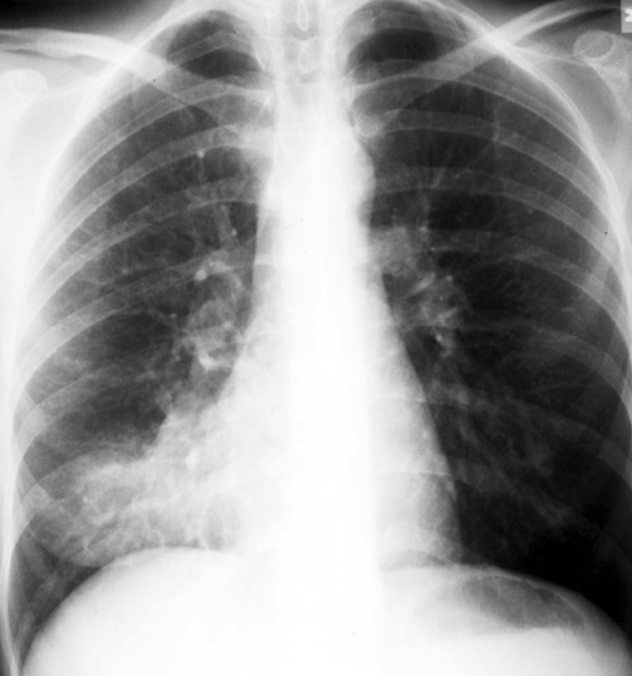
Mr. Alps is a 61yo male with a history of HTN, DM2, CAD with DES to LCx 5 years ago who presents to the ED with a 3-day history of gradually progressive dyspnea now occurring at rest. He’s been having a productive cough with yellow-brown sputum as well as subjective fevers at home. He is adherent to prescribed lisinopril, rosuvastatin, baby aspirin, and metformin. He has a remote smoking history and quit 15+ years ago. He lives at home and was last hospitalized 8 months ago for a chest pain rule-out.
ED Exam: T- 100.9 95/52 P-118 R-28 81% on RA
Gen- Obese, uncomfortable, diaphoretic, AAOx3
HEENT- PERRL, dry mucous membranes, no oral cavity lesions
CV - Heart sounds distant. Tachycardic, regular, no murmurs, unable to assess for JVD due to habitus.
Resp - Labored, speaking in partial sentences, +accessory muscle use. Inspiratory crackles in the left base, no wheezing.
Abd - paradoxical motion, soft/nontender/nondistended, +BS
Ext – warm, 2+ radial and DP pulses. Trace LE edema

Labs:
WBC- 17.4 (82% N, 2% B, 16% lymph); Hgb- 16.4; Plt- 225
Na- 140, K- 3.9, Cl- 103, HCO₃- 12, BUN- 25, Cr- 1.7, glucose 205
UA- neg
ABG- 7.28/26/45 on RA; lactate- 3.3; troponin- <0.07
CXR: as shown
He is placed on 6L O2 by NC with SpO2 increase to 89%. He’s switched to a venturi-mask, SpO2 increases to 96%

- What is the admitting diagnosis for this patient?

- What are your admission orders include for Mr. Alps? To what level of care would you assign? What if he had an anaphylactic allergy to penicillin?

- What are methods for delivering supplemental oxygen? What is the maximum FiO₂ of each one?
- Ambient air is 21% oxygen

- Calculate the A-a gradient. How does this help you? Discuss the pathophysiology of his respiratory failure.
Alveolar-arterial Gradient = PAO2-PaO2 (PAO2 must be calculated. PaO2 is measured on the gas)
PAO2 = FiO2 x (Barometric Pressure - Partial Pressure H2O Vapor) – PaCO2/Respiratory Quotient
PAO2 = FiO2 x (713) – (PaCO2/0.8)
Normal A-a Gradient approx. 10-15 Elderly Normal = Age/4 + 4

Mr. Alps is admitted to MSDU. His work of breathing improves with antibiotics and supplemental O2. He is still 96% on venturi-mask. His BP stabilizes with IVF resuscitation and lactate normalizes. A repeat ABG 6 hours after admission 7.35/35/79

- What is your therapeutic target for oxygenation for this patient? Do you need to change anything now?

Case 2:
You are on night float admitting a patient in B-Pod when your pager buzzes with a Code Blue. You run up and find a 20 year-old female on the bathroom of a room on 7NW. She was visiting her boyfriend in the hospital and he heard her fall so he called his nurse who called a code. Her boyfriend notes she’s a Xanax and heroin addict who is on OCPs. She also just flew in from Australia today and has her leg casted due to a recent tibial fracture.

She is either not breathing or breathing so slowly you can’t tell and the nurse is getting out a non-rebreather.

- Describe your first steps in management:

A very quick and efficient respiratory therapist gets an ABG before the patient is put on a NRB: 7.20 / 78 / 43 on RA

- Quickly calculate her A-a gradient. How does this help you?
A-a Gradient = PAO2-PaO2 (PAO2 must be calculated. PaO2 is measured on the gas)
PAO2 = 0.21 x (713) – (PaCO2/0.8)

Oh, and the Narcan worked.

Expert Questions
BREAK!
Case 3
Mrs. Puffer is a 62 yo female with a history of COPD who presents to the ED with a 2-day history of gradually progressive dyspnea on exertion and increased frequency of her chronic cough which is productive for clear sputum. She denies fevers. She is adherent to prescribed albuterol MDI, salmeterol BID, and tiotropium QD. Her albuterol helps her symptoms some. She has a 30-pack year smoking history and currently smokes 0.5 PPD. Her apartment complex has been cleaning the AC vents recently.
ED Exam: T- 99.3 156/87 P-105 R-26 91% on 2L (new requirement)
Gen- Uncomfortable, AAOx3
HEENT- PERRL, moist mucous membranes, no oral cavity lesions
CV - Heart sounds distant. Tachycardic, regular, no murmurs, no JVD
Resp - Labored, diffuse expiratory wheezing, +accessory muscle use. Able to speak in full sentences
Abd - soft/nontender/nondistended, +BS
Ext - 2+ radial and DP pulses. No LE edema

Labs:
WBC- 7.3 (normal diff); Hgb- 14.3; Plt- 320
Na- 137, K- 4.1, Cl- 101, HCO₃- 30, BUN- 14, Cr- 1.0
ABG- 7.23/60/62 on 2L
CXR: no acute cardiopulmonary process

- What is the diagnosis and what is most appropriate intervention at this time?

- Write the initial orders for the intervention that you chose.

- How soon after initiating this therapy should you check an ABG? What parameters are you hoping to see?

- How long is “too long” in terms of trialing non-invasive ventilation before considering intubation?

You start Mrs. Puffer on bilevel NIPPV. Her nurse calls you about 25 minutes later because she is having a hard time arousing her. You ask for an ABG as you make your way to the room. Upon arriving at bedside, you find that Ms. Puffer requires a sternal rub to open here eyes. When awake she responds but often drifts off. She withdraws to pain in all extremities. The ABG returns with 7.18/70/63 on 2L NC.

- What do you do next? Are there contraindications to NIPPV, if so what are they?

- If Mrs. Puffer carries a diagnosis of COPD, what must her PFTs at one point shown?

Case 4
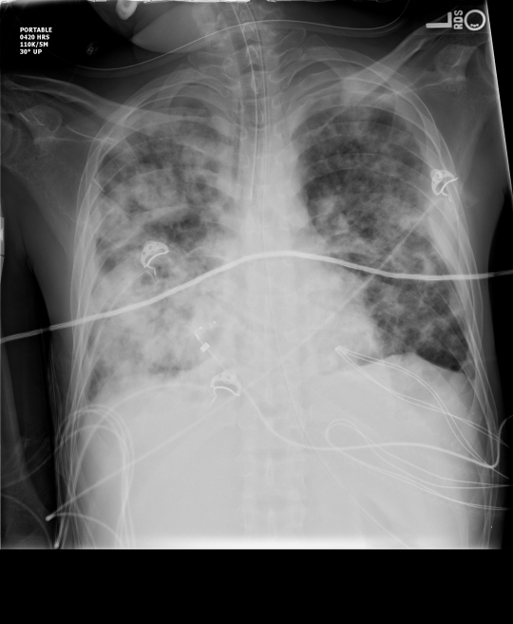
Mr. Hives is a 32 yo M with PMH of HIV was brought into the ED after he was found down at home by a neighbor. His neighbor reports that Mr. Hive’s has been complaining of worsening SOB for 3 weeks now with associated fevers and unintentional weight loss. The neighbor last saw Mr. H 3 days ago and noted that he was much worse and very dyspneic. In terms of his HIV history, Mr. Hives was diagnosed HIV+ in 2011 and is nonadherent to HAART. His last CD4 count 1 month prior was 95.
Vitals:
T 103F, HR 132, BP 80/40, RR 34, SaO2 75% on RA.
Exam: thin, AAOx0 (only making incomprehensible sounds), opens eyes to painful stimuli, withdraws all extremities to pain. He is in severe respiratory distress with diffuse crackles in his lungs bilaterally.
CXR: shown on right (bilateral fluffy infiltrates)
- What are you concerned is going on? How will you confirm your diagnosis?

Mr. Hives is intubated in the ED and started on volume-control continuous mechanical ventilation with a TV of 600 cc, RR 12, FiO2 of 1.0, and PEEP of 5 cm H2O. An ABG is done after intubation which returns 7.10/16/73
- Does he meet criteria for ARDS?

- What are other possible causes of ARDS?

- Do you need to change any orders for Mr. Hives? He is 5’10” (178cm) and 120kg

- What additional admission orders does Mr. Hives need?

- After 30 minutes on the above settings with FiO2 at 1.0, his ABG is 7.28/60/95. What adjustments should be made at this time?

You do the above interventions. Luckily Mr. Hives recovers and is extubated one week later. After extubation he expresses how grateful he is for your efforts. You experienced unending satisfaction from helping Mr. Hives and were so enamored with your time in the ICU that you decide to pursue a career in pulmonary-critical care.

- BONUS: The MICU RT grabs you and pulls you into Pod 1 because the patient in bed 3 ventilator alarms are going off and you are being asked to assess them. You look on the screen and all you can decipher is that the alarm is for high pressures. What do you do?

