Academic Half Day: Pulmonary Hypertension
Learner Guide
1/4/2024

1:00p to 1:20p = theory burst
1:20p to 2:20p = Case 1
2:20p to 2:30p = expert questions
2:30p to 2:40p = break
2:40p to 3:10p = Case 2 + 3
3:10p to 3:20p = expert questions

CASE 1.

44-year-old female w/ hx depression, presenting to her primary care clinic for dyspnea on exertion, slowly worsening over the past 6 months. She and her wife take a walk every evening around the neighborhood with a loop of about a mile that includes a large hill and she has noticed increasing difficulty doing so. She now has to take multiple breaks during the walk, especially at the hill; she made the appointment because she finally had a day where she could not finish the walk. She is easily tired throughout the day and sometimes feels her heart is beating really fast. She denies cough, congestion, chest pain, wheezing, recent sick contacts.

Vitals: T 98.7 F HR 76 BP 105/65 RR 14 SpO2 98% on room air Wt 140lbs (63.5kg)

Exam: Gen: Alert and oriented. Non-toxic appearing.
HEENT: Moist mucous membranes. No lymphadenopathy.
Neck: No JVD. Trachea midline.
CV: Regular rate and rhythm. No murmurs, rubs, gallops. Mild pitting edema in bilateral ankles.
Pulm: Clear to auscultation bilaterally. No wheezing or crackles.
Abd: Soft, non-tender, non-distended. Normoactive bowel sounds.
Neuro: Alert, oriented x3. No focal deficits.

Family Hx: mother has diabetes, father has HTN

Medications: none

- What is your initial differential?

Further information:
- Occasional chest pressure w/ walking the steps, but inconsistently
- No palpitations, weight gain/loss, syncope, heat/cold intolerance, daytime sleepiness
- Partner reports no snoring or apnea
- Regular periods w/o heavy bleeding
- Depression is well controlled – came off sertraline over a year ago, PHQ-9 today is 3
- No tobacco use, no drug use, no alcohol use
- Sexually active w/ wife, monogamous for 10+ years
- Works as a paralegal at a law firm downtown
- 2 cats at home
- No recent travel

- What is your initial workup?

- What definitive testing do you need to officially diagnose pulmonary hypertension?

- Now that you’ve diagnosed pulmonary hypertension, how will you go about determining the etiology and classifying her disease?

WSPH Group | Etiology | Diagnostic Testing
1
2
3
4
5

- Generally speaking, how does therapy change depending on the group?

After further testing, you diagnose the patient with idiopathic pulmonary arterial hypertension (aka we don’t know but everything else is negative right now).

- What other evaluations do you need prior to initiating therapy?

- What therapy would you like to initiate?

Meds | Class | Mechanism of Action | Adverse Effects/Notes
Sildenafil (PO)
Tadalafil (PO)
Ambrisentan (PO)
Bosentan (PO)
Macitentan (PO)
Epoprostenol (IV)
Iloprost (inh)
Treprostinil (SC, IV, inh)
Selexipag (PO)
Riociguat (PO)

- What other general recommendations would you give a patient with pulmonary hypertension regarding the following?
Diet:

Vaccinations:

Exercise:

Pregnancy:

Elective Procedures:

Travelling by Plane:

CASE 2.

It is 9:15pm! The ED has just called up the following admission:

56-year-old female w/ hx T2DM, OSA on CPAP, idiopathic PAH, presenting to the ED w/ worsening SOB and productive cough. Her cough started 5 days ago and she has yellow sputum production. At baseline, she is typically comfortable at rest, but over the past 2 days, she has developed dyspnea while sitting down. She reports subjective fever 3 days ago.

Vitals: T 100.1 HR 102 BP 99/66 RR 22 SpO2 89% on room air

- As you prepare to go see her, what further information do you want to know? What are you looking for on exam? Why?

You go see the patient and collect more history. She denies chest pain, syncope or presyncope, urinary sx, abdominal pain, N/V. She is adherent to all her PAH medications; she is on ambrisentan, tadalafil, and IV epoprostenol. The IV epoprostenol is run through a Hickman catheter via portable pump and she has not noticed any issues with either. She is using her CPAP every night.

Exam: Gen: Awake, alert. In mild distress.
HEENT: No cervical adenopathy, no JVD, no bruits
CV: Tachycardic, regular rate, normal S1, loud S2, no murmur. No parasternal heave. Trace bilateral edema of LE below ankles, warm distal extremities, palpable pulses
Pulm: Labored, inspiratory crackles in the left base. No expiratory wheezing
Abd: Soft, non-tender, non-distended, no ascites
Neuro: AAOx3, no gross motor or sensory deficits
Skin: Tunneled catheter (Hickman) present on right chest, no pain to palpation of catheter site, no surrounding erythema or discharge at insertion site.

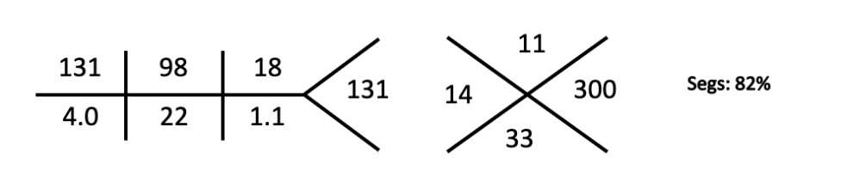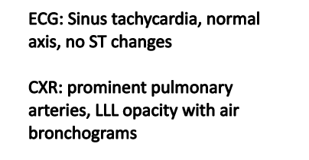

- What admission orders are you going to place?

CASE 3.

61-year-old female w/ hx HTN, hypothyroidism, PAH s/t scleroderma, presents to the ED w/ worsening SOB and weight gain. She was diagnosed w/ PAH a year ago and is on ambrisentan and tadalafil. She is normally able to take the laundry into the bedroom w/ only mild SOB, but now has SOB walking to the bathroom. She didn’t wear socks today because they didn’t fit; she has noticed a 15lb weight gain over the past week. This morning, she had an episode of lightheadedness and had to lie down. She denies CP, cough, fever, N/V/D, abdominal pain, sick contacts.

Vitals: T 98.5 HR 112 BP 87/52 RR 20 SpO2 90% on room air

Exam: Gen: Awake, alert but fatigued. In distress.
HEENT: No cervical adenopathy, + JVD to mandible
CV: Tachycardic, regular rate, normal S1, loud P2, holosystolic murmur loudest at lower left sternal border that becomes louder with inspiration. + Right parasternal heave. 2+ bilateral pitting edema of BLE above the knees, cool distal extremities.
Pulm: CTAB. No expiratory wheezing.
Abd: Soft, NT, +distended. Liver edge palpable 3 cm below costal margin.
Neuro: AAOx3, no gross motor or sensory deficits.
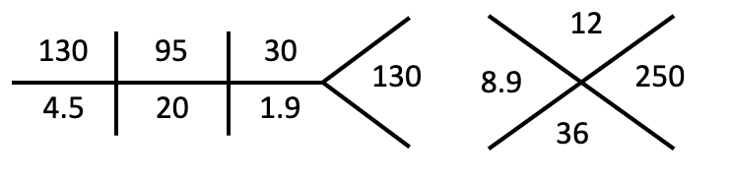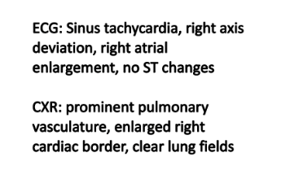
ABG 7.3/36/59 Lactate 2.8 TSH wnl
D-dimer <0.5 BNP 1200

- What is your leading differential? What is your next step in evaluation?

- Where should this patient be admitted?

- How does pulmonary hypertension contribute to right heart failure?

- What are the main components of therapy in acute/chronic right heart failure?

APPENDIX:

Figure 1: Dx features of patients w/ PH
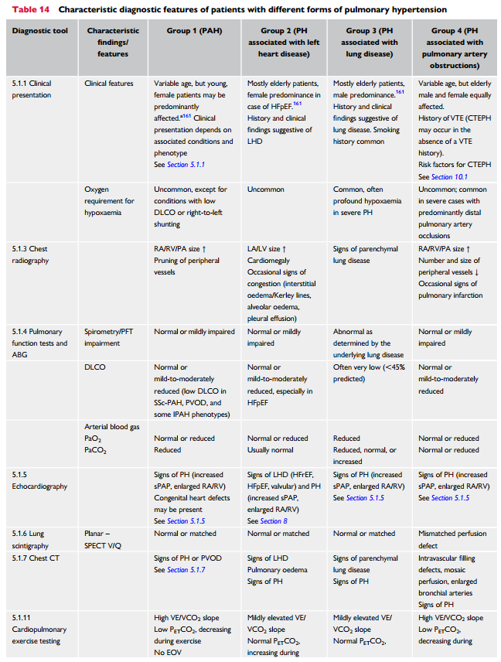

Figure 2: Tx Initiation Guidelines for PAH
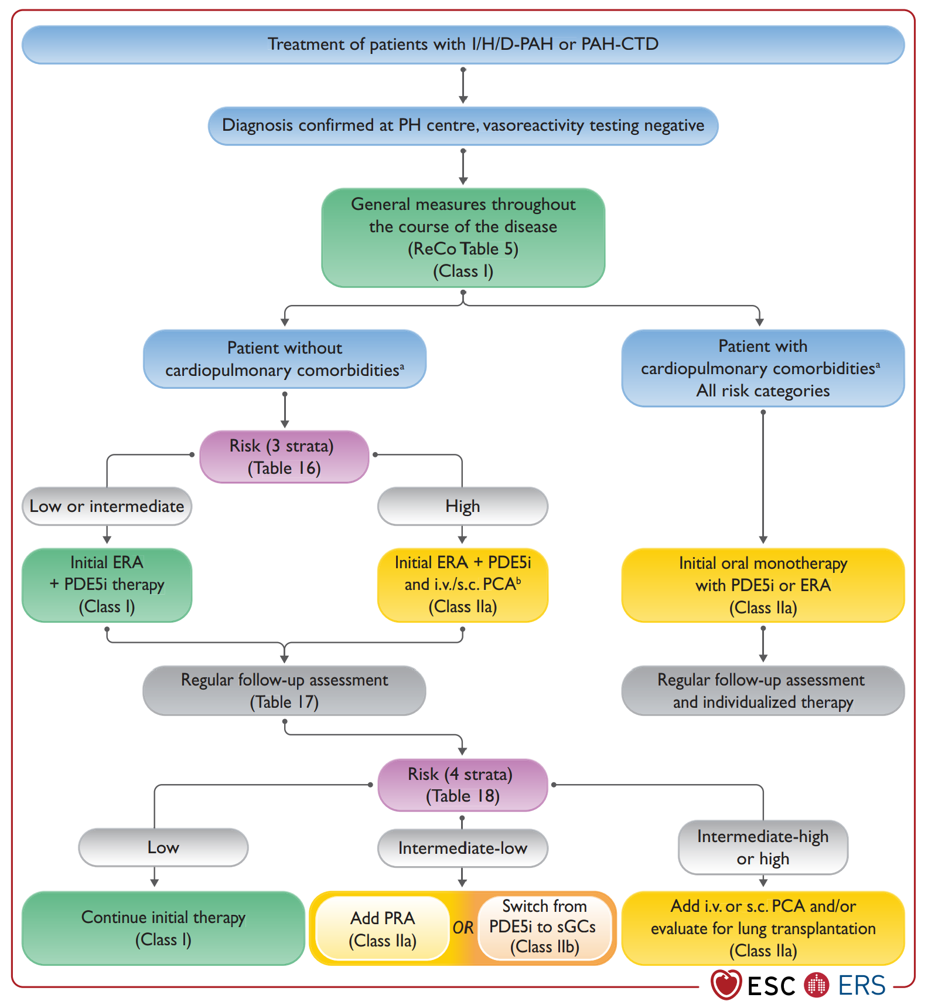

Figure 3. TTE signs of RV failure
