Academic Half Day: Pulmonary Hypertension
Facilitator Guide
1/4/2024

1:00p to 1:20p = theory burst
1:20p to 2:20p = Case 1
2:20p to 2:30p = expert questions
2:30p to 2:40p = break
2:40p to 3:10p = Case 2 + 3
3:10p to 3:20p = expert questions

CASE 1.

44-year-old female w/ hx depression, presenting to her primary care clinic for dyspnea on exertion, slowly worsening over the past 6 months. She and her wife take a walk every evening around the neighborhood with a loop of about a mile that includes a large hill and she has noticed increasing difficulty doing so. She now has to take multiple breaks during the walk, especially at the hill; she made the appointment because she finally had a day where she could not finish the walk. She is easily tired throughout the day and sometimes feels her heart is beating really fast. She denies cough, congestion, chest pain, wheezing, recent sick contacts.

Vitals: T 98.7 F HR 76 BP 105/65 RR 14 SpO2 98% on room air Wt 140lbs (63.5kg)

Exam: Gen: Alert and oriented. Non-toxic appearing.
HEENT: Moist mucous membranes. No lymphadenopathy.
Neck: No JVD. Trachea midline.
CV: Regular rate and rhythm. No murmurs, rubs, gallops. Mild pitting edema in bilateral ankles.
Pulm: Clear to auscultation bilaterally. No wheezing or crackles.
Abd: Soft, non-tender, non-distended. Normoactive bowel sounds.
Neuro: Alert, oriented x3. No focal deficits.

Family Hx: mother has diabetes, father has HTN

Medications: none

- What is your initial differential?
  - Chronic DOE w/o much other signs or sx à differential should be pretty broad
    - When your intern gives a ddx, ask them what history questions can they ask to increase or decrease suspicion for that ddx
    - DOE is the most common presenting sx of PH – index of suspicion has to be high to not delay dx too much
  - Cardiovascular: cardiac ischemia, arrhythmias, valvular disease, heart failure, restrictive cardiomyopathy, pericardiac disease, amyloidosis
  - Pulmonary: asthma, chronic obstructive lung disease, interstitial lung disease, pulmonary hypertension, pulmonary emboli, restrictive lung disease (neuromuscular, obesity)
    - most infectious differentials will probably fall under pulmonary à think longer chronicity infections like fungal or mycobacteria
    - occupational exposures will also fall until pulm à silicosis?
  - Other: anemia, hypothyroidism, pregnancy, anxiety, deconditioning

Further information:
- Occasional chest pressure w/ walking the steps, but inconsistently
- No palpitations, weight gain/loss, syncope, heat/cold intolerance, daytime sleepiness
- Partner reports no snoring or apnea
- Regular periods w/o heavy bleeding
- Depression is well controlled – came off sertraline over a year ago, PHQ-9 today is 3
- No tobacco use, no drug use, no alcohol use
- Sexually active w/ wife, monogamous for 10+ years
- Works as a paralegal at a law firm downtown
- 2 cats at home
- No recent travel

- What is your initial workup?
- Ask them what they are looking for with each test as they ask for it
- Also ask eventually: at what point in here would you get a RHC? ß question for clinical expert
  - Labs:
    - CBC: WBC 6.1, Hgb 13, Plts 225
    - BMP: Na 135, K 4.1, Cl 101, bicarb 26, BUN 11, Cr 0.7, glucose 101
    - BNP: 210
    - UA: unremarkable
    - Troponin? NO. What are you going to do w/ a positive HST outpt?
  - CXR: no acute cardiopulmonary process
  - ECG: normal sinus rhythm, normal axis, no ST changes
  - TTE: What are you looking for on the TTE?
      - r/o other primary cardiac causes à LV EF, valves
      - signs of RV failure? à RV function, hypertrophy/dilation, interventricular septum, IVC
      - Tricuspid regurgitation velocity (TRV) > 2.8m/s is suggestive of PH
        - Measurement of the maximum velocity of the regurgitation jet through the TV
        - pulmonary artery systolic pressure (PASP) is a calculation off TRV and right atrial pressure (RAP) à RAP is highly unreliable, so TRV alone is a better indicator of probable PH than PASP
    - Result: LVEF 55-60%, no LA dilation, no aortic or mitral stenosis or regurgitation, moderate tricuspid regurgitation with a TRV of 3.4 m/s
  - PFTs: no obstructive or restrictive defect, DLCO is 54% predicted
    - decreased DLCO defect is consistent w/ PH
  - CT chest: unremarkable parenchyma, enlarged pulmonary artery

- What definitive testing do you need to officially diagnose pulmonary hypertension?
  - Right heart catheterization! à results: mPAP 35, PCWP 10, PVR 4.2
  - Definitions as follows:
    - PH = mean pulmonary artery pressure (mPAP) > 20
    - Precapillary PH = mPAP >20, PCWP <15, PVR >2 Woods units
    - Post-capillary PH = mPAP >20, PCWP >20, PVR <2 WU
    - Combined pre-post-capillary PH = mPAP >20, PCWP >20, PVR >2 WU

- Now that you’ve diagnosed pulmonary hypertension, how will you go about determining the etiology and classifying her disease?
  - Broad workup to find etiology for WSPH group classifications!
  - Why does this matter? à tx changes based on group by a lot!
  - Learners guide only has the table outline w/ the group # column

WSPH Group | Etiology | Diagnostic Testing
1 | Pulmonary Arterial Hypertension  - Idiopathic  - Drug/toxins: meth, cocaine  - Connective tissue dz: scleroderma, SLE, RA, MCTD  - HIV  - Portal hypertension  - Congenital heart disease  - Thyroid dz  - Schistosomiasis  - PVOD | - TSH, LFTs, HIV  - Autoimmune w/u: ANA, ANCA, RF, anti-CCP, anti-Scl70, etc  - US abd w/ duplex (r/o cirrhosis, portal clots)  - Schistosomiasis  - UDS  - Extra: TTE usually gets most CHD stuff, but some pts might be worth getting TEE on
2 | PH s/t left heart dz  - HFpEF or HFrEF  - Valvular disease | - TTE  - Extra: LHC? Cardiac MRI?
3 | PH s/t lung dz or hypoxia  - Obstructive: COPD  - Restrictive: ILD  - Hypoventilation: OSA, OHS | - PFTs  - CT chest  - Sleep study
4 | PH s/t pulmonary artery obstructions  - CTEPH  - Angiosarcomas | - V/Q scan – NPV of almost 100% for CTEPH (better at evaluation peripheral perfusion defects – CT PA does not evaluate peripheral clots well)
5 | PH s/t ?????  - Sickle cell  - Sarcoidosis  - Fibrosing mediastinitis | - CT chest can sometimes be enough to dx FM  - Might need biopsies  - Other w/u for the misc etiologies

- Generally speaking, how does therapy change depending on the group?
- Frame tx through the lens of pathophysiology
  - 1: pulmonary vasodilators – etiology of PH lies in remodeling w/in the pulm arteries, so you have to focus on the arteries! + tx underlying dz ofc
  - 2: treat the LHD aka GDMT or tx valves – RHF is only d/t LHF, pulm vasodilators are not recommended in isolated post-capillary dz
  - 3: give oxygen! – PH comes from chronic hypoxic vasoconstriction causing long term vascular remodeling, so relieve the hypoxic vasoconstriction w/ O2 vs CPAP/BiPAP + can give some pulm vasodilators in select conditions
  - 4: relieve the obstruction! – anticoagulate, refer for pulmonary endarterectomy, riociguat
  - 5: treat underlying condition
After further testing, you diagnose the patient with idiopathic pulmonary arterial hypertension (aka we don’t know but everything else is negative right now).

- What other evaluations do you need prior to initiating therapy?
  - Risk assessment – the one we use is REVEAL 2.0
  - A big part of risk assessment is functional testing!
    - 6 minute walk distance (6MWD) à result for our pt: 300m
    - Sx by WHO functional classes (basically same as NYHA classes for HF)
      - Class I: no resulting limitation to physical activity
      - Class II: slight limitation of physical activity, +SOB/fatigue/CP/near syncope w/ ordinary activity
      - Class III: marked limitation of physical activity, comfortable at rest, +SOB/fatigue/CP/near syncope w/ less than ordinary activity
      - Class IV: sx at rest
  - have them pull up REVEAL 2.0 on MD calc + calculate for our pt à 7pts
    - < 6 = low risk à >94% predicted 1yr survival
    - 7-8 = intermediate à 70-93% predicted 1yr survival
    - 9+ = high risk à <70% predicted 1yr survival
  - Tx initiation/adjustment is determined by risk scores + clinical status
    - Calculate this for your pts if they’re being admitted for PH exacerbation!

- What therapy would you like to initiate?
  - Pulmonary vasodilators! à refer to guidelines for PAH tx initiation in appendix
    - Specifically: ERA + PDEi dual-therapy
    - Guidelines are almost always for dual therapy except in setting of combined LHD (can trial PDEi monotherapy in that case)
  - If positive vasoreactivity test on RHC, can tx w/ CCBs as well
  - Run through the chart below w/ them, learner guide has empty one

Meds | Class | Mechanism of Action | Adverse Effects/Notes
Sildenafil (PO)  Tadalafil (PO) | Phosphodiesterase inhibitors | Inhibits breakdown of cGMP à inc vasodilation | AE: headache, hypotension  Cannot be taken w/ nitrates
Ambrisentan (PO)  Bosentan (PO)  Macitentan (PO) | Endothelin receptor antagonists | Inhibits endothelin-1 receptors on vascular smooth muscle à inhibit vasoconstriction | AE: N/V/D, fluid retention, hepatotoxic.  Teratogenic.
Epoprostenol (IV)  Iloprost (inh)  Treprostinil (SC, IV, inh)  Selexipag (PO) | Prostacyclin analogues | Stimulates intracellular production of cAMP in vascular smooth muscle à inc vasodilation | AE: local erythema, hypotension.  Epo has half-life of 4min; Treprostinil is 4hrs; selexipag cannot be crushed or given via NG/PEG tube
Riociguat (PO) | Guanylate cyclase stimulator | Stimulates sGC and mimics NO à inc vasodilation | AE: headache, hypotension  Only approved for CTEPH; cannot be taken w/ nitrates; teratogenic

- What other general recommendations would you give a patient with pulmonary hypertension regarding the following?
  - Diet: sodium restricted diet – trying to maintain euvolemia
  - Vaccinations: recommend influenza, pneumococcal, COVID – basically, try and keep them from getting an illness that is gonna cause hypoxia + RHF
  - Exercise: exercise as tolerated, maintaining general conditioning will help
    - Consider cardiopulmonary rehab
  - Pregnancy: EXTREMELY HIGH RISK. Pts need to be on contraception!!
    - Maternal mortality range from ~10-50%, risk is worse w/ PH severity
      - Neonatal mortality also as high as ~10%
    - some meds are teratogenic (ERAs, riociguat), selexipag is unknown
      - PDEi + prostacyclins are considered safe in pregnancy
    - If they get pregnant, their care needs to be at PH center
      - If well controlled dz à consider termination, but risk is lower
      - If poorly controlled dz à termination recommended
  - Elective Procedures: avoid if possible; if not, should get at a PH center w/ cardiac anesthesia – hemodynamics can be wack from general anesthesia + surgeryà RV failure
  - Travelling by Plane: generally well tolerated in controlled disease, supplemental O2 to maintain SpO2 >92%
    - Can do an altitude oxygen test before flying

CASE 2.

It is 9:15pm! The ED has just called up the following admission:

56-year-old female w/ hx T2DM, OSA on CPAP, idiopathic PAH, presenting to the ED w/ worsening SOB and productive cough. Her cough started 5 days ago and she has yellow sputum production. At baseline, she is typically comfortable at rest, but over the past 2 days, she has developed dyspnea while sitting down. She reports subjective fever 3 days ago.

Vitals: T 100.1 HR 102 BP 99/66 RR 22 SpO2 89% on room air

- As you prepare to go see her, what further information do you want to know? What are you looking for on exam? Why?
  - Further hx about illness course + associated sx à still at risk for all the usual things including pneumonia, PE, MI, etc
    - Any OTC meds? à ex: afrin is a vasoconstrictor might affect PH
  - PAH medications? Any changes recently? Adherence? à med changes esp the prostacyclins can precipitate RV failure
    - Is she on prostacyclin? Which one?
      - IV – where is the catheter? Is it functioning?
      - Subq – where is the injection site? Any issues?
      - Inhaled – who manages the inhaler device? (they’re rly hard to use)
    - What’s her dry weight? Is she on diuretics?
  - OSA: is she using her CPAP? à nonadherence can lead to worsening of PH
  - On exam: signs of RHF and volume status (JVD, edema, ascites)
    - If she has a line (hickman), consider looking for a murmur/endocarditis signs
You go see the patient and collect more history. She denies chest pain, syncope or presyncope, urinary sx, abdominal pain, N/V. She is adherent to all her PAH medications; she is on ambrisentan, tadalafil, and IV epoprostenol. The IV epoprostenol is run through a Hickman catheter via portable pump and she has not noticed any issues with either. She is using her CPAP every night.

Exam: Gen: Awake, alert. In mild distress.
HEENT: No cervical adenopathy, no JVD, no bruits
CV: Tachycardic, regular rate, normal S1, loud S2, no murmur. No parasternal heave. Trace bilateral edema of LE below ankles, warm distal extremities, palpable pulses
Pulm: Labored, inspiratory crackles in the left base. No expiratory wheezing
Abd: Soft, non-tender, non-distended, no ascites
Neuro: AAOx3, no gross motor or sensory deficits
Skin: Tunneled catheter (Hickman) present on right chest, no pain to palpation of catheter site, no surrounding erythema or discharge at insertion site.

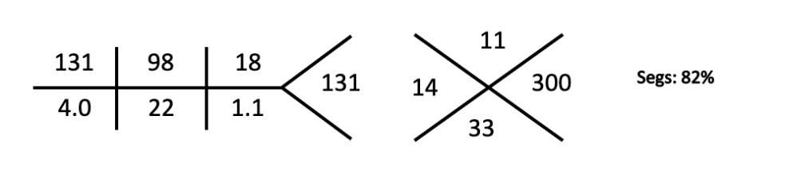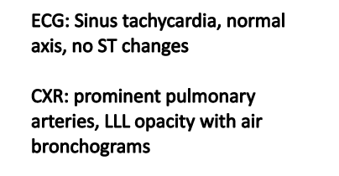

- What admission orders are you going to place?
  - Level of care: stepdown à IV/subq prostacyclins MUST go to MSD b/c only nurses in MSD/MICU/CVICU are trained on the medication/pumps
  - CMU: definitely pulse oximetry (SpO2 was 89%, goal should be 92%)
    - Telemetry could be debated – would probably say yes b/c dyspnea could be from arrhythmias and she is tachycardic
  - Diet: sodium restricted
  - DVT ppx: any – keep in mind possible procedures if catheter is broken
  - Other tests? BNP, LFTs, UA, blood cx
  - Home meds: hold any anti-hypertensives w/ soft pressures in likely infection
    - Do NOT hold PAH medications!!! Even if hypotensive
      - Why?? Removal of vasodilators à vasoconstriction à increased PA pressures = increased RV afterload à RHF à decreased cardiac output
      - If you are nervous, ask pulm/PH team for guidance
      - If they are on a home pump, you need to talk to pharmacy to get them switched to a hospital pump à Nurses aren’t trained in home pumps, so they have to be on a hospital pump in case any issues or changes occur
      - If the inhaled meds, sometimes family members need to stay to help them b/c not all RTs or nurses are trained on them yet
    - Make sure to order home CPAP
  - New meds: CAP coverage!
    - Fluids? Pt could be septic, give cautiously
  - Consults: Pulm!
    - If pts are stable on oral therapies and not in HF exacerbation, do not necessarily need to consult Pulm, but you should have a low threshold
    - Any IV/subq therapies should get a Pulm consult
CASE 3.

61-year-old female w/ hx HTN, hypothyroidism, PAH s/t scleroderma, presents to the ED w/ worsening SOB and weight gain. She was diagnosed w/ PAH a year ago and is on ambrisentan and tadalafil. She is normally able to take the laundry into the bedroom w/ only mild SOB, but now has SOB walking to the bathroom. She didn’t wear socks today because they didn’t fit; she has noticed a 15lb weight gain over the past week. This morning, she had an episode of lightheadedness and had to lie down. She denies CP, cough, fever, N/V/D, abdominal pain, sick contacts.

Vitals: T 98.5 HR 112 BP 87/52 RR 20 SpO2 90% on room air

Exam: Gen: Awake, alert but fatigued. In distress.
HEENT: No cervical adenopathy, + JVD to mandible
CV: Tachycardic, regular rate, normal S1, loud P2, holosystolic murmur loudest at lower left sternal border that becomes louder with inspiration. + Right parasternal heave. 2+ bilateral pitting edema of BLE above the knees, cool distal extremities.
Pulm: CTAB. No expiratory wheezing.
Abd: Soft, NT, +distended. Liver edge palpable 3 cm below costal margin.
Neuro: AAOx3, no gross motor or sensory deficits.
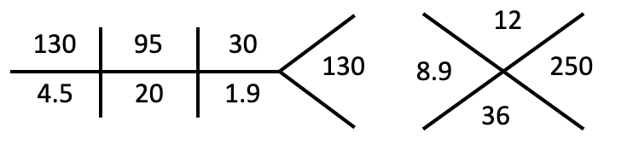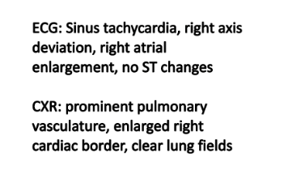
ABG 7.3/36/59 Lactate 2.8 TSH wnl
D-dimer <0.5 BNP 1200

- What is your leading differential? What is your next step in evaluation?
  - Acute right heart failure leading to cardiogenic shock
    - Exam suggests volume overload + labs are concerning for end-organ damage
    - Presumed chronic RHF w/ hx PAH
  - TTE à looking for signs of RV failure
    - See appendix figure 3!
  - Could consider a swan technically, but you have to be careful b/c measuring R sided pressures requires inflating a balloon and temporarily blocking blood flow in the heart à can worsen RV failure

- Where should this patient be admitted?
  - ICU

- How does pulmonary hypertension contribute to right heart failure?
  - Increased RV afterload from PH à RV strain/dilation à RV hypertrophy à increased RV wall tension à decreased RV perfusion à RV ischemia à decreased RV function à further RV strain/dilation à etc
    - Right heart gets perfusion in both diastole AND systole, but mostly the first
      - When RV is dilated, it compresses right side coronary vasculature à decreased RV perfusion even while myocardial demand increases
  - How does volume overload contribute to this?
    - Increased preload à worsened RV dilation
    - Remember Frank-Starling curve!! Optimal myocardial stretch in RV is very narrow window as RV is much thinner normally than LV so patients w/ PH are very sensitive to volume changes

- What are the main components of therapy in acute/chronic right heart failure?
  - Decrease RV afterload à pulmonary vasodilators
    - Can consider initiating IV therapies
    - In hospital can consider inhaled epoprostenol or nitric oxide – theoretically increases perfusion more in areas w/ better ventilation
  - Optimize RV preload à usually means diuresis
    - Avoid large fluid shifts
    - Remember furosemide is a vasodilator as well, so large boluses might be dangerous – consider a drip instead
  - Increase cardiac output à inotropes?

APPENDIX:

Figure 1: Dx features of patients w/ PH
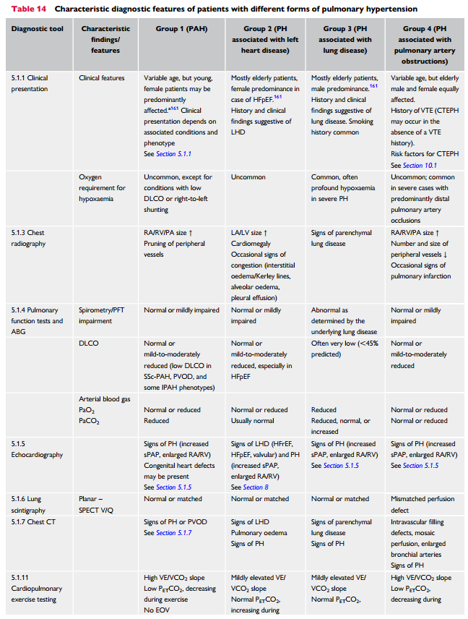

Figure 2: Tx Initiation Guidelines for PAH
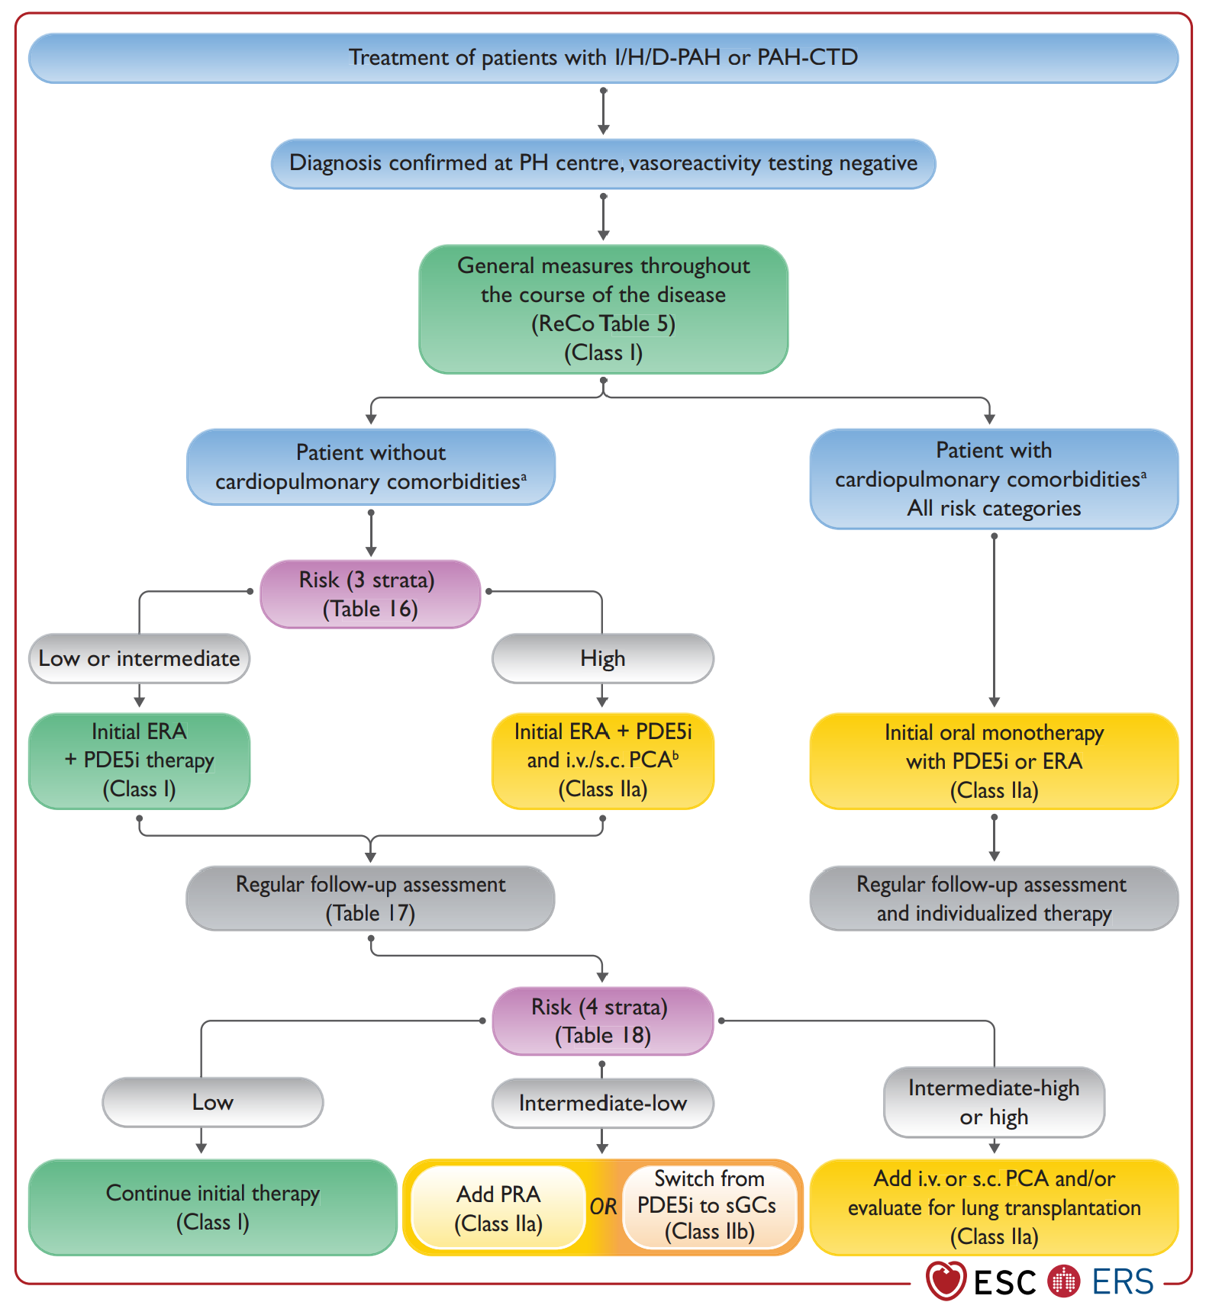

Figure 3. TTE signs of RV failure
