Academic Half Day: Palliative Care
2/15/24

Learner Guide

Prelude
Answer the following questions to the best of your ability! If you don’t know, just take your best guess – write what you would tell a patient right now if they were asking.

- How likely is a patient who underwent in-hospital cardiac arrest to survive to discharge?

- How likely is a patient who underwent in-hospital cardiac arrest to have a “good neurological outcome”?

- How likely is a patient to survive an ICU admission for any reason?

- What are the long-term functional outcomes for patients after ICU admission?

- What are the short and long-term outcomes for a patient requiring dialysis?

- What are the short and long-term outcomes for a patient requiring tracheostomy?

- What is the prognosis for a patient with “end-stage” COPD?

- What is the prognosis for a patient with NYHA class IV heart failure?

PART I

Let's start out with a case, using some of our clinical reasoning skills!

Mr. Spikes is a 66-year-old with HTN, HLD, recent diagnosis of diabetes who presents with progressive jaundice for the past 2 weeks. For the last month he has had intermittent dull, aching abdominal pain. Sometimes the pain is worse after eating a meal.

- What are common etiologies of jaundice? What etiologies are most likely in this patient who also has abdominal pain?

- What other information would you like about the patient?

- What do you want to look for on exam? What work up would you like?

- Do you feel comfortable giving bad news? What kind of emotions do you, as a person, feel when you are giving bad news?

- Reflect on a time when you received bad news (or anything that may have been really emotional). What do you remember about the initial moment when you learned the news?

- Reflect on the last time you either observed bad news being delivered to a patient or gave bad news to a patient. What do you think the patient remembers about that encounter?

- Using the SPIKES framework, how would you tell a patient in the scenario above about their diagnosis?

  - [S] Setting –

  - [P] Perception –

  - [I] Invitation –

  - [K] Knowledge –

  - [E] Emotion –

  - [S] Summarize –

- What would you want to know if you were the patient?

PART II

The following are variations of multiple scenarios that you may encounter in your residency:
- 50-year-old w/ hx HTN, T2DM, admitted for R knee replacement. Code Blue is called for cardiac arrest.
- 23-year-old w/ hx T1DM, admitted for DKA, currently in the ICU as pH is 6.8 on presentation.
- 68-year-old w/ hx metastatic prostate cancer, CAD, admitted for sepsis to the ICU, complicated by oliguric AKI and now requiring dialysis.
- 87-year-old w/ hx lung cancer s/p lobectomy, COPD, hypothyroidism, admitted to the ICU for respiratory failure related to multifocal pneumonia requiring mechanical ventilation. At this time, she has been ventilated for 12 days.

- Assume none of these patients are able to speak for themselves due to encephalopathy of some kind. Who will you discuss medical decision-making with?

- You are the physician for one of the above scenarios. When updating the HCPOA, they ask, “Is [the patient] going to make it? Will we be able to bring them home?” How do you respond?

- Go back to the prelude (first page). Let’s review some answers together.

- Go back to question 1. Is the way you respond now going to be different now that you have this information? Why or why not?

- Using the REMAP framework, how would you approach the conversation in this scenario?

  - [R] Reframe –

  - [E] Emotion –

  - [M] Map –

  - [A] Align –

  - [P] Plan –

PART III

A 68-year-old male w/ hx HTN, CAD s/p CABG 3 years ago, CKD III, T2DM, COPD on 4L home O2, OSA on nocturnal BiPAP, presents to clinic for follow-up. He is having increased shortness of breath and now has dyspnea even at rest on 4L. His pulse oximetry during these episodes has been ~90%. He lives with his eldest son at home and is effectively in bed or in his recliner all day as he cannot even get up to the bathroom without significant symptoms.

He is currently full code. He does not have HCPOA paperwork. He has 4 sons and 2 daughters, all of whom live in Cincinnati. His youngest son and daughter do not speak to him due to past family issues.

- When is an appropriate time to initiate an advanced care planning conversation as an outpatient in any patient?

- Go back to the prelude. Let’s review the following together:
  - What is the prognosis for a patient with “end-stage” COPD?
  - What is the prognosis for a patient with NYHA class IV heart failure?

- What do you want to discuss with the patient today? Which framework do you want to use?

- How will you discuss code status with him?

PART IV

A 78-year-old female w/ hx advanced dementia, seizure disorder, CKD, HTN, A Fib, CAD, is admitted for sepsis related to multifocal pneumonia. Initially she is only on 3L, but she has an aspiration event leading to cardiac arrest. She is intubated and requires mechanical ventilation and subsequent tracheostomy; she is now on trach collar. She had acute renal failure requiring initiation of hemodialysis which will likely be long-term.

She is now on the floor and her mental status remains poor w/ minimal response to pain only. Her HCPOA is her daughter.

- You are discussing the case with her HCPOA, who asks you, “What should we do? What are our options?” What do you tell her? How are you going to frame the conversation?

- How do you explain the difference between palliative care and hospice care to someone?

- What is the difference between inpatient hospice care and hospice at home?

Her daughter ultimately decides on taking the patient home with hospice at home. In the meantime, she would like to pursue comfort care only in the hospital and would like that to start immediately.

- What does that mean for the patient right now? What kind of orders are you going to place?

- How do we manage the following symptoms in hospice care?

Her medication list (other than what you just added) is as follows:

- Aspirin 81mg daily​
- Warfarin 2mg daily​
- Metoprolol 50mg BID​
- Lisinopril 10mg daily​
- Atorvastatin 20mg nightly​
- Levetiracetam 500mg BID​
- Pantoprazole 40mg daily
- Donepezil 10mg daily​
- Memantine 5mg BID​
- Insulin glargine ​15u nightly
- Insulin lispro 5u TIDWC
- Insulin lispro LDSSI TIDWC
- Hypertonic saline nebs BID
- Albuterol nebs BID
- Alendronate 70mg weekly​
- Calcium BID

- How will we adjust her chronic medications at this time?
- When sending someone home with palliative, think through what symptoms they have and how you can help alleviate those symptoms? What are some common symptoms we think about with end-of-life care and medications you can use for those symptoms?

APPENDIX

UpToDate: Significance of physical findings in coma following cardiac arrest
Patients with virtually no chance of regaining independence
Initial examination | No pupillary light reflex
One day | Motor response no better than flexor and spontaneous eye movements neither orienting nor roving conjugate
Three days | Motor response no better than flexor, no spontaneous eye opening
One week | Motor response not obeying commands and spontaneous eye movements neither orienting nor roving conjugate
Two weeks | Oculocephalic response not normal, not obeying commands, no spontaneous eye opening, eye opening not improved at least 2 grades from initial examination
Patients with best chance of regaining independence
Initial examination | Pupillary light reflexes present and motor response flexor or extensor. Spontaneous eye movements roving conjugate or orienting.
One day | Motor response withdrawal or better and eye opening improved at least 2 grades
Three day | Motor response withdrawal or better and spontaneous eye movements normal
One week | Motor response obeying commands
Two weeks | Normal oculocephalic response

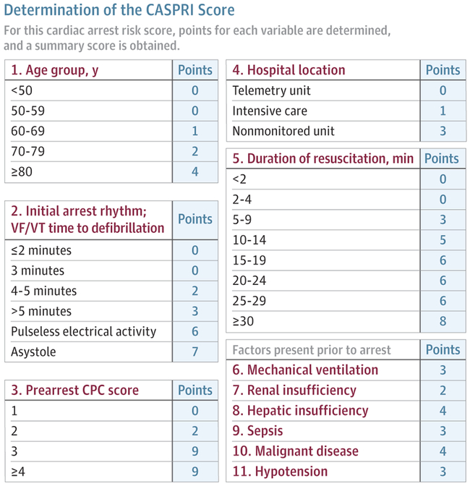
Reprinted from Chan et al,⁸⁴ where a detailed description of the score's interpretation is presented. Scores of 0-4 are associated with 83% survival, 15-19 are associated with 23% survival, and 30-34 are associated with 2% survival. CPC indicates cerebral performance score; VF/VT, ventricular fibrillation or ventricular tachycardia.

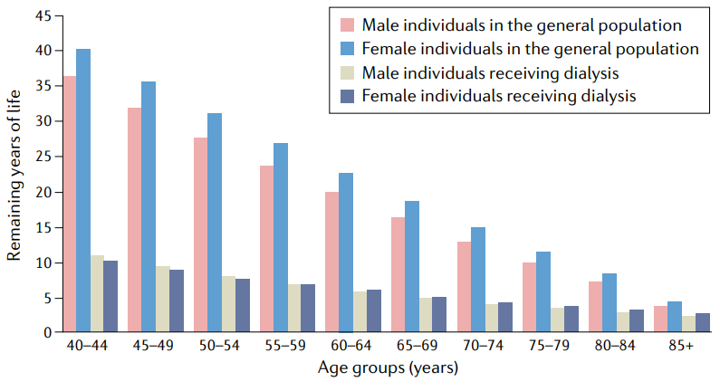
Fig. 2 | Expected remaining years of life in prevalent patients on dialysis. Expected remaining lifetime, in years, for the 2018 prevalent kidney failure population and the 2017 general population in the USA. The graph illustrates the markedly shortened projected lifespan for patients with kidney failure compared with that of individuals without kidney failure. In individuals aged 40–44 years, for example, the projected lifespan difference between men receiving dialysis (expectancy 10.9 years) and men in the general population (expectancy 36.5 years) is >25 years (>30 years for women). Unsurprisingly, the difference in expected remaining years of life decreases with increasing age. However, even men and women aged 80–84 years on dialysis have life expectancies that are 4.3 and 5.3 years shorter, respectively, than their counterparts who are not receiving dialysis.

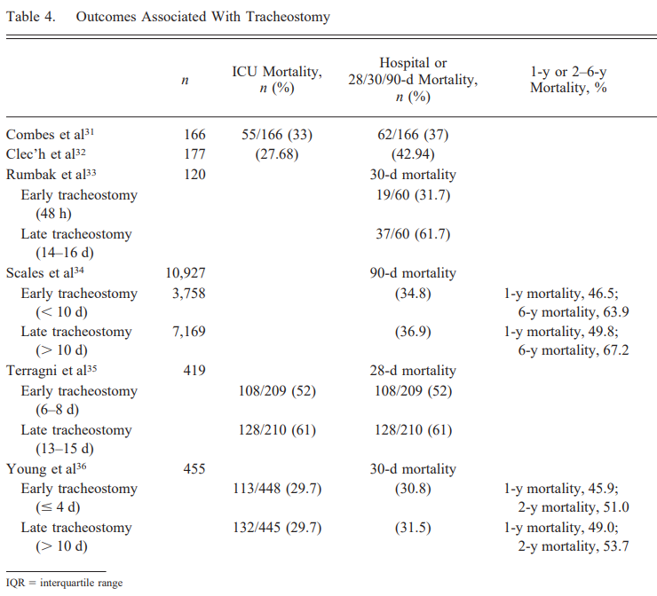

Cheung 2014, Respiratory Care, “Tracheostomy: Epidemiology, Indications, Timing, Technique, and Outcomes”

BODE index for COPD:
