Academic Half Day
Thursday, March 14, 2024

Facilitator Guide
Topic: Nutrition

Case #1:
You are seeing a patient for a follow-up visit in the Hoxworth resident clinic. She is a 72-year-old female with a past medical history of T2DM, HTN, and metastatic melanoma currently on immunotherapy and palliative radiation therapy. She comes into the clinic today because of generalized fatigue, poor appetite, and progressive weight loss over the past 2-3 months. She does not eat breakfast most mornings (only drinks coffee), eats a turkey sandwich with chips and veggies with hummus, and dinner in the evenings with her daughter with whom she lives. On further discussion, she admits to eating about 50-60% of her meals due to poor appetite.

- Vitals: Afebrile, BP 115/76, HR 72, RR 14, SpO2 100% on RA
- Height: 5’5”
- Weight trend: 142 lbs (11/7/2022) -> 140 lbs (3/22/2023) -> 129 lbs (10/17/2023) -> 119 lbs or 54 kg (1/2/2024)
- Current BMI: 19.8
- Physical exam: No acute distress. Tired appearing. Temporal muscle wasting noted bilaterally. MMM. RRR. No murmurs. Lungs are CTAB. Normal work of breathing. Abdomen is soft, nontender, nondistended. Mild pedal edema.

1a) What do you think about this patient’s weight loss? Are there any tools available to help you evaluate a patient for malnutrition? Think about different healthcare settings – outpatient vs inpatients vs ICU
- Regarding weight loss, she has lost 16% of her body weight over 12 months and 7.75% over the past 3 months.

- Universal screening tools:
  - Subjective Global Assessment
    - More detailed assessment form
  - Malnutrition Universal Screening Tool
- For hospitalized patients:
  - Nutrition Risk Screening 2002
- For ICU patients:
  - Nutrition Risk in the Critically Ill (NUTRIC) Score

- Albumin, pre-albumin, and transferrin are negative acute-phase proteins and are inadequate alone to assess nutrition status and/or adequacy of nutrition therapy.

- For this patient, Malnutrition Universal Screening Tool (available on MD Calc) revealed:
  - High risk (MUST ≥2) patients, refer to dietician in hospital or community dietician support team. Increase and document overall nutritional intake. Monitor care plan as follows: Hospital - weekly. Care home or community - monthly.

1b) Can you calculate this patient's caloric needs and specific macronutrient goals?
- Indirect calorimetry is the gold standard to measure resting energy expenditure and is calculated by measuring oxygen consumption and carbon dioxide production.
- Otherwise, can used weight-based equation:
  - Estimated calorie need = 25-30 kcal/kg per day
- There is increasing interest in macronutrient intake per day, specifically regarding protein. Previously, 1.2–1.5 g protein/kg per day was recommended for patients, but recent evidence supports a higher range of 1.5–2.0 g/kg per day

- For the patient in this scenario....
  - 54 kg with 25-30 calories/kg = 1350-1620 calories and ~81 g protein per day

1c) What are the 6 criteria used for diagnosing protein-calorie malnutrition in adults?
Note: See diagram on next page
- Energy intake
- Weight loss
  - Percentage of body weight over given time
- Body fat
  - Loss of subcutaneous fat -- E.g., orbital, triceps, fat overlying the ribs
- Muscle mass
  - Loss of muscle mass -- E.g., wasting of the temples [temporalis muscle], clavicles [pectoralis and deltoids], shoulders [deltoids], interosseous muscles, scapula [latissimus dorsi, trapezious, deltoids], thigh [quadriceps], and calf [gastrocnemius]
- Fluid accumulation
  - Generalized or localized fluid accumulation evident on exam (extremities, vulvar/scrotal edema, or ascites)
  - Weight loss may be masked by generalized fluid retention (edema), and weight gain may be observed.
- Reduced grip strength

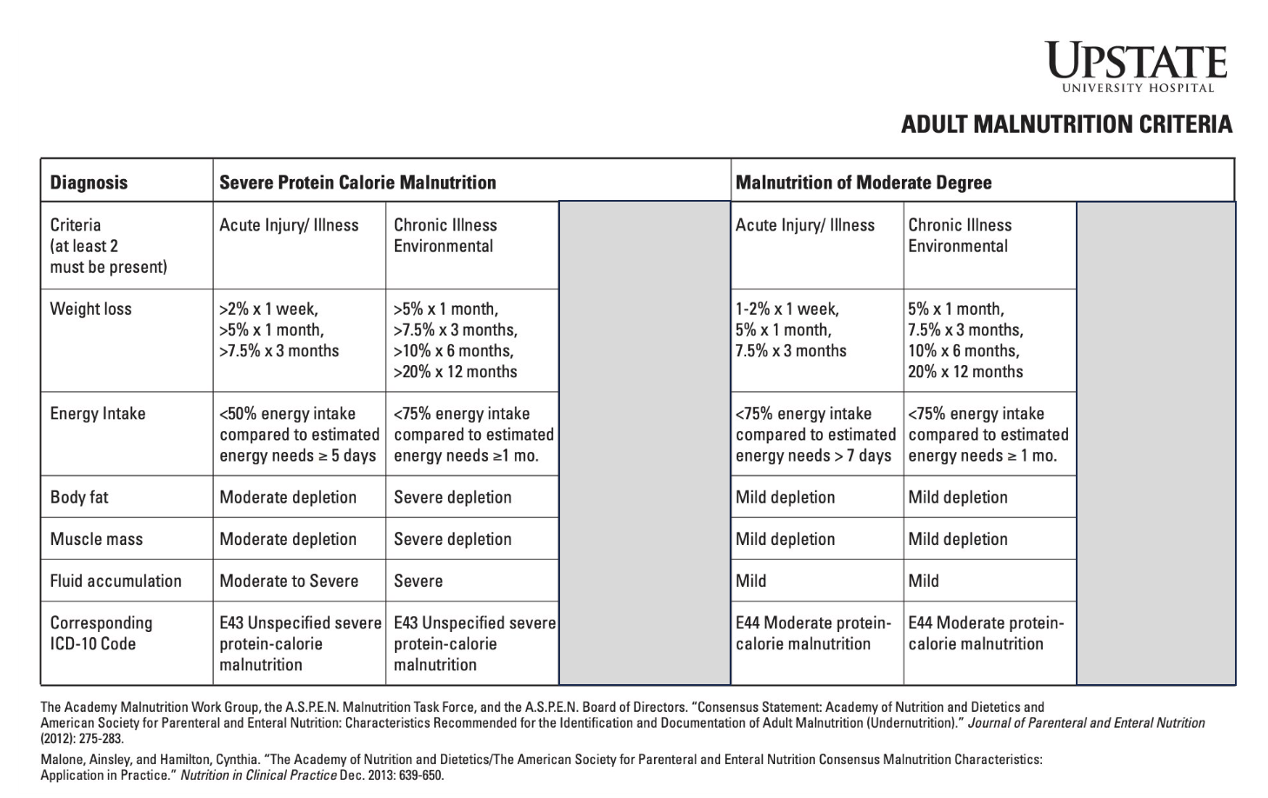

- For the patient in this scenario, she meets the following at least 2 criteria for moderate malnutrition:
  - 1) Chronic illness – Metastatic cancer
  - 2) Weight loss - She has lost 16% of her body weight over 12 months and 7.75% over the past 3 months.
  - 3) Likely taking in <75% of her required energy intake based on the history you obtained regarding her diet.
  - 4) Temporal muscle wasting noted on physical exam.

1d) Should we consider initiating nutritional support for this patient? Why or why not?
- For the patient in this scenario, we would recommend referring to the dietician/ nutritionist, consider sending prescription for protein shake supplementation (e.g., Boost using the diagnosis of moderate protein calorie malnutrition after documenting your findings, and scheduling a follow-up appointment in 1 month.

- For hospitalized patients at high nutritional risk (NRS 2002 of 5 or more; NUTRIC scores 6-10), those who received adequate nutrition therapy had improved outcomes, whereas patients at low nutritional risk did not have significant differences in outcomes associated with nutritional support.

- Generally, consider initiation of acute nutritional support when the disease precludes food intake for more than 5-7 days in adults.
  - Strong evidence to support patients with impaired bowel function (e.g., short bowl syndrome, necrotizing enterocolitis), severe prolonged hypercatabolic states, or severe protein-calorie malnutrition and a treatable disease, and for those requiring prolonged therapeutic bowel rest (e.g., inflammatory bowel disease).

Case #2: Enteral Nutrition
An 83 year-old male with a past medical history of peripheral vascular disease, hyperlipidemia, type 2 diabetes mellitus, and hypertension was found down at his home by a home health aide. On arrival to the ED, he was encephalopathic, dysarthric, and hypoxic, so he was intubated on arrival for airway protection. Further workup reveals that the had a subacute, ischemic stroke, and he is admitted to the NSICU. While caring for this patient during a critical care elective, you calculate his Nutrition Risk in the Critically Ill (NUTRIC) Score is 8.
2a) Should we consider initiating nutritional support for this patient? Why or why not? Do you want to consult any team(s)?
- Early nutritional intervention within 24-48 hours is recommended in patients who are already malnourished, high nutritional risk (NRS 2002 of 5 or more; NUTRIC scores 6-10), or are critically ill.
  - In critically ill patients, early initiation of enteral nutrition has been shown to decrease mortality and length of ICU stay. No evidence that parenteral nutrition improves important outcomes in critically ill patients.
- Although early EN should be initiated within 24–48 h of admission, the timing by which to advance to goal is unclear. When tolerated, feeding should be advanced to goal within 72 hours. With reduced tolerance, feeding should be advanced with caution to goal by 5 to 7 days

- Nutrition consult
  - The inpatient nutrition team will assess the daily caloric needs for each patient and measure dietary intake, give recommendations for nutritional support, and help direct management of EN and PN.
- SLP consult team can evaluate and assess disorders such as:
  - Dysphagia and swallowing safety
  - Aphasia
  - Motor speech disorders (dysarthria and apraxia)
  - Voice and upper airway disorders

2b) What are contradictions to enteral nutrition?
- Absolute
  - Mechanical obstruction
  - Ischemic bowel
  - Peritonitis, uncontrolled
- Relative
  - High vasopressor requirements
  - Open abdomen/recent bowel anastomosis
    - Discuss timing of EN with surgical team
  - Unable to maintain head of bead at 45 degrees

2c) What options are available for an enteral access device? Which do you want to use for this patient?
- For this patient, recommend starting with an orogastric tube since this patient is intubated.

Enteral access device | Length of use: short- or long-term? | Pros | Cons
Nasogastric tube | Short-term | Easy to place (should confirm placement with X-ray); variety of sizes available for patient comfort | Do not use if: bleeding disorder, nasal/facial trauma or fractures
Orogastric tube | Short-term | Lower incidence of sinusitis than NGTs | Not tolerated well in alert patients; tube may damage teeth
Gastrostomy tube | Long-term | Easily cared for and replaceable; large size tube allows for bolus feeding and medication administration | Compared with oral and nasal route, this technique is more invasive
Jejunostomy tube | Long-term | Distal location decreases the risk of food and fluids passing into the lungs | Technically more difficult to place; smaller size tubes may make administration of some medications more difficult
Table adapted from Kirby, D.F. and Fawley, R.K. Enternal and Parenteral Nutrition - What is Meant by and What are Examples of Enteral Access? American College of Gastroenterology. Published Sept. 2011. Updated April 2021. Accessed March 2, 2024. (https://gi.org/topics/enteral-and-parenteral-nutrition/)

2d) Which tube feed are you going to start? What are some of the differences between various tube feed formulations?

Tube Feeds | Notes and Examples
Standard Formulas | - Naming varies based on brand/company  - Vary from 1.0–2.0 kcal/mL as indicated by the number after the product name. Changing the caloric density will alter the total volume (via water content)  - Ex: 1.2 kcal/mL --> Jevity 1.2  - Ex: 2.0 kcal/mL --> Nutren 2.0  - May or may not contain fiber.  - Fiber can help to bulk stools and slow fecal transit time, which lessens loose stools.  - Ex: Fibersource 1.2
Specialized Formulas | - Ex: NovaSource Renal for patients with CKD/ESRD  - Ex: DiabetiSource AC for patients with hyperglycemia/DM  - Also make formulations without certain dietary restrictions/allergens (e.g., gluten, egg, soy)

2e) What is the starting rate for your tube feed orders? What is your plan for titrating to goal?
- This varies somewhat by practice pattern, but generally start the tube feeds at 20 mL/hr.
- If tolerating over next 12-24 hours, can up titrate by 10-25 mL/hr every 4 hours until goal tube feed rate is met.

2f) You are concerned that your patient may have intolerance to the current tube feed rate. How do you assess this?
- Start by evaluating the patient. Some concerning symptoms of tube feed intolerance include vomiting, abdominal pain, and/or abdominal distention.
- Obtaining gastric residual volumes is controversial and not well standardized. The ACG Clinical Guideline: Nutrition Therapy in the Adult Hospitalized Patient states “GRV has been shown to be a poor marker of true gastric volume, gastric emptying, risk of aspiration, pneumonia, and poor outcomes (116-118). Furthermore, the practice of checking GRV is not well standardized, the values are difficult to interpret, an expense involved with allocation of health-care resources (nursing time) is substantial (119 ). The use of GRVs as a monitor increases the likelihood of tube clogging tenfold (120).”

2g) Your patient has improved over the next 2 weeks. He is extubated and able to be moved to med/surg floor level of care. Unfortunately, your patient’s dysphagia is persistent despite these medical improvements and continued work with speech therapy. When do you consider a more long-term feeding tube? Although the time cutoff is somewhat arbitrary, what complications can arise from prolonged placement of NGT/OGT?
- If the duration of enteral nutrition is anticipated to be 4 or more weeks, then a percutaneous enteral access device is generally indicated.
- Prolonged placement of NG and OG tubes can lead to erosion of the nares, sinusitis, vocal cord erosion and/or dysfunction, aspiration pneumonia, and esophageal ulceration or stricture.

2h) The patient and family agree with the recommendation for nutritional support but are concerned about the patient going home with a PEG tube. They ask you, “What are the potential complications?”
- Can become clogged and/or displaced and subsequently will need to be replaced
- Skin/wound infections
- Buried bumper syndrome
  - Uncommon but serious complication
  - Develops due to tight positioning of the external bumper of the PEG tube against the abdominal wall. As a result, the internal bumper migrates along its track towards the external bumper, getting stuck anywhere between the gastric wall and skin.

Case #3: Parenteral Nutrition
You are working as the AOD as a PGY3, and the colorectal surgery team consults you for medical co-management of a patient who recently underwent abdominal surgery for a complete bowel obstruction 5 days ago. The surgical team is planning to return to the OR with the patient next week. You are completing the consult note and relaying your recommendations to the surgery resident. While discussing this patient’s care, the question of whether to initiate TPN comes up given that the patient will be NPO until at least the next surgery. You say, “That’s a great question!”, and remember what we discussed during AHD as an intern!

3a) When should you initiate parenteral nutrition for patients? What's the difference between total parenteral nutrition (TPN) and peripheral parenteral nutrition (PPN)?
- TPN is an alternative to EN in situations as described in the second case when EN is contraindicated.

- Thinking back to malnutrition risk assessments for the first case,
  - Patients with low malnutrition risk and early EN is not feasible, PN should be withheld for the first 7-10 days of hospitalization.
  - For hospitalized patients at high nutritional risk (NRS 2002 of 5 or more; NUTRIC scores 6-10) and EN is not feasible, initiation of TPN may be considered as sas possible.

- Key difference between TPN and PPN:
  - PPN is diluted as a precaution to avoid venous irritation (e.g., phlebitis). Thus, PPN is not a good choice for patients with volume restrictions and usually provides less overall calories than TPN. PPN is intended for short term use (< 2 weeks).
  - TPN provides more calories in a smaller, more concentrated volume.

3b) What are your access options for parenteral nutrition?
- Central catheters needed for TPN
  - Short term – ex: CVC, PICC line
  - Long term – ex: tunneled Hickman catheters, port-a-catheter
- Large-bore peripheral IVs and midlines can be used for PPN

3c) After further discussion with the surgical team, it is collectively decided to proceed with the initiation of TPN. Which additional teams will you need to consult now?
- Nutrition
  - As discussed in the second case
- Pharmacy
  - The inpatient pharmacy team will work with the nutrition team to create the TPN formulation, which includes total caloric need, fluid volume, protein requirements (in the form of amino acids), lipid requirements, carbohydrate requirements (usually in the form of dextrose), electrolytes (Na, K, Mg, Ca, phos, bicarb), and vitamins/trace elements as needed (e.g., multivitamin, zinc, etc.)
- Need to establish venous access
  - PICC team for PICC line
  - Surgical and critical care teams can place central lines
  - IR for tunneled catheter if more permanent/long-term access is indicated

3d) What are some common complications associated with parenteral feeding?
- Complications with the catheter placement include infection, clogging (occlusion), and breakage
- Volume overload
- Acalculous cholecystitis and cholestasis
- Metabolic derangements – electrolyte imbalances, hypertriglyceridemia, hypo- or hyperglycemia

3e) Is this patient at risk for refeeding syndrome? How do you manage/monitor for refeeding syndrome in at-risk patients?
- Any patients with severe malnutrition or prolonged periods of decreased or absent nutritional intake are at-risk for refeeding syndrome.
  - Examples: eating disorders (anorexia nervosa), alcohol and substance use disorders, history of bariatric surgery or bowel resection, malabsorptive syndromes (Celiac disease), malignancy
- Physiology:
  - Low baseline nutrient/electrolyte levels
  - Introduction of food = increased glucose --> Causing increased insulin
  - Leading to: increased protein synthesis, Na (and water) retention, thiamine use, and intracellular uptake of Phos, Mg, K
- Signs/symptoms: Looking for those of the specific electrolyte abnormality
  - Hypophosphatemia – Muscle weakness, paresthesia, confusion, respiratory insufficiency
  - Hypokalemia – Cramping, hypotension, arrythmias, lethargy, polyuria, respiratory insufficiency;
  - Hypomagnesemia – neuromuscular irritability, tremor, tetany and nystagmus if severe
  - Thiamine deficiency
- Treatment: Montior electrolytes regularly (interval depending on severity) and replete as needed

- There is no clear evidence for EN vs PN having a greater risk for refeeding syndrome.

Learning Objectives:
- Understand the criteria to define malnutrition and subsequently apply these criteria to make a diagnosis
- Determine when to start nutritional support in different patient populations (outpatient vs inpatient vs ICU)
- Evaluate whether eternal or parenteral nutrition would benefit a patient

References used throughout the guide:
- Hadefi A, Arvanitakis M. How to Approach Long-term Enteral and Parenteral Nutrition. Gastroenterology. 2021;161(6):1780-1786. doi:10.1053/j.gastro.2021.09.030
- Kirby, D.F. and Fawley, R.K. Enternal and Parenteral Nutrition. American College of Gastroenterology. Published Sept. 2011. Updated April 2021. Accessed March 2, 2024. (https://gi.org/topics/enteral-and-parenteral-nutrition/)
- Kulick D, Deen D. Specialized nutrition support. Am Fam Physician. 2011;83(2):173-183.
- Malone A, Hamilton C. The Academy of Nutrition and Dietetics/the American Society for Parenteral and Enteral Nutrition consensus malnutrition characteristics: application in practice. Nutr Clin Pract. 2013;28(6):639-650. doi:10.1177/0884533613508435
- McClave SA, DiBaise JK, Mullin GE, Martindale RG. ACG Clinical Guideline: Nutrition Therapy in the Adult Hospitalized Patient. Am J Gastroenterol. 2016;111(3):315-335. doi:10.1038/ajg.2016.28
- White JV, Guenter P, Jensen G, et al. Consensus statement: Academy of Nutrition and Dietetics and American Society for Parenteral and Enteral Nutrition: characteristics recommended for the identification and documentation of adult malnutrition (undernutrition). JPEN J Parenter Enteral Nutr. 2012;36(3):275-283. doi:10.1177/0148607112440285

