**Academic Half Day – ACLS**

LEARNER Guide

Feb 8, 2024

Expert: Dr. Alex Garbarino

Designed by: Jackson Walker, Kristen Peterson, Jackson Hearn, Will Jensen

**Agenda**

1:10 - 1:20: Theory burst

1:20 - 2:20: Cases 1-2

2:20 - 2:30: Questions for the expert

2:30 - 2:40: Break

2:40 - 3:20: Cases 3

3:20 - 3:30: Questions for the expert

**Learning objectives:**

1. Develop the ability to differentiate between shockable and non-shockable non-pulsatile rhythms
2. Utilize the ACLS algorithm to identify steps to take during a CODE BLUE
3. Learn the medications and tools available for use during a code
4. Identify and treat reversible causes of cardiac arrest
5. Develop communication strategies to function as a successful team leader

AHA ACLS Algorithm: Recognition and management reversible causes:

 

MGH ACLS app link ($3/year):



**Case 1:**

**Pager:**

**03:00 am RAPID RESPONSE L&D ROOM 3;**

**03:01 am CODE BLUE L&D ROOM 3**

**You enter the 3rd floor and hear a woman screaming as you approach room 3. When you enter the room, a man in street clothes is lying on the floor, and a nurse is alone hunched over him, actively attempting chest compressions. The screams are coming from a patient in the hospital bed. Another nurse enters the room behind you, pushing the code cart. There is no pulse. He has cool hands and feels warm when you try to palpate a femoral pulse. There are now three people responding to this code; what needs to happen next?**

1. **Discuss the various next steps that you’d like to take in the next 2 minutes (even outside of typical ACLS algorithms). How can you keep the room organized in such high stakes? This question is intentionally broad to elicit group discussion. As you go through the various next steps, pause to discuss each in more detail.**

**You successfully initiate CPR. The following is shown on the rhythm strip during your pulse check (there is no carotid pulse):**

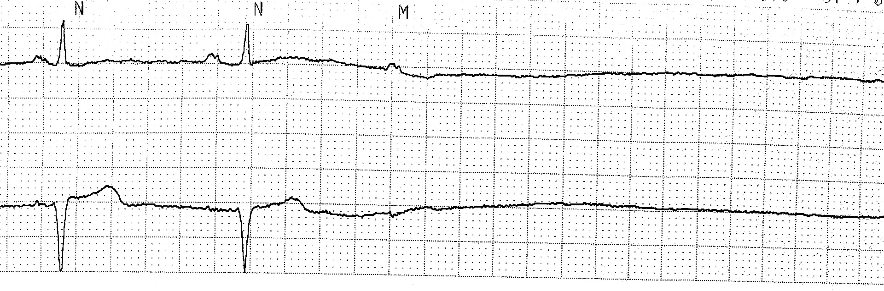

1. **What rhythm do you see?**
2. **Is it shockable or non-shockable?**
3. **What step comes next in the ACLS algorithm? How long until the next pulse check?**

**Case 2:**

**Code BLUE called to the PACU bed 10! You show up to a crowded room and a patient is receiving CPR in his hospital bed. You identify yourself as the AOD and ask the room if someone can summarize what has happened so far. The bedside nurse states that the patient returned from the OR for a routine cholecystectomy about 1 hour prior. About 3 minutes ago, the patient yelled out, became diaphoretic and lost color in his face. He then became unresponsive. CPR was just started.**

1. **What are your first steps?**
2. **While you attach the pads, what is a brief differential cause for post-op cardiac arrest?**

**Initial rhythm below:**

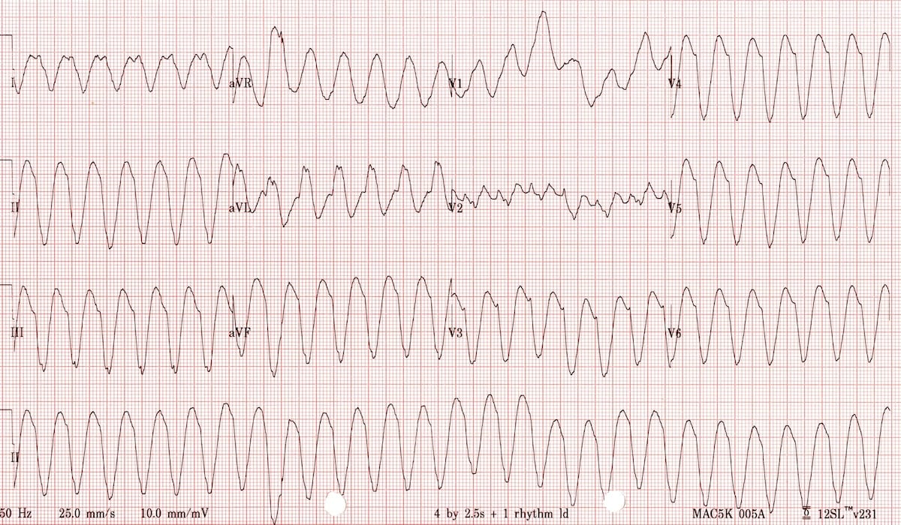

1. **What rhythm does this represent? What are some common causes of this arrhythmia?**
2. **What are common causes of polymorphic VT?**
3. **How do you differentiate VT from SVT with aberrancy?**
4. **Back to the patient in front of us. What is the first action in the ACLS algorithm when you see the rhythm tracing above?**
5. **What voltage do you shock with?**
6. **Shock is delivered and the rhythm persists. What are some adjunctive medications to give at this stage?**
7. **You are two minutes into CPR, have provided one shock and 1 mg epinephrine. What else should you be considering at this stage?**
8. **Your intern pulls up the patient’s chart and sees that he has a history of smoking, CAD and DMII not on insulin. Your team is performing high quality CPR and you wonder if the patient might have a reversible cause of cardiac arrest. Will one individual please summarize the case? Next, what are some reversible causes of cardiac arrest and how would you identify and treat them?**
9. **After your third round of CPR, you notice that the EtCO2 is sustained above 40 and there is a pulse on the pulse check. What are some other signs of ROSC? What do you do next?**

Post ROSC care:



**The patient is following commands and appears very dazed and confused but otherwise neurologically intact thanks to your superb ACLS skills. You begin managing hemodynamic parameters by the post-arrest care algorithm and you obtain an ECG shown below.**

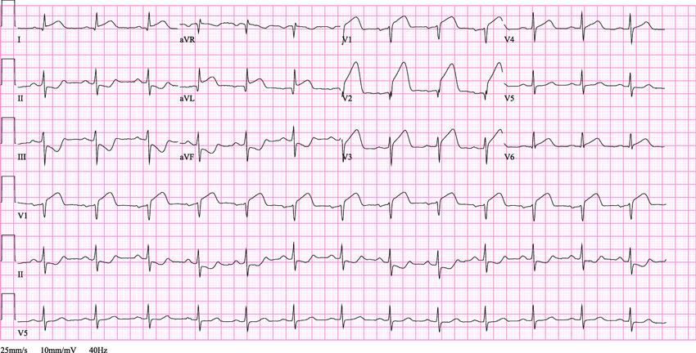

1. **What do you do next?**

**Case 3:**

**A 32 yo female with PMH of elevated BMI (> 35) is admitted with fevers and abdominal pain. Three weeks ago, she delivered two healthy twins via repeat C-section. Unfortunately, her post-partum course was complicated by gangrenous cholecystitis s/p cholecystectomy, pancreatitis and now multiple intra-abdominal abscesses s/p JP drain placement. One morning, she gets out of bed to go to the bathroom but suddenly collapses. Her husband calls out, a nearby nurse arrives and is unable to palpate a pulse. The nurse calls a code blue and begins CPR.**

1. **When you arrive, what do you do first? How might you use closed loop communication?**

**As you are assigning roles and delegating tasks, you notice the bedside nurse asking your medical student (who happens to be a tall man standing next to you) if they can hang bolus fluids without addressing you, mistaking him for the team leader.**

1. **Take a moment to brainstorm how biases impact a high stress code situation. Think about how System 1 thinking (quick, intuitive thinking) could affect the following relationships (both positively and negatively)**

* **How might your relationship (as team leader) with the Code Team be affected by System 1 thinking?**
* **How might the Code Team’s relationship with you be affected by System 1 thinking?**
* **How about the code team’s (including you) system 1 thinking about the patient?**

1. **You notice that the nurse providing compressions appears fatigued and the rate and depth of the compressions is inadequate. How would you effectively and respectfully initiate correction? What actions (if any) would you take to help the nurse?**
2. **Rhythm shows PEA. Based on her history, what are some possible causes of her cardiac arrest?**
3. **Following the ACLS algorithm for PEA/asystole, you have given 2 doses of epinephrine and are now approaching the 6-minute mark of the code without changes in her status. You look in the code cart for some other medications to try. What medications are in the code cart and when would you use them?**

|  |  |  |
| --- | --- | --- |
| **Medication** | **Dose and timing** | **Use** |
| **Epinephrine** |  | Cardiac stimulation; used during cardiac arrest with PEA/asystole and VF/pVT |
|  | 300mg for first dose (bolus), 150mg for second dose |  |
| **Lidocaine** | 1-1.5 mg/kg for first dose; 0.5-0.75 mg/kg for second dose |  |
| **Atropine** |  | Symptomatic bradycardia, until pacer pads can be placed. Avoid in mobitz type II and complete heart block. |
| **Calcium chloride** | 1 g, given over 2-5 minutes; repeat as necessary | Stabilize cardiac membrane, increase contractility; can also be used if there’s concern for electrolyte derangements causing cardiac arrest (hyperK, hyperMg, hypoCa) |
| **Sodium bicarbonate** | 50 mEq/50mL syringe (“1 amp”) | Routine use is not recommended. Special considerations: metabolic acidosis, kyperK, or TCA overdose. Sometimes considered in setting of prolonged cardiac arrest |
| **Adenosine** |  | Used when there is concern for SVT. Will briefly cause complete AV nodal blockade. If the tachycardia is dependent on AV conduction, will cause ventricular pause and you can see underlying atrial rhythm |
| **Dopamine** | Initial: 5 mcg/kg/min with increase by 5mcg/kg/min every 2 minutes (bradycardia)  Range 0.5 - 20 mcg/kg/min | Not often used; can consider in symptomatic bradycardia. Can cause tachyarythmias so used cautiously (if at all) in hypotension, cardiogenic shock, etc. |
| **Naloxone** | IV/IM 0.4 - 2mg every 2-3 minutes  IN 4 or 8 mg every 2-3 minutes | If concerned about opioid OD as cause; IV/IM route more effective. |
| **Dextrose** | D50W (usually 50mL syringe) | Hypogylcemia |

1. **In this case specifically, what would be the next medications you would try in addition to epinephrine?**
2. **You are now approaching the 15 minutes mark of the code. You’ve given 4-5 doses of epi, an amp of bicarb, and a dose of calcium chloride. You’ve done everything you know to do, but the patient’s status is unchanged. How would you elicit further input from your code team?**
3. **Someone suggests performing a bedside ultrasound and notices the RV to be severely enlarged. What would you do next and what are the current recommendations on the use of thrombolytics during ACLS?**

**ROSC is obtained after ~ 15 minutes and she is taken to the ICU for post-cardiac arrest care.**

**Appendix:**



