AHD – Meningitis
Learner Guide
Agenda:
1:00 – 1:15 Meningitis Theory Burst
1:15 – 2:10 Case 1
2:10 – 2:20 Questions for the expert & Break
2:20 – 3:15 Cases 2 & 3
3:15-3:30 Questions for the expert and Wrap Up

Some quick biostats before we begin:
300 people got LPs (gold standard) for suspected bacterial meningitis. 100 patients were CSF culture positive for bacterial meningitis. Of these culture- positive patients, 56 did not have the classic triad of fever, neck stiffness, and altered mental status. What is the sensitivity of the classic triad for bacterial meningitis?

Case 1
A 28-year-old man presents with a 2-day history of severe headache localizing to the back of the head. He has associated nausea, emesis, and light sensitivity. He recently had an episode of sinusitis. He has not had any recent travel. He has no past medical/surgical history. He takes ibuprofen PRN, which he has been using regularly during the past 24 hours for headache. He has no allergies to medications. He is an industrial engineer.

VS: 101.8 °F, BP 134/82, HR 95, RR 13, and 98% on RA.
General: Patient appears uncomfortable.
HEENT: Reports photophobia with eye exam. PERRL. EOMI. No papilledema on non-dilated examination. There is mild, bilateral maxillary sinus tenderness.
Lungs: CTAB, normal effort
CV: RRR, normal S1 and S2, no m/r/g
Neuro: AOx4 without confusion. There are no focal findings.
Skin: He has no rashes, oral or genital ulcers.

- What is on your differential diagnosis?

- What diagnostic studies would you obtain?

- Does this patient need a head CT before LP? Why or why not?

- You perform a Lumbar Puncture. What CSF studies would you order for each tube?

Case 1 continued:

Labs:
\ 14.2 /
8.2 ----- 335
/ 44 \

Differential shows left shift.

135 | 102 | 11 /
------------------------ 110
4.0 | 24 | 0.8 \

Hepatic panel: normal
CRP: 55mg/L (N: 1-10 mg/L)
Serum glucose: 98 @ 12:00PM

CSF analysis @ 12:00PM
Opening pressure: 2200 mm H₂O (normal: 70-200 mm H₂O)
WBC: 1200/µL with 60% neutrophils, 40% lymphocytes (N:0-5/μL (0-5× 10⁶/L))
Glucose: 30 mg/dL (N: 40-80 mg/dL)
Protein: 350 mg/dL (N: 15-60 mg/dL)
Gram stain: see QR code below
Culture: processing

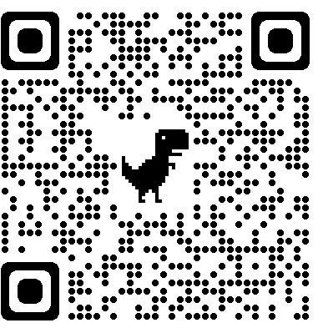

- What is your assessment of the above labs?

- What is your initial management? Write the initial admission orders including doses of any medications.

Questions for the expert!
Break!

Case 2
A 65-year-old female with PMHx of HTN and SLE complicated by nephritis presents to the ED with headache, fever, nausea and vomiting for 2 days. She has associated lightheadedness, photophobia, and neck pain. She is retired and babysits for two school-age grandkids, but neither has been sick. She does not smoke or drink alcohol. Medications include ASA, lisinopril, and cyclophosphamide. She has no allergies to medications.

- What is on your differential diagnosis? How would you use your physical exam to support/refute your concerns?

Case 2 continued:
Physical exam:
Vitals: 100.8°F, BP 125/84, HR 64, RR 18, 99% RA
Gen: Ill appearing but in no acute distress
HEENT: PERRL, EOMI, no papilledema on non-dilated fundoscopic exam
Neck: Neck stiffness, + Kernig, + Brudzinski (see figure 2 in appendix)
CV: RRR, no murmurs
Lungs: CTAB, normal effort
Abd: Scaphoid, soft, nontender
GU: No lesions/rashes
Neuro: CN intact, strength 5/5, sensation intact, DTRs 2+
Skin: Dry skin, no rashes
- Initial labs including CBC, BMP, INR, and CRP are all normal. You are concerned about meningitis. What are the next best diagnostic steps for this patient?

- What therapy will you start?

- The CT Head is negative for recent or remote stroke, hemorrhage, intracranial lesions, or herniation. After multiple attempts by several providers in the ED and on medicine, CSF is unable to be obtained. IR is unavailable currently. Discuss the course of therapy that you would prescribe for this patient.

Case 3
An 80-year-old woman with history of HTN, DM2, early dementia, and hypothyroidism is hospitalized for a 1-day history of AMS and fever. Her family notes that yesterday she seemed confused and had trouble getting dressed. This morning, she was extremely somnolent, and she was transported to the hospital by ambulance. She takes lisinopril, metformin, donepezil, and levothyroxine. She has no medication allergies. Per family, she is independent with ADL’s but does not manage her finances any longer. She lives with her son and grandchildren but has no sick contacts. She has a celebratory glass of wine on holidays, has never smoked and does not use illicit substances.

Physical exam:
VS: 101.2 °F, 118/78, HR 110/min, RR 24/min, and 98% on RA.
Gen: Appears ill. She responds to deep stimulation with a grimace.
Neuro: Oriented to name only, speaking random words. Does not follow commands. She moves all extremities spontaneously, withdraws from pain. Face is symmetric without droop. Opens eyes to pain. PERRL, no papilledema on non-dilated fundoscopic exam. Unable to flex neck, + Kernig, + Brudzinski (see figure 2 in appendix)
Cardiovascular: tachycardic, no murmurs
Pulmonary: CTAB, tachypnea noted
Abdominal: soft, non-tender, non-distended, BS normoactive
GU: No lesions or rashes
Skin: warm, dry, no rash.

Labs/Diagnostics:

Does she need a CT head? Why or why not?

CBC: \12.7/
4.8 ----- 287 with normal differential
/ 37 \
CMP: normal
CRP: 8mg/L (N: 1-10 mg/L)
UA: no WBC, negative nitrite, no protein
Serum glucose: 98 @ 11:00AM
CSF analysis @ 11:00AM
Opening pressure: 80 mm H₂O (normal: 70-200 mm H₂O)
WBC: 11/µL with 60% lymphocytes, 40% neutrophils (N:0-5/μL (0-5× 10⁶/L))
Glucose: 66 mg/dL (N: 40-80 mg/dL)
Protein: 76 mg/dL (N: 15-60 mg/dL)
Gram stain: no organisms
Culture: processing
HSV PCR: processing
Blood cultures: processing

- Discuss your differential diagnosis for this patient.

- Appropriate empiric therapy is started. During her stay an MRI Head is obtained. HSV PCR from CSF returns positive. What is the diagnosis and management?

Case 4 - Bonus
A 68 yo male with a history of HIV (last CD4 count 190 ~1 year ago) nonadherent to HAART, DM2, HTN, and alcohol use disorder presents with altered mental status. He lives at home with his nephew who noticed that he had been “off” the past week and had been complaining of a headache and fatigue. His nephew thought it could be COVID, as these are two of the symptoms. The nephew has been isolating himself in the basement of their shared home for the past 4 days. This morning, the nephew went to check on him and found the patient unarousable in his bed. The patient is retired, widowed, and is not sexually active. His nephew reports the patient does go to the neighborhood bar nightly.

Physical exam:
VS: T 101, HR 102, BP 114/91, RR 22, SpO2 95% on RA
Gen: appears acutely ill, thin, and disheveled
HEENT: normocephalic, atraumatic,
Neck: supple
Neuro: somnolent, intermittently opens eyes spontaneously. Withdraws from pain. Face symmetric, no droop. PERRL.
Cardiovascular: tachycardic
Pulmonary: CTAB, tachypnea
Abdominal: soft, non-tender, non-distended, BS normoactive
Skin: warm, no rash

1. What is your differential for altered mental status in this patient?

2. You appropriately order blood cultures, begin empiric antibiotics, and then obtain a head CT in this patient prior to undergoing LP. Head CT shows mild hydrocephalus. You discuss with neurology and they agree that an LP is necessary for further diagnostic work up. When measuring the opening pressure, CSF shoots out the top of the manometer! What are you thinking next for this patient’s management?

3. The lab calls you with an urgent result (see QR code for stain). What is your treatment approach?

Questions for the expert. End AHD!
Appendix
Table 1: Most common organisms for meningitis
Organisms
Bacterial | Viral
Streptococcus pneumoniae (~50%) | Enterovirus
Neisseria meningitidis (~25%) | HSV 1, 2
Gram-negative bacilli | HIV
Staph. Species | Arthropod-borne viruses (eg – WNV)
Listeria monocytogenes** | VZV, EBV
Pseudomonas aeruginosa
**Risk factors for Listeria meningitis: age >50, pregnancy, immunocompromised, ETOH

Table 2: Bacterial vs Viral CSF analysis
Test | Bacterial | Viral
Opening pressure | High | Normal – high
WBC | Very high; Neutrophilic | High; Lymphocytic
Glucose | Low | Normal
Protein | High | Normal – High
GC / Culture | GS+ >60%; Cx+ >80% | Negative

Table 3: CSF profiles
Cerebrospinal Fluid Profiles
Investigation | Normal | Bacterial | Viral | Tuberculosis | Fungal
Opening pressure | 10-20 cm (50-180 mm H₂O) | High | Normal/high | High | High/very high
Color | Clear | Cloudy | Clear/cloudy | Cloudy/yellow | Clear/cloudy
Cells | < 5 mm³ | 1,000-50,000 mm³ | 50-1,000 mm³ | 50-500 mm³ | 0-1,000 mm³
Differential | Mononuclear | Neutrophilic | Lymphocytic | Mononuclear | Mononuclear
Glucose | > 45 mg/dL (2.5 mmol/L) | < 40 mg/dL (2.2 mmol/L) | > 45 mg/dL (2.5 mmol/L) | < 45 mg/dL (2.5 mmol/L) | > 45 mg/dL (2.5 mmol/L)
Protein | < 45 mg/dL | 100-500mg/dL | < 200 mg/dL = | 50-300 mg/dL | > 45 mg/dL

Figure 1: EPIC Inpatient CSF labs order set

Figure 2: Kernig and Brudzinski sign
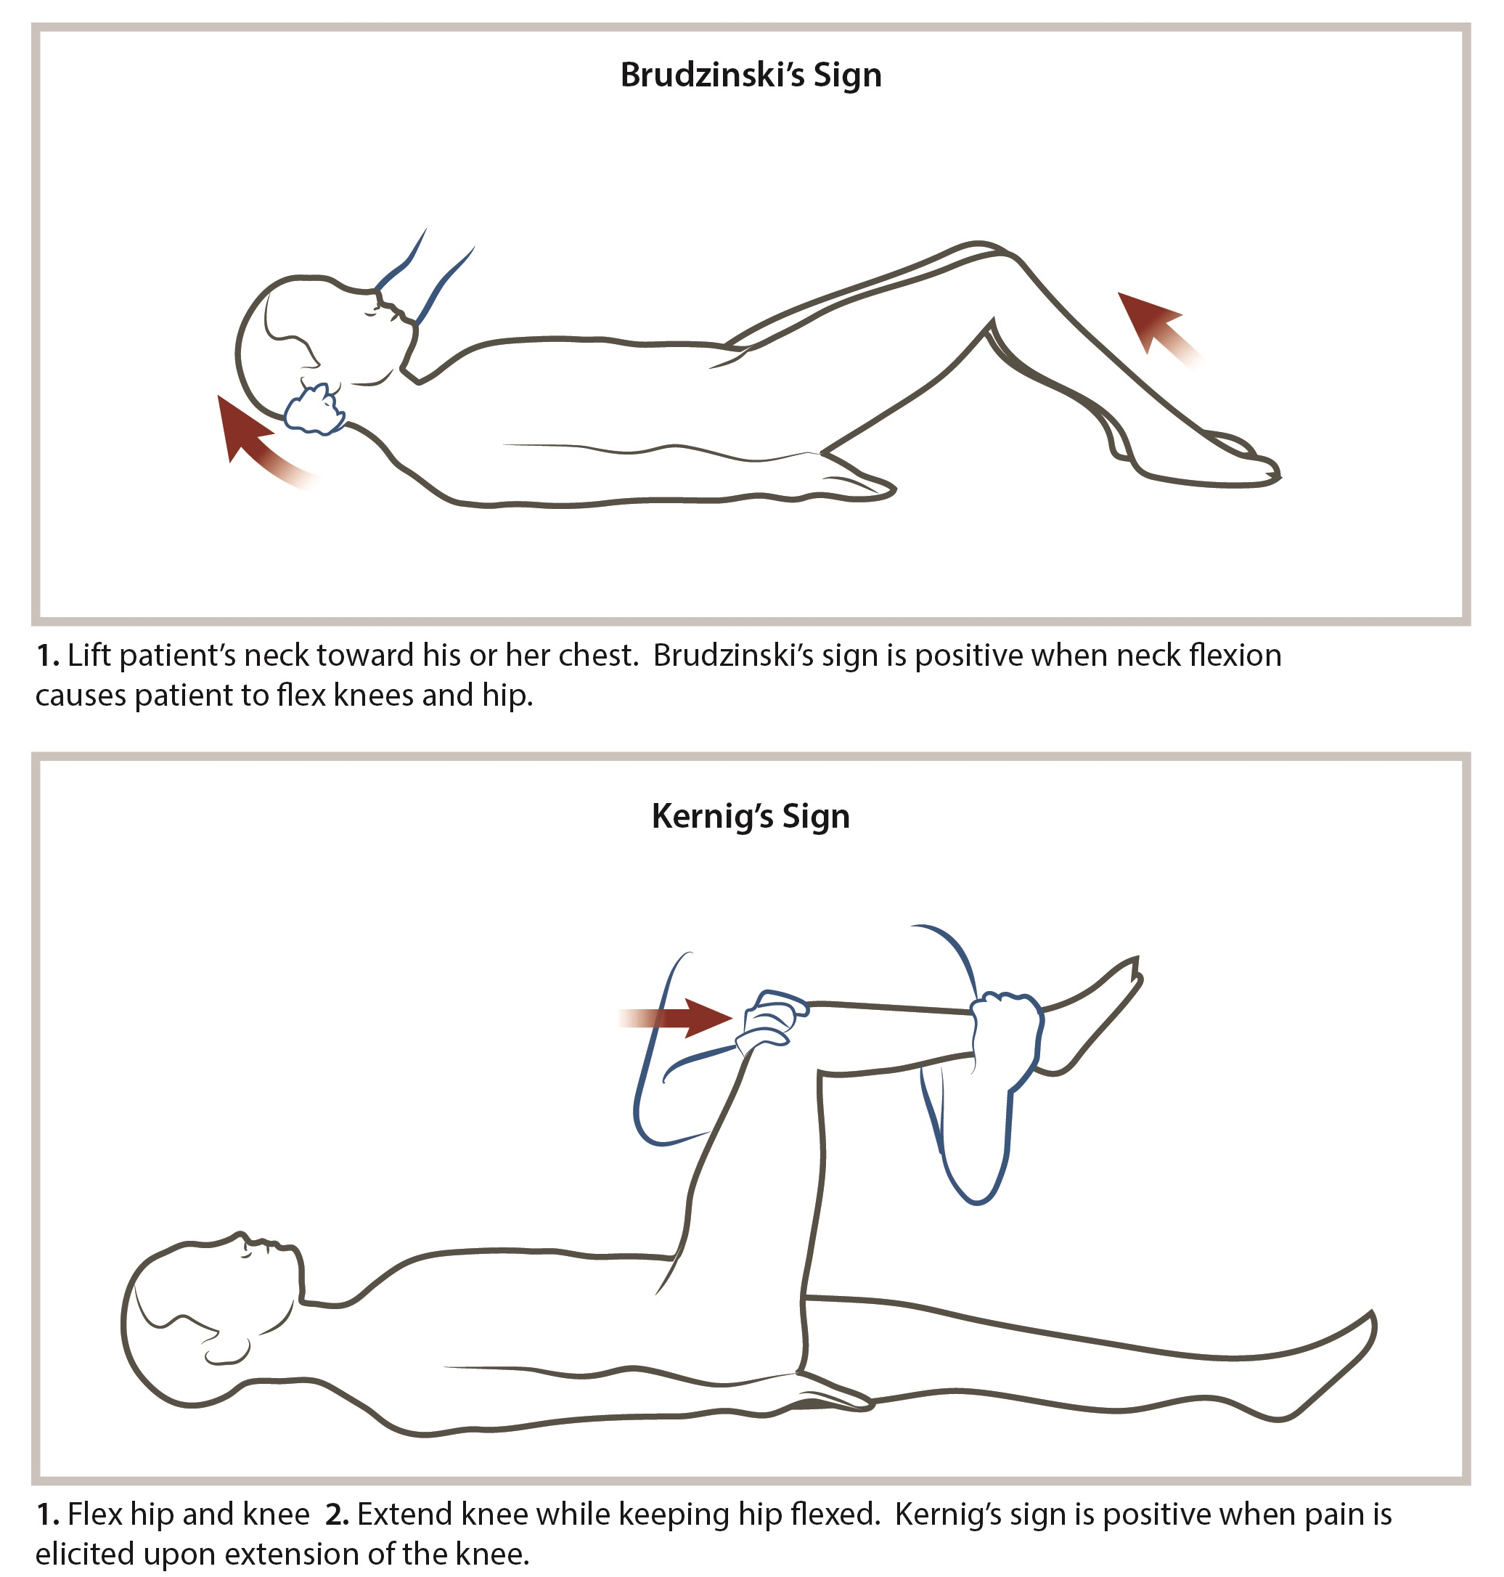

Table 4: Antibiotics and organisms
Antibiotic | Organism coverage
Vancomycin | Resistant S. pneumoniae
Ceftriaxone | S. pneumoniae, H. influenzae, Neisseria meningitidis
Ampicillin | Listeria monocytogenes
Acyclovir | HSV, VZV

Table 5: Duration of treatment based on identified pathogen
Organism | Treatment duration
H. influenza | 7 days
N. meningitides | 7 days
S. pneumoniae | 10-14 days
S. agalactiae | 14-21 days
aerobic gram-negative bacilli | 21 days
L. monocytogenes | at least 21 days
IDSA 2004 recommendations (IDSA Grade A-III)

Table 6: Common bacterial organisms based on patient population
Population | Organisms
2-50 years old | S. pneumoniae; N. meningitis
>50 years old | S. pneumoniae; N. meningitis; Listeria, aerobic gram (-) bacilli
Post-NSGY; CSF shunt | CoNS, S. aureus, aerobic gram (-) bacilli
Skull fracture | S. pneumoniae, H. influenza, group A strep
Penetrating trauma | CoNS, S. aureus, aerobic gram (-) bacilli
Asplenic | S. pneumoniae, N. meningitis, H. influenza

