AHD – Meningitis
Facilitator Guide
Agenda:
1:05 – 1:20 Meningitis Theory Burst
1:20 – 2:10 Case 1
2:10 – 2:20 Questions for the expert & Break
2:20 – 3:15 Cases 2 & 3
3:15-3:30 Questions for the expert and Wrap Up

Quick Biostats before we start:
Please complete prior to starting AHD!
300 people got LPs (gold standard) for suspected bacterial meningitis. 100 patients were CSF culture positive for bacterial meningitis. Of these culture- positive patients, 56 did not have the classic triad of fever, neck stiffness, and altered mental status. What is the sensitivity of the classic triad for bacterial meningitis?

 | Has Disease (Gold Standard +) | Doesn’t Have Disease (Gold Standard -)
Test Positive | 44 (True Positives)
Test Negative | 56 (False Negatives)

- Sensitivity= TP/(TP+FN)= 44/(44+56)= 0.44
- Sensitivity is based upon a 2004 prospective study of 696 cases of community-acquired bacterial meningitis
- The classic triad of fever, neck stiffness, and altered mental status is only 44% sensitive
- Learning point: Almost all patients with bacterial meningitis present with at least 2 of the 4 symptoms – headache, fever, neck stiffness, and AMS (GCS < 14). If a patient has none of these symptoms then there is a high negative predictive value.

Case 1
A 28-year-old man presents with a 2-day history of severe headache localizing to the back of the head. He has associated nausea, emesis, and light sensitivity. He recently had an episode of sinusitis. He has not had any recent travel. He has no past medical/surgical history. He takes ibuprofen PRN, which he has been using regularly during the past 24 hours for headache. He has no allergies to medications. He is an industrial engineer.

VS: 101.8 °F, BP 134/82, HR 95, RR 13, and 98% on RA.
General: Patient appears uncomfortable.
HEENT: Reports photophobia with eye exam. PERRL. EOMI. No papilledema on non-dilated examination. There is mild, bilateral maxillary sinus tenderness.
Lungs: CTAB, normal effort
CV: RRR, normal S1 and S2, no m/r/g
Neuro: AOx4 without confusion. There are no focal findings.
Skin: He has no rashes, oral or genital ulcers.

The Kernig (inability to allow full knee extension when hip is flexed to 90 degrees) and Brudzinski (spontaneous flexion of the hips during attempted passive neck flexion) signs might come up in conversation here. Neither of these tests are useful in ruling in or ruling out bacterial meningitis. The only test that might have diagnostic utility is the jolt accentuation test (patient with headache quickly turns head from side to side and test is positive if headache worsens), which has a high negative LR.

- What is on your differential diagnosis?
- Bacterial / viral meningitis – Table 1 of appendix lists most common organisms
- Drug-induced meningitis (NSAID’s, Bactrim – suspected type 1 & 3 hypersensitivity)
  - Moris G, Garcia-Monco JC. The Challenge of Drug-Induced Aseptic Meningitis. Arch Intern Med.1999;159(11):1185–1194. doi:10.1001/archinte.159.11.1185
- Inflammatory conditions
- Subarachnoid hemorrhage, Subdural hemorrhage, CNS malignancy
- Sinusitis, mastoiditis, spinal epidural abscess, brain abscess
- Primary headache conditions (migraine, etc.) though pt’s fever suggests against this

- What diagnostic studies would you obtain?
IDSA recommended studies:
- Blood cultures: 53% prevalence of bacteremia in cohort of 118 adults with acute bacterial meningitis
  - N. Proulx, D. Fréchette, B. Toye, J. Chan, S. Kravcik; Delays in the administration of antibiotics are associated with mortality from adult acute bacterial meningitis, QJM: An International Journal of Medicine, Volume 98, Issue 4, 1 April 2005, Pages 291–298 full-text)
- CBC, BMP, serum glucose, consider CRP
  - Ask learners: why do you need to check a serum glucose?
    - Compare to the CSF glucose and calculate ratio. If ratio of CSF glucose : serum glucose < 0.4 then bacterial meningitis is likely. (80% sensitive, 98% specific)
  - Normal CRP has high NPV for bacterial meningitis in the context of negative CSF gram stain (IDSA Grade B-II)
- Lumbar puncture: opening pressure, cell count with differential, CSF glucose, CSF protein, CSF gram stain and culture.
  - Enteroviral PCR may reduce length of hospital stay, use of antibiotics, and ancillary diagnostic testing (IDSA Grade B-II)

- Does this patient need a head CT before LP? Why or why not?
- No, this patient does not need a CT.
- Indications for head CT prior to LP:
  - H/o CNS diseases
    - Includes those associated with CSF shunts, hydrocephalus, or trauma, those occurring after neurosurgery, or various space-occupying lesions.
  - New- onset seizures, <1 week
  - Immunocompromised state
    - Includes HIV/AIDS, immunosuppressive therapy, or hx of transplant
  - Suspicious signs of increased intracranial pressure or space-occupying lesions
    - Papilledema
    - Focal neurologic signs (i.e. abnormal LOC, gaze palsy, abnormal visual fields, facial palsy, arm drift, leg drift, abnormal language)
  - Moderate-to-severe impairment of consciousness (GCS <10)
    - an inability to answer 2 consecutive questions correctly or to follow 2 consecutive commands

- You perform a Lumbar Puncture. What CSF studies would you order for each tube?
Tube #1: Cell Count | Tube #2: Gram stain & culture | Tube #3: Protein, glucose | Tube #4: Cell count #2
Numbers correspond to the order the tubes are collected when tap is obtained.
Other tests: eg Viral PCR can go in 5th tube

Case 1 continued:
Labs:
\ 14.2 /
8.2 ----- 335
/ 44 \

Differential shows left shift.

135 | 102 | 11 /
------------------------ 110
4.0 | 24 | 0.8 \

Hepatic panel: normal
CRP: 55mg/L (N: 1-10 mg/L)
Serum glucose: 98 @ 12:00PM
CSF analysis @ 12:00PM
Opening pressure: 2200 mm H₂O (normal: 70-200 mm H₂O)
WBC: 1200/µL with 60% neutrophils, 40% lymphocytes (N:0-5/μL (0-5× 10⁶/L))
Glucose: 30 mg/dL (N: 40-80 mg/dL)
Protein: 350 mg/dL (N: 15-60 mg/dL)
Gram stain: see QR code below
Culture: processing

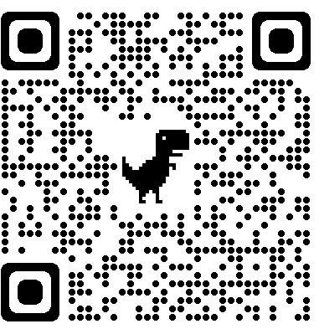

- What is your assessment of the above labs?
Facilitators emphasize bacterial vs viral meningitis based on LP. Refer to tables 2 and 3 of the appendix.

CBC is normal but has a left shift. CRP, while non-specific, is elevated and suggests an inflammatory state. CSF analysis reveals an elevated opening pressure, elevated WBC with neutrophilic pleocytosis, low glucose (<40% of simultaneously measured serum glucose), and high protein, which is consistent with bacterial meningitis. Protein is high due to increased permeability of blood brain barrier which causes markedly elevated CSF protein levels. Gram stain is concerning for pneumococcal meningitis. Can reference the common organisms listed in table 1 of the appendix and Tables 2 & 3 for interpretation of CSF.

Diagnostic accuracy of CSF parameters for diagnosis of bacterial meningitis
- Lactate > 3.5 mmol/L had sensitivity 100%, specificity 100%
- CSF glucose/blood glucose ratio < 0.35 had sensitivity 92%, specificity 100%
- neutrophils > 260 cells/mm³ had sensitivity 92%, specificity 100%
- leukocytes > 388 cells/mm³ had sensitivity 81%, specificity 92%
- protein > 1,934 mg/L had sensitivity 88%, specificity 100%
- Reference - Eur J Clin Microbiol Infect Dis 2015 Oct;34(10):2049

- What is your initial management? What initial admission orders would you place, including doses of any medications?

Start antibiotics ASAP after diagnosis of bacterial meningitis is suspected or proven. Empiric antibiotics indicated if LP is delayed or purulent meningitis. Empiric treatment is based on likely pathogens. Admission orders for our case: Reference figure 1 of the appendix for EPIC orders.
- IV vancomycin 15-20 mg/kg q8-12h with goal serum trough of 15-20 mg/L
  - Indication: for ceftriaxone-resistant S. pneumonia
- IV ceftriaxone 2g q12h or 4g q24h (OR IV cefotaxime 8-12g/day with q4-6h dosing)
  - Indication: for S. pneumoniae, H. influenzae, Neisseria meningitides
- IV dexamethasone 0.15 mg/kg q6h for 4 days (2-4d per IDSA guidelines)
  - First dose 10-20 minutes before or with first antibiotic dose
  - Decreases CNS inflammation that leads to lower mortality, fewer short-term neurologic sequelae, and decreased hearing loss in pneumococcal meningitis when used as adjunctive therapy in developed countries. (CCJM article 2014)
  - Recommended in all adults with suspected/proven pneumococcal meningitis (IDSA Grade A-I). Insufficient data to recommend in adults with meningitis by other pathogens (IDSA Grade B-III).
  - Not recommended in patients who have already received antibiotics as unlikely to improve patient outcomes
- Preventative measures recommended by CDC
  - Droplet precautions for hospitalized patients as soon as diagnosis is suspected through the first 24 hours of antimicrobial therapy (CDC 2007 PDF) (Airborne if any concern for TB meningitis)
  - Chemoprophylaxis for close contacts of patients with N. meningitidis
    - Defined as: closer than 3 ft for >8 hrs OR those exposed to oral secretions and exposed during the 7 days prior to and 1 day after start of antibiotics (ex –roommates, partners)
    - Rifampin 600 mg q12h for 2 days, OR ciprofloxacin 500 mg single dose, OR ceftriaxone 250 mg IM single dose
    - Reference - N Engl J Med 2006 Oct 5;355(14):1466 full-text

Duration of therapy: See Table 5 in Appendix

Possible questions for the expert:
For meningococcal meningitis, what is the close contacts prophylaxis prescribing recommendation? Who is a close contact?
For suspected pneumococcal meningitis, should we be giving rifampin if truly concerned about resistant strep with dexamethasone?
Can you detail when and/or why a CSF lactate would be useful?
IDSA recommends not to give dexamethasone to adults who have already received antibiotic therapy (IDSA Grade A-I). Are there any exceptions to this? What does this mean for treatment?
Must all therapy be completed inpatient or can patients transition to outpatient therapy?
What are the indications for repeat LP in bacterial meningitis?

Break!

Case 2
A 65-year-old female with PMHx of HTN and SLE complicated by nephritis presents to the ED with headache, fever, nausea and vomiting for 2 days. She has associated lightheadedness, photophobia, and neck pain. She is retired and babysits for two school-age grandkids, but neither has been sick. She does not smoke or drink alcohol. Medications include ASA, lisinopril, and cyclophosphamide. She has no allergies to medications.

- What is on your differential diagnosis? How would you use your physical exam to support/refute your concerns?
- Assess for focal neurologic deficits, mental status changes, signs of elevated ICP
- Meningeal signs are not reliable for diagnosing or ruling out meningitis.
  - Prospective study of meningeal signs: Clin Infect Dis 2002 Jul 1;35(1):46 full-text
    - Nuchal rigidity: 30% sensitive, 68% specific, 26% PPV, 73% NPV
    - Kernig sign: 5% sensitive, 95% specific, 27% PPV, 72% NPV
    - Brudzinski sign: 5% sensitive, 95% specific, 27% PPV, 72% NPV
    - Positive likelihood ratios for all 3 signs ranged from 0.94-0.97
- GU exam for herpetic lesions (present in 85% of cases of herpes encephalitis)
- Rashes – Neisseria often has purpuric rash. Viral illnesses with aseptic meningitis can also have various rashes

Case 2 continued.
Physical exam:
Vitals: 100.8°F, BP 125/84, HR 64, RR 18, 99% RA
Gen: Ill-appearing but in no acute distress
HEENT: PERRL, EOMI, no papilledema on non-dilated fundoscopic exam
Neck: Neck stiffness, + Kernig, + Brudzinski (see figure 2 in appendix)
CV: RRR, no murmurs
Lungs: CTAB, normal effort
Abd: Scaphoid, soft, nontender
GU: No lesions/rashes
Neuro: CN intact, strength 5/5, sensation intact, DTRs 2+
Skin: Dry skin, no rashes
- Initial labs including CBC, BMP, INR, and CRP are all normal. You are concerned about meningitis. What are the next best diagnostic steps for this patient?
- Pt is immunocompromised (this patient is immunocompromised, on cyclophosphamide)
- You should obtain blood cultures and then a head CT
- You should start empiric antibiotics prior to obtaining the head CT (but after the Blood Cxs) so as not to delay therapy.
  - Note: complete sterilization of the CSF can occur within 2 hours for N meningitides and within 4 hours for S pneumoniae after starting antibiotic therapy, but antibiotic therapy should not be delayed if a LP cannot be done expeditiously

- What therapy will you start?
Meningitis, bacterial or viral, is highly suspected. The patient is immunocompromised and over the age of 50. As such, would start:
- IV vancomycin for ceftriaxone-resistant S. pneumonia
- IV ceftriaxone for S. pneumoniae, H. influenzae, Neisseria meningitides
  - 3rd gen cephalosporins are bactericidal with good CNS penetrance and coverage of typical organisms
- IV ampicillin 2g q4hrs for Listeria monocytogenes
  - Indicated as empiric therapy for patients > 50 years old or immunocompromised
- Would you give IV acyclovir to cover HSV, VZV? Can discuss. **Consider question for the expert
  - Per IDSA, give empiric acyclovir to all patients with meningoencephalitis pending outcome of diagnostic studies (Grade A-III), with dosage 10 mg/kg IV every 8 hours (IDSA Grade A-I) (Clin Infect Dis 2008 Aug 1;47(3):303 full-text)
- Would you give IV dexamethasone? Can discuss. **Consider question for the expert

- The CT Head is negative for recent or remote stroke, hemorrhage, intracranial lesions, or herniation. After multiple attempts by several providers in the ED and on medicine, CSF is unable to be obtained. IR is unavailable currently. Discuss the course of therapy that you would prescribe for this patient.

- This is a great question/discussion for the expert. In this case where there is a high suspicion for meningitis at the presentation, but we are unable to obtain CSF for culture what do we do? First, look at the blood cultures – if they are positive then this can guide your course of therapy. If the blood cultures are also negative, then you likely need to commit the patient to a full course of antibiotics to adequately cover N meningitides, S pneumo, and Listeria. Depending on index of suspicion for HSV, you might also commit her to a full course of acyclovir.

Reference tables 4-6 of the appendix for bacterial organisms based on patient population, treatment, and duration of therapy.

Case 3
An 80-year-old woman with history of HTN, DM2, early dementia, and hypothyroidism is hospitalized for a 1-day history of AMS and fever. Her family notes that yesterday she seemed confused and had trouble getting dressed. This morning, she was extremely somnolent, and she was transported to the hospital by ambulance. She takes lisinopril, metformin, donepezil, and levothyroxine. She has no medication allergies. Per family, she is independent with ADL’s but does not manage her finances any longer. She lives with her son and grandchildren but has no sick contacts. She has a celebratory glass of wine on holidays, has never smoked and does not use illicit substances.

Physical exam:
VS: 101.2 °F, 118/78, HR 110/min, RR 24/min, and 98% on RA.
Gen: Appears ill. She responds to deep stimulation with a grimace.
Neuro: Oriented to name only, speaking random words. Does not follow commands. She moves all extremities spontaneously, withdraws from pain. Face is symmetric without droop. Opens eyes to pain. PERRL, no papilledema on non-dilated fundoscopic exam. Unable to flex neck, + Kernig, + Brudzinski (see figure 2 in appendix)
Cardiovascular: tachycardic, no murmurs
Pulmonary: CTAB, tachypnea noted
Abdominal: soft, non-tender, non-distended, BS normoactive
GU: No lesions or rashes
Skin: warm, dry, no rash.

Labs/Diagnostics:
Does she need a CT head? Yes – ask them why before you provide the results (GCS < 10)
CT Head: No intracranial hemorrhage or mass. No lesions identified. Normal ventricular size. Chronic small vessel ischemic changes noted.
CBC: \12.7/
4.8 ----- 287 with normal differential
/ 37 \
CMP: normal
CRP: 8mg/L (N: 1-10 mg/L)
UA: no WBC, negative nitrite, no protein
Serum glucose: 98 @ 11:00AM
CSF analysis @ 11:00AM
Opening pressure: 80 mm H₂O (normal: 70-200 mm H₂O)
WBC: 11/µL with 60% lymphocytes, 40% neutrophils (N:0-5/μL (0-5× 10⁶/L))
Glucose: 66 mg/dL (N: 40-80 mg/dL)
Protein: 76 mg/dL (N: 15-60 mg/dL)
Gram stain: no organisms
Culture: processing
HSV PCR: processing
Blood cultures: processing

- Discuss your differential diagnosis for this patient.
- Aseptic Meningitis
  - Non-polio enterovirus as most common causes (coxsackie, echovirus)
  - HSV 1, 2
  - VZV (more often in immunocompromised patients)
  - Arbovirus (West Nile may have neurologic deficit such as asymmetric flaccid paralysis)
  - HIV (eg CSF: WBC 55, lymphocytic, glucose 70, pressure 80mmH2O, protein 149)
- Encephalitis (viral etiologies above)
- Early bacterial meningitis
  - S. pneumoniae, N. meningitides, L. monocytogenes
- Atypical bacterial causes e.g. Lyme, TB, syphilis, cat scratch disease, RMSF
- Hyperthyroid/thyroid storm
- Inflammatory / Autoimmune
  - Malignancy e.g. lymphomatous meningitis, carcinomatous meningitis
  - Autoimmune (rare at this age) e.g. sarcoidosis, SLE
  - CNS vasculitis
- Delirium
  - Infectious, medication, etc.
- Vascular
  - Stroke
- Overdose/medication-related

- Appropriate empiric therapy is started. During her stay an MRI Head is obtained. HSV PCR from CSF returns positive. What is the diagnosis and management?

Diagnosis is HSV encephalitis. >90% of cases are HSV 1. Etiology can be primary infection, reactivation of latent disease, and potentially from reinfection with a second HSV strain. MRI is recommended for all patients with encephalitis. CNS HSV type 1 infection causes a necrotizing infection of the temporal lobes. Localization of inflammation to one or both temporal lobes on neuroimaging strongly suggests HSV encephalitis. The sensitivity and specificity of CSF HSV PCR is >95%. However, in early infection the PCR may be falsely negative. If suspicion for HSV encephalitis is high, then acyclovir should be continued with repeat CSF HSV PCR 3 to 7 days later. Treatment is with IV acyclovir 10 mg/kg q8h for duration of 14-21d. Treatment with acyclovir has reduced mortality from 70% to about 8%-28%.

Case 4 - Bonus
A 68 yo male with a history of HIV (last CD4 count 190 ~1 year ago) nonadherent to HAART, DM2, HTN, and alcohol use disorder presents with altered mental status. He lives at home with his nephew who noticed that he had been “off” the past week and had been complaining of a headache and fatigue. His nephew thought it could be COVID, as these are two of the symptoms. The nephew has been isolating himself in the basement of their shared home for the past 4 days. This morning, the nephew went to check on him and found the patient unarousable in his bed. The patient is retired, widowed, and is not sexually active. His nephew reports the patient does go to the neighborhood bar nightly.

Physical exam:
VS: T 101, HR 102, BP 114/91, RR 22, SpO2 95% on RA
Gen: appears acutely ill, thin, and disheveled
HENT: normocephalic, atraumatic
Neck: supple
Neuro: somnolent, intermittently opens eyes spontaneously. Withdraws from pain. Face symmetric, no droop. PERRL.
Cardiovascular: tachycardic
Pulmonary: CTAB, tachypnea
Abdominal: soft, non-tender, non-distended, BS normoactive
Skin: warm, no rash

1. What is your differential for altered mental status in this patient?
AMS in an immunocompromised patient. The differential is BROAD!
- Infectious: UTI, pneumonia, bacteremia, meningitis, encephalitis, COVID-19 disease
  - Encourage them to think about HIV and particular risk factors for specific infectious etiologies such as cryptococcal meningitis, toxoplasma encephalitis, CMV encephalitis
- CNS lesions: PML, HIV encephalopathy, lymphoma
- Toxic: intoxication, polypharmacy
- Metabolic: electrolyte derangements in an alcoholic, vitamin deficiencies (thiamine, B12), hypoglycemia, HE
- Vascular: ischemic, hemorrhagic
- Autoimmune, vasculitis
- Seizure, status
- Psychiatric

2. You appropriately order blood cultures, begin empiric antibiotics, and then obtain a head CT in this patient prior to undergoing LP. Head CT shows mild hydrocephalus. You discuss with neurology and they agree that an LP is necessary for further diagnostic work up. When measuring the opening pressure, CSF shoots out the top of the manometer! What are you thinking?

- A subacute clinical picture of HA, fever, AMS in an immunocompromised patient non-adherent to HAART, now with high opening pressure on LP and hydrocephalus is concerning for an atypical cause of meningitis. Check CSF for the usual culture and gram stain, protein, glucose, WBC count but also send cryptococcal culture and antigen.
- Serum cryptococcal antigen – in symptomatic patients with suspected cryptococcal meningoencephalitis, sensitivity of serum CrAg testing is comparable to CSF testing in patients who cannot undergo LP.
- ID consult!

3. The lab calls you with an urgent result (see QR code for stain). What is your treatment approach?

- If you haven’t called them yet, call ID!
- Amphotericin B + flucytosine for at least 2 weeks of induction therapy; then fluconazole for consolidation therapy
- If increased ICP, serial LP vs lumbar drain – may be a good question for the expert!

Appendix
Table 1: Most common organisms for meningitis
Organisms
Bacterial | Viral
Streptococcus pneumoniae (~50%) | Enterovirus
Neisseria meningitidis (~25%) | HSV 1, 2
Gram-negative bacilli | HIV
Staph. Species | Arthropod-borne viruses (eg – WNV)
Listeria monocytogenes** | VZV, EBV
Pseudomonas aeruginosa
**Risk factors for Listeria meningitis: age >50, pregnancy, immunocompromised, ETOH

Table 2: Bacterial vs Viral CSF analysis
Test | Bacterial | Viral
Opening pressure | High | Normal – high
WBC | Very high; Neutrophilic | High; Lymphocytic
Glucose | Low | Normal
Protein | High | Normal – High
GC / Culture | GS+ >60%; Cx+ >80% | Negative

Table 3: CSF profiles
Cerebrospinal Fluid Profiles
Investigation | Normal | Bacterial | Viral | Tuberculosis | Fungal
Opening pressure | 10-20 cm (50-180 mm H₂O) | High | Normal/high | High | High/very high
Color | Clear | Cloudy | Clear/cloudy | Cloudy/yellow | Clear/cloudy
Cells | < 5 mm³ | 1,000-50,000 mm³ | 50-1,000 mm³ | 50-500 mm³ | 0-1,000 mm³
Differential | Mononuclear | Neutrophilic | Lymphocytic | Mononuclear | Mononuclear
Glucose | > 45 mg/dL (2.5 mmol/L) | < 40 mg/dL (2.2 mmol/L) | > 45 mg/dL (2.5 mmol/L) | < 45 mg/dL (2.5 mmol/L) | > 45 mg/dL (2.5 mmol/L)
Protein | < 45 mg/dL | 100-500mg/dL | < 200 mg/dL = | 50-300 mg/dL | > 45 mg/dL

Figure 1: EPIC Inpatient CSF labs order set

Figure 2: Kernig and Brudzinski sign
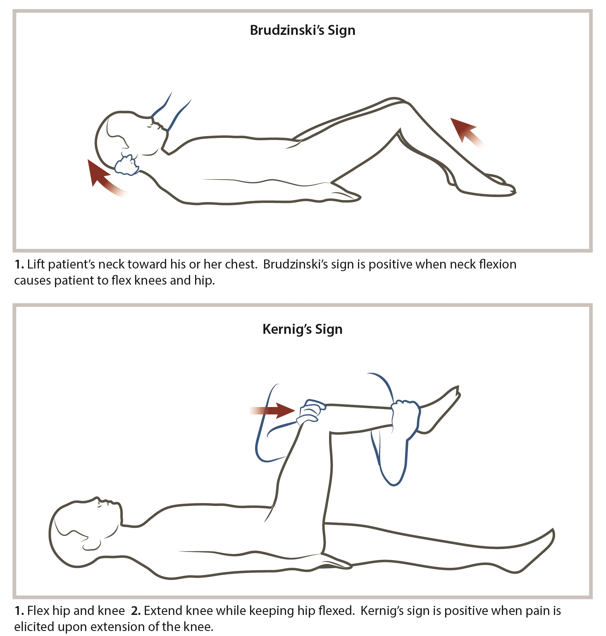

Table 4: Antibiotics and organisms
Antibiotic | Organism coverage
Vancomycin | Resistant S. pneumoniae
Ceftriaxone | S. pneumoniae, H. influenzae, Neisseria meningitidis
Ampicillin | Listeria monocytogenes
Acyclovir | HSV, VZV

Table 5: Duration of treatment based on identified pathogen
Organism | Treatment duration
H. influenza | 7 days
N. meningitides | 7 days
S. pneumoniae | 10-14 days
S. agalactiae | 14-21 days
aerobic gram-negative bacilli | 21 days
L. monocytogenes | at least 21 days
IDSA 2004 recommendations (IDSA Grade A-III)

Table 6: Common bacterial organisms based on patient population
Population | Organisms
2-50 years old | S. pneumoniae; N. meningitis
>50 years old | S. pneumoniae; N. meningitis; Listeria, aerobic gram (-) bacilli
Post-NSGY; CSF shunt | CoNS, S. aureus, aerobic gram (-) bacilli
Skull fracture | S. pneumoniae, H. influenza, group A strep
Penetrating trauma | CoNS, S. aureus, aerobic gram (-) bacilli
Asplenic | S. pneumoniae, N. meningitis, H. influenza

