Academic Half Day – Perioperative Medicine
Learner Guide

Case 1
Perry Oppenheimer is a 48yo male has been admitted with an ankle fracture that he got during a soccer game. Ortho has consulted you for medical clearance prior to surgery. You review his chart to find he has a PMHx of HTN and HLD and is on lisinopril and atorvastatin. Labs including a CBC and renal panel on admission are normal.
PE: BP 130/74. CV exam is normal and L ankle shows deformity and mod effusion.

- How do you clear the patient for surgery?

- What do you want to know on a focused history and exam?

- What tools can you use to risk stratify patients perioperatively?

- How do you advise the patient and your surgical colleagues?

- What group of patients might require additional consideration not captured by RCRI?

Case 2
Ryan Clarke-RIchardson is a 63 yo is admitted with a fracture of the humerus after he slipped on icy steps during the snowpocalypse last week. Ortho has consulted you for medical clearance prior to surgery. You review his chart to find he has a PMHx of HTN, HLD, DMII, and CKD. He is a current smoker and has a 50-pack year history of smoking.
Meds: ASA, atorvastatin, valsartan, insulin glargine 15u, insulin lispro 8u with meals, acetaminophen and ibuprofen PRN
The patient walks 6 blocks from his bus stop to his office building in the mornings and goes up 3 flights of stairs to get to his office. His review of systems is negative.

Vitals and exam are unremarkable except for bruising over high left proximal arm and ROM limited by pain. Labs show a creatinine at baseline of 2.1.

- How do you advise the patient and the surgical teams?

- Would you recommend obtaining an EKG in this patient prior to surgery?

- What instructions would you give this patient about what med changes to make prior to surgery?

  - ASA

  - Atorvastatin

  - Insulin

  - Valsartan

  - Acetaminophen

  - NSAIDs

Case 3
A 57 yo male with a PMH significant for HTN, DMII, and ischemic stroke 4 years ago has been admitted for a known AAA repair. He is non-ambulatory and lives with his wife who is his caretaker. He has a 60-pack year smoking hx (quit after stroke).
Meds: amlodipine, insulin, aspirin, atorvastatin, and fiber supplements.
Cardiopulmonary ROS is negative.
Vital signs are normal. Patient is non-ambulatory. Labs on admission are unremarkable.

General surgery has consulted medicine for cardiac clearance prior to proceeding with AAA repair.

- What do you discuss with the patient and the surgical team?

As you advised, a pharmacologic stress test is performed and is positive with regions of inducible ischemia.

- The surgery team asks when the patient will go for a LHC given abnormal stress. Should this patient undergo a LHC with plans for revascularization?

Case 4
A 58 yo female with a PMH significant for HTN, HLD, type II DM, tobacco use, and CKD is seen for preoperative evaluation for a planned hysterectomy in tomorrow. She is employed as a postal carrier and ambulates 6 miles a day along her route. Cardiopulmonary ROS is negative.

Meds: Lisinopril, amlodipine, glargine, lispro, and atorvastatin
Vitals and labs are normal.
Lab work from last week reveals a baseline serum creatinine of 2.5.

- What is your cardiac risk assessment of this cardiac risk? And what are your next steps?

- When do we start beta-blockers preoperatively to reduce risk of an intra- /post- op MI?

- How might initiation of beta-blockers affect perioperative risk of MACE?

- What if the patient was already taking metoprolol for HTN? Should it be held on day of surgery?

Case 5
A 61-year-old man is seen for preoperative evaluation before left total hip arthroplasty scheduled in 1 week. In addition to chronic left hip pain, his medical history is notable for CAD s/p PCI 5 months ago. TTE at the time revealed a normal LVEF and no structural heart disease. His physical activity is extremely limited due to hip pain, but he denies angina, dyspnea, palpitations, and syncope.
PMHx: CAD, HTN, HLD, OA
Meds: aspirin, clopidogrel, carvedilol, atorvastatin, and lisinopril
Physical exam: BP 126/78, HR 64. Cardiopulmonary exam is normal.

The surgery team has asked you if this patient can stop his dual antiplatelet therapy prior to surgery.

- What do you advise?

- You find out that the patient had a DES stent placed in LAD 5 months ago for an NSTEMI. What do you recommend?

- What if the stent had been placed for chronic angina that was not adequately responding to medical therapy?

- You find out that that the chart was incorrect and that the patient actually only had a balloon angioplasty performed 5 months ago and did NOT receive a stent. What do you recommend?

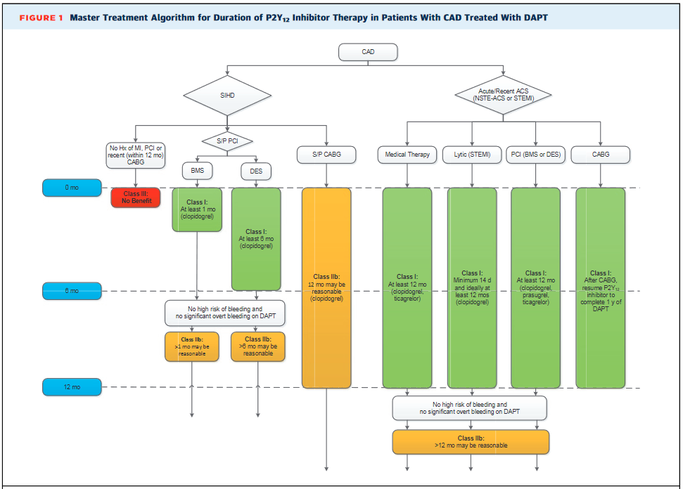
2016 ACC/AHA GUIDELINES focused update on DAPT duration

Case 6
A 68-year-old male is seen for preoperative evaluation prior to repair of an abdominal aortic aneurysm in 2 weeks. He has been in good health. He exercises on an elliptical for 30 minutes daily. He denies angina, dyspnea, palpitations, and syncope.
PMHx: atrial fibrillation, HTN
Meds: warfarin, amlodipine, atorvastatin, multivitamin

PE: BP 124/72, pulse is 60. Cardiovascular examination reveals an irregular rhythm, normal S1, S2.
INR 2.4 (three days ago)
EKG 2 months ago showed Afib with no other abnormalities
TTE 2 months prior showed normal left ventricular function

- What is this patient’s perioperative cardiac risk?

- What do you do with this patient's anticoagulation?

- Do you need to bridge this patient’s anticoagulation? How do you decide?

- What if this patient was on anticoagulation for their prosthetic mitral valve. How would you advise?

Case 7
72yo male with PMHx of HTN, HLD, DMII, COPD, CVA and smoking is seen prior to morning rounds where he complains of severe pain from his left leg that start a few minutes prior. He was admitted to your service two nights ago for a COPD exacerbation and is being treated with PO prednisone. He was due to discharge today since his breathing had stabilized. At baseline, he walks short distances with a walker because of his chronic osteoarthritis.
Meds: insulin glargine, insulin lispro, aspirin, lisinopril, pravastatin, ipratropium/albuterol, prednisone
PE: BP 150/85, HR 105, RR 18, SPO2 95% on RA.
Cardiac exam normal, Lungs clear, DP/PT pulse not obtainable even with doppler.
Patient unable to dorsiflex L ankle. R leg unremarkable
Labwork from yesterday morning shows mild leukocytosis and renal function panel significant for bicarb of 30. Admission EKG showed sinus tachycardia with normal ST and T waves.
You contact vascular surgery who is on the way to see the patient and plans to operate.

What is the next step in periop management?
