HIV and AIDS Academic Half Day
Facilitator Guide

1:10 - 1:25: Theory Burst
1:25 – 2:15: Cases
2:15 – 2:25: Questions for the Expert
2:25 – 2:35: Break
2:35 – 3:20: Cases
3:20 – 3:30: Questions for the Expert

Case #1
A 32 yo F with no past medical history sends you a MyChart message:

Hi doc- Two days ago I had unprotected sex with a man who has HIV. Yesterday I took an at home HIV test which was negative. Is there anything else I should do?

1) EBM Review: Which of the following qualities is most important in a screening test for HIV? Why?
High sensitivity, High Specificity, High Positive Predictive Value, High Negative Predictive value.

- High sensitivity! Remember that the sensitivity of a test is the probability that the test will be positive in those who have disease. When you have a test that has high sensitivity, this helps you rule OUT disease in those patients who have a negative test. In contrast, highly specific tests helps you to rule IN disease if positive. Sensitivity and specificity are qualities of the test and do not change with disease prevalence.
- Positive predictive value reflects the probability that a patient with a positive result truly has the disease. Negative predictive value reflects the probability that a patient with a negative result does not have the disease. PPV and NPV vary with disease prevalence! If we test in a high prevalence area, it’s more likely that a person with a positive test truly has the disease.

2) There is one FDA approved at-home oral swab to test for HIV, Oraquick. How does it work and what does it test for? What is the 4th generation blood test for HIV that we use here, and what does it detect? What are the sensitivity and specificity of these tests? At what point would they be positive after exposure? Divide your team into two groups to look up the answers!

- Currently, there is one home test approved for HIV, Oraquick. This test is commercially available at pharmacies. The patient does a swab of the cheek/gums and places the swab in a tube. This is a test for HIV antibodies and is 91% sensitive and 99.9% specific. However, antibodies usually take about 3-4 weeks to form after infection, so this test is not appropriate for our patient.
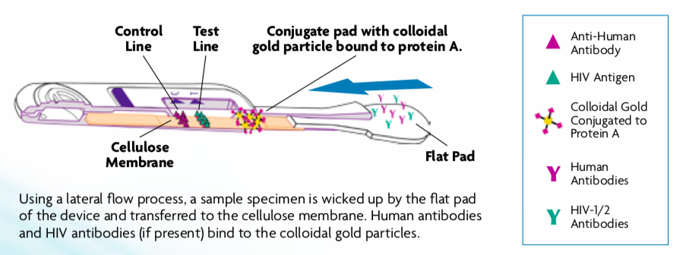
- In contrast, the 4th generation HIV test is the blood test we use in our lab. This test checks for the presence of HIV1 and 2 antibodies AND the p24 antigen (a viral surface protein). There are a few different companies that make this test, but sensitivity AND specificity are around 99.5%. These tests can be positive as early as 2-3 weeks after exposure.

3) Should this patient receive post-exposure prophylaxis (PEP)? Should you get any labs before starting PEP? What is a standard PEP regimen and duration?

- Yes! She has had a high risk exposure to a known HIV positive person in the last 72 hours. See the algorithm below.

Learners have this algorithm in the Appendix of their learner guide.

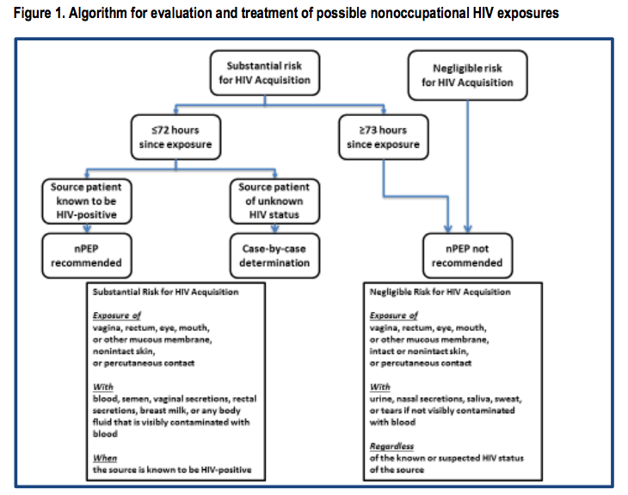
- Baseline labs: HIV test, HBV testing (Surface Ag, Surface Ab, Core Ab), HCV Ab, syphilis, gonorrhea, chlamydia screening (urine +/- oral or rectal swabs if indicated), pregnancy test, renal, LFTs
- Standard regimen is a 3-drug regimen in adults (including pregnant women!) and adolescents >13 with CrCl >60 of tenofovir DF (NRTI) PLUS emtricitabine (NRTI) WITH EITHER raltegravir OR dolutegravir (integrase inhibitor). She should take this for 28 days with a plan for repeat testing at 4-6 weeks after exposure, 3 months, and 6 months.
Case #1, Continued: Despite several attempts, you are unable to contact your patient for follow-up. 10 days later, she presents to the ED with fever, malaise, and sore throat.

4) How does Acute HIV present and what else should be in your differential?
Symptoms of acute HIV can include acute malaise, myalgias, anorexia, weight loss, GI upset, aphthous ulcers, lymphadenopathy, pharyngitis, and rash. This is a very similar presentation to many other acute viral illnesses. Oftentimes, individuals have non-specific or mild symptoms and do not come to the attention of healthcare providers during the acute phase.
Differential Diagnosis:
Most Common: EBV (many experts define acute HIV as a mononucleosis-like illness), Influenza, Strep pharyngitis, Viral/Noninfectious gastroenteritis, Viral URI
Less Common: Acute Viral Hepatitis, Drug Reaction, Primary Herpes Simplex, Secondary Syphilis
Uncommon: Acute CMV, Disseminated Gonococcemia, Primary Immunodeficiencies, Measles, Travel Related Diseases – Malaria, Typhoid

5) You suspect Acute HIV. What is the best test to order at this time and why?
There are two different approaches that you can take to diagnose acute HIV. With both methods you have to consider the window period (Ab not detectable). If a patient is having symptoms then they likely have a positive RNA, but may not have a detectable Ab or Ag:

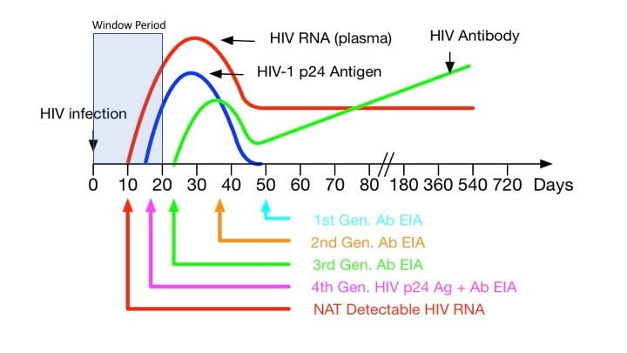
- Order 4th generation HIV Ag/Ab test – This test detects the p24 antigen, which is detectable approximately 15-20 days after HIV exposure, or 5-7 days after viral RNA is detectable. If the test is negative, but you still have a high suspicion for acute HIV then you can repeat the test in 2-4 weeks. The benefit of this test is that it is less expensive than the viral PCR.

- Order HIV Viral RNA- This test turns positive sooner after HIV exposure (can be positive 4-12 days after exposure). The period before RNA is detectable is called the ‘eclipse period’

6) You check the lab discussed above. What do you think this patient’s CD4 count, RNA PCR, HIV Antibody testing to show?
RNA PCR / Viral Load – Elevated. High viremia means that the patient is very contagious.
CD4 Count – Variable in acute HIV
HIV Antibody – May not be present yet due to window period. (p24 antigen may be detectable)

7) You discuss the patient’s HIV infection as well as Anti-Retroviral Therapy (ART). Who should be treated with ART? After initial diagnosis, what other baseline labs should she receive?

Indications for ART:
- All patients with HIV should be offered ART regardless of CD4 count and it should be initiated as soon as possible.
  - Reduces serious AIDS- and non-AIDS-related complications.
  - Reduces risk of AIDS-related morbidity and mortality in CD4 < 350 (used to be some practice of waiting for CD4 count to fall, but recent data has shown morbidity/mortality benefits to initiating before CD4 counts decline)
  - Reduces risk of transmission
- Prior to initiating ART make sure that the patient is agreeable to the medication and willing to commit to a lifelong daily medication regimen. Suboptimal adherence reduces effectiveness and can induce permanent resistance to antiretroviral medications. Also make sure that there are no financial barriers to obtaining the medication – link patients to social services, case management, HIV education, and counseling as indicated.
  - If there are barriers to treatment then address these barriers prior to starting ART.
- Only RARE circumstances exist for NOT initiating ART as soon as possible which include contraindication based on drug-drug interactions with ART (rare with modern drugs), and in acute cryptococcal meningitis, where initiation of ART should be delayed 2-10 weeks after diagnosis to avoid increased morbidity/mortality from IRIS. Note, this is in contrast to other AIDS defining illnesses such as PJP where early initiation of ART reduces mortality).

Baseline Labs:
- Comorbidities & ART Monitoring: CBC, Renal Function (HIV Nephropathy), Hepatic Function, Lipid Profile (increased risk of cardiac events in HIV and effects of ART), Glucose
- Disease Baseline: HIV RNA level and CD4 count
- Resistance Testing: HIV Genotyping
- Infectious Screening:
  - Toxoplasma IgG – if future low CD4 < 100 AND Toxo IgG positive, then will need prophylaxis with Bactrim
  - Syphilis Testing – Trepia if no history of syphilis and RPR if positive history of syphilis
  - Gonorrhea/Chlamydia - swab all orifices (vagina or urine, anal, throat)
  - Hepatitis B – HIV quickens liver damage of HBV and if co-infected with HBV then this affects ART regimen selection.
  - Hepatitis A and C
  - MMRV titers – to inform need for vaccination (although may not give depending on CD4 count)
  - PPD – Induration > 5 mm is positive in the HIV+ population
    - Caveat: if CD4 <200, you should repeat PPD once CD4 count >200 (to avoid false negative)
- Side Effects
  - G6PD – Test in patients of Mediterranean or African origin as some components of ART and prophylaxis medications can cause hemolysis if G6PD deficient
  - HLA-B*5701 – Test before initiation of abacavir due to risk of hypersensitivity reaction
- Pregnancy test – alters treatment regimen and is an absolute indication for treatment.

8) How are you going to monitor her HIV and potential complications?

Serial CD4 Counts and Viral Loads – Every 3 to 6 months. Guidelines (2018) say viral load q 3 months until <50, for one year, then q 6 months. A bit more controversial is CD4 count q 6 months until >250 for a year, then stop checking CD4 unless viral load increases.
Co-infection screening: GC/Chlamydia, Syphilis screening, HCV yearly

9) What preventative care items need to be addressed in patients with HIV?

Vaccinations: Have learners note what vaccines (live) are contraindicated in patients with low CD4 counts. Can discuss why prevnar should be given prior to pneumovax. Prevnar, PCV13 is a conjugated vaccine whereas pneumovax, PPSV, is a polysaccharide vaccine. PCV is recognized as T cell dependent, stimulating antibody response, mucosal immunity, and immunologic memory. PCV stimulates memory B cells and can “prime” the immune system for an enhanced secondary immune response to PPSV.

Learners have this vaccine schedule in the Appendix of their learner guide.

 | HIV Infection with CD4 < 200 | HIV Infection with CD4 >=200 for 6 months
Influenza (inactivated) | 1 dose annually
Influenza (live) | Not recommended
Tdap | 1 dose Tdap then Td or Tdap booster every 10 years
MMR | Not recommended | 2 doses
Varicella | Not recommended | 2 doses
Shingrix | No recommendation
Zostavax | Not recommended | No recommendation
HPV | 3 doses through age 26 years
PCV13 | 1 dose
PPSV23 | 1st – 8 weeks after PCV13, 2nd – 5 years later, 3rd – after age 65 and 5 years from previous PPSV23
Hep A | 2 or 3 doses depending on vaccine
Hep B | 2 or 3 doses depending on vaccine
MenACWY | 2 doses 8 weeks apart and then Q5Years
MenB | Recommended if another risk factor or indication
Hib | Recommended if another risk factor or indication

Cancer Screening – Typical screening per age. However, recommendations state that women with HIV should have more frequent pap smear testing initially after diagnosis (every 6 months – 1 year until 3 consecutive negative tests then can space).
Other Screening – Typical guidelines for AAA screening, osteoporosis, depression, etc.

Case #1 Continued
Your patient moves to Florida and loses touch with the medical system. 12 years later she presents with a generalized tonic-clonic seizure. Prior to this, she had a 2-3 week history of fevers and headaches. Her CD4 count is 14, HIV RNA is >500,000. She is confused, and has a temperature of 101. No nuchal rigidity. On a cursory neurologic exam she has no focal abnormalities.

10) What is on your differential? If you were admitting this patient, what would you do next? Meningitis review: Does this patient require a head imaging before lumbar puncture?
a) Meningitis AHD review: This patient has multiple indications for imaging prior to LP!
- Indications for head CT prior to LP:
  - H/o CNS diseases
  - Includes those associated with CSF shunts, hydrocephalus, or trauma, those occurring after neurosurgery, or various space-occupying lesions.
  - New-onset seizures,<1week
  - Immunocompromised state
    - Includes HIV/AIDS, immunosuppressive therapy, or hx transplantation
  - Suspicious signs of increased intracranial pressure or space-occupying lesions
  - Papilledema
  - Focal neurologic signs (i.e. abnormal LOC, gaze palsy, abnormal visual fields, facial palsy, arm drift, leg drift, abnormal language)
  - Moderate-to-severe impairment of consciousness (GCS <10)
  - an inability to answer 2 consecutive questions correctly or to follow 2 consecutive commands

A CT Head is notable for multiple ring enhancing lesions.

Differential Diagnosis - Most concerning given his CD4 count is Toxoplasmosis or CNS Lymphoma. Toxoplasmosis often has multiple ring-enhancing lesions. Brain abscess and tuberculosis are also on the differential, but less likely. If the lesion had been enhancing on only T2 with flair then PML (JC virus reactivation) would be on the differential diagnosis.

11) How would you further evaluate her? How would you proceed to treat and/or differentiate between etiologies of your differential?

Toxoplasmosis serology studies – If negative then unlikely to be toxoplasmosis.
CD4 Count – If high CD4 count then unlikely to be toxoplasmosis. Toxoplasmosis reactivation typically occurs when CD4 < 100.
Brain Biopsy – This is the only way to definitively tell the difference between toxoplasmosis and CNS lymphoma.

**If patient is at risk for toxo and serology is positive then start treatment. Treatment with pyrimethamine (+leucovorin to prevent marrow suppression) and sulfadiazine. Look for clinical improvement within several days and follow for radiologic improvement in 2-3 weeks. If no improvement then move towards brain biopsy.

12) How could this complication have been prevented in this patient? What are the indications for primary prophylaxis against opportunistic infections in patients with HIV/AIDs?

- Vaccination! See the schedule above.
- Toxoplasmosis: Patients with a CD4 count <100 AND positive Toxoplasma IgG should be given prophylaxis. First line is TMP-SMX 1 DS tab daily. Alternative regimens include dapsone + pyrimethamine + leucovorin or atovaquone +/- pyrimethamine + leucovorin.
- PJP: CD4 <200. TMP-SMX 1 DS tab daily (alternatives: dapsone, atovaquone, inhaled pentamadine)
- Coccidiomycosis A new positive IgM or IgG serologic test in patients who live in a disease-endemic area and with CD4 count <250 cells/μL. Fluconazole 400 mg daily.
- MAC (Mycobacterium avium complex): Prophylaxis is NOT recommended for those who immediately initiate ART even if CD4 is <50. If suppression cannot be achieved and CD4 remains low, prophylaxis is indicated with 1200 mg azithromycin weekly.

Questions for the Expert and Break
Case #2
32 y/o M presents with 2 weeks of shortness of breath, dyspnea on exertion, and cough. He has a 25 lb weight loss over the past 2-3 months. He was diagnosed with HIV in 2006 and had a “pneumonia” five months ago. He takes only OTC medications. When he had “pneumonia”, his CD4 was 135, HIV Quant 329,000 copies
Vital Signs: T 103F, HR 132, BP 80/40, RR 24, SaO2 80% on RA.
Physical Exam: He is thin, tacky mucous membranes, tachycardic, in moderate respiratory distress, has a mildly productive cough, no lymphadenopathy, and has some minor diffuse crackles in his lungs bilaterally.
1) You are admitting this patient to step down level of care during long call. What are your initial steps in management?

Sepsis review! Define sepsis vs septic shock. How much fluid should this patient receive and over what time period?
- Sepsis (Life-threatening organ dysfunction caused by a dysregulated host response to infection) vs Septic Shock (patients who fulfill the criteria for sepsis and require vasopressors to maintain a MAP ≥ 65 mmHg and a lactate > 2 mmol/L (despite adequate fluid resuscitation)
- IVF: 30 cc/kg given within the first 3 hours of resuscitation

2) What is on your differential and what are the next steps in your workup?
Discuss differential: Concerning for PJP Pneumonia – why? Subacute +/- acute decompensation, SOB, dry cough, fever, diffuse bilateral infiltrate. CXR can be normal in 1/3 of cases, High Res CT often has ground glass opacities. Bacterial Pneumonia? Tuberculosis? Histoplasmosis? Also consider non-infectious causes- with uncontrolled AIDs he could have lymphoma and be presenting with a massive PE.

Definitive diagnosis can only be made by demonstration of organism in tissue, sputum, or BAL fluid.
Induced Sputum: Sensitivity 50-90%. Consider obtaining if bronch is delayed.
Bronchoscopy: Sensitivity 96-98% by obtaining samples for PCR.
Discuss empiric treatment vs definitive diagnosis.

What about other possible tests? Beta d glucan aka fungitell (a cell wall component of all fungi) has a high sensitivity and NPV for patients with PJP. Some learners may mention LDH, used to be present in 90% of HIV infected patients with PJP (in the age before ART).

Can discuss management of respiratory failure and sepsis here as well – the patient needs an ABG, both for grading severity of his respiratory failure (regardless of etiology) and for management decisions related to his likely PJP. He also needs to be started on sepsis protocol with fluid resuscitation due to his low blood pressure and tachypnea. (could calculate NEWS/MEWS if you want to)

3) You obtain the appropriate tests and your suspicion was confirmed. How do you grade severity? How can you treat this infection?
- BAL or induced sputum with PJP
- Need ABG to eval A-a Gradient. Moderate-to-severe disease is defined by room air pO2 <70 mm Hg or A-a O2 gradient ≥35 mm Hg
- Preferred treatment regimen is TMP-SMX (15-20 mg/kg/day of TMP) PO or IV in 3 divided doses
- Corticosteroids are indicated for patients who moderate to severe disease as defined above. Patients can clinically worsen on the 2nd and 3rd days of treatment, thought to be due to inflammation due to dying organisms. Steroids can decrease the mortality and respiratory failure associated with PJP. Compared with placebo, the risk ratios for overall mortality in patients receiving adjunctive corticosteroids were 0.56 at one month and 0.59 at three to four months of follow-up.
  - Prednisone 40 mg PO BID x 5 days followed by
  - Prednisone 40 mg PO daily x 5 days followed by
  - Prednisone 20 mg PO daily for 11 days
- Start ART!!! Early therapy (within 2 weeks of infection) reduced the risk of AIDS progression and death by almost half, and was not associated with an increase in adverse events or an increase in the incidence of immune reconstitution inflammatory syndromes (IRIS).

Case #3:

45 year old F with history of AIDS (recent PJP infection, last CD4 of 28) who presents with headache and fever over the last 2 weeks. Her boyfriend brought her in because she was confused. She didn’t know where she was, and wasn’t answering questions appropriately. Her temperature is 101 and she has some neck rigidity and grimaces and resists when you try to flex her neck. He does not believe she has been taking any medications recently.

A CT head is obtained which shows mild atrophy but no mass lesions. A lumbar puncture is performed and analysis of the CSF shows 7 WBC/mm³, glucose of 41 mg/dL and a negative gram stain. The opening pressure is 310 mm H₂O (normal 10-20 mm H₂O). Her current CD4 count is 12. Toxoplasma serology shows IgG positive and IgM negative.

1) What is on your differential diagnosis?
Cryptococcal meningitis. The diagnosis of cryptococcal meningitis should not be ruled out with only 7 wbc/mm³ found in the CSF. More than 50% of AIDS patients with acute cryptococcal meningitis will have a CSF wbc count of less than 20.

Toxoplasma? Less likely as more than 90% of patients with AIDS with Toxoplasma encephalitis will have one or more mass lesion observed on contrast brain CT Scan.

PML? The clinical presentation for PML does not include fever. CT is typically normal, but brain MRI would show extensive white matter lesions.

CNS Lymphoma? Most patients with CNS lymphoma present with a focal finding and evidence of a mass lesion on brain imaging

- What test helps to make the diagnosis?
Cryptococcal antigen test – CSF or Serum. Serum antigen test is positive >95% of patients with active crypto meningitis. Lumbar puncture is important to eval for bacterial meningitis.

Opening pressure should always be measured and often is the clue that suggests cryptococcal meningitis. In a study among 221 patients, 54% had an opening pressure greater than 250mm H20 and 27% had an opening pressure greater than 350mm Hg H20.

- How do you treat the infection?
Start induction therapy with amphotericin B (0.7mg/kg) IV PLUS Flucytosine (100mg/kg PO daily) x 2 weeks. Liposomal amphotericin B preparation 3-5 mg/kg IV (preferred due to lesser side effects)

Then consolidation therapy fluconazole 400mg po daily x 12 weeks. Prior to moving to consolidation, patient must have substantial clinical improvement and a negative CSF fungal culture on repeat lumbar puncture.

Then step down to Maintenance therapy, fluconazole 200mg po daily. Therapy remains lifelong at 200mg daily unless patient has completed initial course of therapy, has no symptoms of cryptococcosis, and the patient’s CD4 count >200 for prolonged treatment.

- Your patient is started on the above therapy, your patient initially improves, but then over the next 24-48 hours her mental status waxes and wanes. Her nurse calls you to the bedside to evaluate the patient – he is worried your patient may be seizing. What could be going on?

Among other things, the patient could have symptoms from increased intracranial pressure. They may require serial lumbar puncture taps, especially if the patient is symptomatic. Goal CSF pressure is <20cm H2O.

- The patient improves with your treatment and is discharged on all of her medications including starting ART with plans to complete therapy for her crypto meningitis. Several days later she returns with severe headache, nausea, vomiting, and malaise, and myalgia. She has had low grade fevers at home. She’s been taking all of her medications, what could be going wrong?

She could have Immune Reconstitution Inflammatory Syndrome.
Consider IRIS when inflammatory signs or symptoms occur after recent initiation, re-initiation, or change to a more effective combination ARV therapy with associated increase in CD4 cell count and/or decrease in viral load and the following have been excluded:
- Worsening of known infections due to inadequate or inappropriate therapy
- New infections not known to be associated with IRIS (e.g., bacterial sepsis)
- Medication reaction

In acute cryptococcal meningitis initiation of ART should be delayed 2-10 weeks after diagnosis to avoid increased morbidity/mortality from IRIS.

Case #4
A 25 yo M presents to your clinic to establish care. He recently saw a TV ad for PrEP and is wondering if he should be on PrEP. He was treated for gonorrhea 6 months ago at the health department.

1) What else would you like to know? What are the indications for PrEP? What is the recommended PrEP regimen? What are common side effects of this regimen?
- Additional sexual history- new partners, MSM, protection, etc.
- An history of IVDU or any other needle sharing (also consider tattoos, razors, etc)
Indications for PrEP: Learners have this table in the Appendix, but encourage them to think through the answer before directing them there!
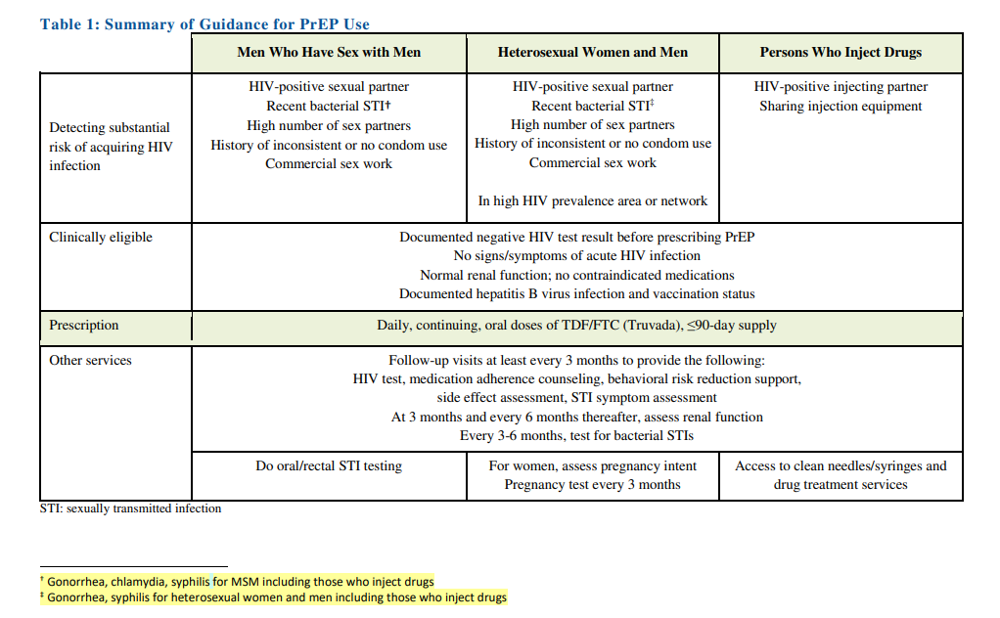
- Medications approved for PrEP:
1. Truvada = tenofovir DF (NRTI) PLUS emtricitabine (NRTI). Common side effects: GI upset (nausea, flatulence), rash, headache, nephrotoxicity
2. Descovy = tenofovir AF (NRTI) PLUS emtricitabine (NRTI), same side effects.
- Based on his recent infection with gonorrhea, he likely qualifies for PrEP.
3. Cabotegravir (injectable)

2) Before initiating PrEP, what testing would you like to order?
- Baseline labs: HIV test, HBV testing (Surface Ag, Surface Ab, Core Ab), HCV Ab, syphilis, gonorrhea, chlamydia screening (urine +/- oral or rectal swabs if indicated), pregnancy test, renal, LFTs
- For patients with GRF <60, cannot use Truvada. For patients with GFR <30, cabotegravir may still be an other
- Hepatitis B screening is important to ensure appropriate treatment when starting antivirals
3) How often should patients on PrEP be evaluated? What lab testing should you order at each visit?
- Patients should been evaluated every 3 months to assess side effects, adherence. It is recommended that these visits be used as ongoing opportunities for discussion of risk reduction (condom use, needle exchange, etc).

- Follow-up testing:
  - Every 3 months: Pregnancy test, HIV test, STI screening in symptomatic patients and asymptomatic MSM patients
  - Every 6 months: Renal function, STI screening in all sexually active patients, even if asymptomatic

