Academic Half Day – Clinical Reasoning 2 (Management Reasoning)
Learner Guide

Agenda
1:05-1:20 Theory Burst
1:20-2:10 Case 1
2:10-2:20 Group Discussion
2:20-2:30 Break
2:30-3:20 Small groups: Cases 2-3 and Mini-Exercises 4-6
3:20-3:30 Group Discussion

Learning Objectives:
- Practice forming a problem representation
- Define a management script
- Explore utilizing a management script in tandem with shared decision making
- Apply an Equity Pause to clinical management

Case 1
Mr. Cal is a 55 yo man who presents from his nursing facility with confusion. He has a past medical history of tobacco use disorder and schizophrenia with an appointed guardian. His nursing facility caretakers noted that he was more agitated than usual the past few days, followed by lethargy which prompted them to call EMS. In the ED, he was afebrile and HDS. He was difficult to arouse but able to state his name when prompted.
Medications:
Benztropine 0.5 mg PO BID
Memantine 10 mg PO daily
Olanzapine 15 mg disintegrating tablet PO at bedtime
Risperidone 2mg disintigrating tablet PO BID
Aspirin 81 mg PO daily
Depakote DR tablet 1,000 mg BID
Multivitamin daily
Omeprazole 20 mg PO every morning

Exam:
Vitals: AF, HR 96, RR 14, BP 124/72, POX 100% on RA
Gen: asleep but arousable, alert to self and location
HEENT: poor dentition, NCAT, PERRL, no palpable neck masses
CV: RRR, no m/r/g, no edema or JVD
Pulm: CTAB, no wheezing or rhonchi
Abd: NT, ND, no organomegaly
Neuro: Alert, oriented to person and place (hospital), does not follow commands, unable to answer most questions appropriately, spontaneous movement in all 4 extremities, speaks some short phrases nonsensically
Psych: Tangential thought process
Labs:
Na 140 / K 3.6 / Cl 108 / CO2 27 / BUN 25 / Cr 1.05 / Glucose 118
Ca 14.1 / Free Calcium 7.74 / Mg 2.0 / Phos 2.0
ALP 48 / AST 17 / ALT 8 / Albumin 3.1 / Total protein 8.7 / Bili, ind 0.4 / Total Bili 0.4
Lactate 1.5
CK 106
Depakote 43
WBC 6.7 / Hg 8.9 / RDW 17.4 / Plt 243

What are the 3 components of a problem representation? What is your problem representation for this patient?

What diagnoses are included in your differential for this patient?

What’s your management script for hypercalcemia? Complete the table. Decide as a group which management steps you would select for this patient.
Types of Intervention | Potential Management Options | Considerations | Selected Management for this Patient
Labs |  | Uncertainty: Lack of clarity due to ambiguity and complexity  Thresholds: Probability of diagnosis needed to perform test/treatment  High Value Care: Appropriateness of intervention  Shared Decision Making: Collaboration with patient and other key stakeholders
Imaging
Procedures
Specialists
Medications
Monitoring
Table 1. Management Script Template, adapted from Abdoler et al. Teaching Management Reasoning, 2023.

Let’s practice a management pause. Reflect on the following questions.
- Why are we choosing this intervention for this patient?
- What are the potential downsides?
- What are the potential alternatives and why are we not choosing them?
- Have we asked the patient for their perspective?

The following labs and test results return:
PTH 8.0 (low) / PTHrP 3.2 (nl <2.0)
Vitamin D 25-OH 37.0 / Vitamin D 1,25-dihydroxy 54.2
Cortisol 9.6
TSH 1.30 / FT4 1.18
SPEP/UPEP: Pending

CT Head Non-contrast: No intracranial hemorrhage or mass effect, stable moderate small vessel ischemic disease
CT Chest/Abdomen/Pelvis with contrast:
Low-attenuation left hilar mass/lymph node conglomerate most likely representing necrotic metastases. Additional mediastinal and hilar lymph nodes are not discretely enlarged but concerning for metastases. Patchy sclerotic osseous lesions in the left humeral head and T11 vertebral body concerning for osseous metastases.
Multiple metastases scattered throughout the liver, the largest measuring up to 8.1 cm in the caudate lobe that causes compression/narrowing of the IVC and main portal vein.
Short segment concentric narrowing in the ascending colon measuring up to 3 cm would be better evaluated with colonoscopy.
Indeterminate ill-defined lesion in the lateral interpolar right kidney that could represent a metastasis. Additional indeterminate 1.2 cm lesion in the lower pole of the left kidney.
Indeterminate sclerotic lesion along the medial right femoral neck.

After completing the management script table for this patient, you can see there are a lot of management options! Mr. Smith remains oriented to self and location. He is unable to demonstrate understanding around admission diagnosis and management options. You decide to call his guardian to discuss the possibilities. ROLE PLAY TIME!

Let’s consider a few other scenarios that may impact your management of this patient.
- What if the patient is a difficult stick and he becomes agitated when phlebotomy attempts to draw blood?
- What if the patient has an EF 20-25%?
- What if Mr. Cal could not lie flat for imaging due to back pain?

Mini-Exercise 1
A 68 yo F PMH HTN, COPD, tobacco use presents to the emergency department with shortness of breath and the following labs:

Exam:
Vitals: 98.9, HR 102, RR 26, BP 121/98, POX 85% on 4L
GEN: Is drowsy and seems much more tired and sleepy than the ED described, dozes off but easily arousable. Intermittently follows commands, alert and oriented x3 with significant prompting
CV: Tachycardic, regular rhythm, normal S1, S2, no M/R/G
Pulm: Distant breath sounds, prolonged expiratory phase accompanied by expiratory wheezes, no gurgling or drooling
Labs:
CBC: WBC 8.8, Hb 14.8, Hct 44.5, Plt 185
Renal: Na 140, K 3.9, Cl 98, HCO3 32, BUN 20, Cr 1.2, Glu 127
BNP: < 15
CXR: no acute cardiopulmonary disease, stable compared to prior
VBG: 7.34/60 > Now 7.24/80

With HVC in mind, choose a few people from the group to argue for or against 1 or 2 of the following management options for this case:
- RVP vs. No RVP
- CTPA or not
- Sputum culture or not
- CAP coverage or not

Mini-Exercise 2
Consider the follow clinical vignettes in the context of testing and treatment thresholds. Discuss as a group. Remember, testing and treatment thresholds may be different amongst individuals in the group.

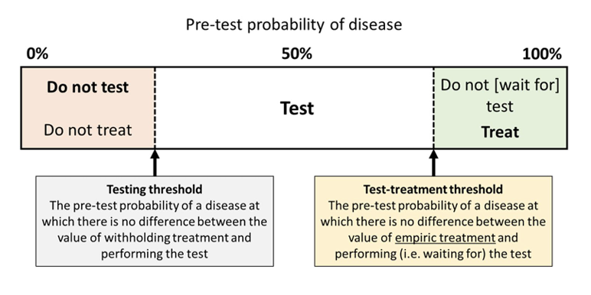
- A 74 yo F with PMH tobacco use disorder, COPD, HFpEF, CKD4 presents to the ED with shortness of breath. She is found to be newly hypoxic on 3L NC, in normal sinus rhythm HR 98, and notes she coughed up a little blood earlier today but has not had any since. CXR shows edema vs possible pneumonia, correlate clinically. Her eGFR is 7 today compared to 24 a few months ago. What is your testing threshold to evaluate for PE in this patient? What is your treatment threshold to initiate anticoagulation in this patient?
- A 68 yo M with PMH asthma, CAD s/p CABG, HFrEF (ICM EF 35-40%), presents to resident clinic with several days of fevers, myalgias, cough, congestion. His rapid tests are negative for COVID-19 and Flu in clinic. He thinks he may have been around someone who was sick last week but can’t remember. You’ve seen several cases of Flu A this week already. What’s your threshold to treat for either viral illness? What factors from this case do you consider when making this determination?
- A 55 yo F with PMH DM2 (HgA1c 8.4%), HTN, HLD presents to the ED with chest pain that awoke her from sleep. She states she hasn’t felt this pain before and isn’t sure what words to use to describe it. BP 164/92, HR 98, SORA. EKG shows nonspecific T wave changes. HS-Trp is 45>49. She continues to experience chest pain.
  - From 0-100%, how likely do you think ACS is in this patient? Share the number with the group and discuss why your number may be different than someone else's. There is no “right” answer!
  - What is your threshold to initiate treatment for ACS? Look at the following QR code to find likelihood ratios for ACS. How might you use the information provided to revise your pretest probability for ACS?
  - What tests do you think are required to determine a diagnosis of ACS? How will the results change your management (i.e. If positive, I would do X, If negative, I would do Y)?
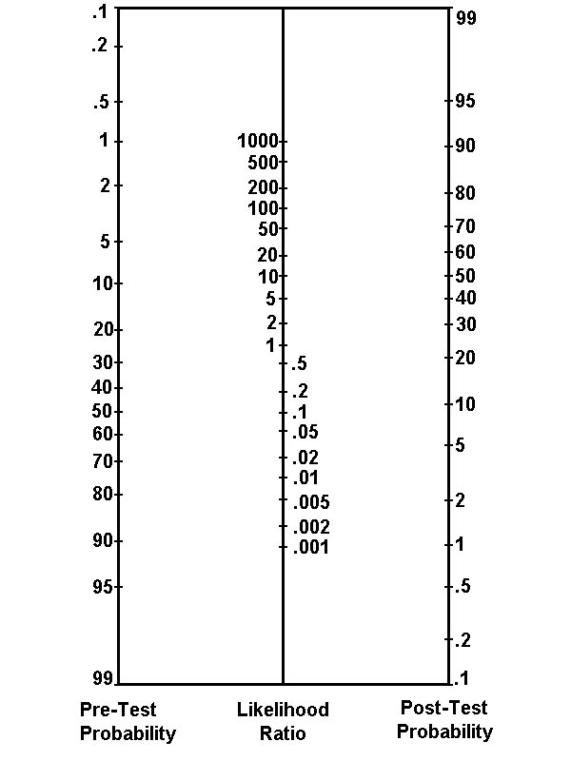

Case 3
Mr. Gibbs is a 72 yo M who identifies as Black with PMH alcohol use disorder c/b alcohol withdrawal syndrome, bipolar disorder, housing instability (currently unhoused), and has had 25 ED visits in the past 6 months for various chief complaints (intoxication, falls, URI for example), who presents to clinic with abdominal pain. He’s noticed over the past several months he’s felt more tired than normal and has gained 30 lbs. His pants no longer fit, nor do his shoes due to swelling in his feet and legs. When you inquire about other symptoms, he states that the other day, his neighbor remarked that the whites of his eyes had a yellowish tint. He denies fevers, chills, dysuria, confusion, hematemesis, hematochezia, or changes in sleep-wake cycle. He states he doesn’t look at his stool so he isn’t sure if it’s been black. He drinks about 2 tall boys daily and his last drink was yesterday evening.
Exam:
AF, BP 98/58, HR 102, BMI 25.4
Gen: disheveled appearing, awake, alert, NAD, body habitus with central obesity and thin extremities
HEENT: PERLA, sclera appear icteric, EOMI
CV: RRR, no m/r/g, 2+ LE pitting edema
Pulm: CTAB, NWOB
Abd: nontender but distended, + fluid wave
Skin: no appreciable caput medusae, + spider angiomata, no rashes
Psych: Psychomotor agitation, tangential, difficult to redirect

What is your problem representation for this patient? Leading diagnosis?

What do you do today in clinic?

You send him to the ED for evaluation. In ED triage, his vitals are AF, HR 110, BP 98/54, 98% on RA. He is admitted to medicine for further evaluation after the following additional data is obtained:
Rectal Exam: Melanic stool in rectal vault, no hemorrhoids, normal rectal tone
CBC: WBC 10.2, Hb 6.7 (8.2 last week, 10.5 6 months ago), Plt 102
Renal: Na 140, K 3.9, Cl 98, HCO3 24, BUN 45, Cr 0.9, Glu 127
LFTs: ALP 50, AST 49, ALT 25, Alb 2.4, Protein (total) 4.6, Total Bili 15.4, Bili (I) 4.0, Bili (D) 11.4, INR: 1.5, PTT 32s
NH3: 13
Paracentesis: performed, cell count, gram stain, and culture pending
CXR: no acute cardiopulmonary disease, stable compared to prior
EKG: Sinus tachycardia, ventricular rate of 108, non-ischemic, otherwise unremarkable

In the ED, he is refusing many interventions with the care team. He declines a physical exam because “I already had that done by the other doctor!” and states he just wants to be left alone. When you ask him what he knows about what’s going on, he becomes frustrated and states “How am I supposed to know! Why don’t you focus on my pain instead of this swelling?” He requests that you leave his room. How do you manage this situation?

Complete the management script for your leading diagnosis (Cirrhosis d/b ascites and GIB).
Types of Intervention | Potential Management Options | Considerations | Selected Management for this Patient
Labs |  | Uncertainty: Lack of clarity due to ambiguity and complexity  Thresholds: Probability of diagnosis needed to perform test/treatment  High Value Care: Appropriateness of intervention  Shared Decision Making: Collaboration with patient and other key stakeholders
Imaging
Procedures
Specialists
Medications
Monitoring
Table 1. Management Script Template, adapted from Abdoler et al. Teaching Management Reasoning, 2023.

When you return to the patient’s room to discuss the management options you think are most appropriate right now, he states “That’s fine, but I don’t want to do that today. Maybe tomorrow but I’m tired and don’t feel like doing any more tests today”. How does this change which management options may be offered to him? Does this affect your perception of the patient? If so, how?

Let’s take a moment for an Equity Reflection. This is an opportunity to discuss what management options we’re pursuing and how these may be affected by the biases we hold. Reflect on the following questions:
- Are we deviating in any way from the standard of care in this situation?
- In what ways are we deviating?
- Why are we deviating? What emotions have you felt walking through this case?
- Instead of deviating, what could we do differently to ensure we are providing the highest value care?

FINAL EXERCISE: What skills or tools discussed today will you take with you into your clinical practice?

