Arrhythmia AHD 3/7/2024
Developed by Jackson Walker
Expert: Wai Tam
Schedule:
1:00-1:20: Theory Burst
1:20-2:20: Cases
2:20-2:30: Expert Questions
2:30-2:40: Break
2:40-3:20: Cases
3:20-3:30: Expert Questions
Plug: AHA ACLS App. Very useful for codes, tachycardias, bradycardias. $3 per/yr
Case 1:
It's 7:30 AM and you are on Cardiology Wards. You get a STAT page from one of the 6S nurses. Your patient admitted to obs for ACS rule out is suddenly tachycardic. The nurse tells you that the patient is still feeling OK, but just feels lots of palpitations. BP 115/72, HR 160, SpO2 95% on 1L NC, RR 18. You walk over to the room.
What about the patient’s history and hospital course do you want to know as you are walking over?
Note to preceptor: Feel free to embellish or make up any part of the patient’s history that is not here already. The key is that the patient is here for ACS rule out and does not have a history of arrhythmias.
Presenting complaint: 1 day of substernal chest pain, squeezing in quality. He presented 1 day ago. Plan for today is a nuclear stress test.
History: 58 yo M with PMH CAD s/p PCI 2019 (currently on aspirin monotherapy for antiplatelet), DMII (A1C 8.5), mild COPD, BMI 40, hx smoking but quit 3 years prior. No known hx of arrhythmias. Has been taking all medications. No recent illicit drug use.
Hospital course: admitted with typical sounding chest pain but this resolved after 1 dose of nitroglycerin. No troponin elevation or ECG changes on admission. Patient has been on telemetry awaiting stress test. Exam has been unchanged from baseline.
What test do you already have that will be useful when assessing this new problem?
Recent ECG:
Encourage learners to formally interpret this ECG, going through all the usual steps.
You arrive at the room, what are the first things you are going to do?
Talk to the patient, make sure stable
Recheck vitals
Ask about symptoms, check for exam changes
Ask for a new EKG
For preceptor: patient is comfortable, complaining of palpitations but otherwise no sxs
You look at the tele box and see a fast rhythm reading about 162 BPM. You cannot clearly tell from the tele box whether the rhythm is wide or narrow.
What arrhythmias are on the ddx for this presentation?
Have the learners break the ddx into buckets based on narrow vs wide complex
Narrow: sinus tachycardia, Afib, Aflutter, Atach, AVRT, AVNRT, MAT (+plus some others that don’t need to be mentioned here)
Wide: VT, VF or any of the arrhythmias above with aberrancy (conduction system issues). Emphasize that conduction issues can be rate dependent. This means a narrow baseline ECG does not always mean that a wide complex rhythm is VT.
While you are awaiting the formal ECG, you ask the nurse to wait with the patient and you go to the telemetry computer. What is your approach to interpreting the tele?
Most interns will have their own approach to this, likely starting with the “Alarms”
The writer recommends starting with the “Hemodynamic Review” tab. This graphs the HR through time (HR on y axis, time on x axis). This tracing is very helpful in a number of ways.
1) it allows you to generate a hypothesis about the type of arrhythmia. Sinus tachycardia develops gradually (gently upward sloping line) whereas paroxysmal arrhythmias like AVRT/AVNRT develop suddenly. In paroxysmal arrhythmias, instead of an upward slope, you will see a vertical “step up” when the arrhythmia starts.
2) if the HR flatlines around 150 BPM this increases your suspicion for Aflutter with 2:1 AV block (baseline rate for Aflutter circuit is about 300 BPM).
3) the hemodynamic monitoring tab helps you quickly identify when the arrhythmia starts so you do not have to sift through the alarms. Certain arrhythmias can be triggered by PACs or PVCs which can be helpful to look for.
Preceptors, take your time on these points. This may be the first time the interns are learning about hemodynamic review tab on the tele box. Here is a picture of where to find it (this tracing shows sinus rhythm with HR changes related to exertion/movement)
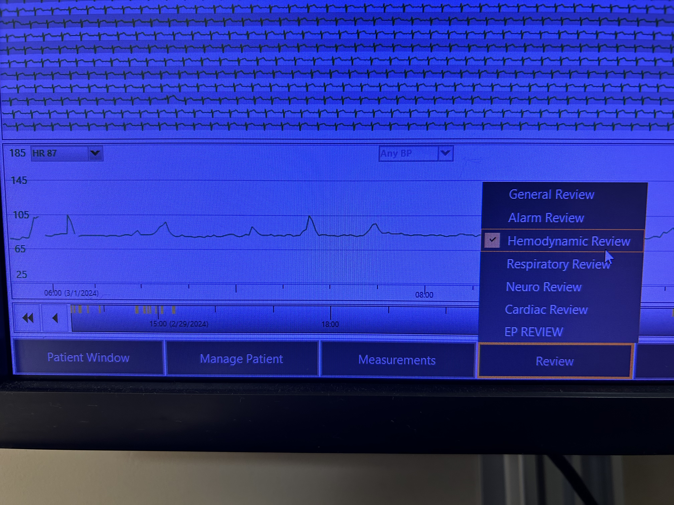
You obtain the ECG:
Have the learners formally interpret this ECG going through all the usual steps.
What do you think is going on here?
Have them first identify that this is a narrow complex tachycardia and restate that differential.
This particular rhythm is AV Nodal Reentrant Tachycardia (AVNRT).
How do we know this is AVNRT?
The key here is the P-waves. To explain how the P-waves are relevant, first look at the mechanism of AVNRT: As you can see on the right side of the figure, there is retrograde conduction up the AV node into the atrium. On the ECG of AVNRT, these retrograde P-waves will be seen either buried at the end of the QRS complex or immediately after the QRS complex. Take another look at the patient’s ECG above and you will be able to see the retrograde P-waves immediately after the QRS complexes.
A point about nomenclature. Mostly all narrow complex tachycardias are technically “supraventricular” or “SVTs” as in their origin is above the ventricle. In colloquial terms, you will hear cardiologists refer to SVT (supraventricular tachycardia) only when speaking about AVNRT and AVRT. This is important to know to avoid confusion.
Now that we have a suspected diagnosis, what parts of this presentation argue against this tachycardia representing Atrioventricular Reentrant Tachycardia (AVRT)? How does the baseline ECG help you?
- AVRT occurs as part of the WPW syndrome. The patient’s baseline ECG does not have delta-waves at the beginning of the QRS. The accessory pathway that causes delta-waves is necessary for the development of AVRT
  - See here for an example of delta-waves on baseline ECG: Also note the very short PR interval since conduction starts very quickly down the accessory pathway when it bypasses the delay of the AV node.
- If you did not have a baseline ECG, with AVRT, the duration of time from the QRS complex to the retrograde P-wave is longer than in AVNRT (this is designated as a prolonged RP interval). Do not spend too much time on this, this is a relatively advanced concept
How will you manage our patient?
Walk the learners through this algorithm. Ask what to do if the patient was not stable.
What are some vagal maneuvers?
Valsalva is probably most frequently used. Diving reflex is also an option (breath hold and cold-water splash to the face)
The vagal maneuvers did not work, what will you do next?
Adenosine. What does adenosine do? Temporarily pauses AV nodal conduction.
Ask learners what steps need to be taken to give adenosine.
1) patient needs defibrillation pads placed on chest (incase this devolves into a cardiac arrest),
2) you need an experienced nurse who knows how to push adenosine (needs to be pushed and then quickly flushed through the IV line),
3) patient needs to have ECG leads on and the ECG should be set to the “continuous” setting,
4) patient needs to be counseled that this will make them feel really weird/bad for a few seconds.
Start with 6mg dose and watch ECG strip. Can go to 12mg next if 6mg did not work.
You give 6mg of adenosine and see this on the continuous ECG: Besides feeling terrible when the medication was given, your patient now reports the palpitations have stopped. Good work!
What if this patient did not have AVNRT? What will adenosine do for narrow complex tachycardias that are not AVRT or AVNRT?
Adenosine will be diagnostic but not therapeutic. AV conduction to the ventricles will pause, but for rhythms like Aflutter or Afib, the atrial conduction circuit will continue. When this happens, you will be able to see the underlying atrial rhythm more clearly without the QRS complexes. Here is an example diagnosing Aflutter (not the best quality ECG, sorry).
Back to the beginning of the case. What would you be concerned for if you were called to the room and the patient’s ECG looked like this?
What is the broad classification for this type of tachycardia? Narrow or Wide? What is your differential for wide complex tachycardia?
- VT
- VT
- VT
- Any of the narrow complex tachycardias with aberrancy (e.g. conduction system disease like bundle branch block). For example, if a patient has a baseline RBBB on ECG, if they go into AVNRT, the QRS will also be wide. Of note, there can be rate-dependent bundle branch blocks that only occur with tachycardia. Unfortunately, the baseline ECG may not help in these situations.
- Antidromic AVRT. This occurs when the reentrant circuit goes down the accessory pathway and up the AV node which creates a wide complex tachycardia (don’t spend a lot of time on this one):
Here are some methods for distinguishing VT from SVT (for your reference and as spaced learning from ACLS AHD): If your group would like to, try applying these criteria to the above ECG. Is our patient’s ECG suggestive of VT or SVT? Know that this is an advanced skill and ok to skip to the next question.
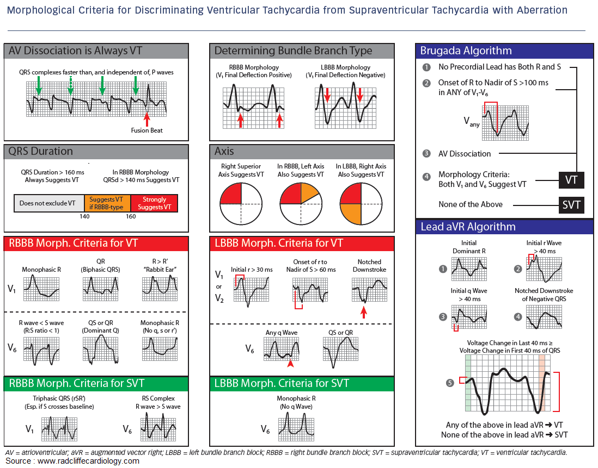
This is VT. Satisfies 1st criteria in the Brugada algorithm and the 3rd criteria in the aVR algorithm. Also some evidence of AV dissociation with buried P-waves and a fusion (capture) beat.
What are your management steps for a patient in VT that is stable? What about unstable?
Stable: Urgent call to cardiology, first-line medication for undifferentiated VT at our institution (especially in patients with structural heart disease) is amiodarone (150 mg bolus + followed by continuous infusion), initiate rapid response, place defibrillator pads on patient, may need urgent revascularization depending on cardiology evaluation. Other medications to consider but guided by cardiology would be IV beta blocker, procainamide and sotalol. Magnesium is an important treatment for patients with Torsades de Pointes.
Unstable: Cardioversion + amiodarone bolus and infusion. If pulses lost, will need to initiate ACLS algorithm.
Polymorphic VT is frequently caused by acute ischemia while monomorphic VT is commonly caused by old infarct/scar.

Case 2:
You are called by the ED to admit a 75-year-old female patient with PMH notable for COPD on 2L supplemental O2, HFrEF (20-25%, NICM), group II PH, CKD, Afib on AC, DMII, hypothyroidism who presents with 4 pillow orthopnea, worsening dyspnea, leg swelling, weight gain and palpitations ongoing for the last week.
BP 105/75
HR 142
SpO2 92% on 4L
Afebrile
RR 18
Labs notable for Cr 1.8 (bl 1.2), HsT 32>>34, lactate 1.9, mild anemia, bilirubin mildly elevated, alk phos mildly elevated, BNP 2400 (1100 at last hosp discharge).
CXR with bilateral infiltrates at the bases, bilateral pleural effusions
ECG:
What does this ECG show?
Have the learners interpret this in a systematic way. Shows afib with RVR, rate about 150.
You go to evaluate the patient and she reports similar chief complaints noted from the ED signout. In addition, she reports chest tightness and palpitations that have been ongoing since she began to feel more dyspneic.
What other information do you want to know from history and exam?
For preceptors: feel free to answer how you would like here. This case is meant to capture someone on the brink of cardiogenic shock but not quite there, still with warm extremities, good mentation, normal urine output. Symptoms/exam findings related to volume overload predominate. Patient has been taking her anticoagulation and GDMT for HFrEF (including 100 mg metoprolol succinate daily).
What is at the top of your differential in this case?
ADHF, Afib with RVR
How do you triage this patient and why?
Although this patient currently has a normal blood pressure and is not currently in shock, they are on the brink. The tachycardia and how this patient might respond (and potentially worsen) after an intervention makes Step Down LOC preferred (in the writer's opinion).
Anticipated LOC needs are sometimes necessary considerations when placing admit orders. This patient may end up on a continuous infusion medication or may worsen when we attempt to rate control, factors which could cause rapid decompensation and need for higher LOC.
Can anyone summarize how the combination of HFrEF, volume overload and RVR all contribute to worsening cardiac output?
Patients with HFrEF have worse systolic function at baseline. They also all have diastolic dysfunction. Afib, even rate-controlled Afib, causes a loss of atrial kick, which can no longer help push blood into a stiff left ventricle. The RVR worsens things further because LV filling time decreases. Lastly, the volume overload pushes the LV off the Starling Curve and further worsens LV stiffness and LV contractility.
During all this, the left atrium is chronically remodeling making Afib more and more persistent and difficult to control.
In addition to diuresis, should we attempt to control the patient’s heart rate?
We should. Although patients with decompensated heart failure require a degree of tachycardia to maintain their cardiac output, this patient’s RVR is likely too fast and thus worsening cardiac output as explained above.
What are ways in which we could attempt to control this patient’s heart rate?
There is not one right answer to this question. Although we are taught to avoid negative inotropes (BB, CCB) in severe decompensated HF, sometimes careful administration of BB (usually IV metoprolol) can improve the RVR enough to increase cardiac output > the negative inotropic effect. CCBs should almost never be used in ADHF.
For this patient, BBs may be too risky. Primary considerations would be amiodarone or digoxin. IV magnesium infusion (similar to electrolyte replacement protocol doses) can also help to control heart rate (recently added to Afib guidelines)
What are some considerations when using amiodarone for rate/rhythm control of RVR? What are some of the adverse effects of amiodarone when used long-term?
This has the potential to chemically cardiovert the patient. If they have not been consistently anticoagulated for the month prior to presentation (and able to continue anticoagulation for the subsequent month after), they are at risk for systemic embolism. If the patient really needs amiodarone and is not currently on AC, this would be a risk/benefit discussion. There are also many other potential adverse effects of amiodarone including thyroid, lung and liver toxicity. These organs need to be monitored during long-term amiodarone treatment.
In the acute setting, amiodarone is given as a bolus then continuous drip.
How would digoxin be used in this situation? What are some of the adverse effects of digoxin?
Digoxin for rate control in RVR requires a digoxin load. A digoxin load is typically written as 0.25 mg IV q6 for 24-36 hours (max load 1.5 mg over 24 hours) followed by daily dosing. Digoxin has a narrow therapeutic window and drug levels need to be monitored. Adverse reactions can include nausea, vomiting, visual disturbances and arrhythmias (commonly atrial tachycardia with AV block). Despite this, the medication does have a role in decompensated HF with need for rate control without rhythm control.
Given the patient’s uninterrupted anticoagulation you initiate an amiodarone load and give some IV magnesium. You hold the patient’s home BB and initiate IV diuresis. The patient is tenuous over the first 6 hours and you keep a close eye on them. HR slowly starts to come down and patient begins making a lot of urine. By the next AM they seem to be out of the woods, and you downgrade to floor level of care. You transition to PO amiodarone with a total amiodarone load goal of 6-10 g. You refer to EP since this patient’s HF appears exacerbated by Afib for further consideration of rate vs rhythm control.

Case 3
Rapid Fire:
What are the types of bradycardias?
Sinus brady
First degree AV block
2nd degree AV block type 1 (Wenckebach)
2nd degree AV block type 2 (Mobitz II)
3rd degree AV block (complete heart block)
Sinus node dysfunction
What ECG characteristics define Mobitz 1 AV block? What is the pathophysiology of Mobitz 1 AV block?
Progressive prolongation of the PR interval followed by a dropped beat. This occurs when atrial conduction reaches the AV node during its relative refractory period. When the depolarization reaches the AV node during the relative refractory period, this slows conduction through the AV node further. Eventually the depolarization reaches the AV node during the absolute refractory period and the beat is dropped.
When there is 2:1 AV block, how do you tell if it is 2nd degree type 1 or 2?
You cannot tell which one it is.
What is sinus arrhythmia?
This is ECG coding for physiologic variations in the sinus rate based on the respiratory cycle. It commonly occurs in younger patients. It is not something to worry about.
What types of AV block require evaluation for PPM? Why do these rhythms require PPM?
Usually 2nd degree type 2, 3rd degree, symptomatic 2:1 AV block. These arrhythmias commonly require PPM placement because they are indicative of “infranodal” conduction disease (disease of the ventricular conduction system). Infranodal block can progress to 3rd degree heart block. Severely symptomatic 1st degree block and 2nd degree type 1 also may end up needing PPM.
When is a PPM necessary for sinus node dysfunction?
This is a tough question because there is no clear cut off for sinus pause duration and when a PPM is required. Much of this decision depends on symptoms and or inability to tolerate important therapy like BB for HFrEF. This decision will require formal evaluation by EP. Some patients with tachy-brady syndrome (afib with RVR followed by sinus bradycardia when afib ceases) require complete ablation of the AV node with permanent PPM placement.

The End

