**Academic Half Day – ACLS**

FACILITATOR Guide

Feb 8, 2024

Expert: Dr. Alex Garbarino

Designed by: Jackson Walker, Kristen Peterson, Jackson Hearn, Will Jensen

**Agenda**

1:10 - 1:20: Theory burst

1:20 - 2:20: Cases 1-2

2:20 - 2:30: Questions for the expert

2:30 - 2:40: Break

2:40 - 3:20: Cases 3

3:20 - 3:30: Questions for the expert

**Learning objectives:**

1. Develop the ability to differentiate between shockable and non-shockable non-pulsatile rhythms
2. Utilize the ACLS algorithm to identify steps to take during a CODE BLUE
3. Learn the medications and tools available for use during a code
4. Identify and treat reversible causes of cardiac arrest
5. Develop communication strategies to function as a successful team leader

AHA ACLS Algorithm: Recognition and management reversible causes:

 

MGH ACLS app link ($3/year):



**Case 1:**

**Pager:**

**03:00 am RAPID RESPONSE L&D ROOM 3;**

**03:01 am CODE BLUE L&D ROOM 3**

**You enter the 3rd floor and hear a woman screaming as you approach room 3. When you enter the room, a man in street clothes is lying on the floor, and a nurse is alone hunched over him, actively attempting chest compressions. The screams are coming from a patient in the hospital bed. Another nurse enters the room behind you, pushing the code cart. There is no pulse. He has cool hands and feels warm when you try to palpate a femoral pulse. There are now three people responding to this code; what needs to happen next?**

1. **Discuss the various next steps that you’d like to take in the next 2 minutes (even outside of typical ACLS algorithms). How can you keep the room organized in such high stakes? This question is intentionally broad to elicit group discussion. As you go through the various next steps, pause to discuss each in more detail.**

*This question is designed to elicit discussion and prompt feelings of uncertainty and ask participants to choose a next step. You can be comfortable allowing extended conversation and elaboration of ideas. This question can serve to gauge the group’s overall comfort with the content as well:*

Activate Emergency response system? H*ow do you call a code blue using a hospital phone? Where can you find this information?*

* Back of your badge*-* 3333 identify main hospital, location, code blue
* Pull code blue button in room
* Ask nurse to call

Gather information/listen to the nurses?

* “What happened?” *This is the patient’s husband, he was found when we came in to get vitals on the patient. He was lying on the couch and wasn’t responsive. He looked blue when we found him.*
* “What all has been done so far?” *The nurse started compressions about a minute ago.*
* Get Vitals? *Will you get a radial, femoral, or carotid pulse?* 
  + Can you feel a pulse when chest compressions are being performed? *Yes*

Place back board to ensure quality compressions

What are potential roles?

- Leader

- Compressor

- Relief Compressions

- Airway

- Meds

- Defibrillator operator

- Recorder

- Runner

- Chart review

Assign roles/Identify yourself? *How do you identify yourself during a code?*

“I’m ____ from the code team. I’m going to take the lead until more help arrives.”

*Below code team structure also in the appendix at the end for the learner guide:*



Airway tips: (Although if you are the leader, you should not have any other role than leading)

*What tools can you use to secure an airway? What should you use first?*

* Hands! (jaw thrust, head tilt, chin lift)
* Oral Airway
* Ambu bag; even without a tube, bag-valve-mask (BVM) is important!
* Narcan (help the patient protect their own airway.
* I-gel/supraglottic airway
* ET-tube

Gather equipment? *What equipment do you need to effectively carry out CPR?*

* Back board,
* Ambu bag, BVM
* Defibrillator
* Attach pads
* IV access
* End tidal CO2
* Algorithm (apps, cards)

Defibrillator and CPR: It may take a minute to get the defibrillator up and running (make sure that someone is working on this from the beginning). During this time high quality CPR should be continued until you are able to perform the first rhythm check.

**You successfully initiate CPR. The following is shown on the rhythm strip during your pulse check (there is no carotid pulse):**

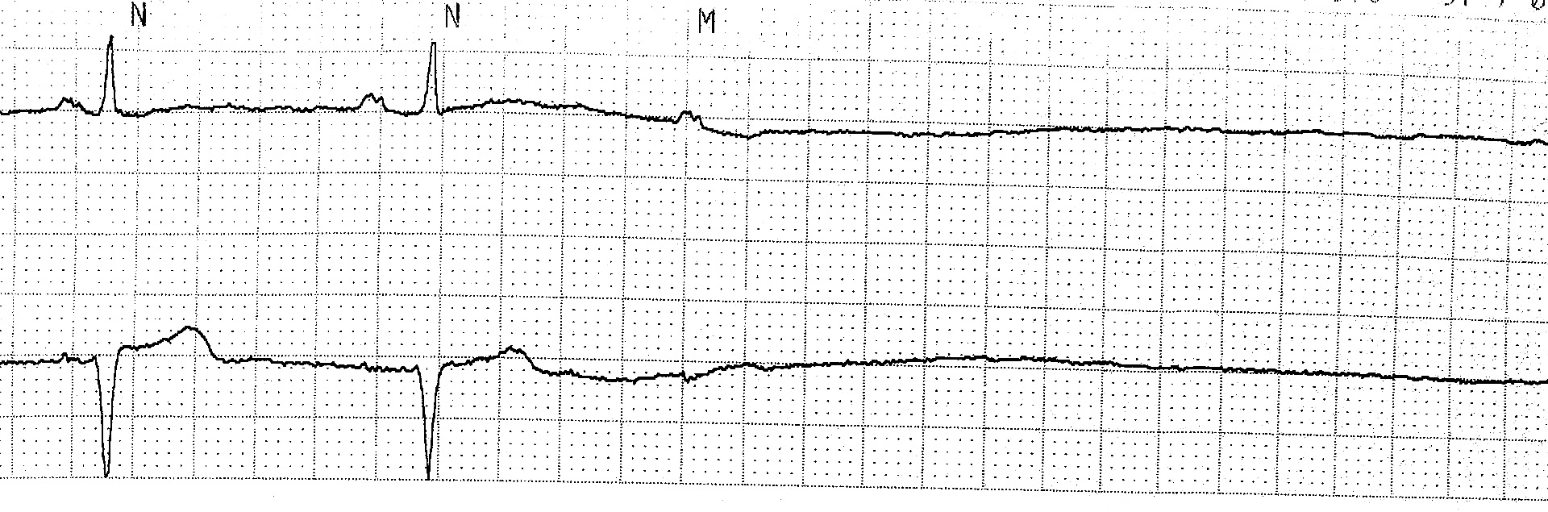

1. **What rhythm do you see?**

Pulseless electrical activity/asystole

1. **Is it shockable or non-shockable?**

Non-shockable

1. **What step comes next in the ACLS algorithm? How long until the next pulse check?**

* Epi
  + Dose, route: 1 mg q3-5 mins IV or IO
* 2 minutes of CPR before next pulse check
* Encourage learners to use their algorithm/resources

**Case 2:**

**Code BLUE called to the PACU bed 10! You show up to a crowded room and a patient is receiving CPR in his hospital bed. You identify yourself as the AOD and ask the room if someone can summarize what has happened so far. The bedside nurse states that the patient returned from the OR for a routine cholecystectomy about 1 hour prior. About 3 minutes ago, the patient yelled out, became diaphoretic and lost color in his face. He then became unresponsive. CPR was just started.**

1. **What are your first steps?**

Repetition from the above case. Have them rehash this information again (SPACING)!

* assigning roles (what are the various roles again?)
* place backboard
* IV access
* oxygen therapy
* EtCO2 monitor
* place defib pads
* FSBG.

1. **While you attach the pads, what is a brief differential cause for post-op cardiac arrest?**

DDx is broad, but may include: Hemorrhage, volume depletion, anesthesia reaction, pulmonary embolism, MACE, electrolyte abnormalities.

**Initial rhythm below:**

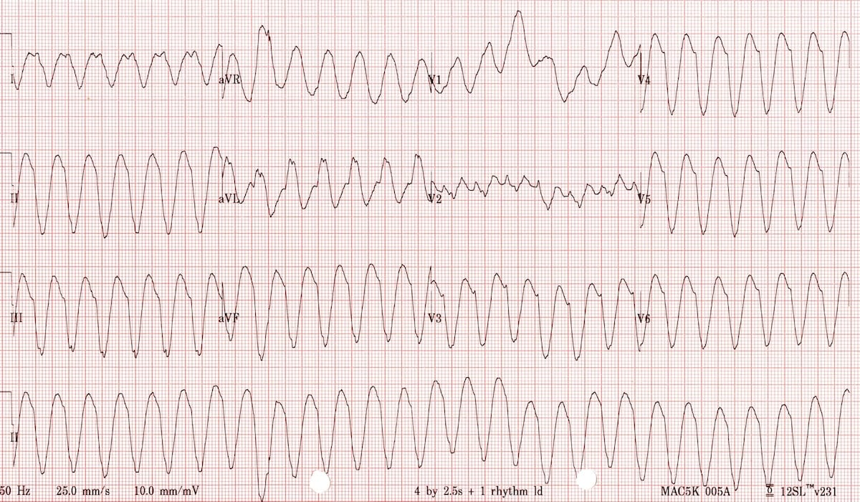

1. **What rhythm does this represent? What are some common causes of this arrhythmia?**

* Encourage learners to define the type of VT (monomorphic).
* Causes: Most common is *ischemia* or *structural heart disease*. A zone of slow conduction develops in ischemic myocardium or scarred myocardium because of fibrillar disarray. Reentrant tachycardias occur when a wave of depolarization travels through the zone of slow conduction and there is enough time for the remainder of the myocardium to repolarize. Similar to the mechanism of AVNRT.

The below image will be in the appendix for learners.

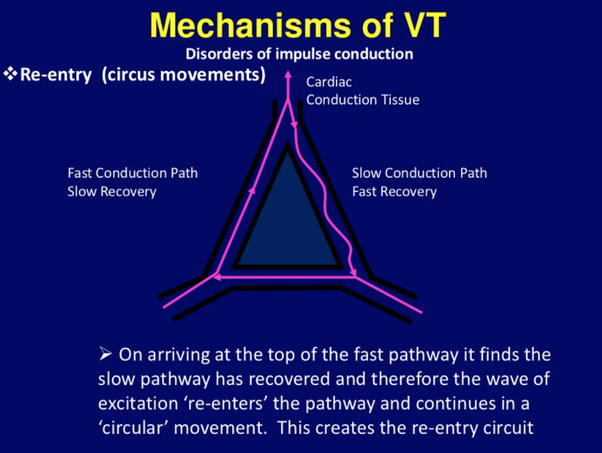

1. **What are common causes of polymorphic VT?**

* Causes: Torsades, congenital channelopathies, acute ischemia.
* Common causes of Torsades include hypomagnesemia and QT prolonging drugs. Have the group name off some classes of drugs associated with prolonged QT.
  + Pathophysiology is based on the R-on-T phenomenon when there is a ventricular depolarization during the T wave. During this time in the cardiac cycle, not all myocytes are uniformly repolarized, and therefore depolarization at this stage can lead to disordered conduction.

1. **How do you differentiate VT from SVT with aberrancy?**

Also in the appendix:

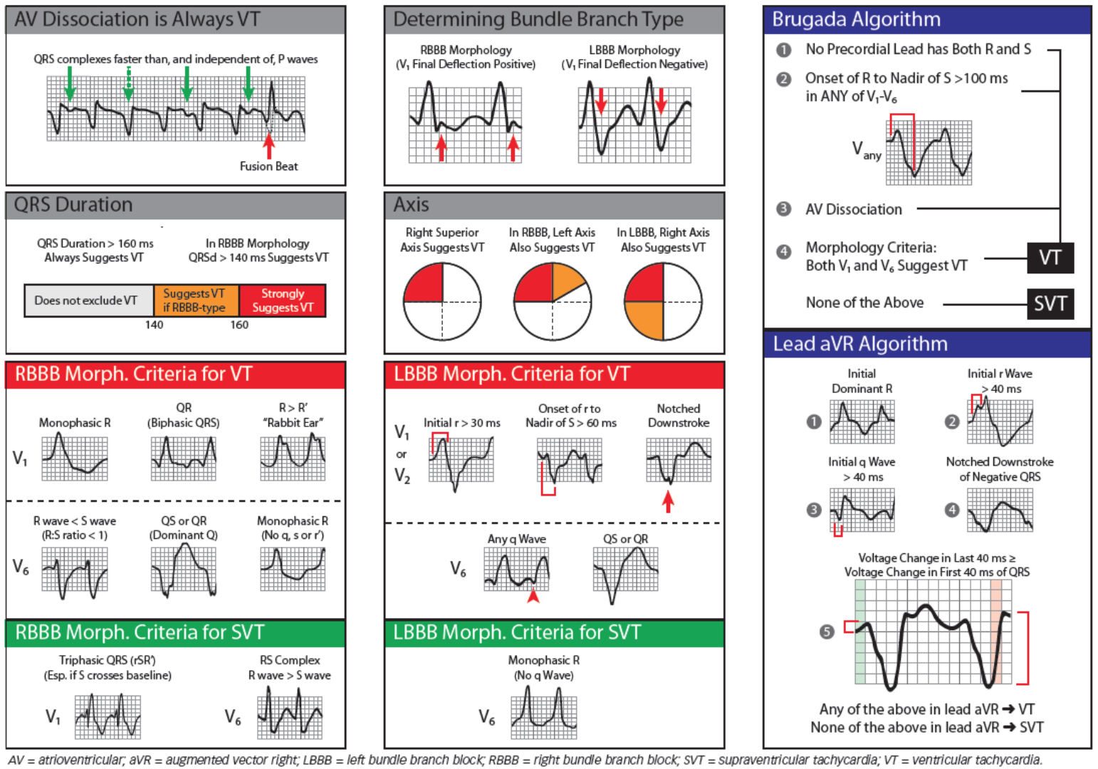

In the situation of a code, if the patient is truly pulseless, differentiating SVT vs VT is unnecessary. The right approach would be to follow the shockable rhythm pathway. As an aside, if the rhythm happens to be SVT with aberrancy, the risk of defibrillation vs cardioversion is creating an R-on-T phenomenon and precipitating Torsade's, the treatment of which would be defibrillation.

1. **Back to the patient in front of us. What is the first action in the ACLS algorithm when you see the rhythm tracing above?**

Defibrillation.

*What is the difference between defibrillation and cardioversion?* Defibrillation is a shock given at any time in the cardiac cycle. Synchronized cardioversion refers to a timed shock specifically to avoid R-on-T phenomena.

1. **What voltage do you shock with?**

Depends on the device but for monophasic typically 360 J, biphasic 200. It is reasonable to shock at the highest voltage in cases of cardiac arrest. This information is also present on the MGH ACLS app.

1. **Shock is delivered and the rhythm persists. What are some adjunctive medications to give at this stage?**

* Epinephrine 1 mg every 3-5 minutes
* amiodarone 300 mg first bolus and 150 mg second bolus
* lidocaine 1-1.5 mg/kg first dose and 0.5-0.75 mg/kg second dose.
* Typically start with epi, then anti-arrhythmic next.

1. **You are two minutes into CPR, have provided one shock and 1 mg epinephrine. What else should you be considering at this stage?**

* Switch compressors
* Make sure someone is recording meds and timing
* Ensure high quality CPR with EtCO2. The higher the better, needs to be >10, preferably >20 (normal around 40)
* Should have anesthesia place an advanced airway
* Consider reversible causes
* Obtain ABG+ (includes lytes, glucose, lactate, Hb, and the rest of an ABG), troponin
* Check in with team
* Summarize situation and ask for further patient background

1. **Your intern pulls up the patient’s chart and sees that he has a history of smoking, CAD and DMII not on insulin. Your team is performing high quality CPR and you wonder if the patient might have a reversible cause of cardiac arrest. Will one individual please summarize the case? Next, what are some reversible causes of cardiac arrest and how would you identify and treat them?**

* Have a volunteer summarize the case
* What are the reversible causes of cardiac arrest? Have team refer to QR code at beginning of packet or have them call out causes. Talk about what the potential causes are, how to identify these causes, and what to do for management.
* There will not always be an ultrasound machine available but can be especially useful for identifying tamponade, PTX, hemorrhage, massive PE. Subcostal window is best for identifying pericardial effusion (especially when someone is performing CPR).
* Physical exam can demonstrate evidence of poisoning, such as pinpoint pupils.
* ABG + can show acid/base abnormality, glucose level, electrolyte abnormalities, low Hb.

1. **After your third round of CPR, you notice that the EtCO2 is sustained above 40 and there is a pulse on the pulse check. What are some other signs of ROSC? What do you do next?**

* Signs of ROSC: Spontaneous breathing, pulses, arterial waveform on arterial line, movement, coughing.
* Post ROSC management: Use QR code *below* for details and to ask learners about next steps.



**The patient is following commands and appears very dazed and confused but otherwise neurologically intact thanks to your superb ACLS skills. You begin managing hemodynamic parameters by the post-arrest care algorithm and you obtain an ECG shown below.**

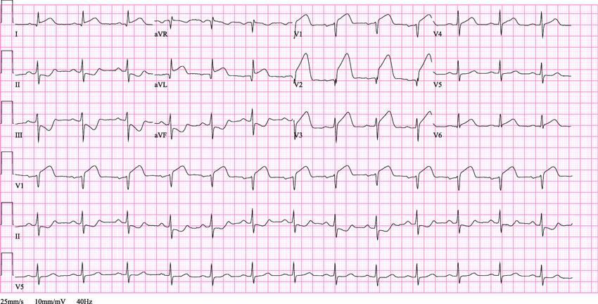

1. **What do you do next?**

* Call Code STEMI and get the patient to the cath lab. How do you call a code STEMI?
* What happened to this patient? Post-op MACE. Patient had underlying risk factors for a thrombotic event which was provoked by surgery/anesthesia.

**Case 3:**

**A 32 yo female with PMH of elevated BMI (> 35) is admitted with fevers and abdominal pain. Three weeks ago, she delivered two healthy twins via repeat C-section. Unfortunately, her post-partum course was complicated by gangrenous cholecystitis s/p cholecystectomy, pancreatitis and now multiple intra-abdominal abscesses s/p JP drain placement. One morning, she gets out of bed to go to the bathroom but suddenly collapses. Her husband calls out, a nearby nurse arrives and is unable to palpate a pulse. The nurse calls a code blue and begins CPR.**

1. **When you arrive, what do you do first? How might you use closed loop communication?**

* Establish self as code leader until further help arrives.
* Assign roles (compressor + next in line if enough people available, respiratory support, AED)
* Leaders please build in examples of closed-loop communication here.
  + E.g.: Ask a group member “how would you tell X to start compressions?” Then have X reply in a closed-loop manner.
* Discuss why closed-loop communication is important.
  + Avoids ambiguity, provides some control to the chaos
  + Ensures clear communication and the ability to correct if task was heard wrong
  + All team members are able to hear the plan, keeps all on same page
* Ensure IV access
* Apply AED pads
* Get some history

**As you are assigning roles and delegating tasks, you notice the bedside nurse asking your medical student (who happens to be a tall man standing next to you) if they can hang bolus fluids without addressing you, mistaking him for the team leader.**

1. **Take a moment to brainstorm how biases impact a high stress code situation. Think about how System 1 thinking (quick, intuitive thinking) could affect the following relationships (both positively and negatively)** You may have to do some prompting and start the group off by providing some examples below.

* **How might your relationship (as team leader) with the Code Team be affected by System 1 thinking?**
  1. Closing yourself off to suggestions due to insecurity or overconfidence
  2. Believing that all tasks should be carried out automatically
  3. Addressing team members in a rude manner due to stress
  4. Reticence to correct or delegate due to fear of being bossy
* **How might the Code Team’s relationship with you be affected by System 1 thinking?**
  1. Low confidence in your leadership if you are not brash or loud
  2. Overconfidence in your leadership if you are the above
  3. Afraid to speak up due to power differential
* **How about the code team’s (including you) system 1 thinking about the patient?** 
  1. Risk of groupthink
  2. In effective teams, System 1 thinking can be positive when it quickly leads to enacting tasks that do not require further critical thinking
  3. Risk of tunnel vision. So focused on running the logistics of the code, forgetting to take a step back to think of potential underlying causes.

1. **You notice that the nurse providing compressions appears fatigued and the rate and depth of the compressions is inadequate. How would you effectively and respectfully initiate correction? What actions (if any) would you take to help the nurse?**

* Responses should provide corrections but do so respectfully.
* Actions: clearly communicate to a second nurse/resident/person that they need to take over compressions.

1. **Rhythm shows PEA. Based on her history, what are some possible causes of her cardiac arrest?**

* Thrombosis (PE). Hypovolemia (sepsis), Hypoxia (ARDS from pancreatitis?), Hydrogen ions (acidosis possibly from sepsis), hypo or hyperkalemia. Less likely coronary thrombosis given age (despite elevated BMI risk); unlikely to be other remaining “Ts” given known history.

1. **Following the ACLS algorithm for PEA/asystole, you have given 2 doses of epinephrine and are now approaching the 6-minute mark of the code without changes in her status. You look in the code cart for some other medications to try. What medications are in the code cart and when would you use them?**

|  |  |  |
| --- | --- | --- |
| **Medication** | **Dose and timing** | **Use** |
| **Epinephrine** | 1 mg (1mg in 10mL), every 3-5 minutes | Cardiac stimulation; used during cardiac arrest with PEA/asystole and VF/pVT |
| **Amiodarone** | 300mg for first dose (bolus), 150mg for second dose | Attempts to control ventricular arrythmias; cardiac arrest with VF/pVT |
| **Lidocaine** | 1-1.5 mg/kg for first dose; 0.5-0.75 mg/kg for second dose | Same as above but less commonly used |
| **Atropine** | 0.5-1mg every 3-5 minutes | Symptomatic bradycardia, until pacer pads can be placed. Avoid in mobitz type II and complete heart block. |
| **Calcium chloride** | 1 g, given over 2-5 minutes; repeat as necessary | Stabilize cardiac membrane, increase contractility; can also be used if there’s concern for electrolyte derangements causing cardiac arrest (hyperK, hyperMg, hypoCa) |
| **Sodium bicarbonate** | 50 mEq/50mL syringe (“1 amp”) | Routine use is not recommended. Special considerations: metabolic acidosis, kyperK, or TCA overdose. Sometimes considered in setting of prolonged cardiac arrest |
| **Adenosine** | 6 mg first dose, 12 mg second dose | Used when there is concern for SVT. Will briefly cause complete AV nodal blockade. If the tachycardia is dependent on AV conduction, will cause ventricular pause and you can see underlying atrial rhythm |
| **Dopamine** | Initial: 5 mcg/kg/min with increase by 5mcg/kg/min every 2 minutes (bradycardia)  Range 0.5 - 20 mcg/kg/min | Not often used; can consider in symptomatic bradycardia. Can cause tachyarythmias so used cautiously (if at all) in hypotension, cardiogenic shock, etc. |
| **Naloxone** | IV/IM 0.4 - 2mg every 2-3 minutes  IN 4 or 8 mg every 2-3 minutes | If concerned about opioid OD as cause; IV/IM route more effective. |
| **Dextrose** | D50W (usually 50mL syringe) | Hypogylcemia |

1. **In this case specifically, what would be the next medications you would try in addition to epinephrine?**

* Calcium (if you’re concerned about stabilizing the myocardial membrane after electrolyte disturbance)
* Sodium bicarb (only if you’re concerned about acidosis or other specific indications like TCA OD or hyperkalemia, otherwise not evidence based)

1. **You are now approaching the 15 minutes mark of the code. You’ve given 4-5 doses of epi, an amp of bicarb, and a dose of calcium chloride. You’ve done everything you know to do, but the patient’s status is unchanged. How would you elicit further input from your code team?**

* Have them summarize the HPI and code up to this point, and have the group think about how to effectively get input from a team. Remind them that we don’t have to know everything to be a leader, but a good leader instead uses their team effectively.
* Can ask open-ended questions after the summary... “We have been unable to obtain a pulse. The predominant rhythm has been PEA or asystole. We have done x, y, and z so far. Does anyone else have thoughts on what else we could try?”
* Can be more directed …"[summarize]. Pharmacy: do you have any other suggestions on medications we can try?”

1. **Someone suggests performing a bedside ultrasound and notices the RV to be severely enlarged. What would you do next and what are the current recommendations on the use of thrombolytics during ACLS?**

* Based on the 2020 AHA ACLS guidelines, use of thrombolytics has:
  + Moderate (benefit >> risk) to weak (benefit > risk) recommendation for use. Level C-LD (limited data)
* Recommendations are divided into two categories: “confirmed PE” and “suspected PE”.

*The below recommendations are in the appendix as well:*

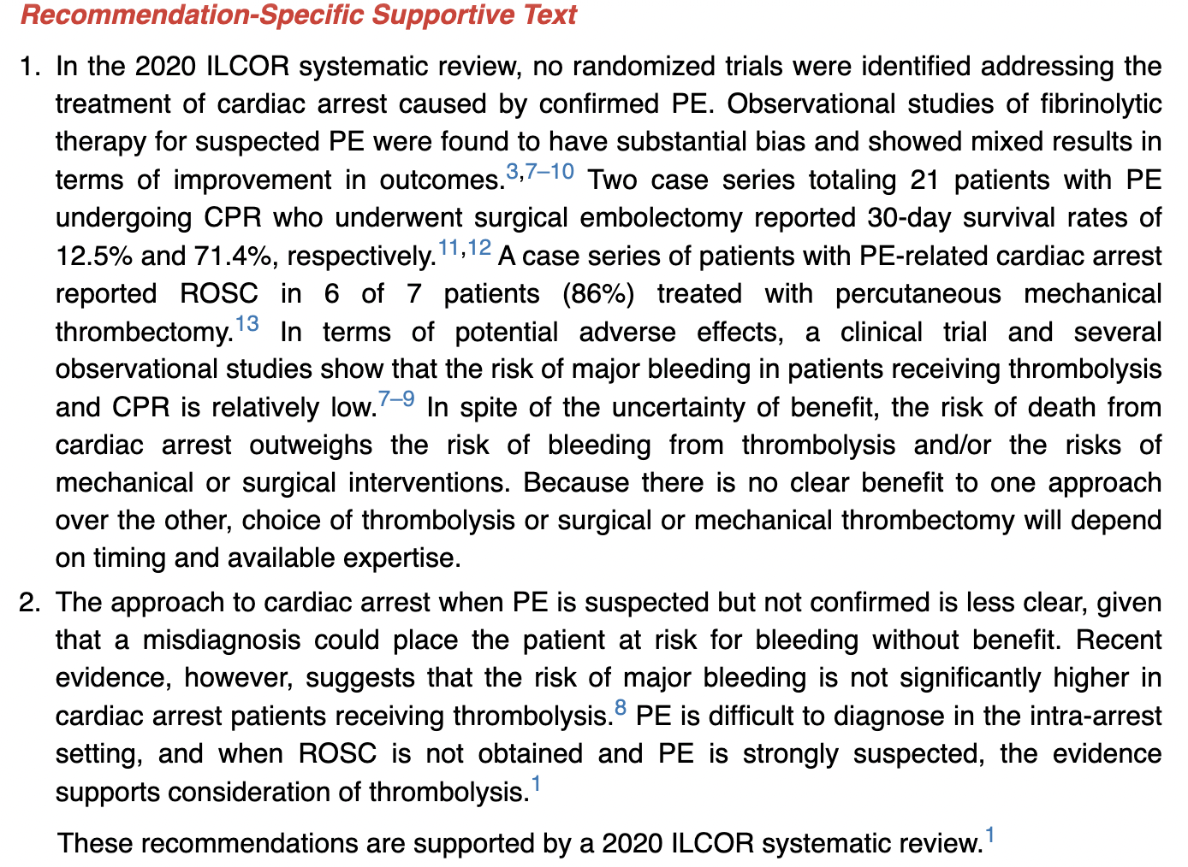

*From the AHA ACLS 2020 guidelines*

* Management of acute PE depends on disease severity (submassive vs massive). Fulminent PE (a subset of massive PE) that causes cardiac arrest or severe hemodynamic instability is the focus of the AHA recommendations.
  + PEA is presenting rhythm in 36-53% of PE-related cardiac arrests; primary shockable rhythms are uncommon
* Treat submassive and most massive PEs with prompt anticoagulation (heparin gtt, apixaban, LMWH, etc). However, anticoagulation alone is inadequate for fulminant and most massive PEs. Both thrombolytics (tPA) and mechanical thrombectomy may be considered in these situations.
* *If thrombolytics are given, the team must continue CPR for at least another 15-20 minutes.*

**ROSC is obtained after ~ 15 minutes and she is taken to the ICU for post-cardiac arrest care.**