Academic Half Day: Palliative Care
2/15/24

Facilitator’s Guide

***
FACILITATORS: Many questions in this half day are about allowing the residents to reflect on their own values, patients’ values, and how we translate something as abstract as values into medical decisions. As such, there are many questions without “right” or “wrong” answers. The goal of facilitators in this section is to encourage dialogue and reflection, including asking them to reflect on the conversations they may have had throughout the year already with various patients. If you want to go off-script to follow a line of dialogue your group is interested in, that’s okay!!
***

Prelude --- Facilitators should do this part too without looking ahead!!
Answer the following questions to the best of your ability! If you don’t know, just take your best guess – write what you would tell a patient right now if they were asking.

- How likely is a patient who underwent in-hospital cardiac arrest to survive to discharge?

- How likely is a patient who underwent in-hospital cardiac arrest to have a “good neurological outcome”?

- How likely is a patient to survive an ICU admission for any reason?

- What are the long-term functional outcomes for patients after ICU admission?

- What are the short and long-term outcomes for a patient requiring dialysis?

- What are the short and long-term outcomes for a patient requiring tracheostomy?

- What is the prognosis for a patient with “end-stage” COPD?

- What is the prognosis for a patient with NYHA class IV heart failure?

PART I

Let's start out with a case, using some of our clinical reasoning skills!

Mr. Spikes is a 66-year-old with HTN, HLD, recent diagnosis of diabetes who presents with progressive jaundice for the past 2 weeks. For the last month he has had intermittent dull, aching abdominal pain. Sometimes the pain is worse after eating a meal.

- What are common etiologies of jaundice? What etiologies are most likely in this patient who also has abdominal pain?
Indirect hyperbilirubinemia
Bilirubin breakdown: hemolysis, hematoma
Impaired conjugation: Gilbert
Increase hepatic intake: portosystemic shunts, drugs (rifampin)
Direct hyperbilirubinemia
Intrahepatic – viral hepatitis, cirrhosis, infiltrative, drugs (DILI)
Extrahepatic – stone, sludge, parasites, stricture, compression from mass, autoimmune (PSC)

Abdominal pain with jaundice increases the likelihood that jaundice is more likely from involvement of the biliary system and/or pancreas.
- What other information would you like about the patient?

Provide information below:

Additional history – The pain is located in the epigastric region and RUQ. It is intermittent and dull. Sometimes worse after eating a meal. ROS revealed 15 lb weight loss in the past month. He also feels fatigued. He lives with his husband and 2 dogs. They like to go on long walks every night, but lately he does not have the energy to go on the nightly walks. He has not had any changes in his diet or bowel movements. No fevers, cough, chest pain or shortness of breath. He has a 20-pack year history of smoking but quit 25 years ago. He drinks 1-2 alcoholic beverages a week.

Medications – Lisinopril, atorvastatin, metformin

- What do you want to look for on exam? What work up would you like?

Provide information below as requested:
Vitals – afebrile, HR 98, BP 132/84, 97% on RA

Exam – RRR, no murmurs, CTAB, scleral icterus, jaundice, mild epigastric tenderness to palpation, no stigmata of liver disease (palmar erythema, gynecomastia, ascites etc), no asterixis, A&O x4, no focal deficits

Labs
CBC – WBC 13.2, Hgb 10.1, platelets 210
Hepatic – AST 62, ALT 34, Alk phos 328, total bilirubin 8.2, direct bilirubin 6.8
Renal panel normal

Here you can discuss interpretation of liver labs – cholestatic (greater elevation in Alk phos and direct bilirubin) vs hepatocellular (greater elevation in AST and ALT). This is cholestatic liver injury, which makes us think about biliary obstruction or compression of the biliary tree. The next step is to obtain imaging. There are many imaging modalities that can be used – US w/ doppler, CT, MRCP. When trying to figure out what imaging to get, it depends on urgency and availability. US is great to look at biliary tree but may not happen in the evening or overnight.

CT abdomen/pelvis showed dilation of common bile duct to 1.5 cm and no discrete stones.

At this point, briefly discuss how their differential has changed with the labs and imaging and what are the next steps? After a brief discussion, provide the information and diagnosis listed below:

GI is consulted for an ERCP. ERCP can allow us to look at the biliary tree (a stone or a mass that wasn’t seen on CT), provide a therapeutic intervention (biliary dilation or stent), and get a biopsy if needed. ERCP and EUS revealed a pancreatic head mass and distal bile duct stricture. A biliary stent was placed. Biopsy of the mass showed pancreatic adenocarcinoma

- Do you feel comfortable giving bad news? What kind of emotions do you, as a person, feel when you are giving bad news?
  - I am predicting many people will say things like ‘I feel anxious’ or ‘I feel uncomfortable’ or other ‘negative’ emotions. If not, then move on to the follow up questions.
  - FOLLOW UP QUESTIONS:
    - When you are feeling those emotions, how do you talk to people?
    - How do your words come out?
    - How does that affect what the patient hears?
  - The goal of this is to let people reflect on what emotions they as physicians bring to the conversation

- Reflect on a time when you received bad news (or anything that may have been really emotional). What do you remember about the initial moment when you learned the news?
  - Ask if anyone is comfortable sharing their example.
    - IT IS OKAY IF NOT. JUST MOVE ON IF NO ONE VOLUNTEERS.
  - FOLLOW UP QUESTIONS:
    - Does anyone remember the exact words that were said?
    - What do you think your patients remember about the moment they get told of their cancer diagnosis?
    - What do you think a family member remembers about the moment they are told a loved one is dying in the ICU?

- Reflect on the last time you either observed bad news being delivered to a patient or gave bad news to a patient. What do you think the patient remembers about that encounter?
  - FOLLOW UP QUESTION: What do you want the patient to remember about that encounter? How will you make that happen?

- Using the SPIKES framework, how would you tell a patient in the scenario above about their diagnosis?
Ask your group what they would do or say for each section of this. Ask them for examples that they’ve seen where someone has done this really well or really poorly. Ask them what they might want a physician to say to them or to their mother/father/spouse/loved one.

  - [S] Setting – Choose the right setting and time! Room should be as private with as little distractions as possible. If you can hand off your pager to someone else, do that. Make sure everyone who needs to be present is present. Try and have everyone seated at the same level. Have tissues in the room.

  - [P] Perception – What does the patient/family know about the situation? What’s the best way to elicit this information?
    - What do you know about your illness?
    - What have you been told about what’s going on?
    - What’s your understanding of what is happening to your family member?

  - [I] Invitation – What does the patient want to know? Invite them to ‘direct’ the conversation. Some people want more info and others only want broad strokes.
    - What else do you want to know about what’s going on?
    - Would it be helpful to know what to expect from here?
    - Would it be okay for me to talk about your latest results / provide a medical update?

  - [K] Knowledge – Deliver the news. KEEP TERMS SIMPLE AND DIRECT. Give information in small chunks and allow them time to digest. Check in to see how they’re processing throughout the conversation. Repeat important points if needed.
    - FOLLOW UP QUESTION: Is it okay to be silent for a long period of time?
      - YES!! Give them time to just sit with the news!
      - This is where recognizing our own discomfort is really important! How often do we just keep talking to fill in the space? Is that what’s helpful to the patient?

  - [E] Emotion – Respect your patient's emotions! Give them space to feel whatever, but also if they don’t want to talk about it, that’s okay too.
    - NAME + NORMALIZE: Can be helpful to have them NAME the emotion so you can help NORMALIZE how they feel and support them.

  - [S] Summarize – Recap situation + next steps. Use simple and clear statements to assure them you are there to help them and they won’t be alone in their care.
- What would you want to know if you were the patient?
  - Examples might be:
    - How long do I have left?
    - What should I tell my family?
    - What are the next steps. --> This is going to be a big question. Often as medicine physicians (not specialists), we don’t have the answers to this. How can you explain the next steps based on your knowledge – i.e get more imaging to stage, consult heme/onc, etc

PART II

The following are variations of multiple scenarios that you may encounter in your residency:
- 50-year-old w/ hx HTN, T2DM, admitted for R knee replacement. Code Blue is called for cardiac arrest.
- 23-year-old w/ hx T1DM, admitted for DKA, currently in the ICU as pH is 6.8 on presentation.
- 68-year-old w/ hx metastatic prostate cancer, CAD, admitted for sepsis to the ICU, complicated by oliguric AKI and now requiring dialysis.
- 87-year-old w/ hx lung cancer s/p lobectomy, COPD, hypothyroidism, admitted to the ICU for respiratory failure related to multifocal pneumonia requiring mechanical ventilation. At this time, she has been ventilated for 12 days.

- Assume none of these patients are able to speak for themselves due to encephalopathy of some kind. Who will you discuss medical decision-making with?
  - HCPOA!
  - Assuming no HCPOA paperwork, default order of HCPOA in Ohio:
    - Guardian
    - Spouse
    - Adult child of patient (or a majority available w/in reasonable period of time)
    - Parents
    - Adult sibling (or a majority available w/in reasonable period of time)
    - Nearest adult related by blood or adoption available w/in a reasonable period of time
  - If the above people meet one of the following criteria, they are disqualified and skipped:
    - Pending divorce/dissolution/legal separation
    - If pt is under protection order against them
    - If they have been charged w/ assault against pt

- You are the physician for one of the above scenarios. When updating the HCPOA, they ask, “Is [the patient] going to make it? Will we be able to bring them home?” How do you respond?
  - FOLLOW UP QUESTION: How comfortable are you in providing prognostic information?
  - FOLLOW UP QUESTION: How good do you think physicians are at prognosticating?
    - Cheon 2016, “The accuracy of clinicians’ predictions of survival in advanced cancer: a review”: Meta-analysis of 15 studies
      - “ the median estimated survival was consistently higher than observed survival, regardless of how near patients were to death” à we overestimate survival and tend towards optimism
    - A study by Christakis asked 343 physicians to provide survival estimates for 468 terminally ill patients at the time of hospice referral. Only 20% of predictions were accurate (as defined as within 33% of actual survival). Overall, doctors overestimated by a factor of 5.3
    - Appropriate prognostic information is essential for informed advance planning decisions.

- Go back to the prelude (first page). Let’s review our answers together:
Go through these relatively quickly. The goal is just to make people aware of some ballpark numbers for common things we talk about in the hospital.
  - How likely is a patient who underwent in-hospital cardiac arrest to survive to discharge
    - A 2003 report of in-hospital CPR outcomes from the National Registry of Cardiopulmonary Resuscitation, reported data from 14,720 resuscitation attempts (2000-2002) in adults from 207 U.S. hospitals
      - Survival 20 minutes after CPR was 44%, and 17% of all CPR patients survived to discharge.
      - Pre-CPR, 84% of patients came from home. Among survivors, 51% returned home, the remainder were discharged to another hospital, a rehabilitation facility, or a nursing home. Two percent were discharged to hospice care.
    - A meta-analysis by Reisfield of 42 studies from 1966-2005 showed that 6.7% of cancer patients (localized: 9.1%; metastatic: 5.6%) survived CPR to discharge
    - Three studies looked at CPR outcomes in a total of 137 dialysis patients. Survival to discharge was seen in 14% of patients.
    - Physicians can say roughly 15%, or 1 in 6 patients, who undergo CPR in the hospital may survive to discharge. Specific co-morbidities (cancer, dialysis) will reduce the chance of survival, and surviving patients are at risk for a range of complications including permanent neurological and functional impairment
    - See CASPRI score in appendix
  - How likely is a patient who underwent in-hospital cardiac arrest to have a “good neurological outcome”?
    - Very hard to say
    - Table for “significant of physical exam findings in coma following cardiac arrest” is at back of packet
  - How likely is a patient to survive an ICU admission for any reason?
    - From UTD:
      - Patients transferred to an ICU who do not require mechanical ventilation have approximately a 25% likelihood of dying before leaving the hospital
      - Adult oncology patients who require mechanical ventilation for acute respiratory failure experience an ICU mortality >40%
      - Mortality in adults is typically >60% when two or more organs fail and approaches 100% when four or more organs fail
    - A model for predicting mortality in ICU patients
      - APACHE – Can look this up on MD calc, Takes age, vitals, labs into acccount
      - Simplified Acute Physiology Score – Can look this up on MD calc. Extensive and takes multiple factors into account, including age, length of ICU stay, intrahospital location before ICU, infection, GCS, labs (bili, creatinine, pH, platelets), BP, PaO2, comorbidities, reason for ICU admission
    - Among sepsis survivors, up to 25% readmission w/in 30d
  - What are the long-term functional outcomes for patients after ICU admission?
    - Post-intensive care syndrome (PICS) is a big thing which we won’t get into too much but basically = cognitive OR psychiatric OR physicial impairment post-ICU
      - PICS-F = effect of an ICU stay on family members (usually psychiatric)
    - PICS likely in 50% or more of all ICU survivors (63% at 3mo, 56% at 6mo)
      - Cognitive impairment in 40% of ICU survivors, improved to 34% at 12mo
      - PTSD 44% at discharge, 24% at 8yrs
      - Physical impairment of 36% at discharge, 9% at 2yrs
  - What are the short and long-term outcomes for a patient requiring dialysis?
    - Bello 2022, “Epidemiology of haemodialysis outcomes”: DOPPS analysis of the mortality patterns in 86,886 patients in 11 countries (Australia, New Zealand, Belgium, Canada, France, Germany, Italy, Japan, Sweden, UK and USA)
      - crude mortality (deaths per 100 patient-years) were 26.7 (range 17.0–33.5) in the early period (<120 days), 16.9 (range 5.3–21.8) in the intermediate period (121–365 days) and 13.7 (range 5.2–19.9) in the late period (>365 days)
    - Table in appendix: Expected remaining years of life in prevalent patients on dialysis
  - What are the short and long-term outcomes for a patient requiring tracheostomy?
    - Cheung 2014, “Tracheostomy: Epidemiology, Indications, Timing, Technique, and Outcomes”: table in appendix
      - Main takeaway is that pts who are sick enough to need trachs have poor survival rates
  - We’ll get to the rest later!
  - FOLLOW UP QUESTION: How would you utilize this information when talking to patients/families? How would you frame this information? – we do NOT recommend using straight numbers w/ pts/families, they do not have the context to understand
- Go back to question 1. Is the way you respond now going to be different now that you have this information? Why or why not?
  - FOLLOW UP QUESTION: BIAS CHECK!! Are we bringing our own values of what we see as a meaningful life into how we talk to the patient?

- Using the REMAP framework, how would you approach the conversation in this scenario?
Ask them for examples that they’ve seen where someone has does this really well or really poorly. Ask them what they might want a physician to say to them or to their mother/father/spouse/loved one.

  - [R] Reframe – Reframe why things have changed and why we’re having this conversation
    - “What do you understand about the current situation?” “Is it okay if I share my understanding?” “Unfortunately, we are in a different place now…”

  - [E] Emotion – Expect emotional responses and support them through it!
    - NAME + NORMALIZE!
    - “This is really hard.” “I know this must be really difficult for you and your family.”
    - Ask permission to move forward from here – “Is it okay if we talk about possible next steps?” It’s okay if they can’t talk more yet! Even in the ICU, you can give them some time to process.

  - [M] Map – Map out what’s important to the patient. What are their values?
    - “Given what we’ve talked about, what’s most important to you now?...What else?”
    - “What do you hope for? What do you worry about?”
    - “As you look toward the future, is there anything you want to avoid?”
    - “What does a good day look like now?”
    - “Has anyone close to you ever been on a breathing tube? What was that like?”

  - [A] Align – Make sure you’re aligned with the patient’s values!
    - “It sounds like what’s most important to you now is X, Y, and Z. Do I have it right?”

  - [P] Plan – Propose a plan that fits with the values they’ve now declared. Ask permission!
    - “Is it okay if I make a recommendation based on what you’ve told me?”
    - “If the most important things you are X, Y, and Z, then I recommend we do [ABC].”
      - Make recommendations for things you would do before recommending against things you wouldn’t do.
      - YOU ARE THE EXPERT! Don’t force them to make a medical decision they may not fully understand! If you don’t think this is what the patient would want, then go back to MAP and ALIGN.
    - Check in with them. “What do you think about that?” “How does that sound?”

OPTIONAL: There is a framework for handling emotions as well called NURSE. We have simplified it for the sake of time to NAME + NORMALIZE but if you want to go through the full thing it is:
[N] Name the emotion – “It sounds like you’re feeling XXX.” “This isn’t what we were expecting.”
[U] Understand where they are – “This is really hard.” “This is a lot.”
[R] Respect – “You’ve done everything right.” “You’ve been a wonderful advocate for your mother.”
[S] Support – “We’re going to be here with you every step of the way.”
[E] Explore what they’re thinking – “Tell me more…”

OPTIONAL: Debrief here if you want about what your team has experienced so far in residency. How will they lead an intern through this experience?

PART III

A 68-year-old male w/ hx HTN, CAD s/p CABG 3 years ago, CKD III, T2DM, COPD on 4L home O2, OSA on nocturnal BiPAP, presents to clinic for follow-up. He is having increased shortness of breath and now has dyspnea even at rest on 4L. His pulse oximetry during these episodes has been ~90%. He lives with his eldest son at home and is effectively in bed or in his recliner all day as he cannot even get up to the bathroom without significant symptoms.

He is currently full code. He does not have HCPOA paperwork. He has 4 sons and 2 daughters, all of whom live in Cincinnati. His youngest son and daughter do not speak to him due to past family issues.

- When is an appropriate time to initiate an advanced care planning conversation as an outpatient in any patient?
  - Any time! “I noticed that you don’t have any ACP documents on file. Has anyone ever discussed this with you before?”
  - Especially helpful to discuss in patients that you know are closer to end-stage disease, whatever disease it is.

- Go back to the prelude. Let’s review the following together:
  - What is the prognosis for a patient with “end-stage” COPD?
    - BODE index for COPD at end of packet
    - Roughly 10% of patients admitted with a PaCO2 >50 mmHg will die during the index hospitalization, 33% will die within six months, and 43% die within one-year
    - COPD patients who require mechanical ventilation have an-hospital mortality of ~25% (5,6).
  - What is the prognosis for a patient with NYHA class IV heart failure?
    - Based on data from SUPPORT, Framingham, IMPROVEMENT, and other studies, 1-year mortality estimates based on NYHA class are:
      - Class II (mild symptoms): 5-10%.
      - Class III (moderate symptoms): 10-15%.
      - Class IV (severe symptoms): 30-40%.
    - See end of packet for outcomes

- What do you want to discuss with the patient today? Which framework do you want to use?
  - HCPOA
  - Goals of care
  - If you talk about GOC, intubation will be the main thing b/c he is high risk for not being able to come off the ventilator due to severe COPD
  - SPIKES might be appropriate to talk about his COPD prognosis.
  - REMAP is a bit better for figuring out an action plan moving forward.

- How will you discuss code status with him?
  - MAP THE VALUES. MAKE RECOMMENDATIONS BASED ON VALUES.
  - Full code = all resuscitative efforts will be pursued
  - Ohio designations only:
    - DNR-CCA = all therapies will be pursued up until the point of cardiac arrest
      - This means intubation for respiratory failure is okay unless DNI specified
    - DNR-CC = variable – ranging from medical therapies okay w/o intubation to comfort care only
  - Mechanical ventilation for respiratory failure has to be specifically asked about and delineated in the ACP documentation.
  - it can help to explicitly refer to DNR as “allowing natural death”

PART IV

A 78-year-old female w/ hx advanced dementia, seizure disorder, CKD, HTN, A Fib, CAD, is admitted for sepsis related to multifocal pneumonia. Initially she is only on 3L, but she has an aspiration event leading to cardiac arrest. She is intubated and requires mechanical ventilation and subsequent tracheostomy; she is now on trach collar. She had acute renal failure requiring initiation of hemodialysis which will likely be long-term.

She is now on the floor and her mental status remains poor w/ minimal response to pain only. Her HCPOA is her daughter.

- You are discussing the case with her HCPOA, who asks you, “What should we do? What are our options?” What do you tell her? How are you going to frame the conversation?
  - Either SPIKES or REMAP can work here
  - Simplified options: continue current care OR change goals of care
  - FOLLOW UP QUESTIONS: What exactly do we mean by goals of care?
    - Whatever the patient wants to achieve during that episode of care

- How do you explain the difference between palliative care and hospice care to someone?
  - Palliative care = symptomatic management of a serious illness, with or without curative intent
  - Hospice care = symptomatic management of a terminal illness with life expectancy of <6mo, no curative intent
  - Both focus on comfort and what the patient wants!
  - FOLLOW UP QUESTION: Which one would you recommend for this patient? Why?

- What is the difference between inpatient hospice care and hospice at home?
  - Inpatient hospice care = at a facility w/ full support from staff
  - Hospice at home = nurse/staff may visit multiple times a week, but otherwise all other care will be from family members – important to check if family is okay with this b/c it can be very taxing even for a short period of time

Her daughter ultimately decides on taking the patient home with hospice at home. In the meantime, she would like to pursue comfort care only in the hospital and would like that to start immediately.

- What does that mean for the patient right now? What kind of orders are you going to place?
  - DOCUMENT! Write the ACP or LST note to document the conversation + place the order for change in code status.
  - Notify nursing staff immediately
  - Discontinue all life-prolonging therapies that do not also provide sx management
  - Discontinue monitoring! No more CMU/pulse oximetry/EEG, don’t need vitals
  - Dialysis should be discontinued as it is life-prolonging – if there is a trialysis line, it should be removed unless needed for IV access for medications
  - Trach collar is okay – low levels of O2 support helps alleviate dyspnea – air hunger is very uncomfortable

- How do we manage the following symptoms in hospice care?
  - “Universal Comfort Care” is an orderset in Epic w/ medications for pain, anxiety, etc
  - Generally speaking:
    - antinausea meds
    - anti-secretion meds (scopolamine)
    - Opioids for pain + air hunger
      - morphine is great except in renal failure, then use dilaudid
      - Should be given based off pain, but for non-verbal/encephalopathy pts, can give based off respiratory rate (aim for rate ~10)
    - Benzos or anti-psychotics for anxiety/agitation – avoid restraints
  - Avoid meds that are rectal d/t discomfort
  - Foleys may be more comfortablein some situations

Her medication list (other than what you just added) is as follows:

- Aspirin 81mg daily​
- Warfarin 2mg daily​
- Metoprolol 50mg BID​
- Lisinopril 10mg daily​
- Atorvastatin 20mg nightly​
- Levetiracetam 500mg BID​
- Pantoprazole 40mg daily
- Donepezil 10mg daily​
- Memantine 5mg BID​
- Insulin glargine ​15u nightly
- Insulin lispro 5u TIDWC
- Insulin lispro LDSSI TIDWC
- Hypertonic saline nebs BID
- Albuterol nebs BID
- Alendronate 70mg weekly​
- Calcium BID

- How will we adjust her chronic medications at this time?
  - Can probably discontinue almost everything
  - Can leave AED – seizures are bad
  - QID insulin is very uncomfortable as it requires FSBG checks as well
  - May be worth keeping metoprolol for rate control of A Fib – switch to XL form to make it easier to take
  - There’s not really any guidelines here – sometimes discontinuing certain medications will make the family nervous. If it’s not doing harm (causing side effects or prolonging suffering) and family wants to continue, it’s okay to just leave it be.
- When sending someone home with palliative, think through what symptoms they have and how you can help alleviate those symptoms? What are some common symptoms we think about with end-of-life care and medications you can use for those symptoms?

Nausea
- Anti-dopaminergics – recommended for nausea related to medications
  - Haloperidol 1-2mg/day
  - Olanzapine 10 mg
  - Metoclopromide – motility agent
- 5HT3 antagonist (ondansetron)
- Antihistamines and anticholinergics
  - Promethazine
  - Benadryl
  - Scopolamine (vertigo related nausea)
- Dexamethasone (intracranial malignancies)
- Cannabinoids
- Lorazepam
- Peppermint oil

Pain – multimodal approach with Tylenol, NSAIDs, opioids, lidocaine patches

Constipation – Be sure to send them with stool softeners, especially if they are getting opioids. Constipation can be uncomfortable! Avoid suppositories and enemas if they cause patient discomfort.

APPENDIX

UpToDate: Significance of physical findings in coma following cardiac arrest
Patients with virtually no chance of regaining independence
Initial examination | No pupillary light reflex
One day | Motor response no better than flexor and spontaneous eye movements neither orienting nor roving conjugate
Three days | Motor response no better than flexor, no spontaneous eye opening
One week | Motor response not obeying commands and spontaneous eye movements neither orienting nor roving conjugate
Two weeks | Oculocephalic response not normal, not obeying commands, no spontaneous eye opening, eye opening not improved at least 2 grades from initial examination
Patients with best chance of regaining independence
Initial examination | Pupillary light reflexes present and motor response flexor or extensor. Spontaneous eye movements roving conjugate or orienting.
One day | Motor response withdrawal or better and eye opening improved at least 2 grades
Three day | Motor response withdrawal or better and spontaneous eye movements normal
One week | Motor response obeying commands
Two weeks | Normal oculocephalic response

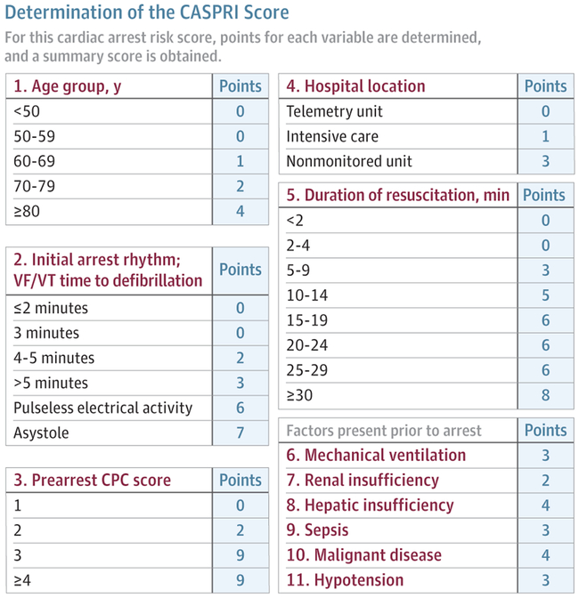
Reprinted from Chan et al,⁸⁴ where a detailed description of the score's interpretation is presented. Scores of 0-4 are associated with 83% survival, 15-19 are associated with 23% survival, and 30-34 are associated with 2% survival. CPC indicates cerebral performance score; VF/VT, ventricular fibrillation or ventricular tachycardia.

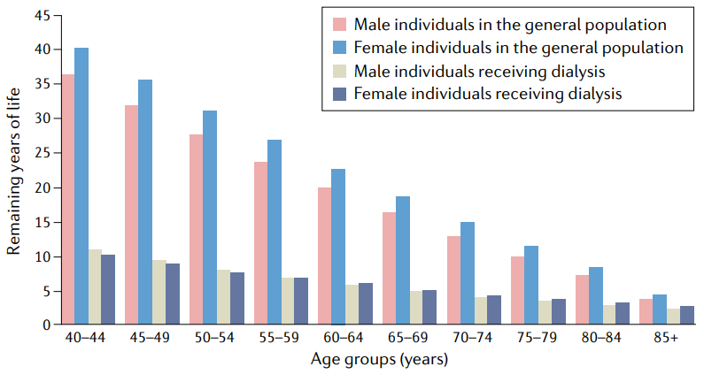
Fig. 2 | Expected remaining years of life in prevalent patients on dialysis. Expected remaining lifetime, in years, for the 2018 prevalent kidney failure population and the 2017 general population in the USA. The graph illustrates the markedly shortened projected lifespan for patients with kidney failure compared with that of individuals without kidney failure. In individuals aged 40–44 years, for example, the projected lifespan difference between men receiving dialysis (expectancy 10.9 years) and men in the general population (expectancy 36.5 years) is >25 years (>30 years for women). Unsurprisingly, the difference in expected remaining years of life decreases with increasing age. However, even men and women aged 80–84 years on dialysis have life expectancies that are 4.3 and 5.3 years shorter, respectively, than their counterparts who are not receiving dialysis.

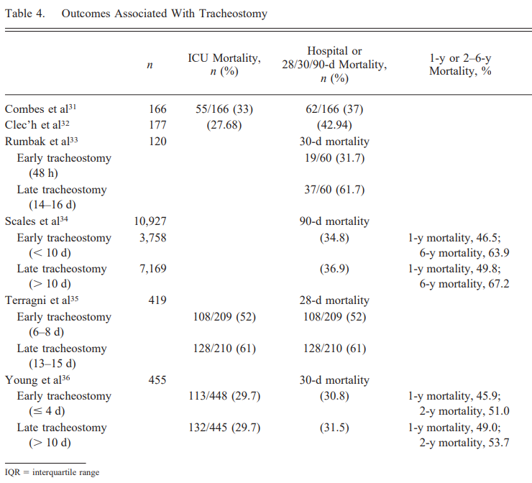

Cheung 2014, Respiratory Care, “Tracheostomy: Epidemiology, Indications, Timing, Technique, and Outcomes”

BODE index for COPD:
